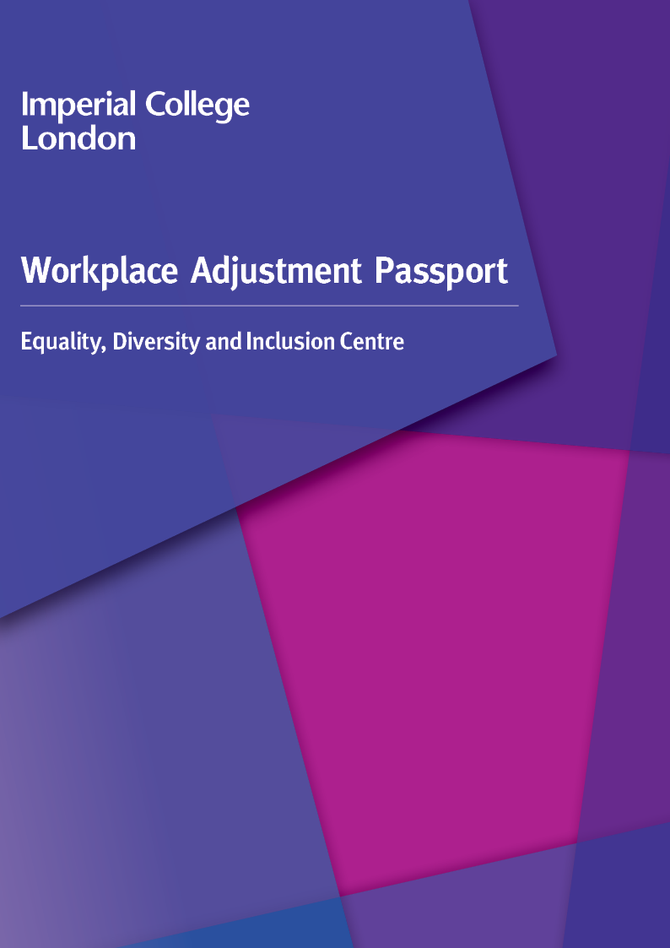

How to use this passport
The purpose of this Passport is to provide an outline of the process of agreeing Workplace Adjustments and creating a record agreed between you, your line manager, and the College to support you at work.
The Passport is open to anyone requiring Workplace Adjustments. Reasons for requiring Workplace Adjustments often relate to living with a disability, impairment, or long-term health condition. You and your line manager may agree to use this Passport as a way of recording other adjustment requirements including having caring responsibilities, for faith-based reasons or if you are undergoing gender reassignment.

It is recommended the Passport guidance is read by managers and staff members prior to completing this Passport.

The Passport is a tool to:
- Record the initial agreement between you and your Line Manager.
- Provides a structure to review/check-in and update your Workplace Adjustments. (This can be done regularly, where you decide how often and when there are circumstances requiring an alteration to your Adjustments.)
- Act as a starting or review/check-in point for discussion when you change roles, are being relocated, are required to alter your work location pattern, or assigned a new manager.
- Plan for when you are unwell and/or need additional support because of your disability or condition.

It is recommended that the staff member (you) begin by completing part 1. Guidance is available under personal details guidance.

It is then recommended you complete the subsequent parts together with your manager.

Include as much detail as you feel is appropriate and skip parts that are not relevant, or you do not wish to complete. Physical and non-physical Adjustments can be included (further information can be found under types of adjustments) as well as temporary or permanent Adjustments.

Completion of the Passport is voluntary. You have control over the content and once agreements are recorded, we request that you share your Passport with the Equality, Diversity and Inclusion Centre (EDIC) via email.

You can seek further support and guidance from the Equality Diversity and Inclusion Centre on how to fill out the Passport.

Passport reviews
The Passport is a live document; you and your line manager should review this document at least annually. You may decide to have more regular reviews if your role changes, if your situation/condition(s) change, or if you are trialling a Workplace Adjustment. This is to ensure the Workplace Adjustments continue to meet both your and the College’s needs and are removing any identified workplace barriers.

Change of Line Manager
It is strongly recommended you arrange a meeting with a new line manager to share your Passport. Your new Line Manager should acknowledge that they are fully aware of the Workplace Adjustments and agree to continue the support as required unless there has been a meaningful change to the role and or condition which would require further conversation about the most suitable Adjustments.

Confidentiality
The Passport contains data which is classified as confidential.
The Equality Diversity and Inclusion Centre, staff (you), and line managers are responsible for keeping this document safe and secure. Data regarding an individual's disability is considered sensitive personal data under GDPR. This means the Passport needs to be processed in line with the College’s GDPR regulations and Privacy Notice and maybe used to review the provision of adjustments at the College. You have the option to not continue to fill out the passport but please note this means the College will not have a record of your agreed adjustments.
A copy of the completed and or updated Passport should be held by you and your manager and the Equality Diversity and Inclusion Centre. Please email the completed/updated Passport to equality@imperial.ac.uk.

Part 1: Personal Details

Name
Job title
Department

Please provide an overview of why you require Workplace Adjustments. We recommend you read the guidance notes before completing this section (SEE PERSONAL DETAILS GUIDANCE DOCUMENT).
You might wish to separate this page from the Passport and share it with your team or wider stakeholders.

- Briefly describe your condition(s)/or situation which requires you to need Workplace Adjustments.

- What impact does this have on you in the workplace?

- What support do you need from your Line Manager, team and or stakeholders to enable you to work efficiently?

Part 2: Agreed Adjustments
Please note the Passport should only contain agreed and approved adjustments.

Local Workplace Adjustments
Please list any Workplace Adjustments that you and your line manager have agreed. It may be helpful to refer to the guidance on what types of Workplace Adjustments exist (see types of adjustments)
If you have more than two agreed adjustments, please copy and paste the boxes as required.
Agreed adjustment
Purpose
Start Date
Additional information

Agreed adjustment
Purpose
Start Date
Additional information

Additional notes.

Specialist Workplace Adjustments
Please document any recommendations made following a specialist external assessment, or occupational health review which you, your Line Manager, and the College have agreed to implement. You may wish to include your assessment report as part of your Passport.
If you have more than two agreed Workplace Adjustments, please copy and paste the boxes as required.

Agreed adjustment
Purpose
Start Date
Additional information

Agreed adjustment
Purpose
Start Date
Additional information

Additional notes.

Part 3 – Staying Well Plan (swell)

The Basics
What is your baseline? How do you feel when you are well?
How does your health condition / impairment/situation affect you? How do you feel and come across when you are impacted?

Triggers
Triggers are things that happen that may set off a worsening of your condition(s) or situation.
Describe any triggers you have identified that tend to worsen your symptoms or situation. These can be workplace or external triggers:
How can your colleagues help minimise triggers or support you to manage your symptoms or situation at work?

Early Warning Signs
These are the subtle signs that you may be experiencing a worsening in your condition(s/situation). Sharing yours will help others to look out for you and support you when you need it most.
What early warning signs should your colleagues look out for?
What steps or support can your colleagues provide if they recognise the early warning signs?
What steps can you take to manage your condition(s) in the workplace?

Detailed below is a section for optional support networks information. This is in addition to emergency details provided via the Imperial College In
You are under no obligation to provide these details. You can choose to fill out emergency information details for one, none, or all the suggested boxes or provide contact details for groups not suggested here. You may also want to share information about medication.

Emergency Situations
Should you be in a position where you are unable to communicate your needs to a first responder or emergency services provider is there anything important your Line Manager or Colleagues should be aware of and ready to pass on

Here is another section for optional medical information.
You are under no obligation to provide information about your medication. You may choose to share information that you think is relevant for others to know on an ongoing day to day basis.

Medication
Use this space to share any important information that others may need to know about medication you take to manage your condition(s)/situation. This can include side effects, or anything else you feel is relevant.

Do you have a Personal Emergency Evacuation Plan (PEEP)?
Yes/No
If yes, please provide information on your agreed evacuation arrangements. Please ensure a copy of your PEEP is available to all relevant parties including the EDI Centre and all other departments and individuals listed on your PEEP.

Support Networks
Please give details of friends, family, or health care professionals that you may want your colleagues to call if your health deteriorates. Be specific of who you would want contacted in specific situations
Name:
Relation:
Contact details:
When they should be contacted:
Name:
Relation:
Contact details:
When they should be contacted:
Part 4: Review of agreements
Use this section to review all agreed adjustments and all updates. Include:
- When you first create your Passport.
- Whenever you review your Passport. Record if adjustments remain and if they change.
- Whenever you change Line Manager.
We recommend you use e-signatures for convenience.

Date  dd/mm/yyyy | Reason for Review and Amendments made | Your  Signature | Line Manager Signature

