Delegated Authority – Maintain ARCs
Log into IC Manager Self Service in one of the following ways:
If you do not use ICIS already: | Existing ICIS users:
1. You should use the link (http://icis.imperial.ac.uk/). Use your College network username and password to login.  - Use Unified Access or the remote desktop connection for access.  - When logging in for the first time, you will be asked to validate the login via MFA.  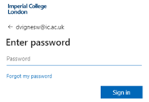  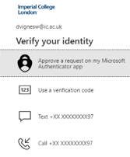  - After successful authentication, you will be redirected to the ICIS sign in page. | - You should use the link (http://icis.imperial.ac.uk/) and your College network username and password to login.  - Use Unified Access or the remote desktop connection for access.  Once logged in navigator to the Delegated Manager Self Service folder:  An example 

Expand your delegated authority responsibility. N.B. this will take the format IC HR MM – Delegated MSS. The highlighted digits determine which area of records you have been given access to. For example, MM would give you access to update records for those that sit within the MM Primary HR Organisation.

To update line manager data expand your Delegated MSS responsibility, and select Maintain ARC.
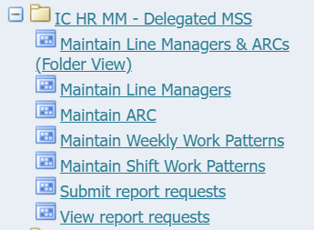
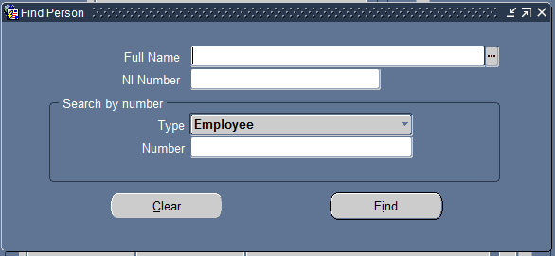
To find the record you need to update you can search by the name or CID number of the individual. If searching by their name use the format SURNAME% or if by their full name SURNAME%FIRSTNAME, e.g. PATEL%PRIYA

The previous ARC entries for that individual will be displayed, plus a new blank line opened up on today’s date. In the new line, change the Start Date field to reflect when the ARC you’re recording was carried out. Click into the Detail field against the same row.
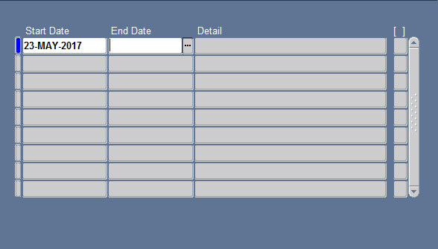

You will see 3 fields.
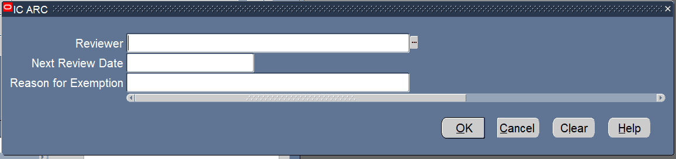

Reviewer: Enter the name of the individual who carried out the ARC meeting. Enter this in the format SURNAME%FIRSTNAME. When you hit enter, the system will search for you and provide you with a list of matching options. Select the correct entry.

Next Review Date: This should be the date the next ARC is due. E.G. If you’ve entered 23 May 2017 as the date this current ARC was due, you should enter 31 May 2018 for the next review date.
Reason for Exemption: If for whatever reason a ARC could not be complete, but you don’t want the individual to appear on reports for non-completion you can enter a reason for exemption. To see the pick list of options for exemption, click into the field and select the 3 dots at the end;
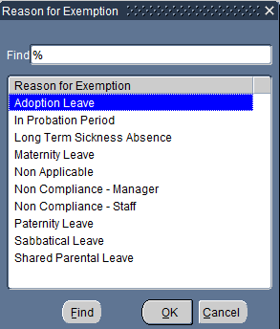

Select the appropriate entry and then hit OK.

You will be returned to the list of ARC records for that individual, and you should be able to see the entry you’ve just made;

Reviewed would have information entered into the 1st two fields and show as
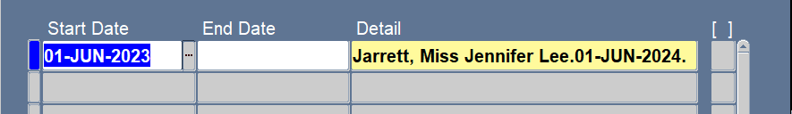
Exemption would have information in the 2nd & 3rd fields and show as


To save your entry, hit the yellow disk icon on the grey tool bar;

