IMPERIAL COLLEGE

SELF SERVICE USER GUIDE

Contents:

Button Index: 3
Updating Personal Details: 4
Emergency Contact Details: 8
Update: 8
Remove: 9
Add: 10
Updating Education and Qualifications details: 13
Further and Higher Education Qualifications: 14
Add: 14
Update: 16
Delete: 17
Update Disability Information……………………………………………………………..19
Add Disability details to a blank page.…………………………...…………………...21
Correct or Complete the current details………………………………………………24
Enter new information ……………..…………………………………………………..27
Add more than one current disability………………………………………………….30

Button Index:
Name: | Description:
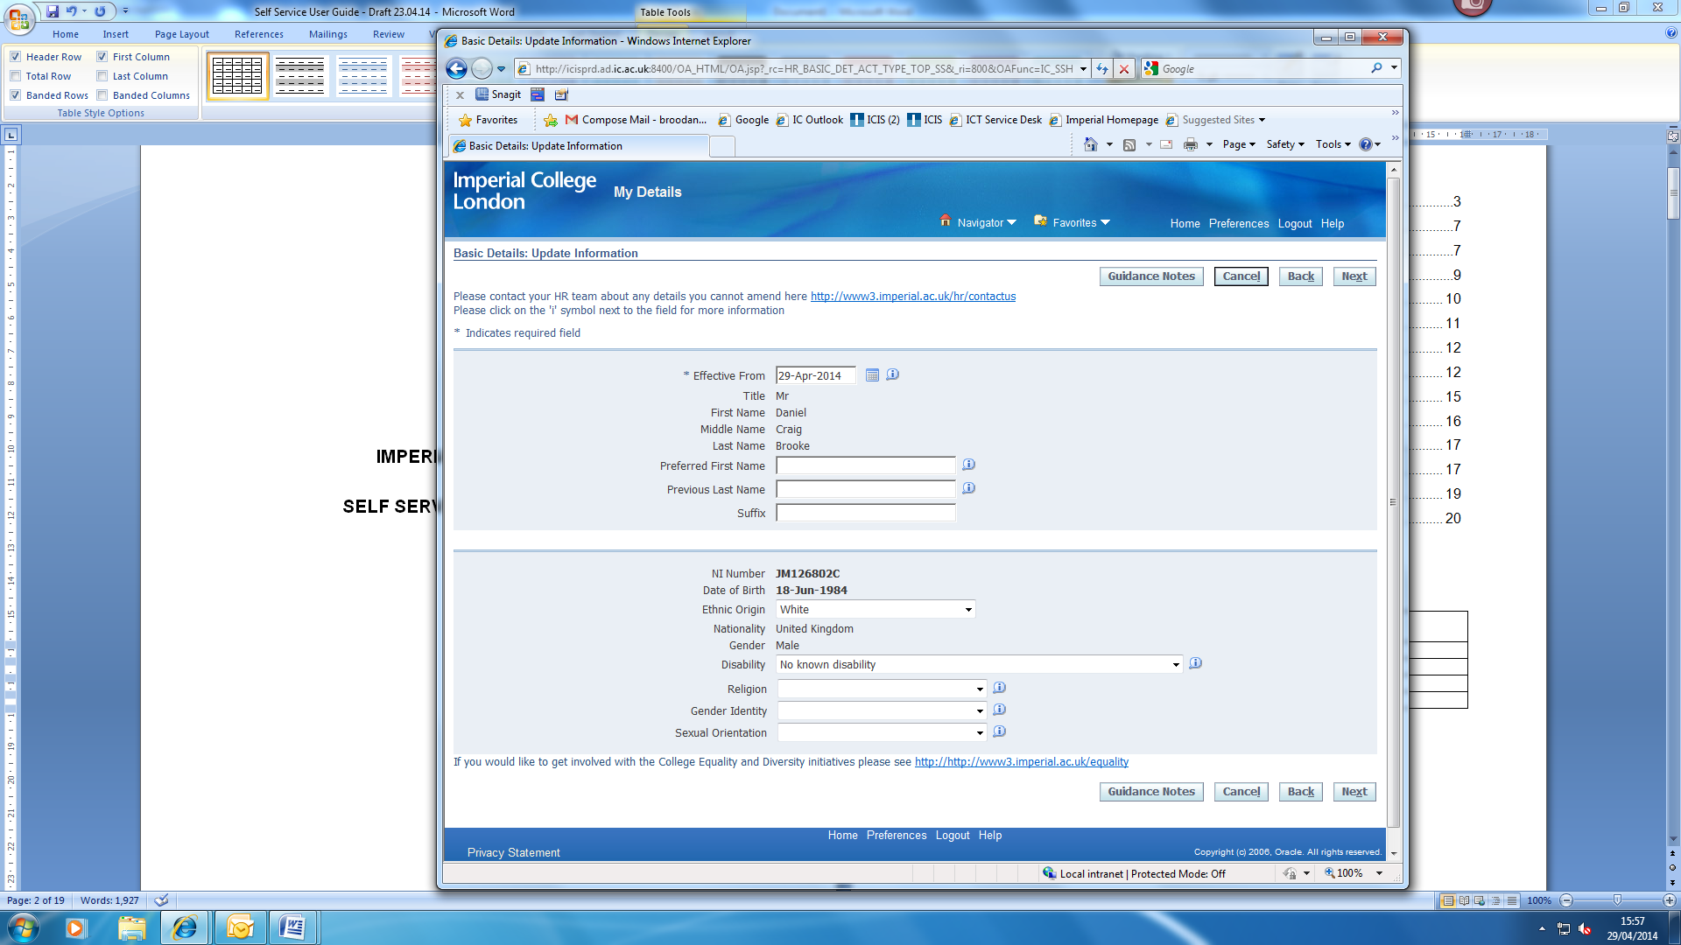 | Clicking on this button will take you to the Employee Self Service webpage where user guides, on-line demonstrations and FAQs can be found.
 | Clicking on this button will cancel your current action.
 | Clicking on this button will take you back to the previous page.
 | Clicking on this button will take you to the next page.
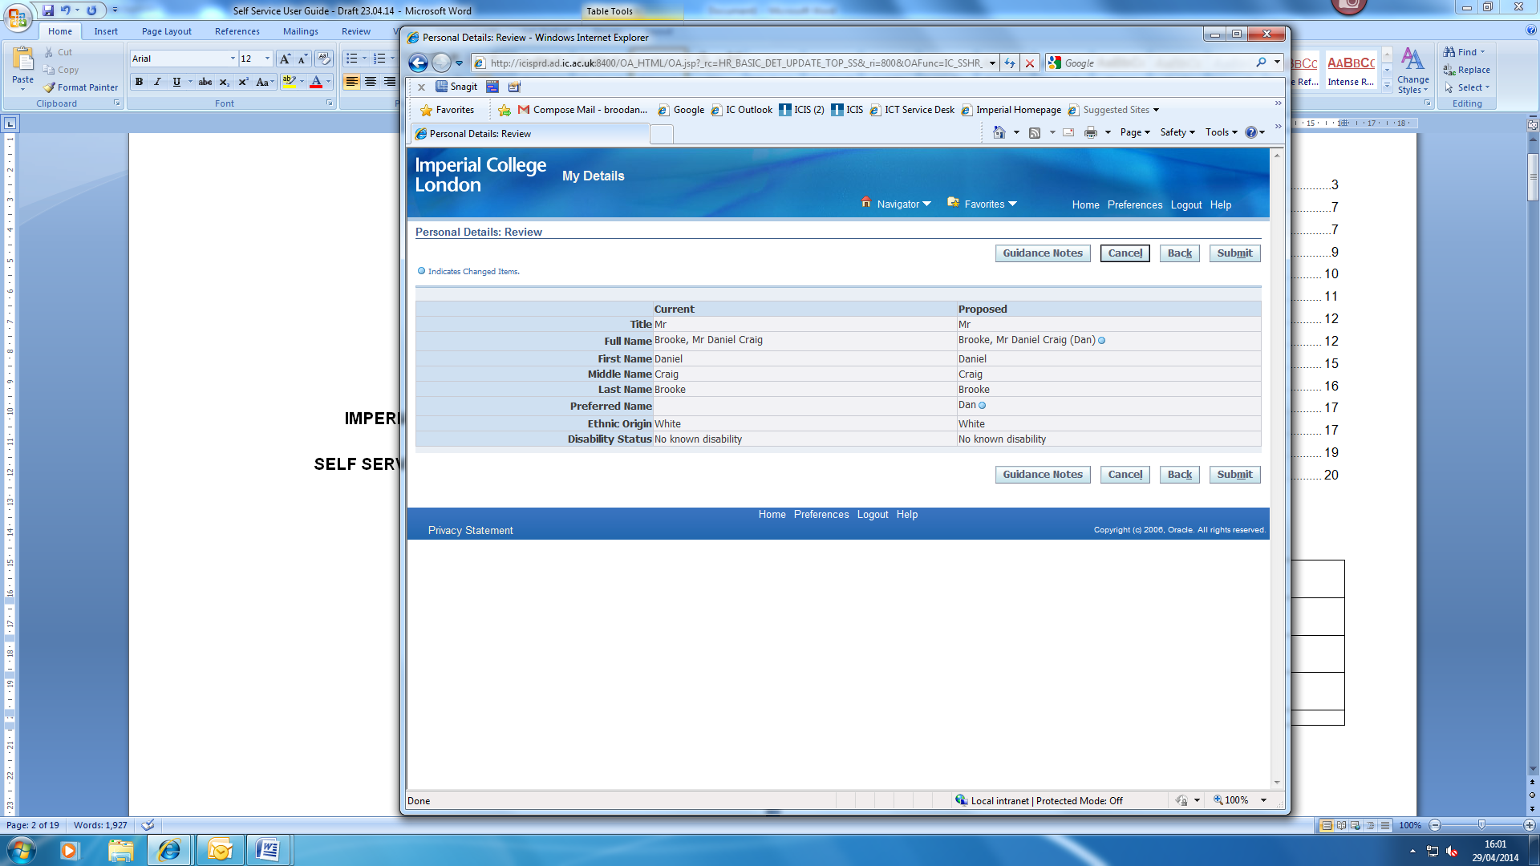 | Clicking on this button will submit the changes you have made.
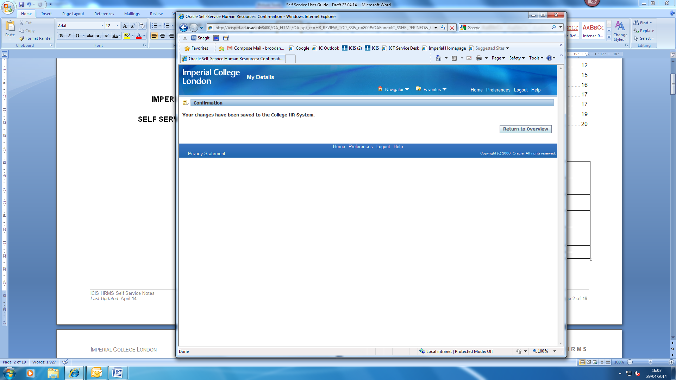 | Clicking on this button will return you to the overview page.
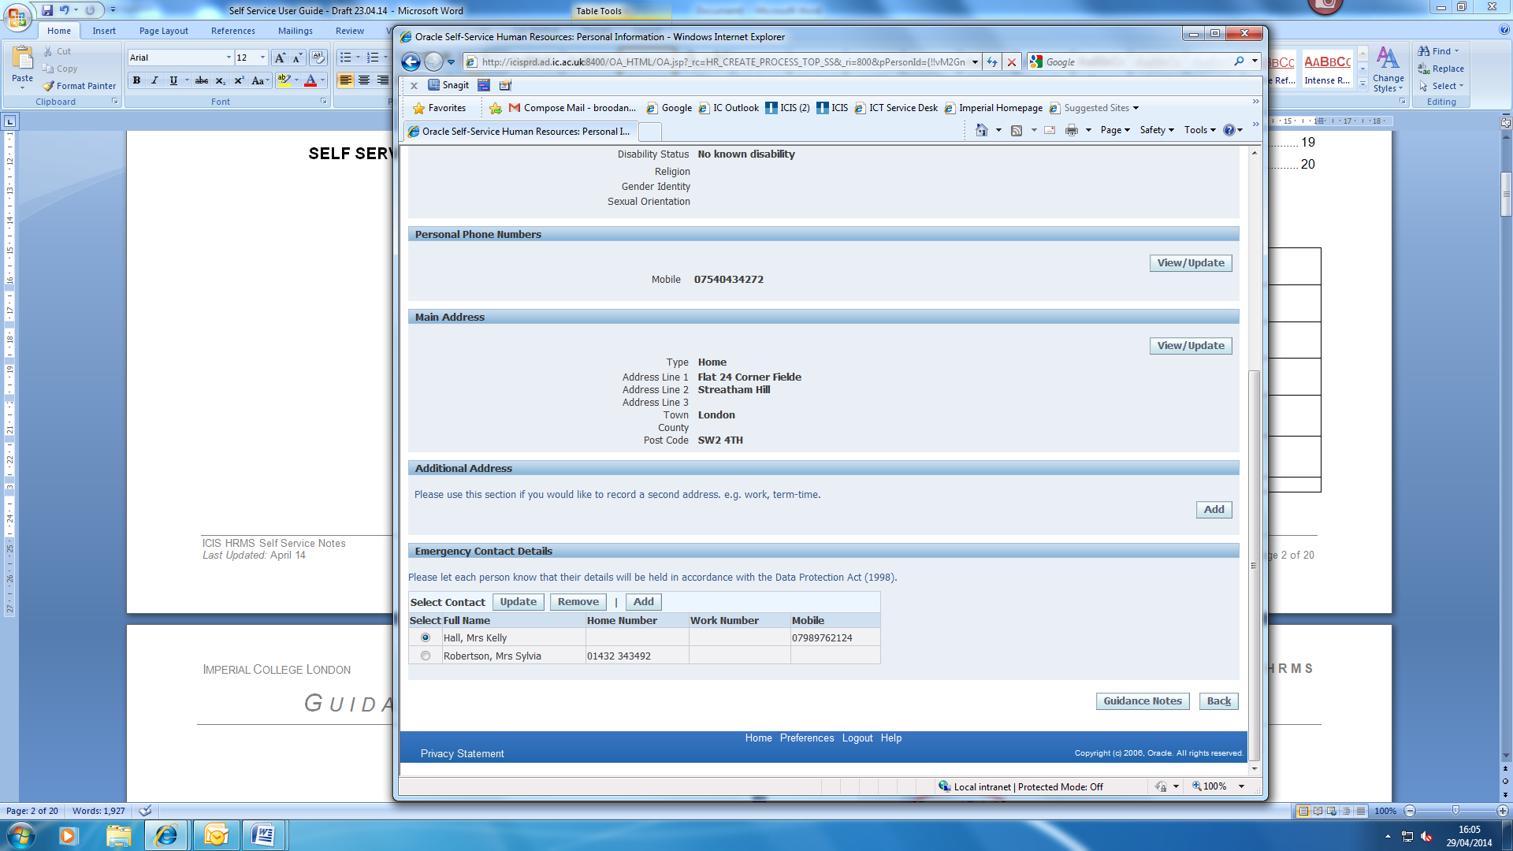 | Clicking on this button will allow you to update the information currently recorded.
 | Clicking on this button will allow you to remove any incorrect information.
 | Clicking on this button will allow you to add information.
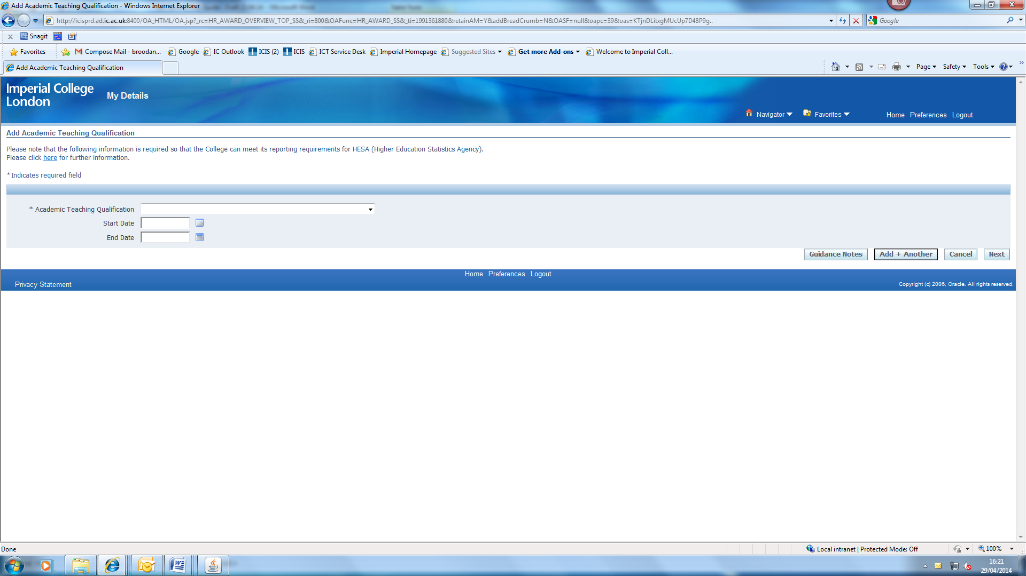 | Clicking on this button allows you to add information plus any additional information before submitting.

Viewing, Adding or Updating your Personal Information using HR Self Service within ICIS

Updating Personal Details:
- Log into HR Self Service in one of the following ways using the same link https://www4.imperial.ac.uk/OA_HTML/OA.jsp?OAFunc=OAHOMEPAGE

If you do not use ICIS already: | Existing ICIS users:
- Use your College network username and password to login.  - Use Unified Access or the remote desktop connection for access.  - When logging in for the first time, you will be asked to validate the login via MFA.  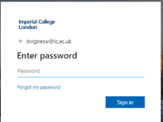  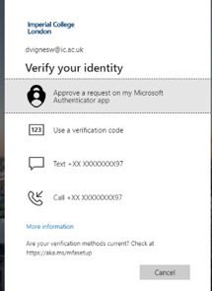  - After successful authentication, you will be redirected to the ICIS sign in page. | - Use your College network username and password to login.  - Use Unified Access or the remote desktop connection for access.  HR Self Service has been added to your ICIS account so you will be able to find it in your ICIS main menu when you log in.

- From the menu select My Details.
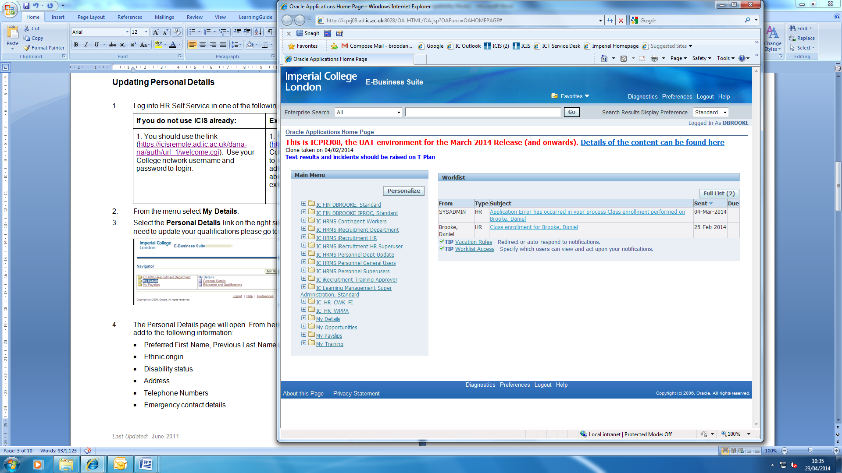
- Select Personal Details. For guidance on how to update your Education and Qualifications please click here.
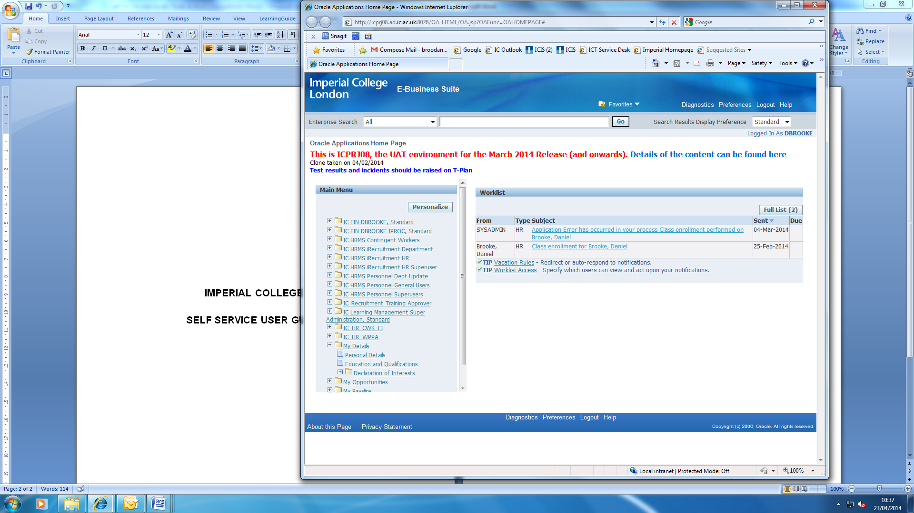
- The Personal Details page will open. From here you can view, update or add (if no information currently exists) the following information:
  - Preferred First Name, Previous Last Name and Suffix
  - Ethnic origin
  - Religion
  - Gender Identity
  - Sexual Orientation
  - Personal Phone Numbers
  - Main Address
  - Additional Address
  - Emergency Contact Details
To amend any personal details that are not found in self service e.g. Last Name, please contact the HR Staff Hub, as any changes to these fields require further verification. An example of when further verification is required is when a change in Last Name following marriage is requested. In this scenario, HR would need to view and take a copy of the marriage certificate before updating any details within ICIS.
Ask the Staff Hub here: Ask the Staff Hub | Administration and support services | Imperial College London.

NOTE: Please do not use the back button on your internet browser to return to the previous page. Please use the BACK button provided on the pages where you can review your information to navigate around the system.

- Click the View/Update button next to the item(s) you would like to update.
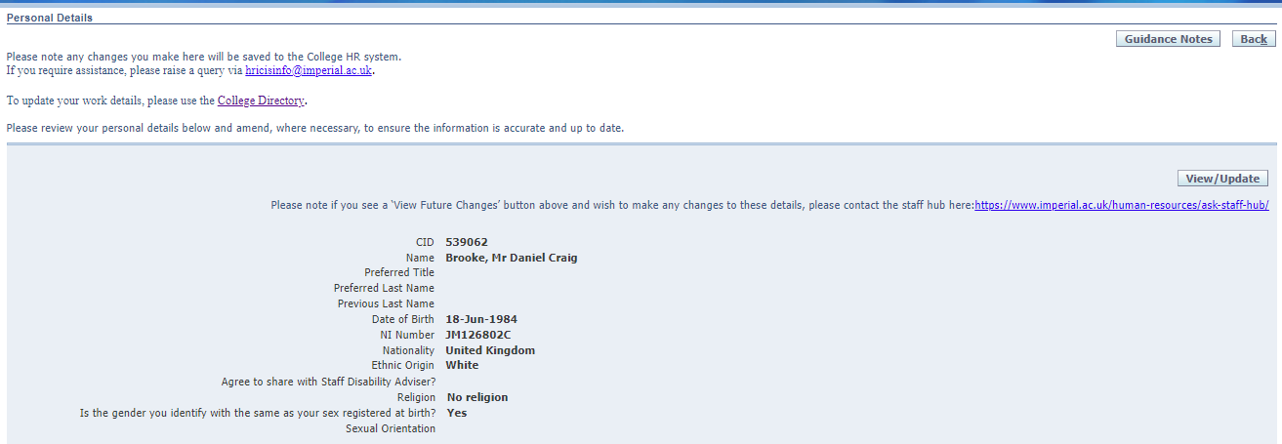

- Select either Amend current details or Enter new information and click on Next to continue.
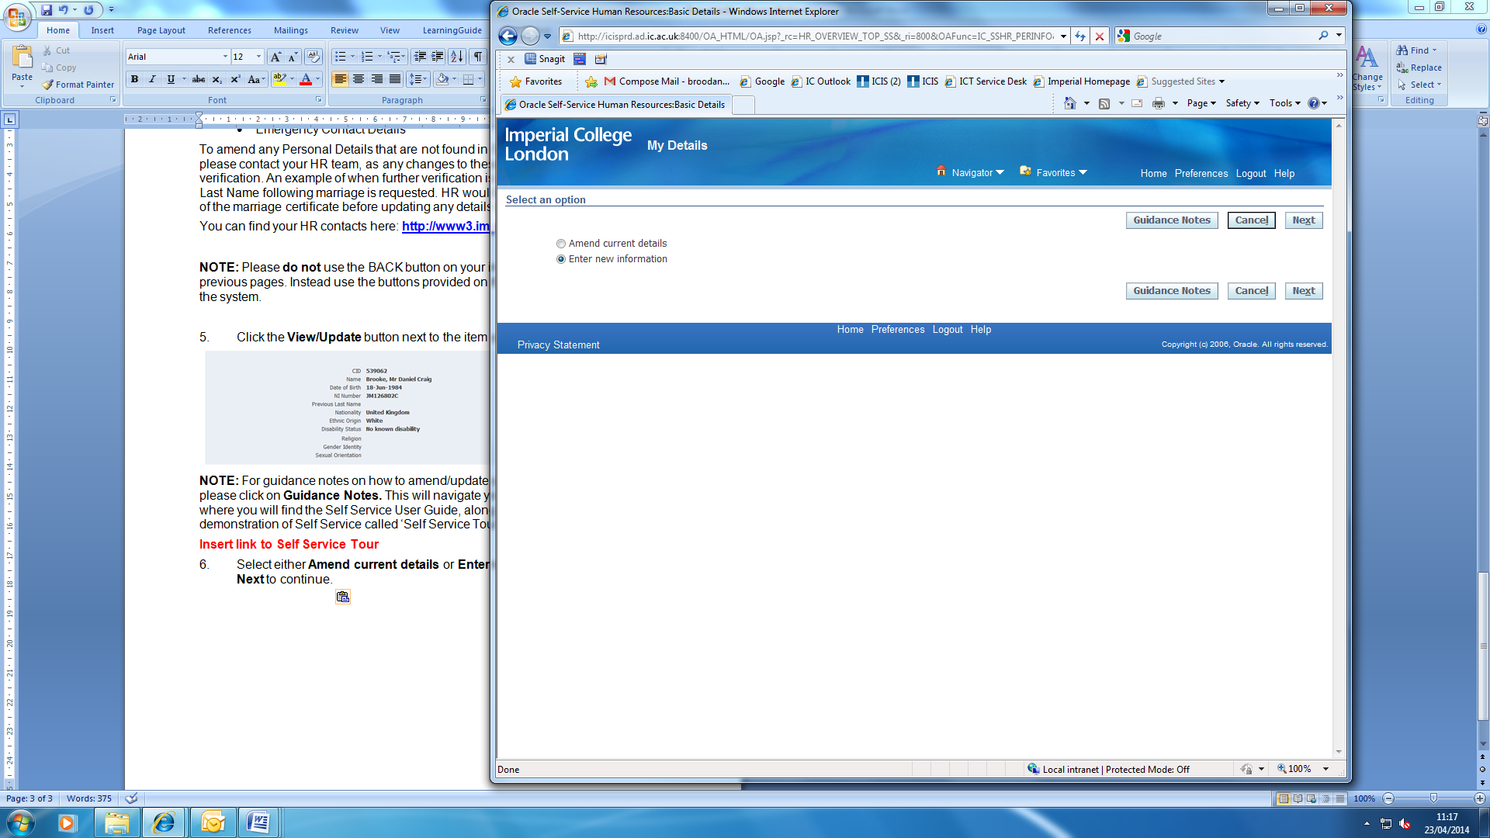

NOTE: Select Amend current details, if you wish to correct the information that already exists in your ICIS record or select Enter new information, if you wish to add information that is not currently recorded in your ICIS record.
- If you are amending your current details, either overtype what is already entered in the relevant field, or select the relevant option from the pick list (if applicable) by clicking on the down arrow at the end of the field. If no information already exists, you can also enter information missing from your ICIS record.
- Once you have made your change(s), click the Next button to continue.
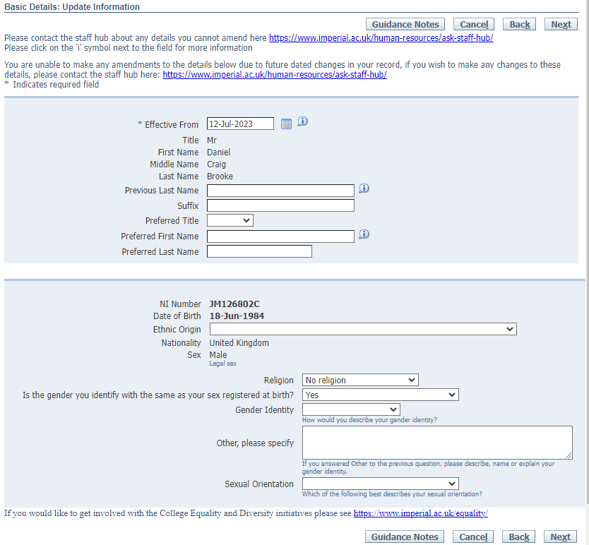
- On the Personal Details: Review page, click on the Submit button to submit your changes.
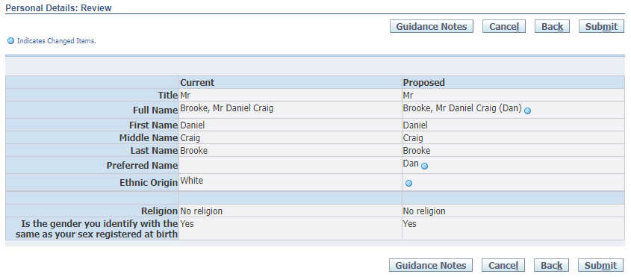
- A confirmation message will be displayed as below:
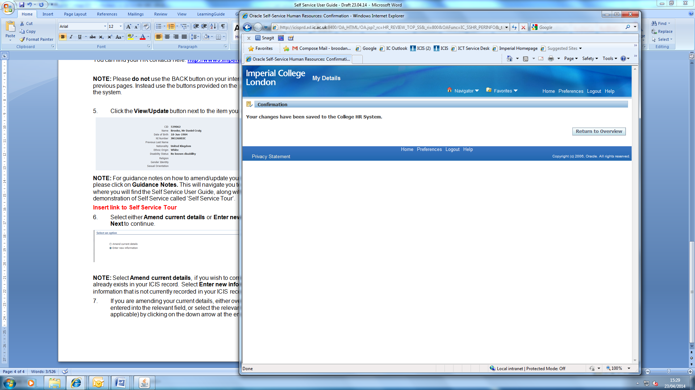
- If you have finished and would like to exit the system, click on Logout at the top of the page. To review any other personal information, please click on the Return to Overview button to return to the Personal Details page.

Emergency Contact Details:
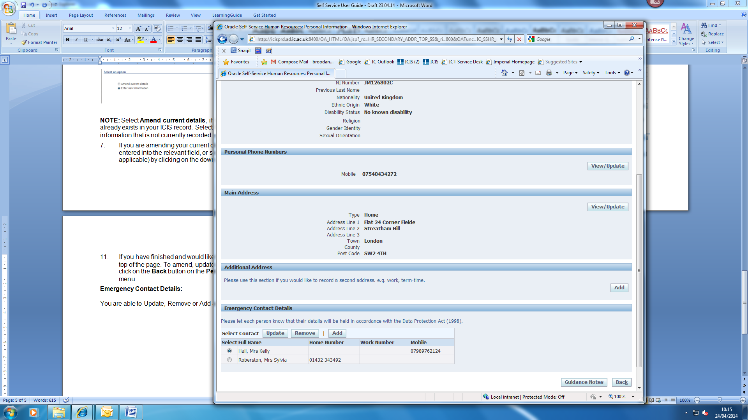

You are able to Update, Remove or Add an Emergency Contact’s details by clicking on the relevant button.

Update:

- To update an emergency contact’s details, select the contact and click on the Update button.

- Update the fields you wish to amend and then click on the Next button.

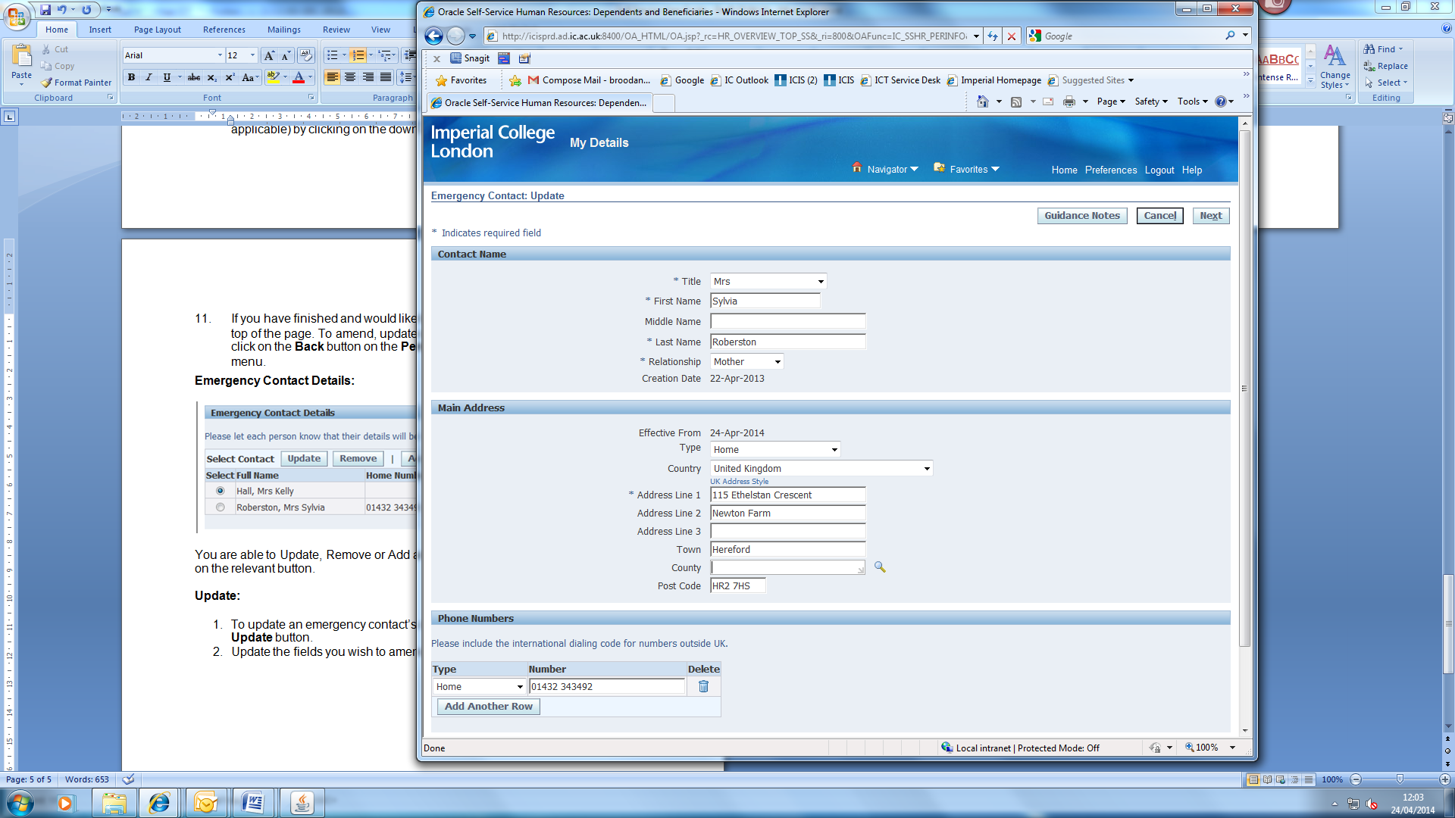

- On the Personal Details: Review page, click on the Submit button to submit your changes.

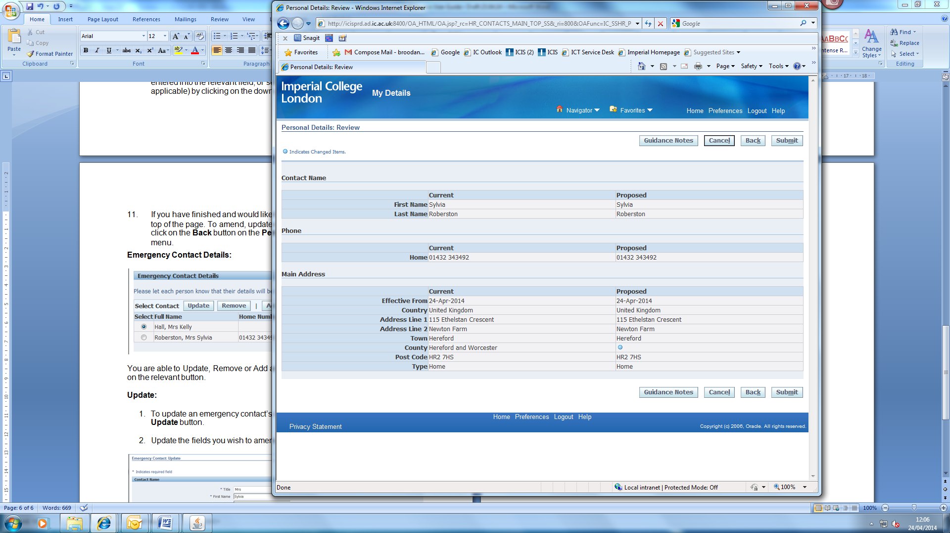

- A confirmation message will be displayed as below:
- If you have finished and would like to exit the system, click on Logout at the top of the page. To review any other personal information, please click on the Return to Overview button to return to the Personal Details page.

Remove:

- To remove an emergency contact, select the relevant contact and click on the Remove button.

- In the End Date field either type in the relevant end date in the following format: 23-APR-2014 or select the date using the calendar icon.

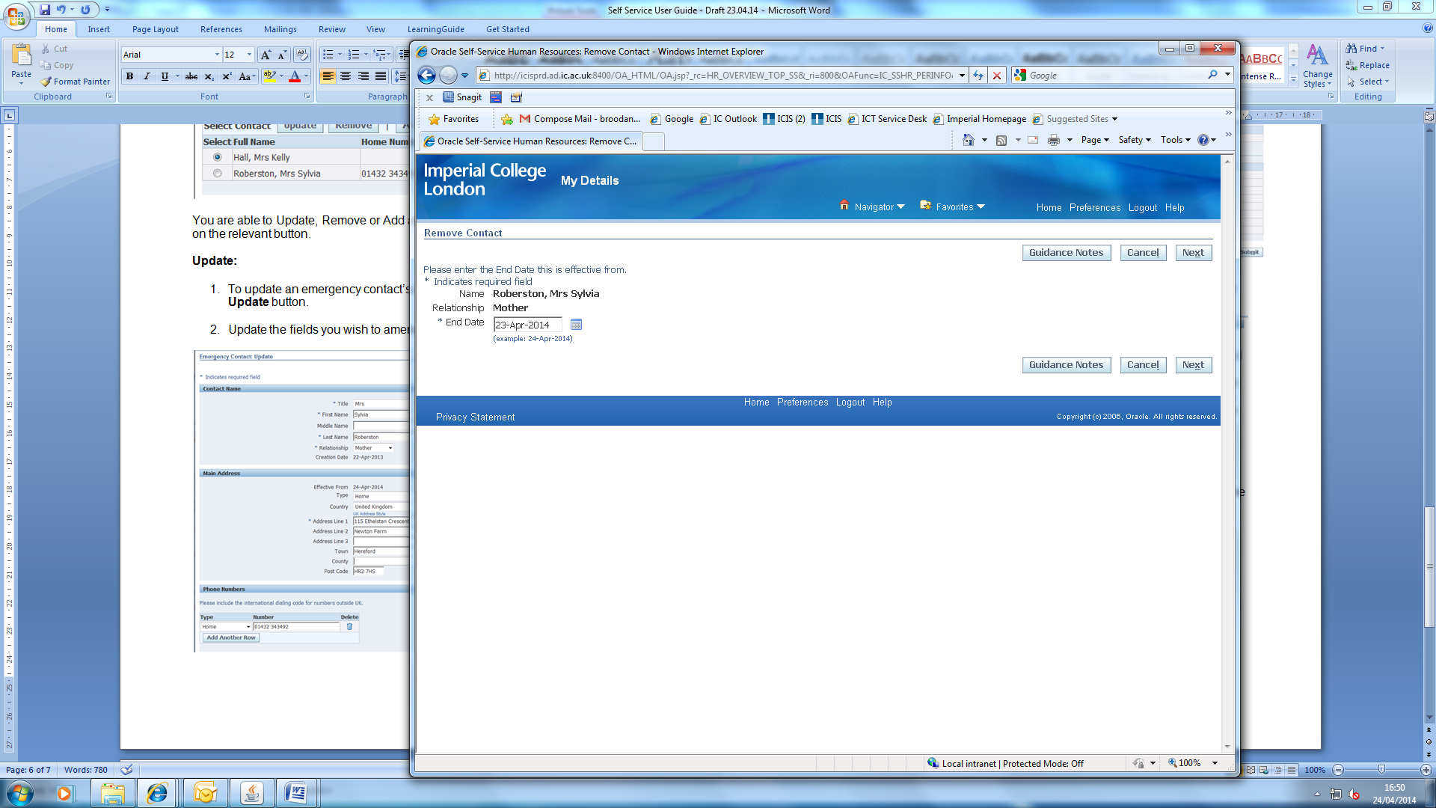
- Click on the Next button.

- On the Personal Details: Review page, click on the Submit button to submit your changes.

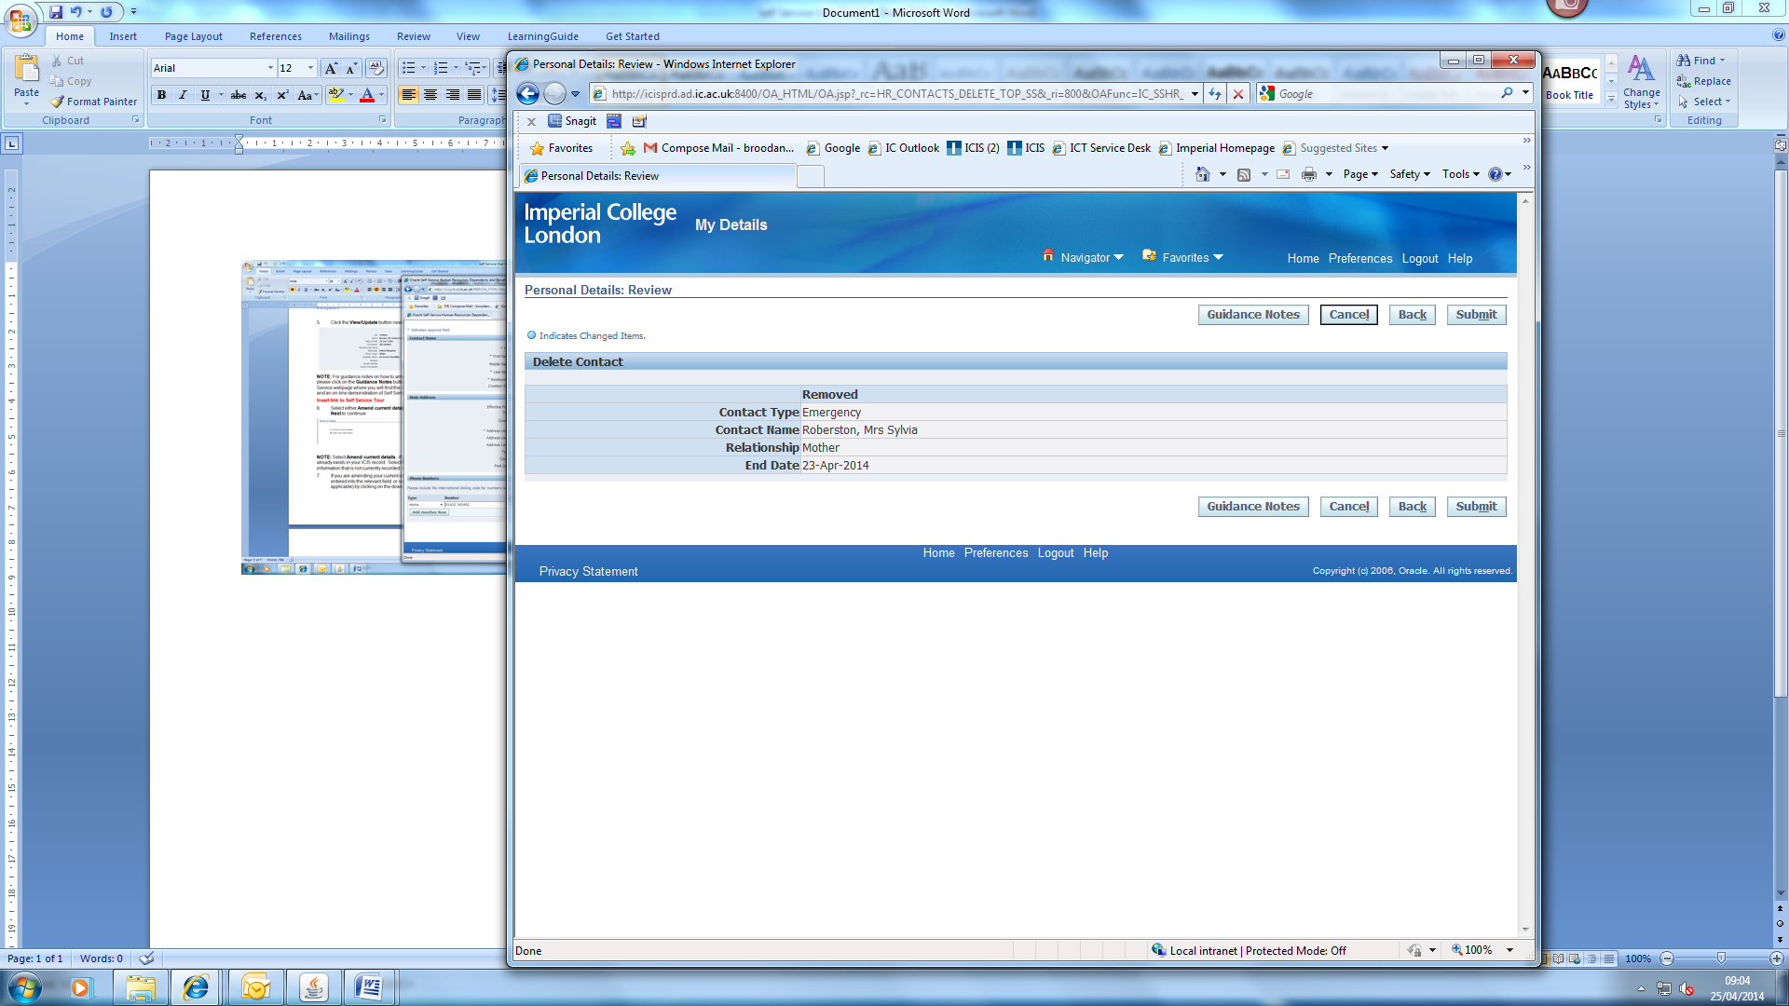

- A confirmation message will be displayed as below:
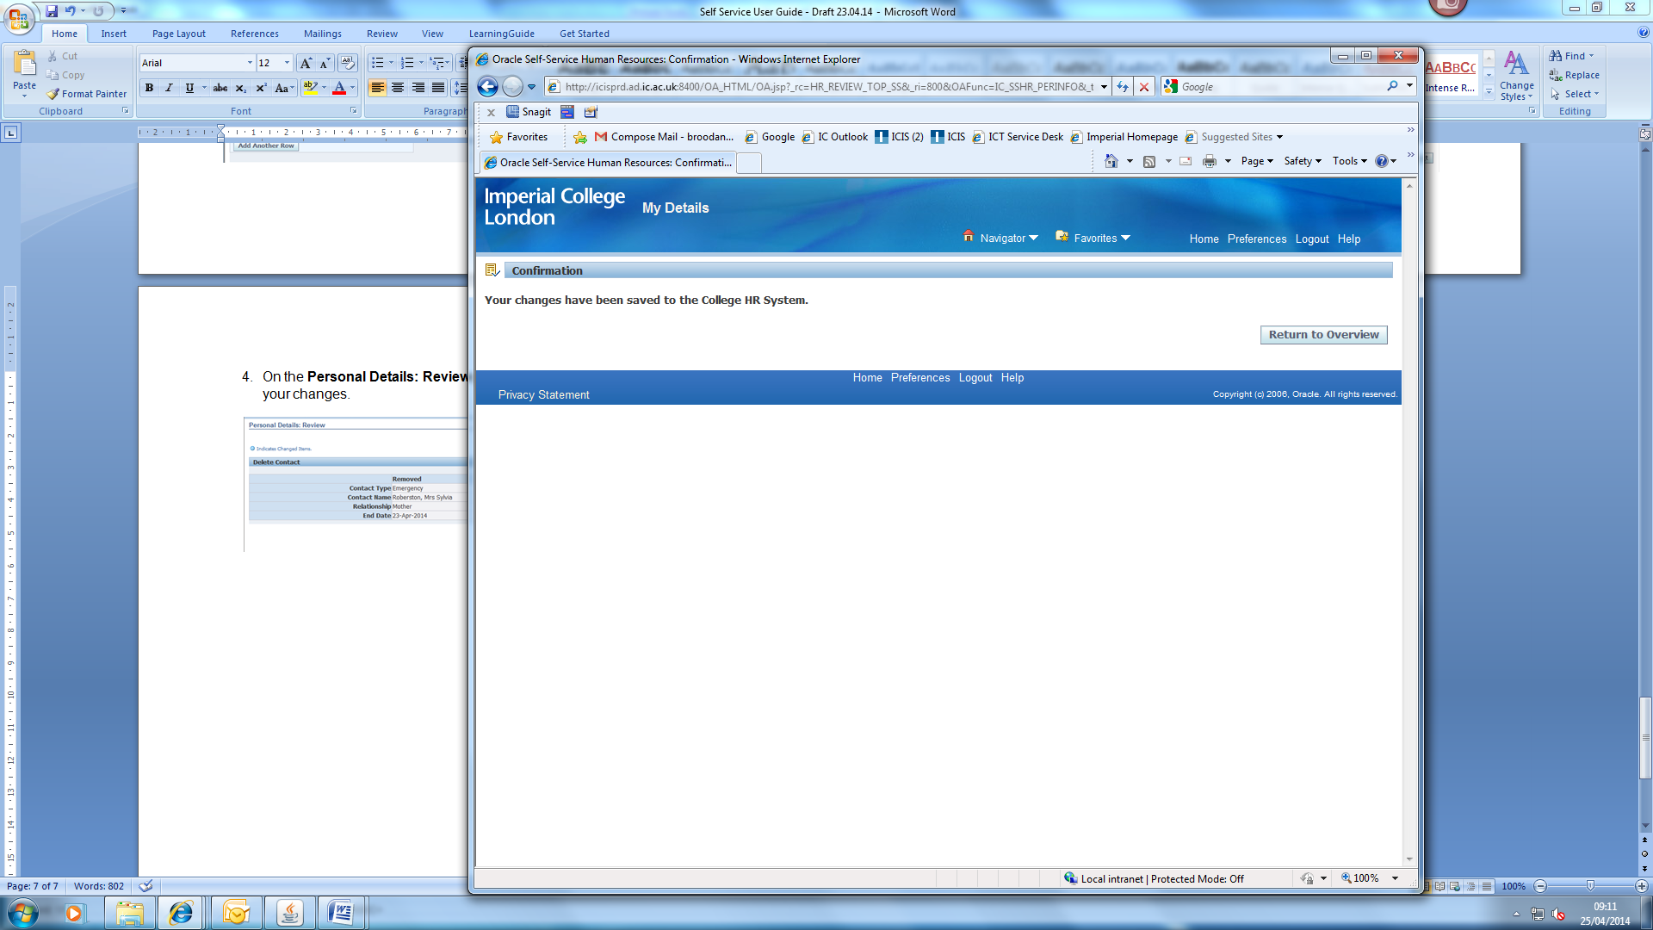
- If you have finished and would like to exit the system, click on Logout at the top of the page. To review any other personal information, please click on the Return to Overview button to return to the Personal Details page.

Add:

- To add an emergency contact’s details, click on the Add button.

- Complete all relevant fields and where required, select the relevant option from the pick list by clicking on the down arrow at the end of the field.

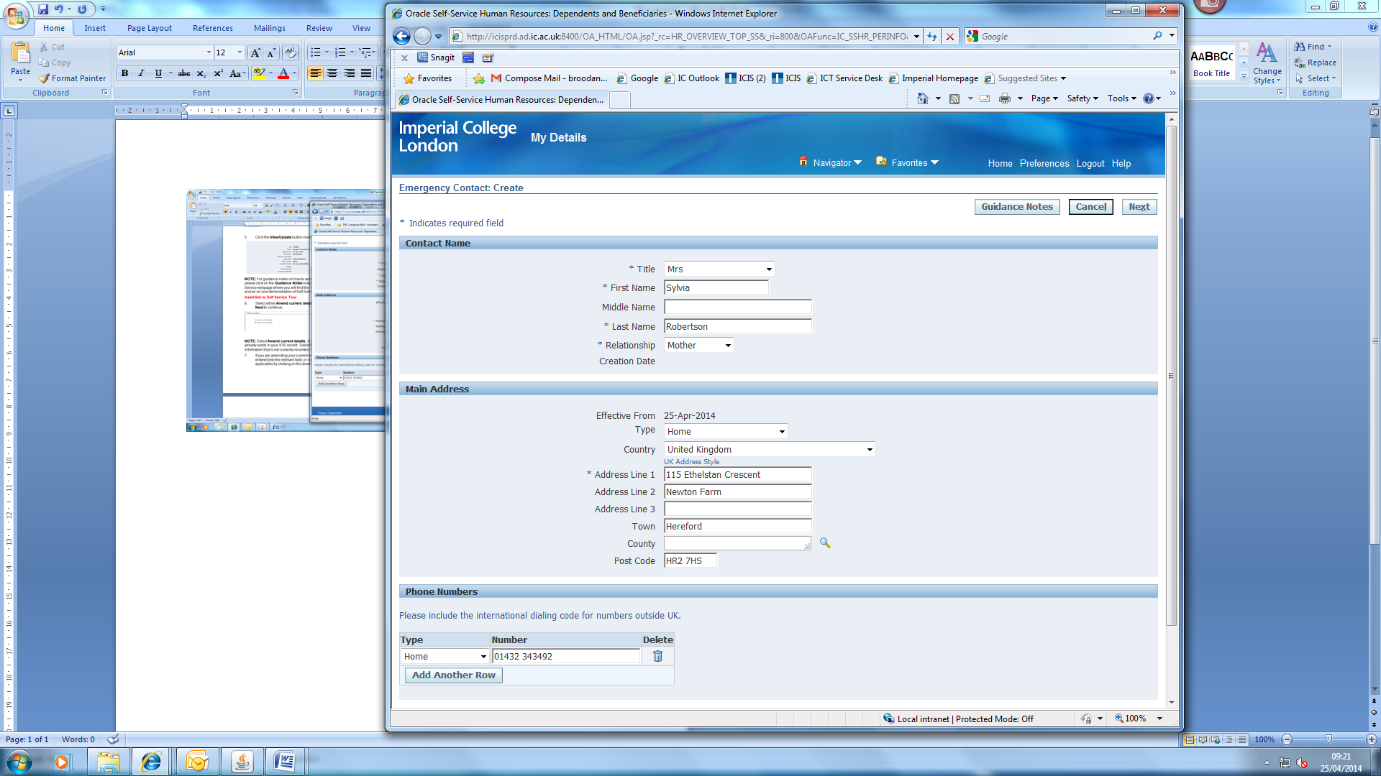

- Click on the Next button.

- On the Personal Details: Review page, click on the Submit button to submit your changes.

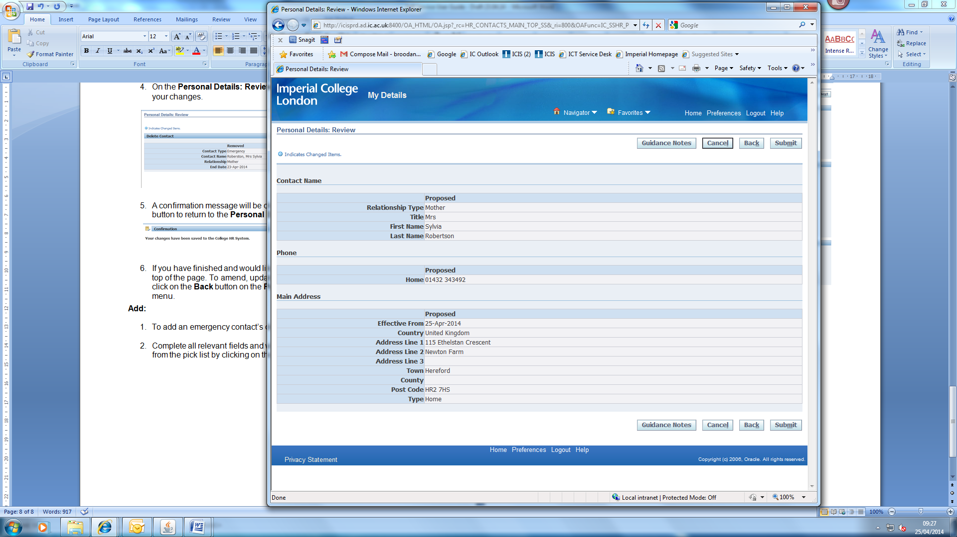

- A confirmation message will be displayed as below:
- If you have finished and would like to exit the system, click on Logout at the top of the page. To review any other personal information, please click on the Return to Overview button to return to the Personal Details page.

Updating Education and Qualifications details:
- Log into HR Self Service in one of the following ways using the same link https://www4.imperial.ac.uk/OA_HTML/OA.jsp?OAFunc=OAHOMEPAGE

If you do not use ICIS already: | Existing ICIS users:
- Use your College network username and password to login.  - Use Unified Access or the remote desktop connection for access.  - When logging in for the first time, you will be asked to validate the login via MFA.  - After successful authentication, you will be redirected to the ICIS sign in page. | - Using your College network username and password to login.  - Use Unified Access or the remote desktop connection for access.  HR Self Service has been added to your ICIS account so you will be able to find it in your ICIS main menu when you log in.
- From the menu select My Details.
- Select Education and Qualifications.

- The Education and Qualifications page will open. From here you can update, add (if no information currently exists) or delete (if applicable) the following information:
  - Further and Higher Education Qualifications
  - Academic Teaching Qualification (ATQ)

Further and Higher Education Qualifications:

Add:
- To add a qualification, click on the Add Qualification button.
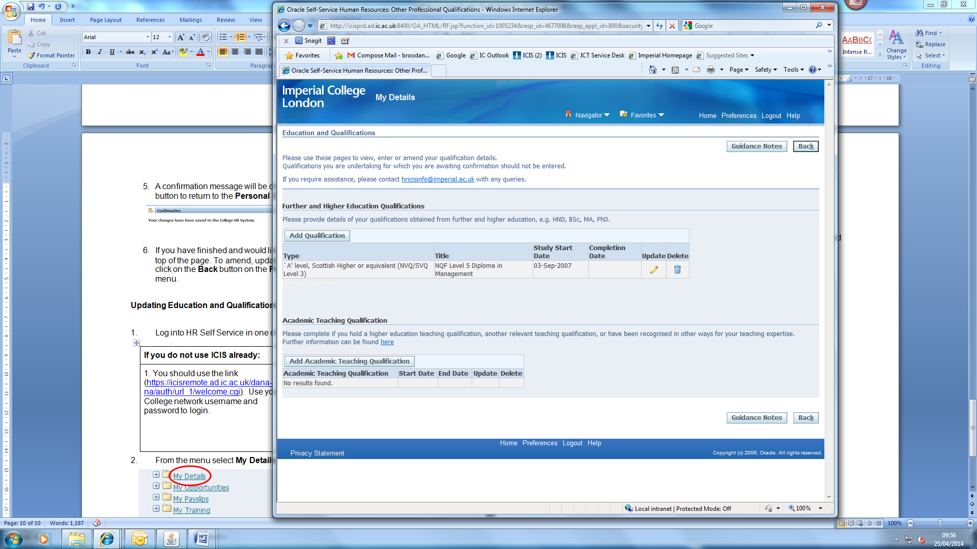

- To enter the Type of qualification, click on the magnifying glass icon at the end of the field.
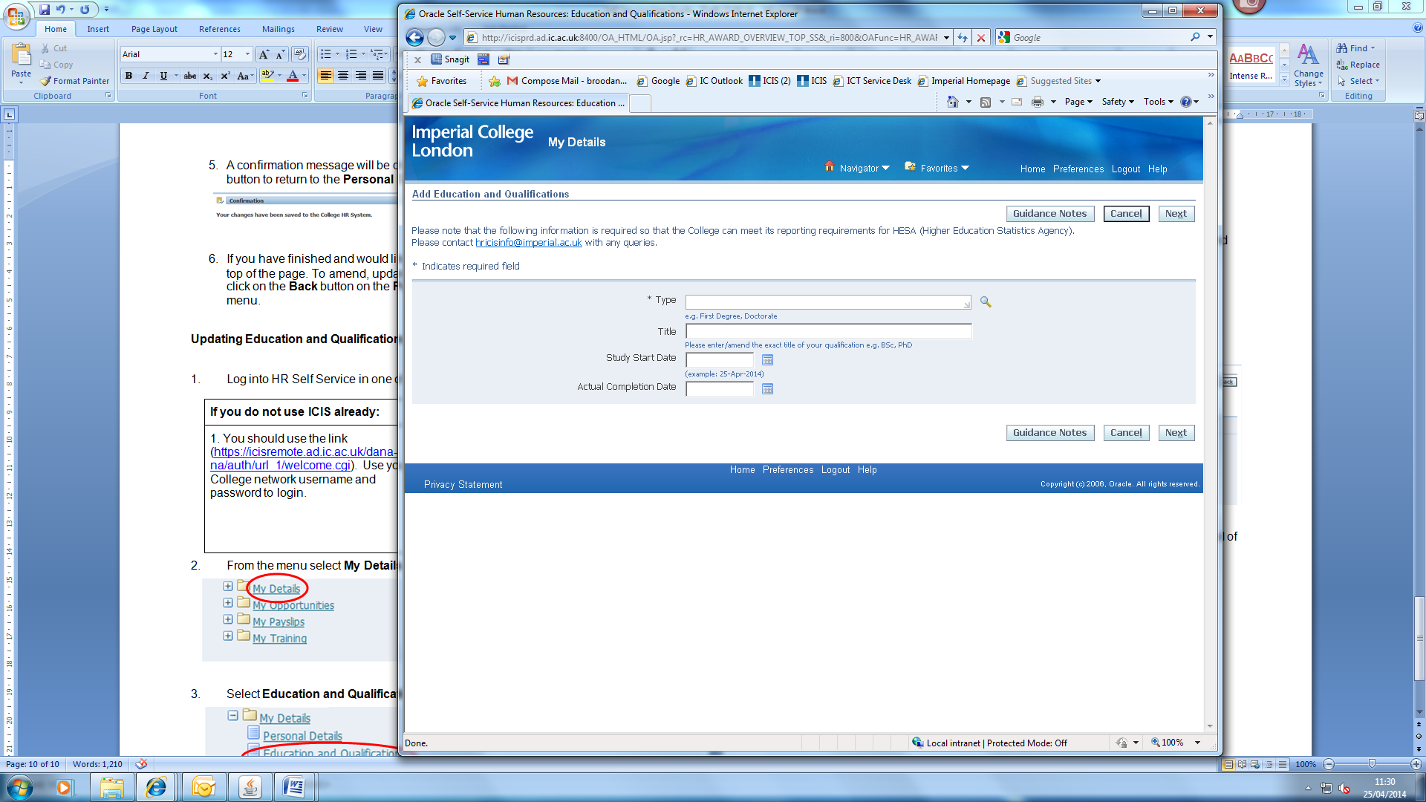
- Leave the Search by Name field blank and click on the Go button. The full list of options available will then be displayed as below:
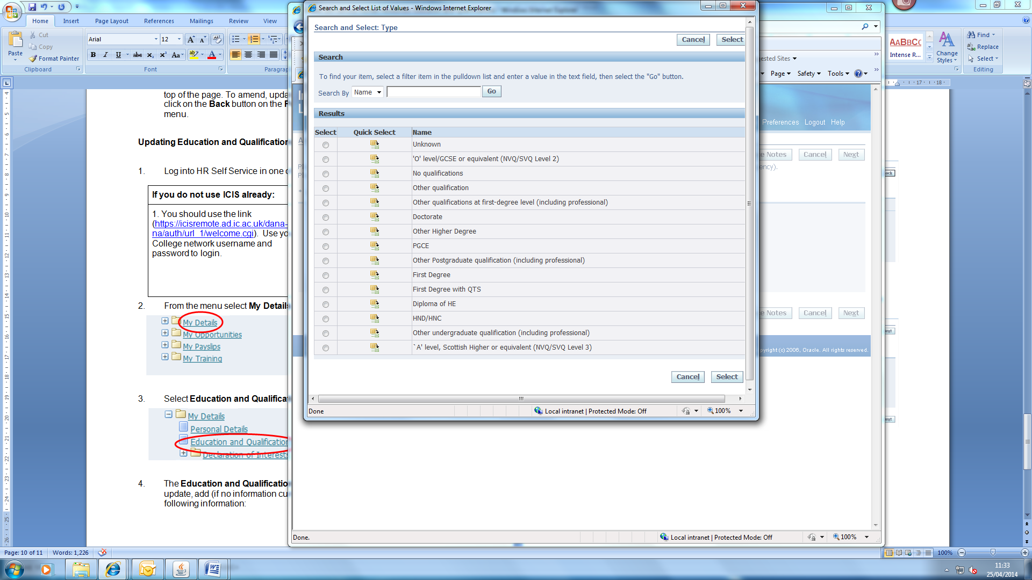
- Click on the Quick Select icon next to the relevant qualification type, which will return you to the Add Education and Qualifications page.
- Complete the remaining fields as required and then click on the Next button.
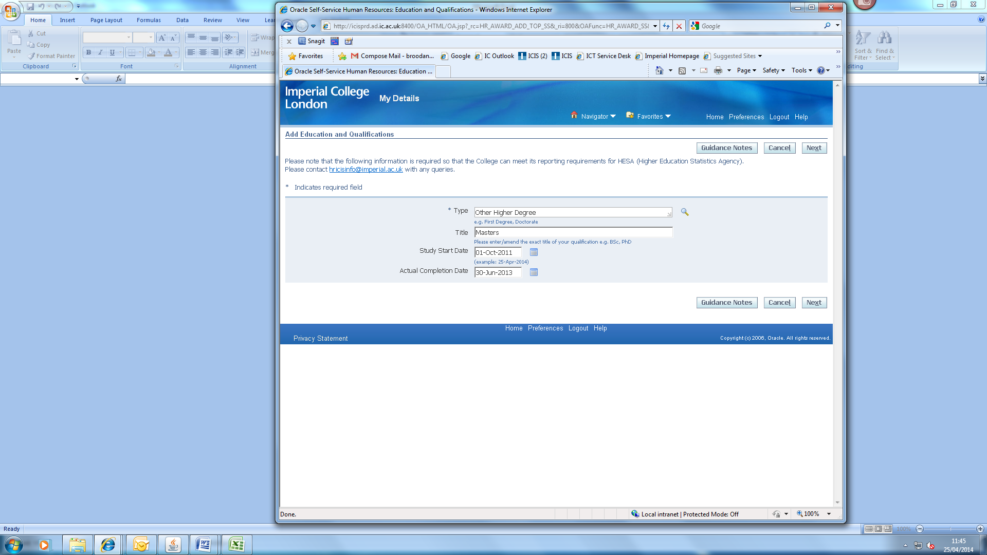
- On the Education and Qualifications: Review page, click on the Submit button to submit your changes.
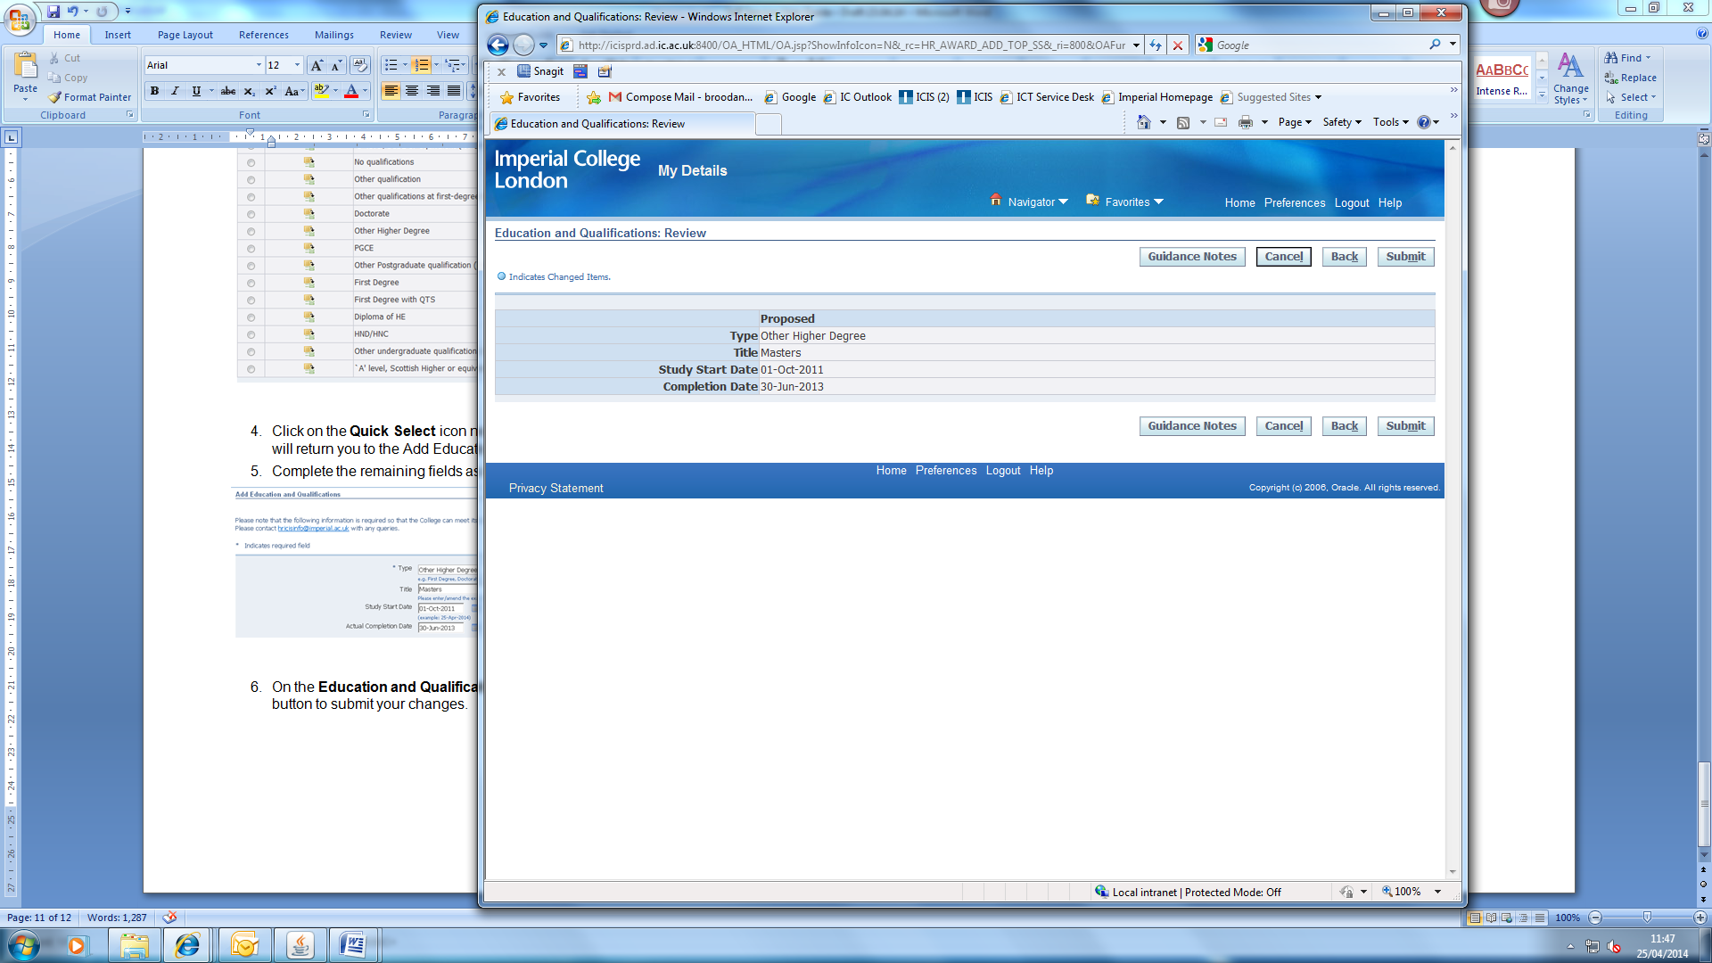
- A confirmation message will be displayed as below:
- If you have finished and would like to exit the system, click on Logout at the top of the page. To review any other education and qualifications information, please click on the Return to Overview button to return to the Education and Qualifications page.

Update:

- To update a qualification, click on the Update (pencil) icon against the relevant qualification.
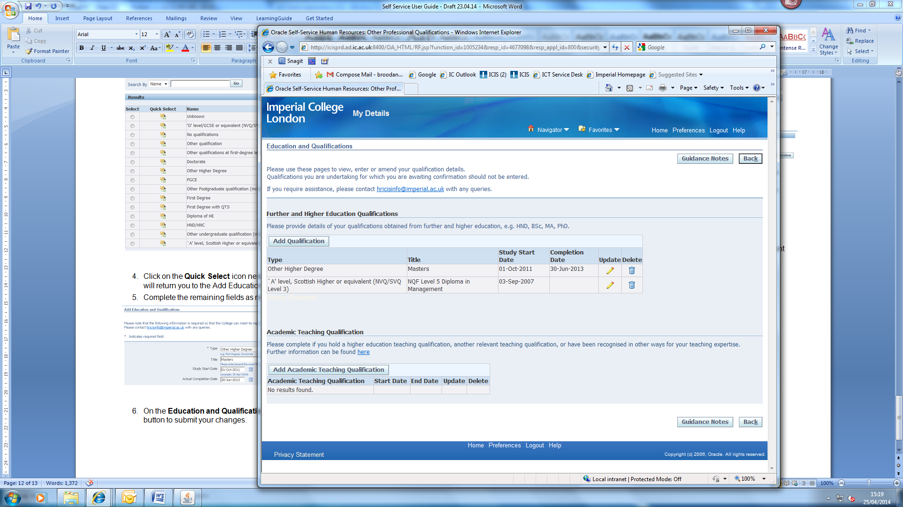
- On the Update Education and Qualifications page, update the relevant fields.
NOTE: You are not able to update the qualification type on this page, to update the type, please delete the qualification and re-enter (please see further notes on how to delete qualifications below on page 16).
- Click on the Next button.
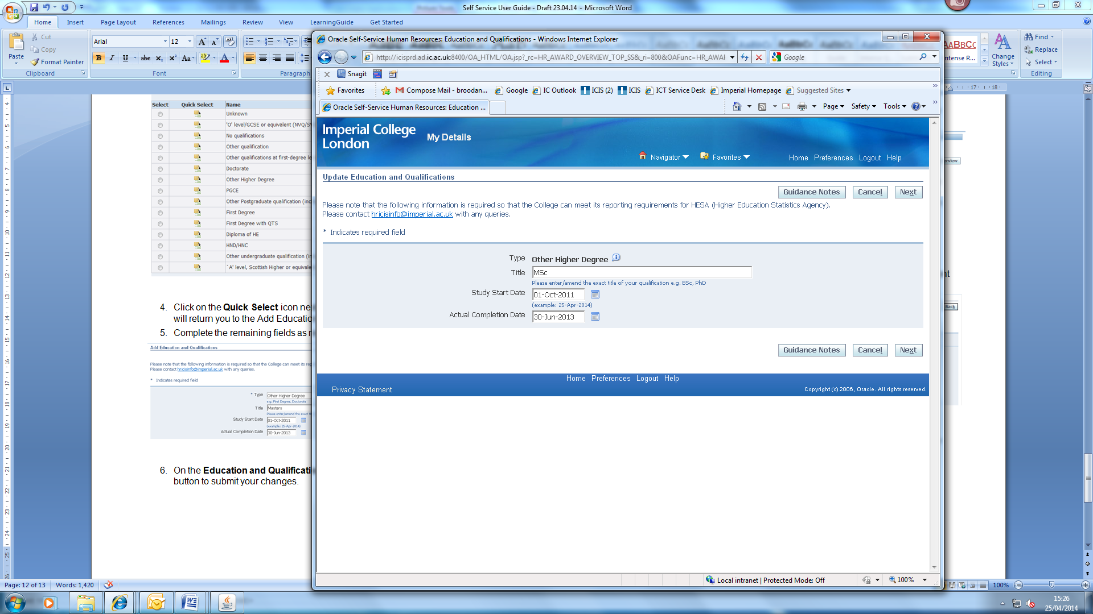
- On the Education and Qualifications: Review page, click on the Submit button to submit your changes.

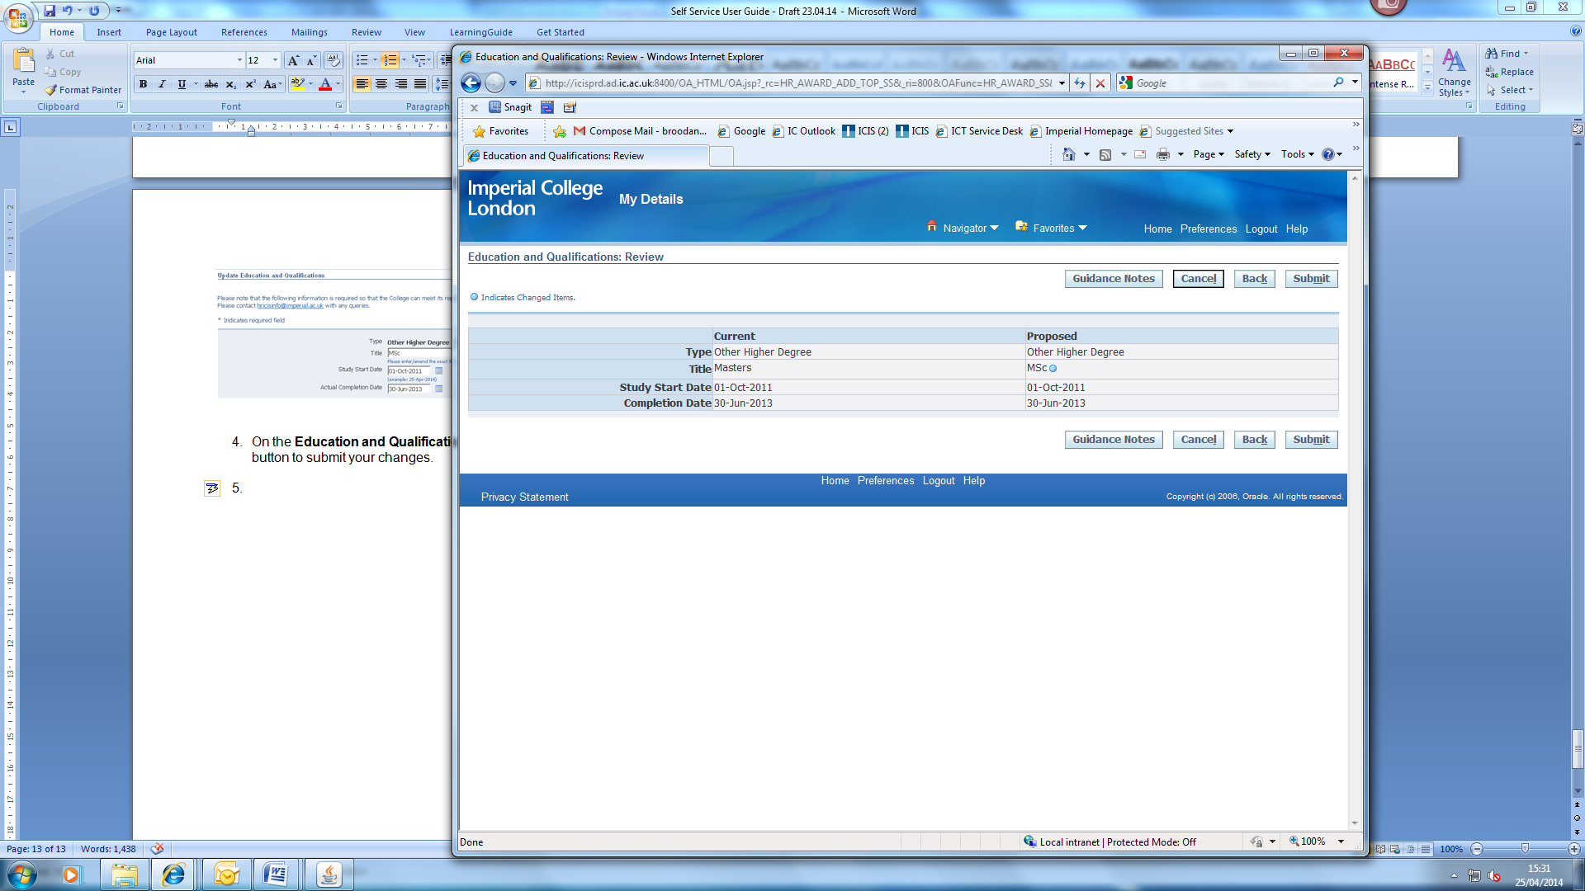

- A confirmation message will be displayed as below:
- If you have finished and would like to exit the system, click on Logout at the top of the page. To review any other education and qualifications information, please click on the Return to Overview button to return to the Education and Qualifications page.

Delete:
- To delete a qualification, click on the Delete (dustbin) icon against the relevant qualification.
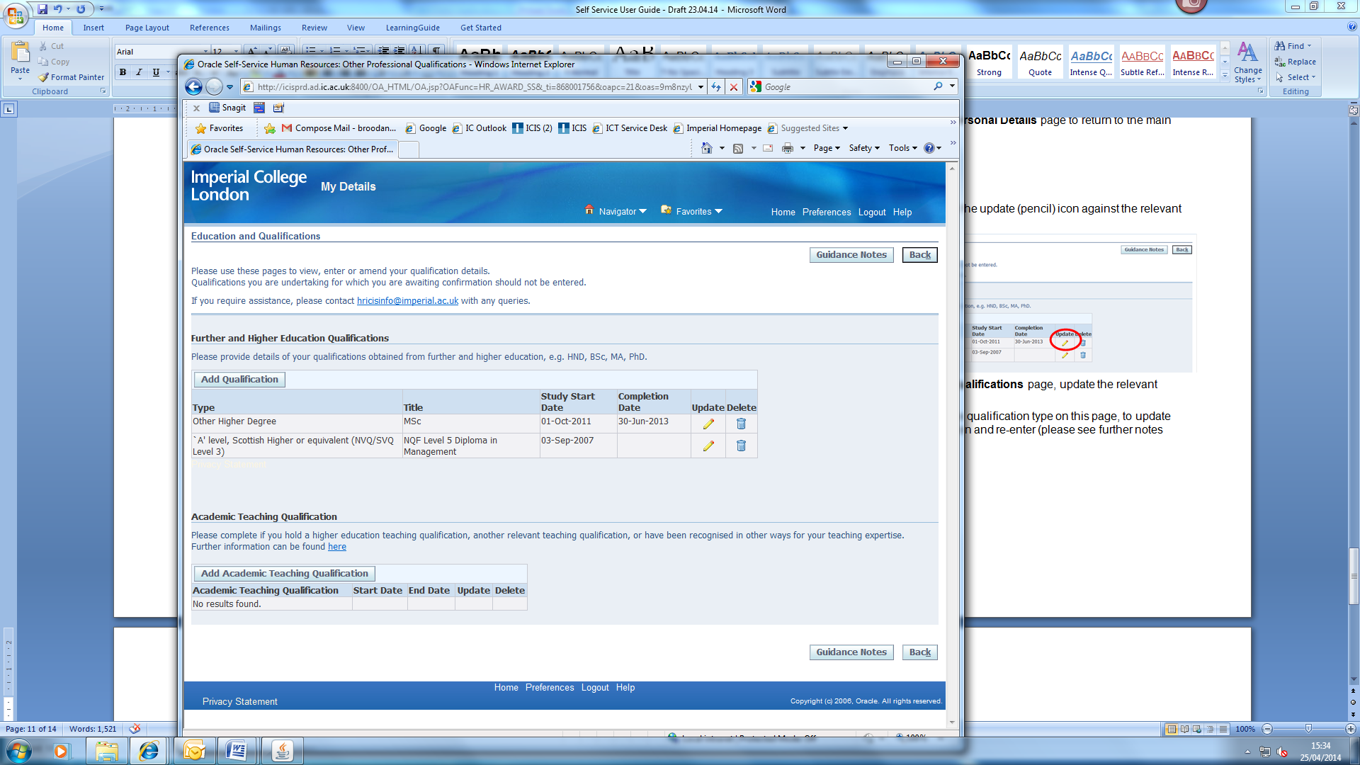
- On the Education and Qualifications: Review page, click on the Submit button to submit your changes.

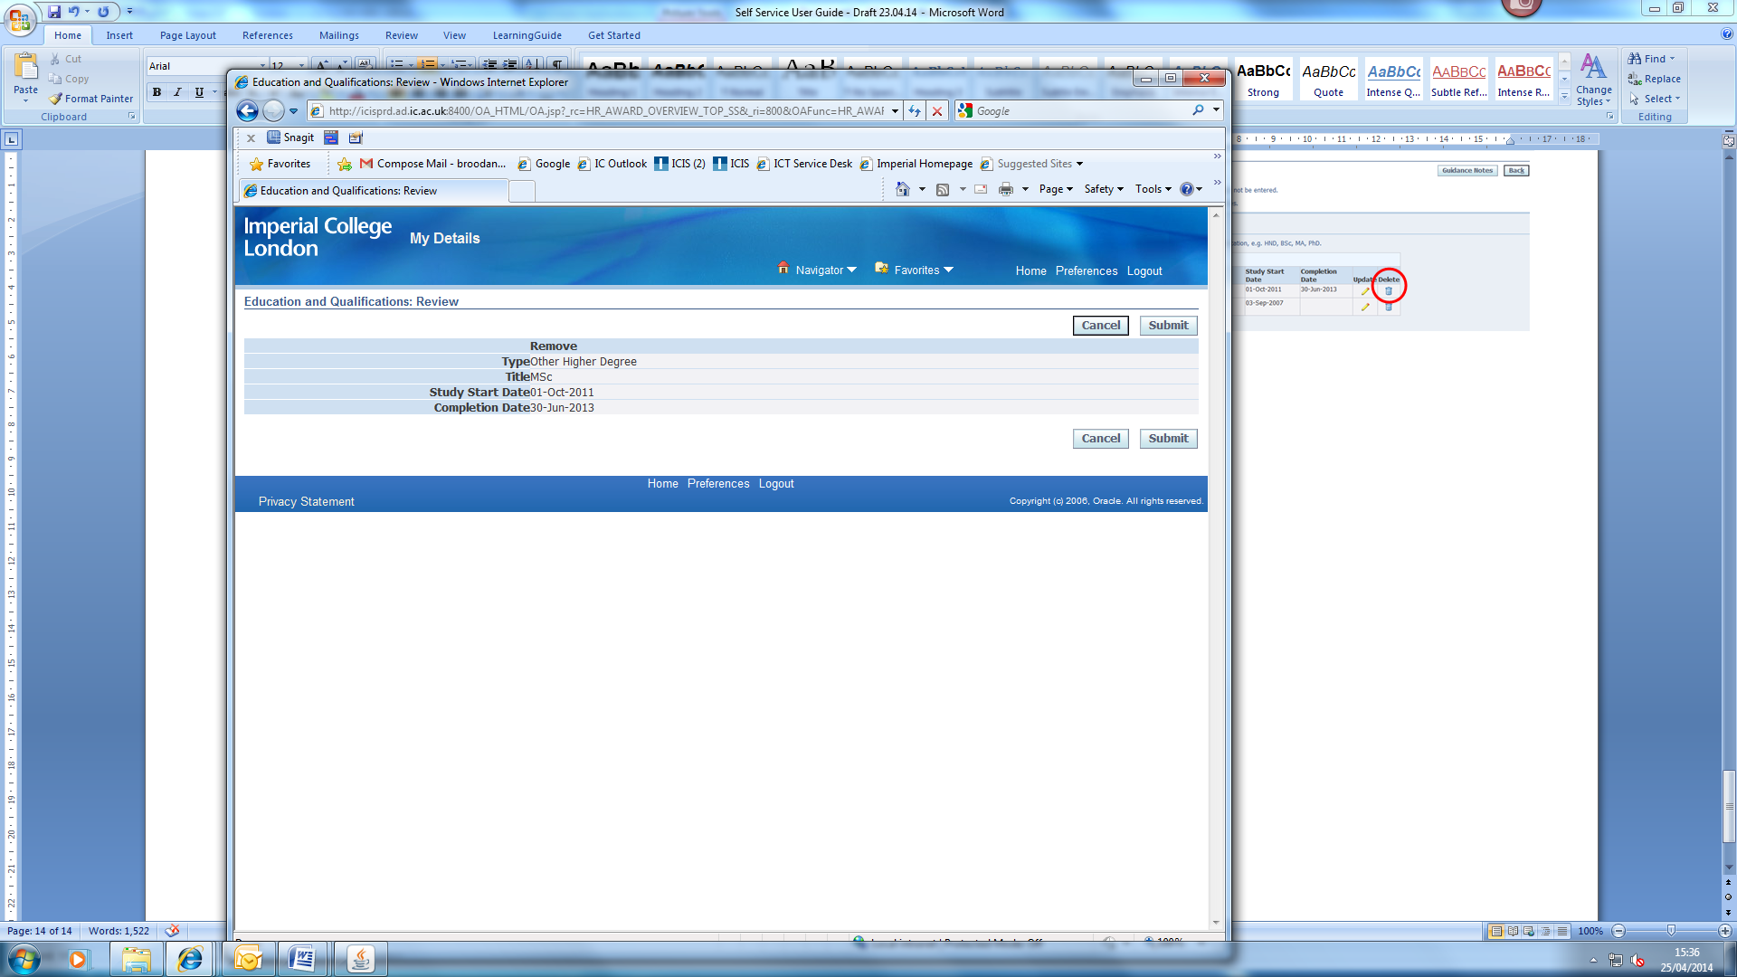
- A confirmation message will be displayed as below:

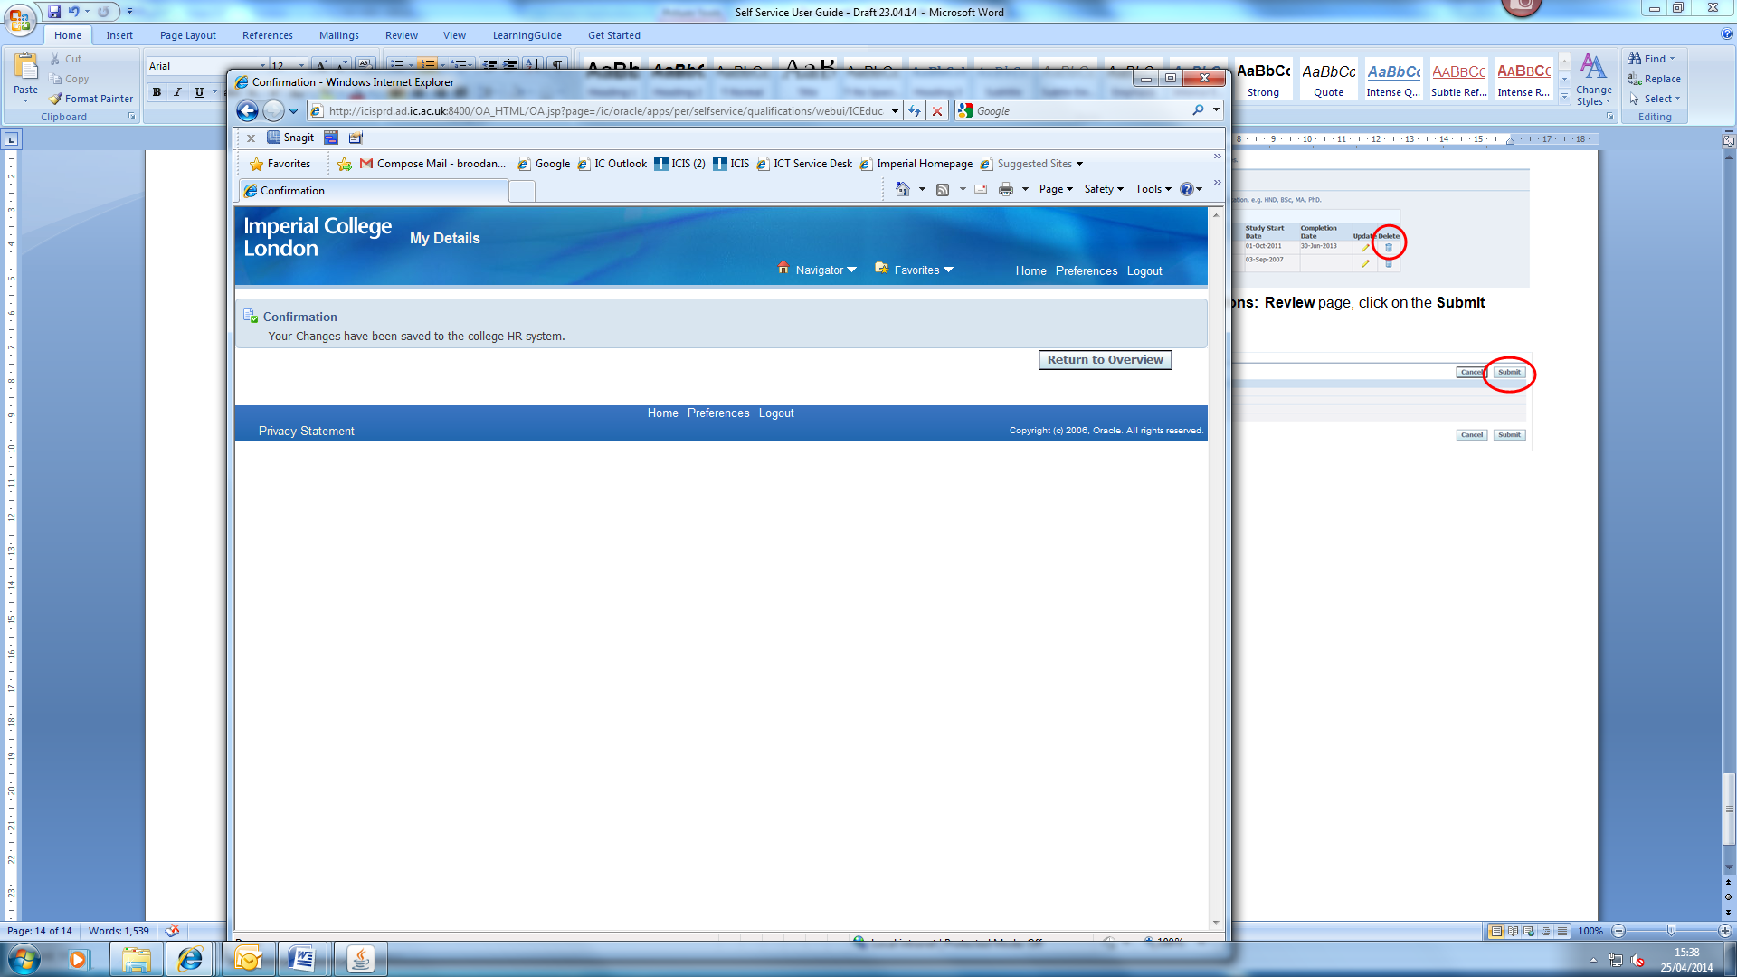
- If you have finished and would like to exit the system, click on Logout at the top of the page. To review any other education and qualifications information, please click on the Return to Overview button to return to the Education and Qualifications page.

Updating Personal Details:
- Log into HR Self Service in one of the following ways using the same link
https://www4.imperial.ac.uk/OA_HTML/OA.jsp?OAFunc=OAHOMEPAGE

If you do not use ICIS already: | Existing ICIS users:
- Use your College network username and password to login.  - Use Unified Access or the remote desktop connection for access.  - When logging in for the first time, you will be asked to validate the login via MFA.  - After successful authentication, you will be redirected to the ICIS sign in page. | 1. Using your College network username and password to login.  - Use Unified Access or the remote desktop connection for access.  HR Self Service has been added to your ICIS account so you will be able to find it in your ICIS main menu when you log in.

- From the menu select My Details.
- Select Disability Information.
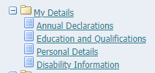

- The Disability Information page will open.
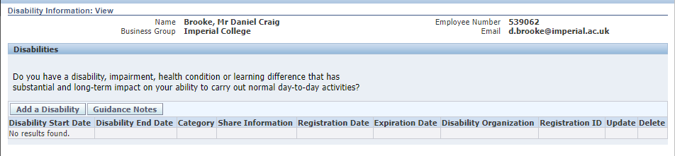
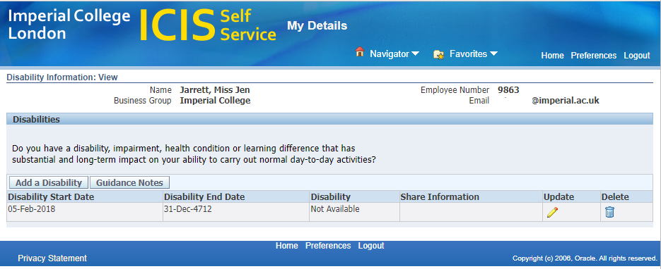

- From here you can view the information and update or add Disability information:
- Complete a blank disability page
- The Update icon 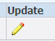 will open the Disability Information: Update page with two options
  - Correct or Complete the current details will allow you to update the current information
  - Enter new information will end date the current logged disability and add a new line with the newly entered disability
- The Add a Disability button will open the Disability Information: Create page where additional current consecutive disability can be added

TO COMPLETE a blank disability page
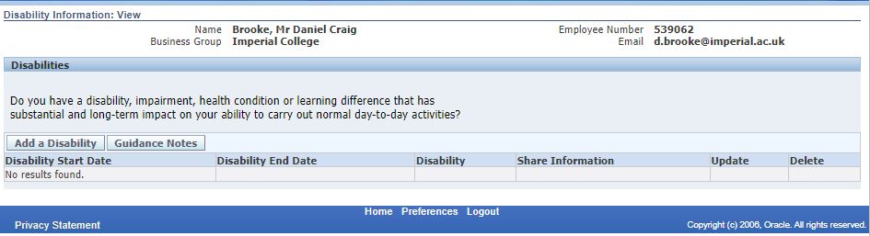
- Press the Add a Disability button:

- Disability Information: Update page will open
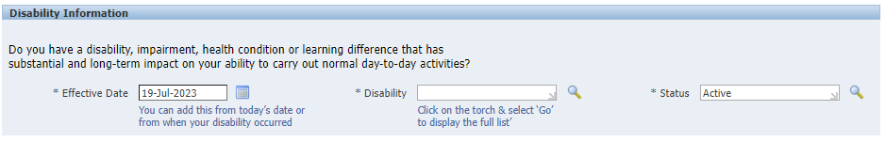

- The Effective Date field will automatically populate with the current date. To make a correct to the Date click on the calendar icon to open and select the month/year/date
  - In this example the effective date was added to the staff members start date at the college

- Go to the Disability field next and click on the magnifying glass icon 
  - In the search field press the Go button
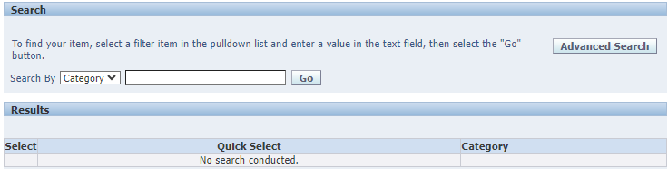
  - The Category list will appear. To move between the first and second page press Next or Previous 
  - To select a Category press the Quick Select icon 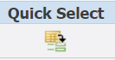

- In the Disability Support section to the to Agree to Share questions
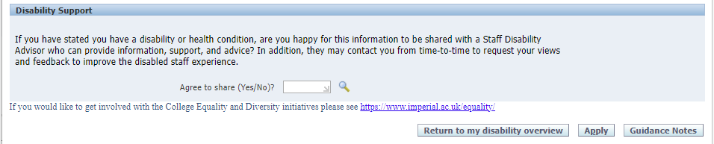
  - Click on the magnifying glass icon and press the go button
  - Use the Quick Select icon to pick Yes or No

- Press Apply button
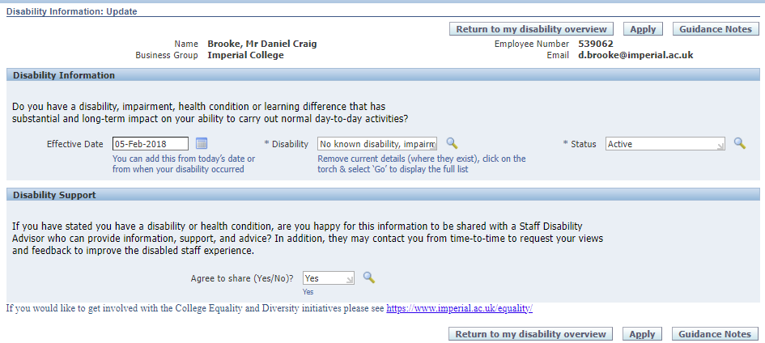

- A confirmation will appear in the top left corner of the screen
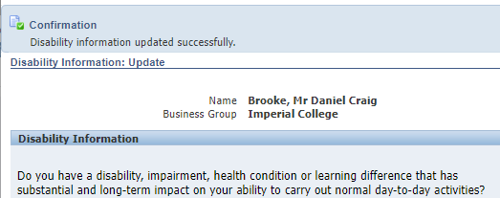

- Press Return to My Disability Overview button to return to the Disabilities Overview page
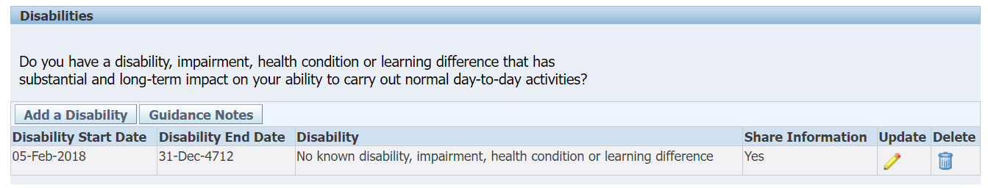
Note: The My Disability Overview will show the full history of all declared disability (from historical to current). A current or all current Disability details will hold an End Date of 31-Dec-4712.

TO CORRECT or COMPLETE
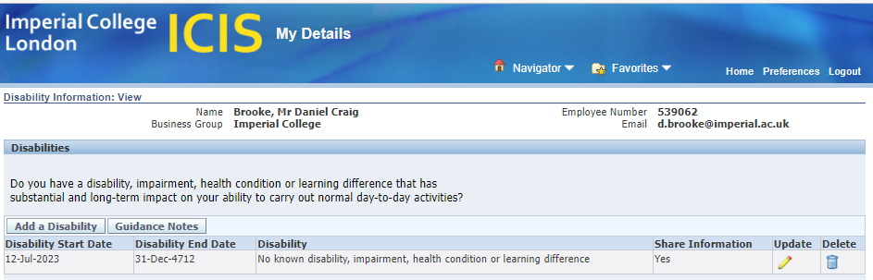
- Press the update icon

- This will open to the selection box. Select the Correct or Complete the current details and press the Next button
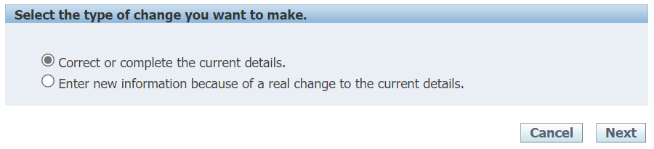
- Disability Information: Update page will open with the information held on the overview page:
  - Date and Disability:
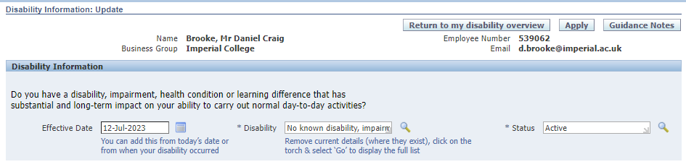
- To make a correct to the Date click on the calendar icon to open and select the month/year/date

- To make a correction to the Disability field and click on the magnifying glass icon
  - In the search field clear the search box and press the Go button
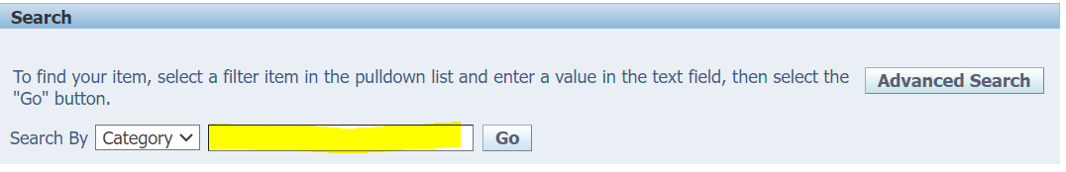
  - The Category list will appear. To move between the first and second page press Next or Previous
  - To select a Category press the Quick Select icon

- In the Disability Support section to the to Agree to Share questions
  - Click on the magnifying glass icon and press the go button
  - Use the Quick Select icon to pick Yes or No

- Press Apply button
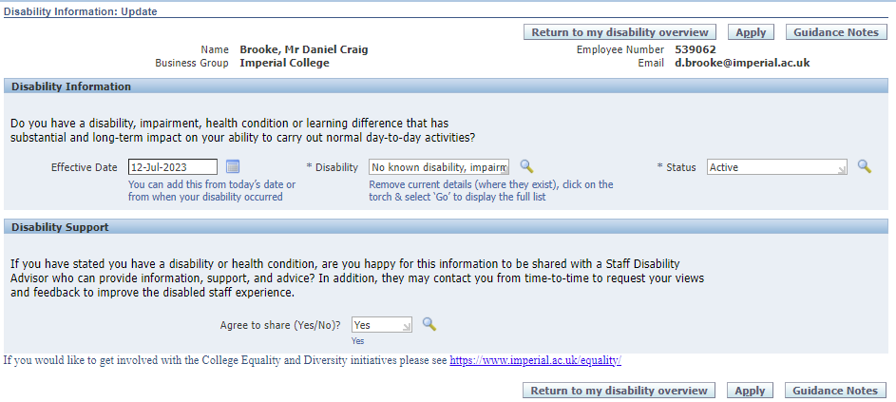
- A confirmation will appear in the top left corner of the screen
- Press Return to My Disability Overview button to return to the Disabilities Overview page
Note: A full history of all current and historical declared disability will displayed on the My Disability Overview page. All current Disability details will hold an End Date of 31-Dec-4712.

To ENTER NEW INFORMATION
- Press the update icon

- This will open to the selection box. Select the Correct or Complete the current details and press the Next button
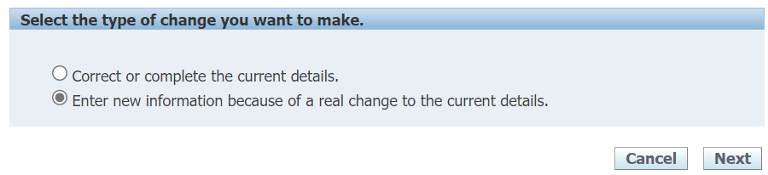
- The Disability Information page will open and where you will add the new disability information
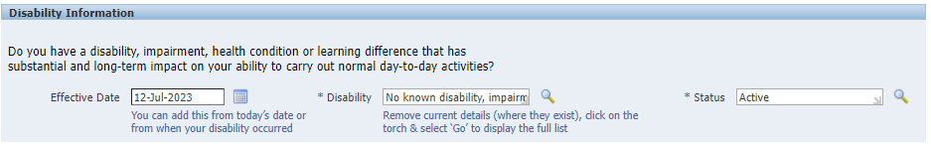

- Go to Effective Date field and enter the relevant date the new disability
  - By pressing the calendar icon and selecting the date

- Go to the Disability field and click on the magnifying glass icon
  - In the search field clear the search box and press the Go button
  - The Category list will appear. To move between the first and second page press Next or Previous
  - To select a category press the Quick Select icon

- In the Disability Support section to the to Agree to Share question
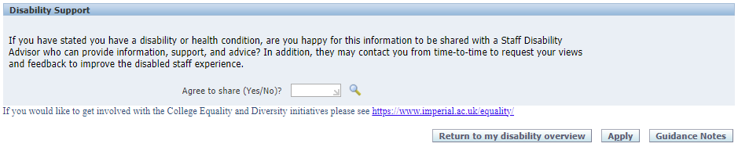
  - Click on the magnifying glass icon and press the go button
  - Use the Quick Select icon to pick: Yes or No

- Press the Apply button
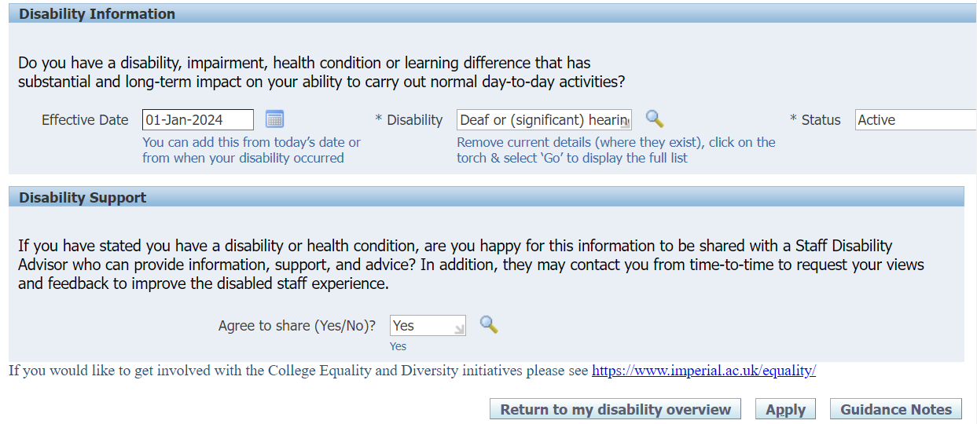

- A confirmation will appear in the top left corner of the screen
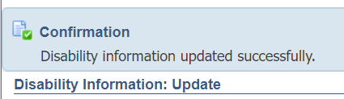

- Press Return to My Disability Overview button to return to the Disabilities Overview page
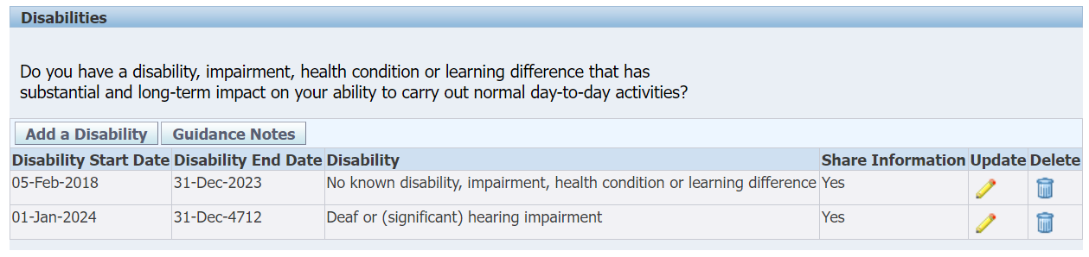
Note: By entering new information, the old declared disability will be end dated and a new line will hold the now current declared disability.

The My Disability Overview will show the full history of all declared disability (from past to present) and a current Disability details will hold an End Date of 31-Dec-4712.

TO ADD ADDITONAL CURRENT DISABILITIES
- Press the Add a Disability button in the top left corner of the Disabilities page

- The Disability Information page will open
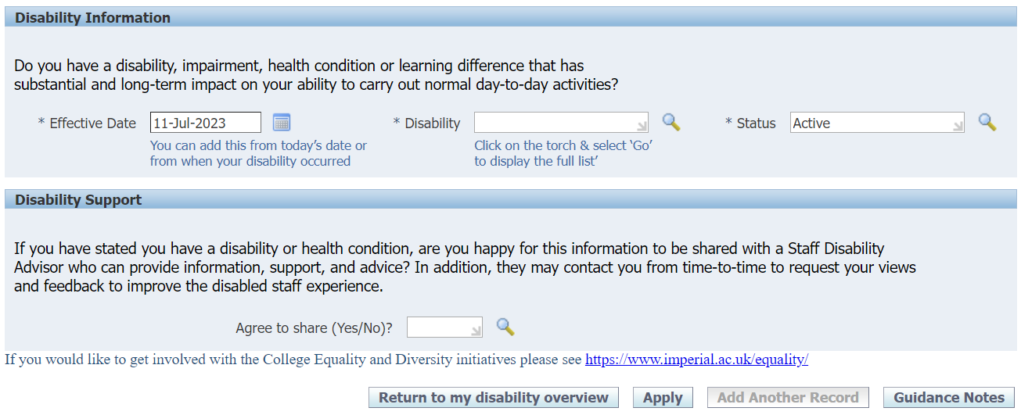

- Go to Effective Date field and enter the relevant date
- By over typing the date
- Or pressing the calendar icon and select the date

- Go to the empty Disability field and click on the magnifying glass icon
- In the search field press the Go button
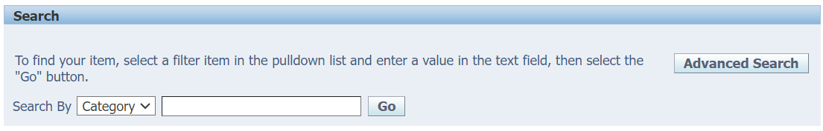
- The Category list will appear. To move between the first and second page press Next or Previous
- To select a category press the Quick Select icon

- In the Disability Support section to the to Agree to Share questions
  - Click on the magnifying glass icon and press the go button
  - Use the Quick Select icon to pick: Yes or No

- Press the Apply button
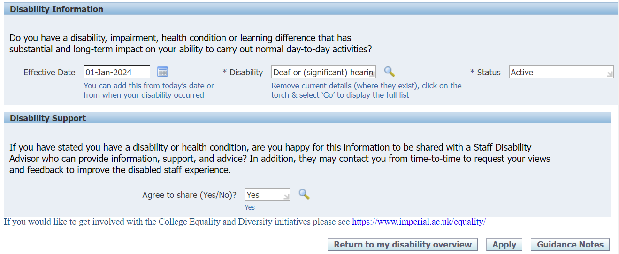
- A confirmation will appear in the top left hand corner

- Press the Return to my disability overview button to return to the Disabilities Overview page
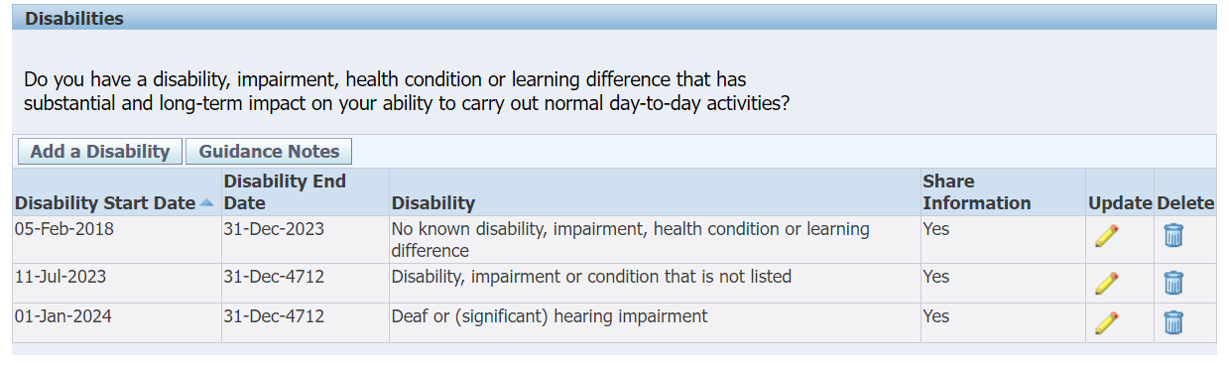
Note: By adding this additional new information, the Disability Overview page will hold the current declared disabilities.

The full history of all current and historical declared disability will displayed on the My Disability Overview page. With all current Disability details holding an End Date of 31-Dec-4712.

