Entering ARC Data for those who are Exempt

An entry is required for those who were exempt for the annual ARC process.

Log into IC Manager Self Service in one of the following ways:

(i) If you are accessing ICIS from a computer with a wired connection on the College network (not halls, wireless or VPN) , log in as normal http://icis.imperial.ac.uk/and look for “IC Manager Self Service” in your list of responsibilities. You are particularly urged to adopt this route, rather than following the link which appears in the next paragraph.

(ii) If you are accessing ICIS from home, wirelessly, from halls or via VPN, please click on the following link and follow the instructions:
https://icisremote.ad.ic.ac.uk/dana-na/auth/url_1/welcome.cgi

Expand your responsibility “IC Manager Self Service” and select “Maintain ARC details”.

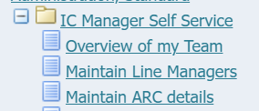

This will take you through to the page entitled “Maintain ARC Details: People in Hierarchy”. Within this list you should see all your direct. You will also be able to see indirect reports – i.e. those employees that your own direct reports line manage (if applicable).

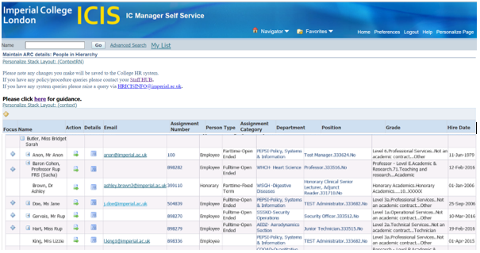

To view and enter the ARC data for your direct reports, click on the action icon in the column labelled Action.

A list of all existing ARC data for that individual will be displayed;

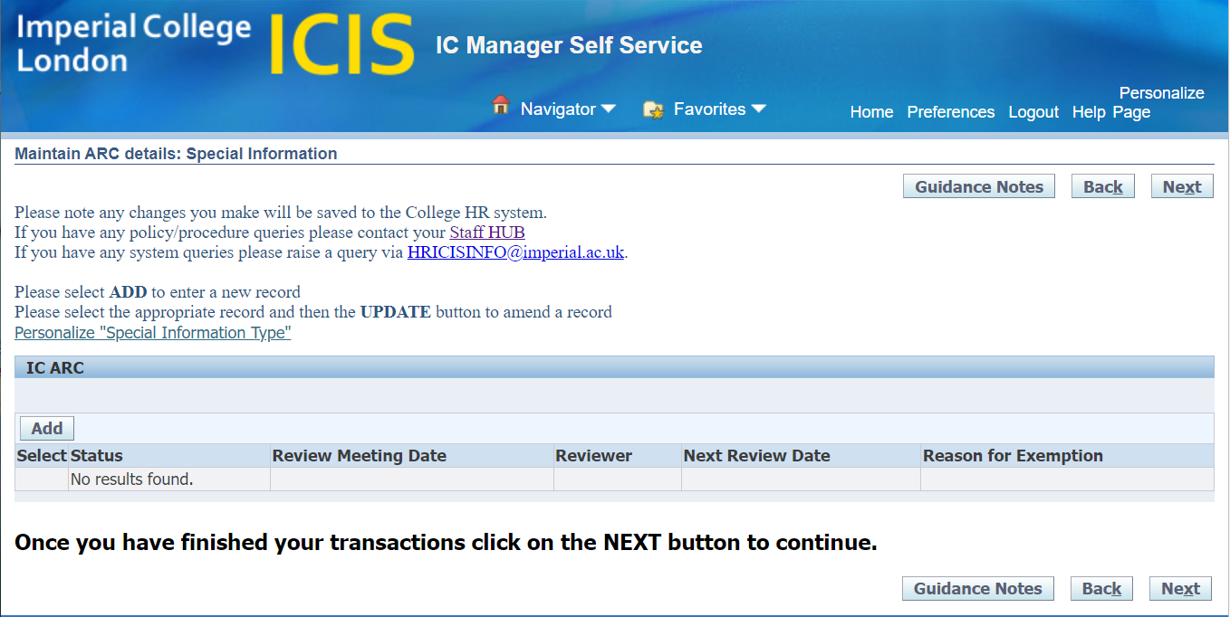

Adding new ARC Data for someone who is Exempt

Click on the button. The following page will be displayed;

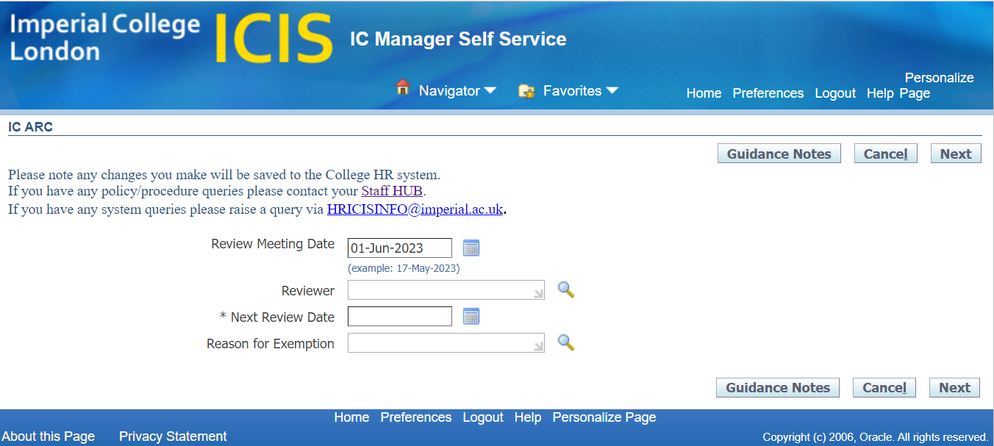

In the Review Meeting Date field enter the date that the ARC was due to be completed.

The Reviewer field to be left blank.

The Next Review Date field enter the date that the next ARC will be due

In the Reason for Exemption field, choose the appropriate entry from the available options. To display the options, click on the magnifying glass icon then enter click on Go.

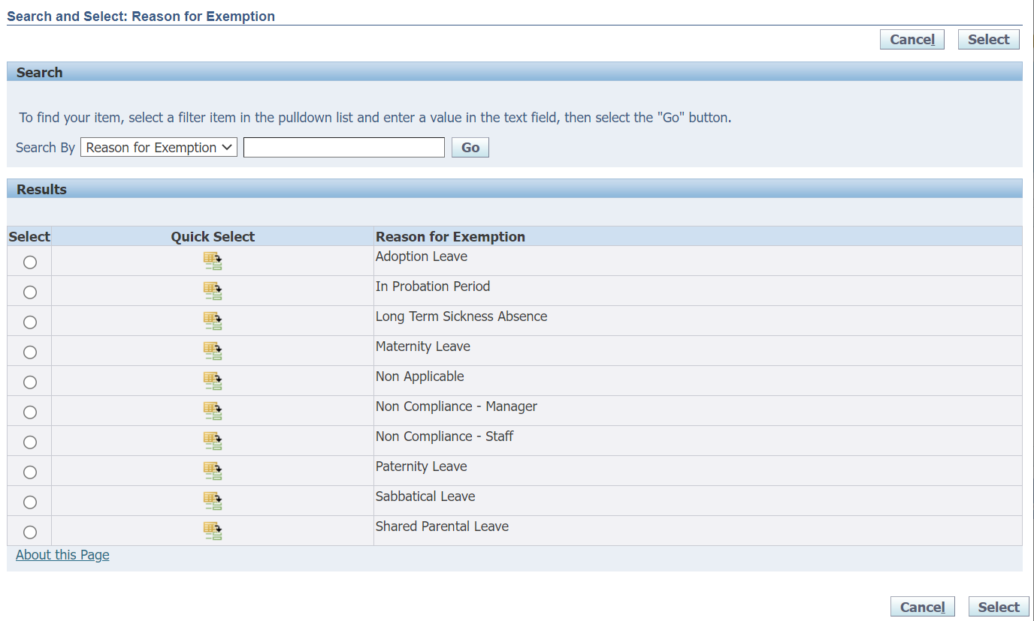
Click on the icon  in the quick select column against the appropriate reason. This will populate the field.

Click on Next. A summary of the information you have entered will be displayed;

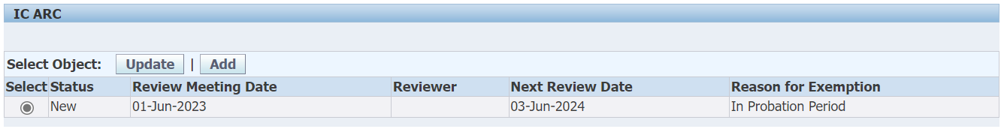

Once you are happy with the information you’ve entered, click on Next.

A final summary of the information you’ve entered will be displayed;

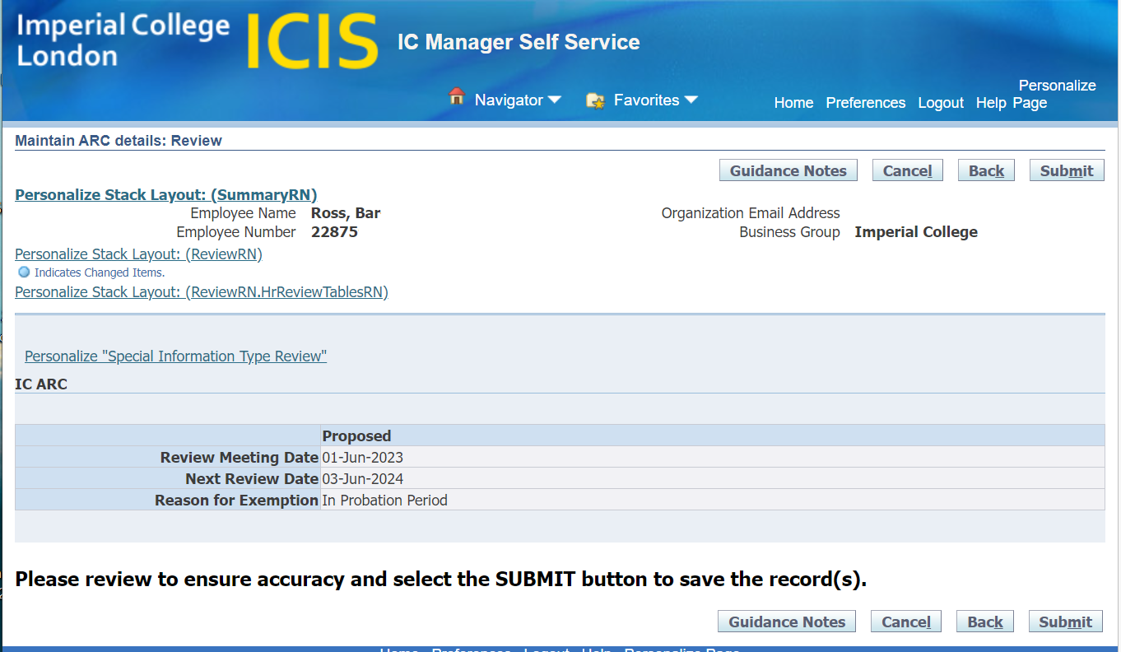

Click on Submit to enter the ARC information into the College HR System. Your ARC information will not be saved until you get to this final submission stage.

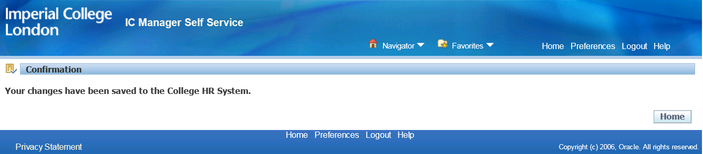

N.B. As with adding new ARC data, there is no approval and the information will go straight through to the College HR System. Therefore please take the time to review the information you’re inputting to ensure accuracy before submitting.

