Entering New ARC Data

As a Line Manager you now have the responsibility of entering new ARC data for all of your direct reports.

Log into IC Manager Self Service in one of the following ways:

(i) If you are accessing ICIS from a computer with a wired connection on the College network (not halls, wireless or VPN), log in as normal http://icis.imperial.ac.uk/and look for “IC Manager Self Service” in your list of responsibilities. You are particularly urged to adopt this route, rather than following the link which appears in the next paragraph.

(ii) If you are accessing ICIS from home, wirelessly, from halls or via VPN, please click on the following link and follow the instructions:
https://icisremote.ad.ic.ac.uk/dana-na/auth/url_1/welcome.cgi

Expand your responsibility “IC Manager Self Service” and select “Maintain ARC details”.

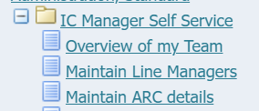

This will take you through to the page entitled “Maintain ARC Details: People in Hierarchy”. Within this list you should see all your direct reports. You will also be able to see indirect reports – i.e. those employees that your own direct reports line manage (if applicable).

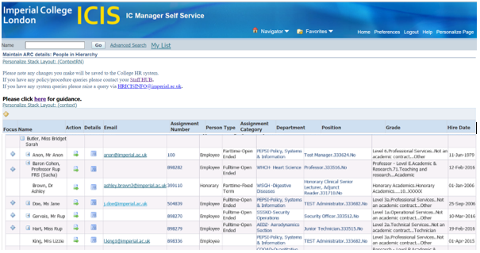

To view the ARC data for your direct reports, click on the action icon in the column labelled Action.

A list of all existing ARC data for that individual will be displayed;

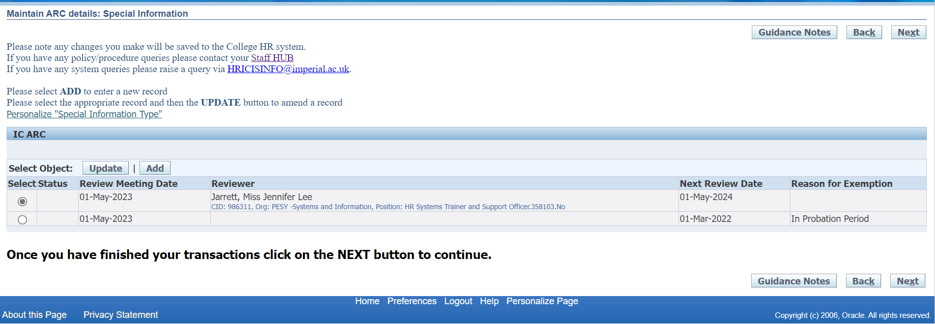

Adding new ARC Data

Click on the Add button .

A blank form for entering new ARC data will be displayed. The Review Meeting
Date field will automatically default to today’s date, but this can be changed either by overtyping or selecting the date using the calendar icon. This date should be the date the actual ARC meeting took place.

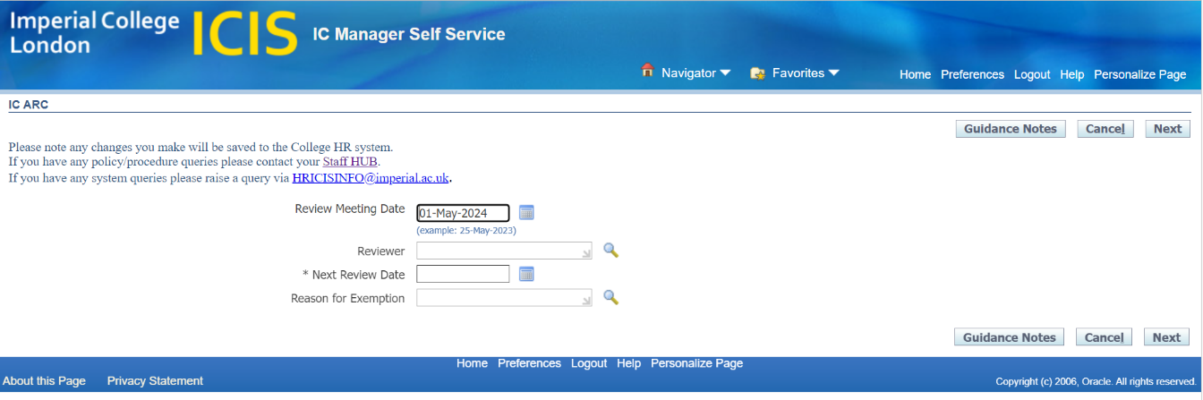

In the Reviewer field enter the name of the person that carried out the ARC meeting – we would expect this to be the line manager’s name.

When you type in the surname the system should automatically search for people within the system with that name.

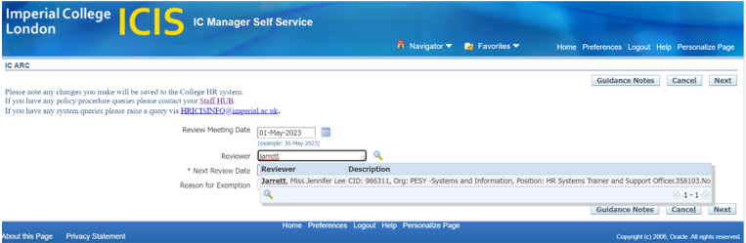

Alternatively you can search for the reviewer’s name by clicking on the magnifying glass icon and entering the details of the person who carried out the ARC meeting.

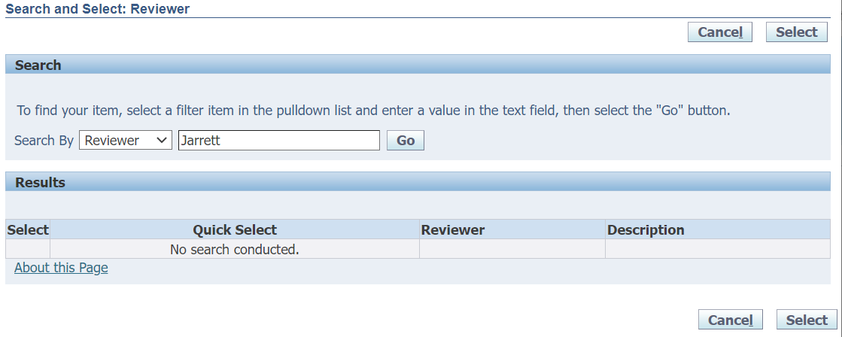

Click on Go and a list of all matching entries will be displayed. You would then need to click “Quick Select” or the select radio button to enter this information into the field.

You will need to enter a date into the “Next Review Date” field before you are able to progress to the next stage.

Select “Next” to submit the new data.

A summary of the information you’ve entered will be displayed, along with all existing ARC information for that individual. The new entry will be labelled “New” in the status column.

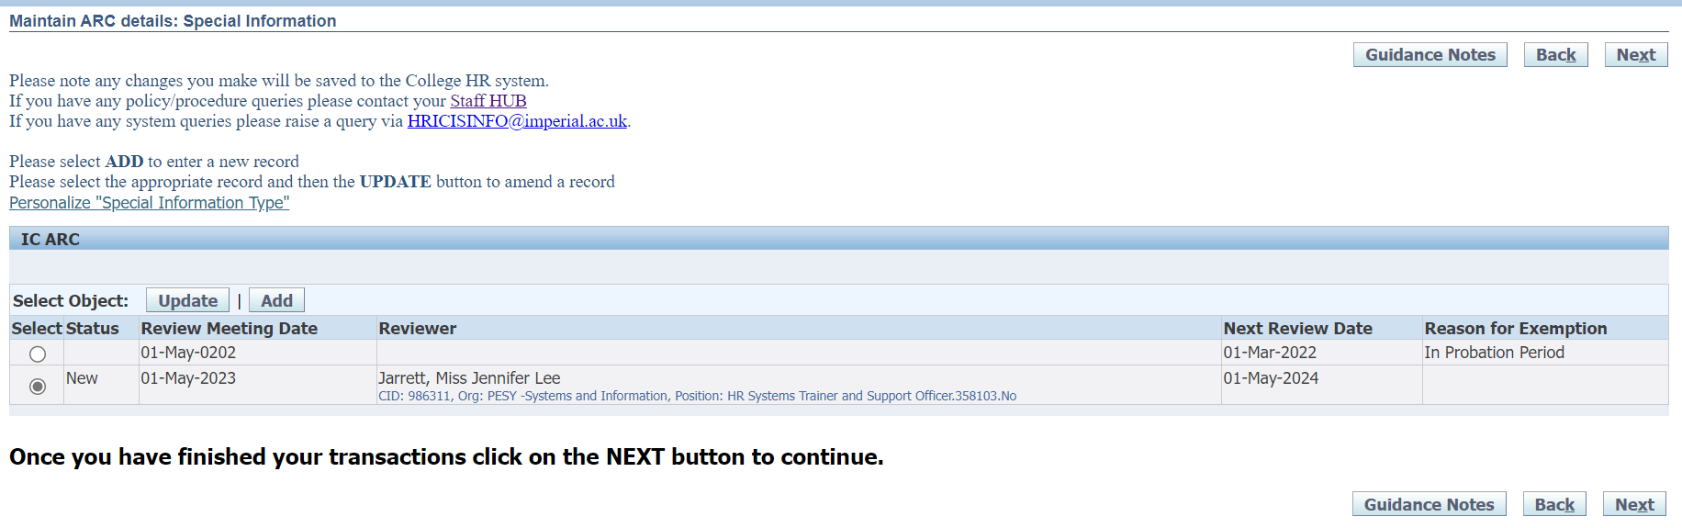

Click on Next to progress with your submission.

A Review page summarising the information you’ve entered will be displayed.

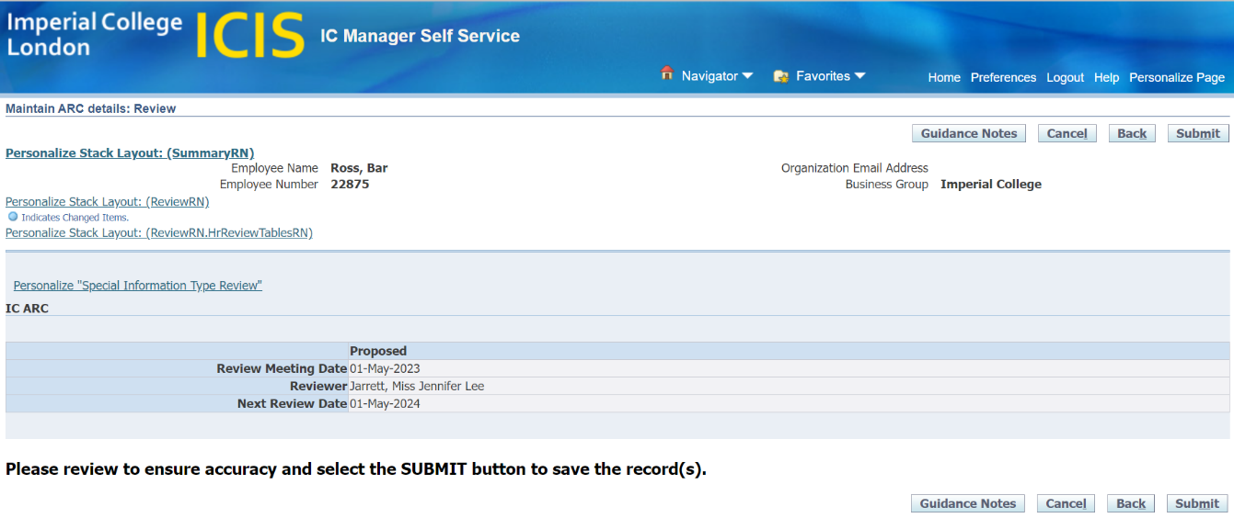

N.B. There is no approval for ARC data, therefore want you enter will feed straight through to the individual’s record. Please review this information to ensure accuracy before submitting your input.

Click on Submit to enter the ARC information into the College HR System.

N.B. Your ARC information will not be saved until you get to this final submission stage.

