**Running the ARC Compliance Report**

Expand the IC Manager Self Service responsibility and select “Submit report requests”

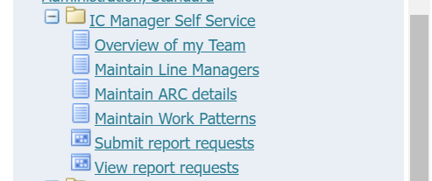

When prompted, select that you wish to run a Single Request and hit OK;

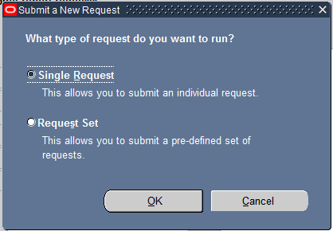

Click on the picklist icon at the end of the yellow “Name” field;



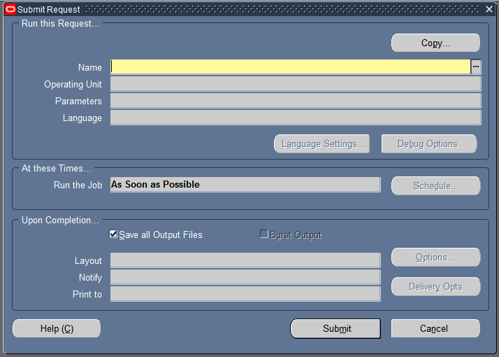

Select the ARC report “IC PRDP Compliance Report”.

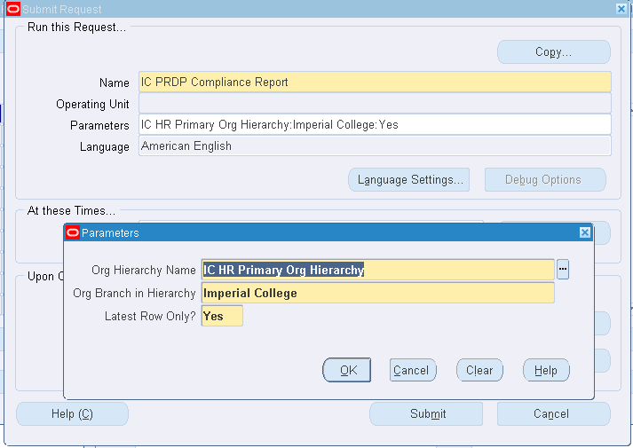

A parameters box will be displayed which has already been pre-populated with the correct entries for yourself. **You do not need to change anything in these boxes**. However if you wish to see a record of all ARCs for your direct reports, you can select “No” in the “Latest Row Only” field and it will populate the report with all records held.

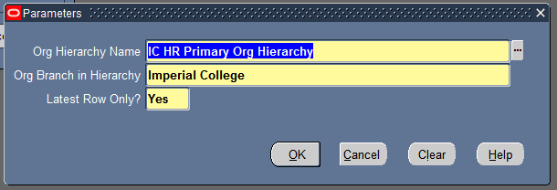

Hit OK.

A summary of the report you’re requesting will be displayed, to run this report hit the Submit button;

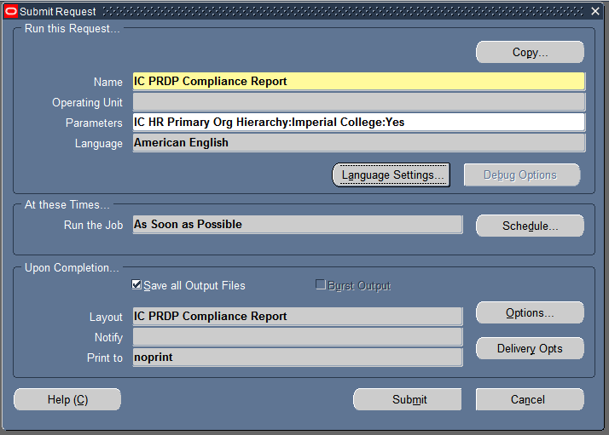

Your report request will be submitted, and you’ll see the phase column showing as “Running”

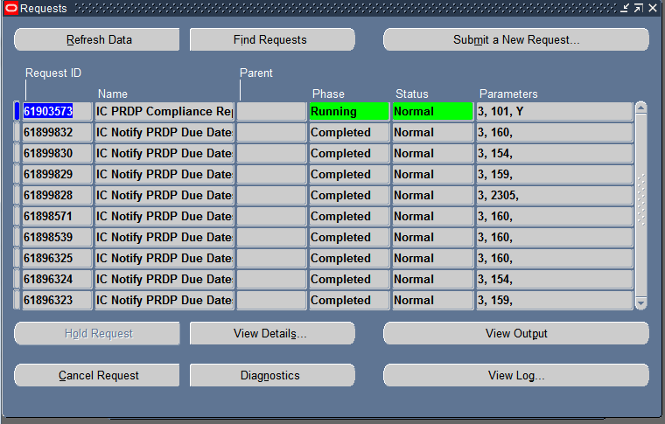

You can use the “Refresh Data” button to check the progress of your report. Once it has finished running, the Phase column will show as Completed.

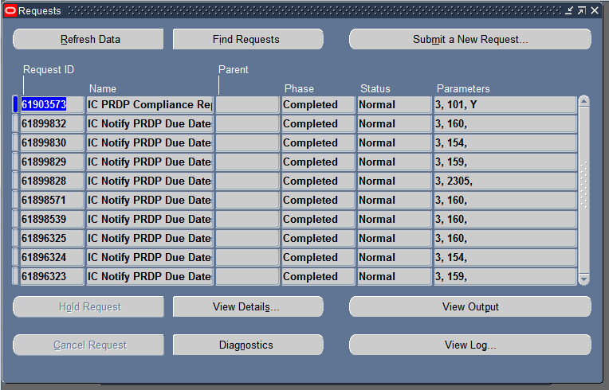

To view your completed report, select the View Output button. This will copy the report out into Excel for you;

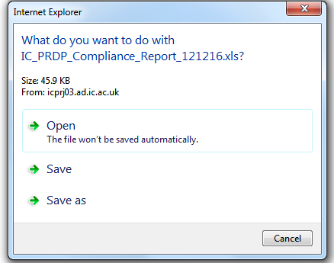

Select Open when you see the above prompt;

You may see the following message. If you do, select Yes.

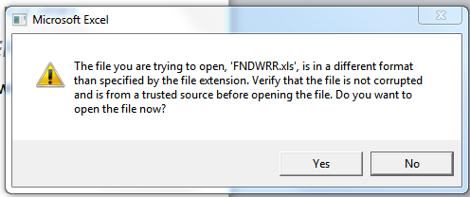

A report detailing when the ARCs for people in your person tree are due will be displayed. You will see the following columns populated for all people that you have access to;

