MSS - Entering a Work Pattern with Manager Self Service

Contents

Adding a New Work Pattern pg 1

Adding a new Work Pattern Shift pg 3

Summary of the Day and Hourly Based work pattern pg 6
How to add as a day based work pattern pg 6
How to add as an hours based work pattern pg 7

Adding a Work Pattern Weekly pg 9

Summary of Day, Hours, weekly and no fixed based work pattern pg 10
How to add as a day based work pattern pg 6
How to add as an hours based work pattern pg 7
How to add a Mon to Fri based work pattern pg 11
How to add a no fixed based work pattern pg 12

Trouble shooting work pattern issues
Beware of Work Pattern issue pg 14
Correcting a Work Pattern pg 14

Adding a New Work Pattern:

Log into IC Manager Self Service in one of the following ways:

- If you are accessing ICIS from a computer with a wired connection on the College network (not halls, wireless or VPN), log in as normal http://icis.imperial.ac.uk/and look for “IC Manager Self Service” in your list of responsibilities. You are particularly urged to adopt this route, rather than following the link which appears in the next paragraph.

(ii) If you are accessing ICIS from home, wirelessly, from halls or via VPN, please click on the following link and follow the instructions: https://icisremote.ad.ic.ac.uk/dana-na/auth/url_1/welcome.cgi

Expand your responsibility “IC Manager Self Service” and select “Maintain Work Patterns”.
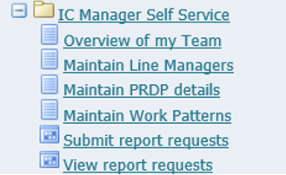

This will take you through to the page entitled “Maintain Work Patterns: People in Hierarchy”. Within this list you should see all your direct reports. You will also be able to see indirect reports – i.e. those employees that your own direct reports line manage (if applicable).

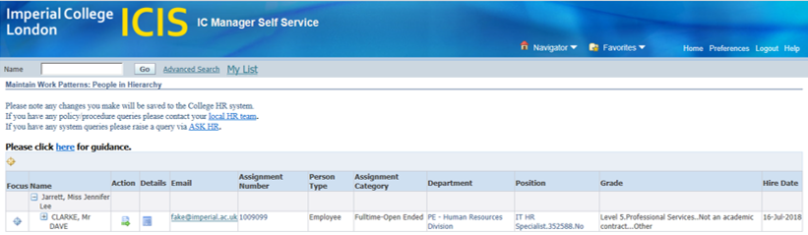
To enter the work pattern for your direct reports, click on the action icon in the column labelled Action.
This will take you through to the page entitled “Maintain Work Patterns: Special Information”. Where the IC HRMS Work Pattern Shift and IC HRMS Work Pattern Weekly can be added or corrected.

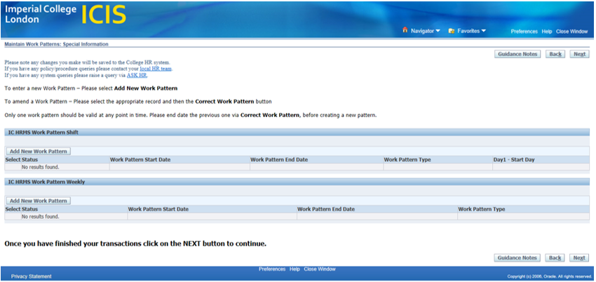
To add new Work Pattern Shift
Click on the Add New Work Pattern button

This will take you through to the page entitled “IC HRMS Work Pattern Shift”. Where the Work Pattern Shift can be added.

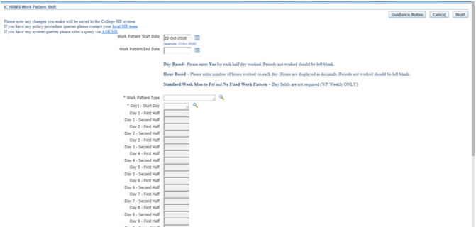

Check the Work Patter Start Date: To amend the work pattern start date click on the calendar icon 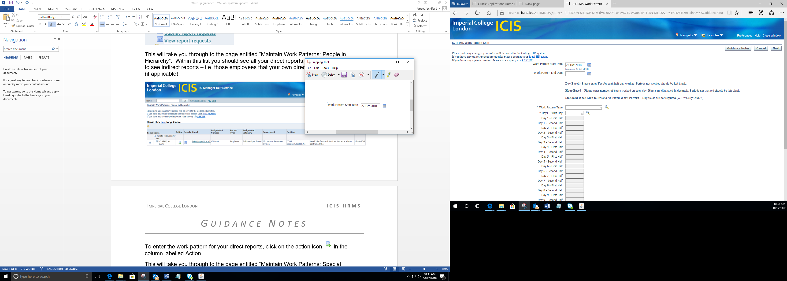 and select the date from the pop up calendar

If a Work Pattern End Date is required click on the calendar icon and select the date from the pop up calendar

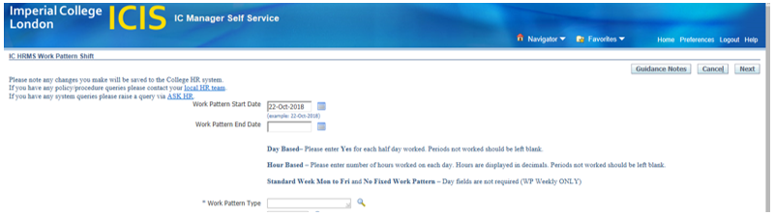

To add the Work Pattern Type click on the magnifying glass 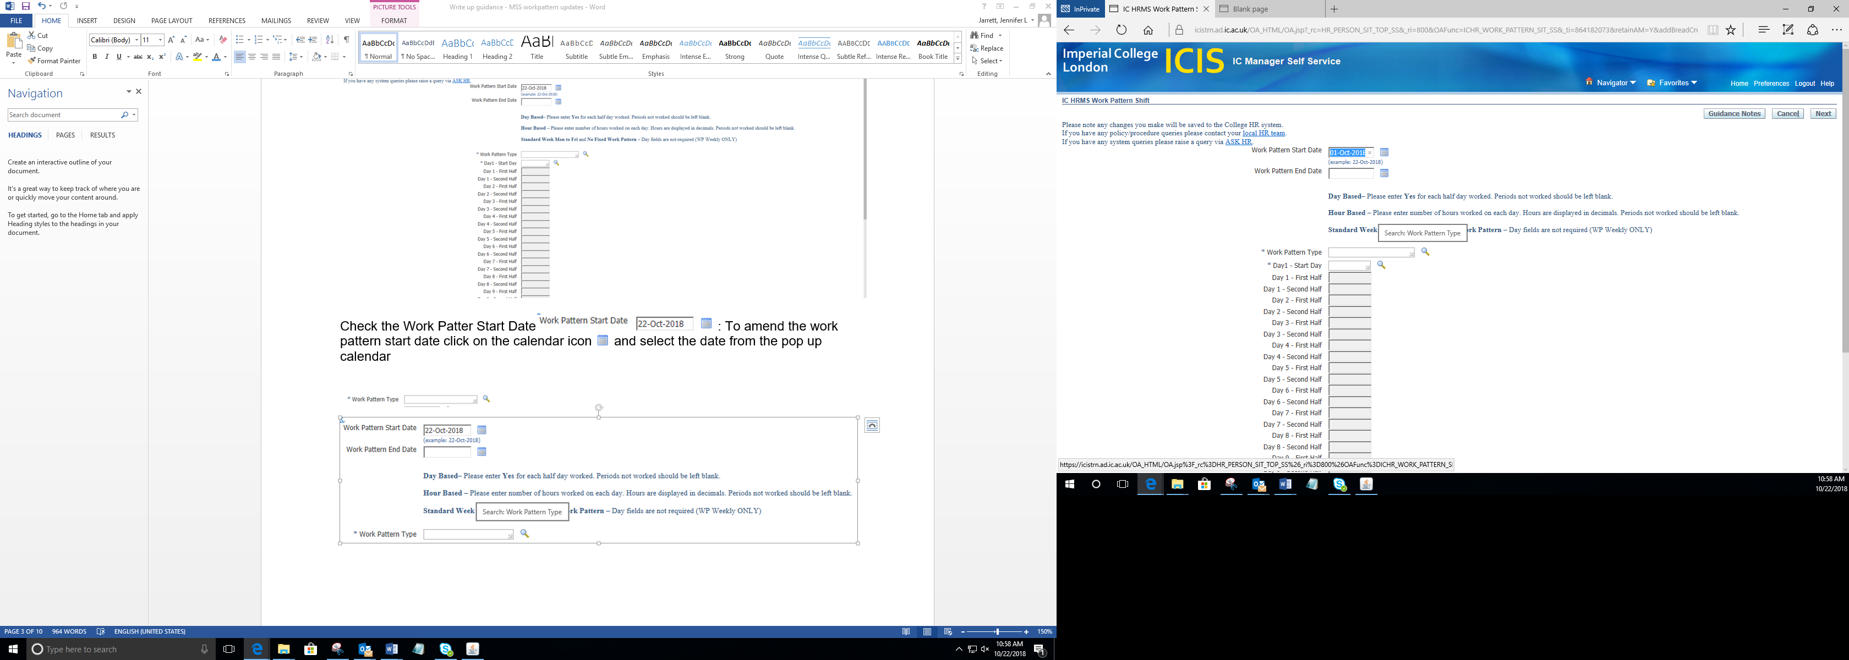 and this will open a pop up page entitled “Search and Select: Work Pattern Type”.
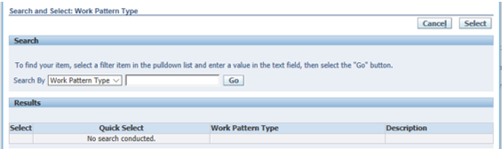
To select the Work Pattern Type either start typing the number of days for the pattern type and use the magnifying glass and click on the GO button 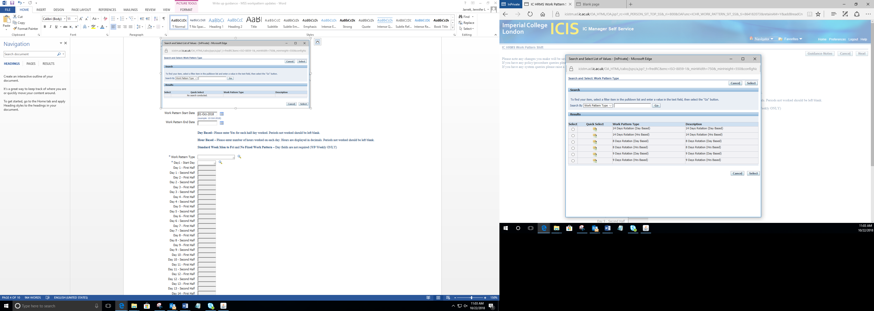 to open a search with matching results populated.
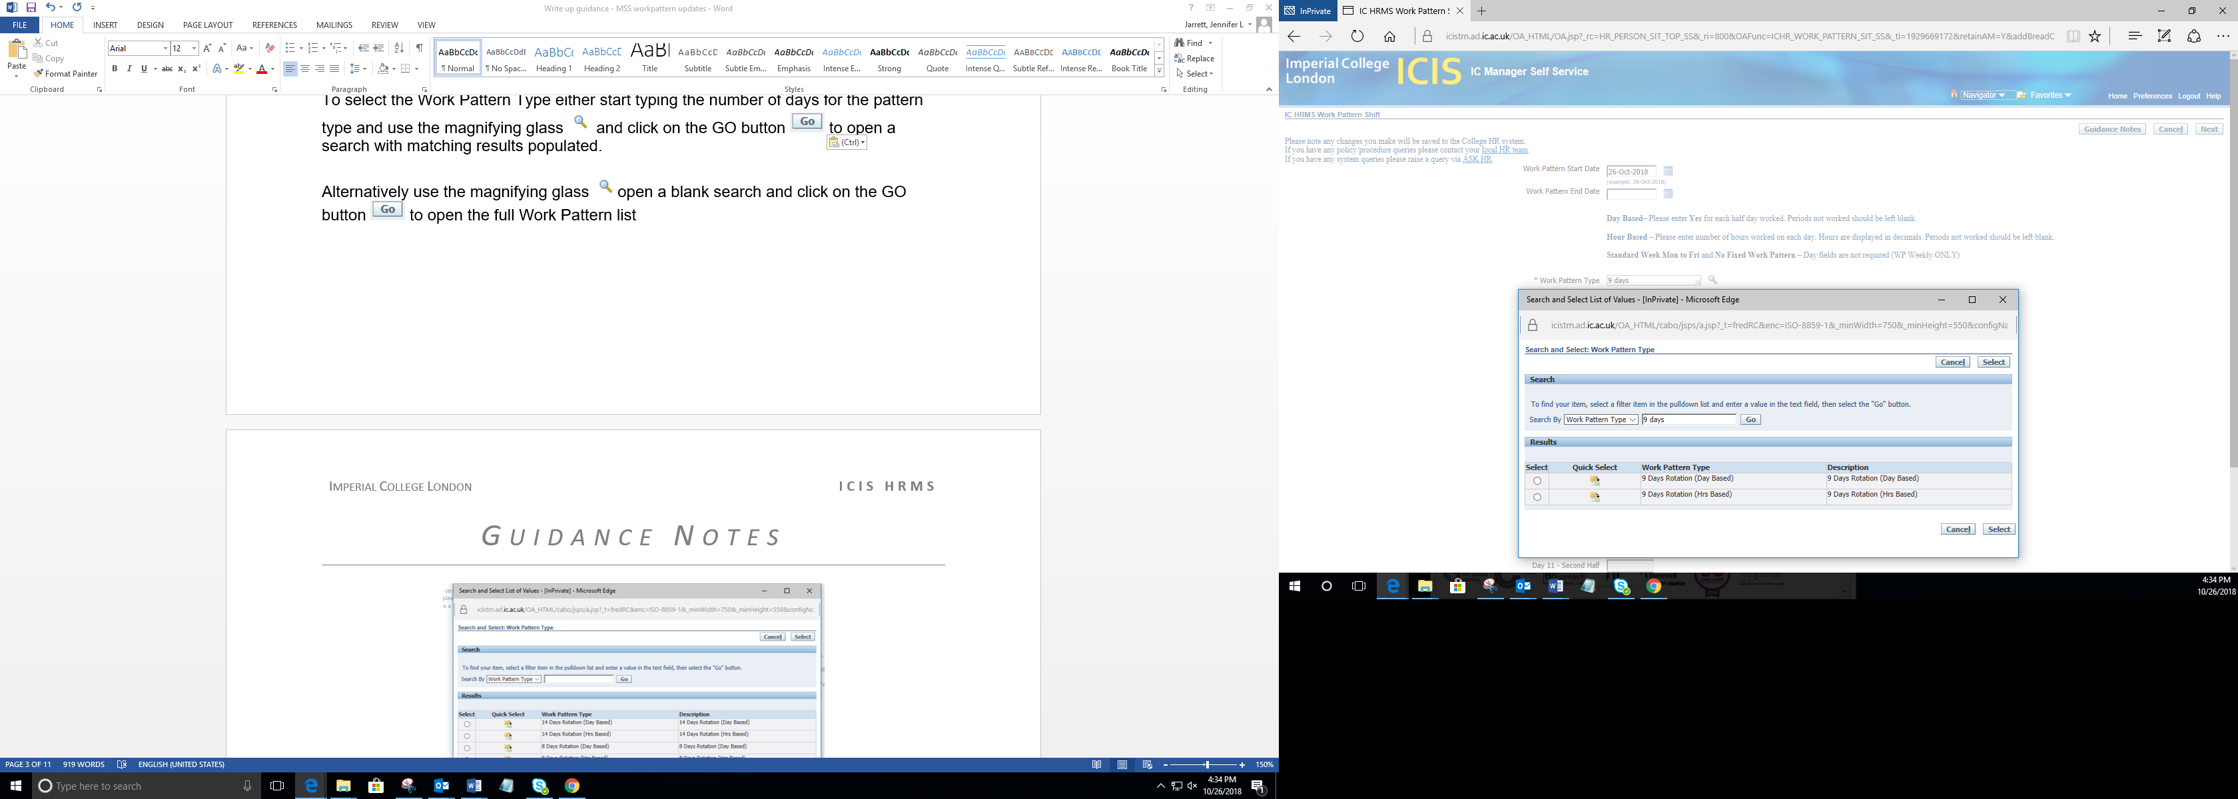

Alternatively use the magnifying glass open a blank search and click on the GO button to open the full Work Pattern list

Click on action icon 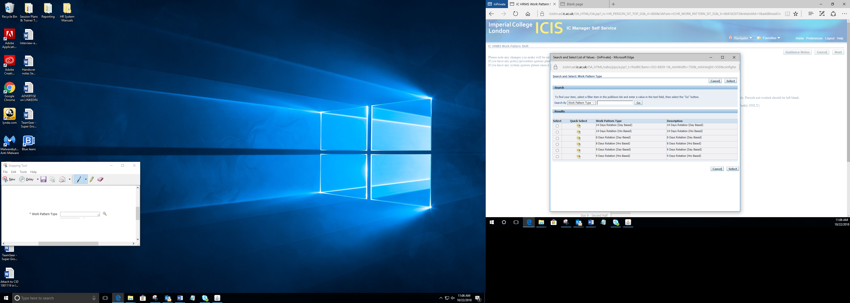 in the column labelled Quick Selection to pull through the specific work pattern.

This will take you back to the “IC HRMS Work Pattern Shift” page to add the first day of the work pattern. 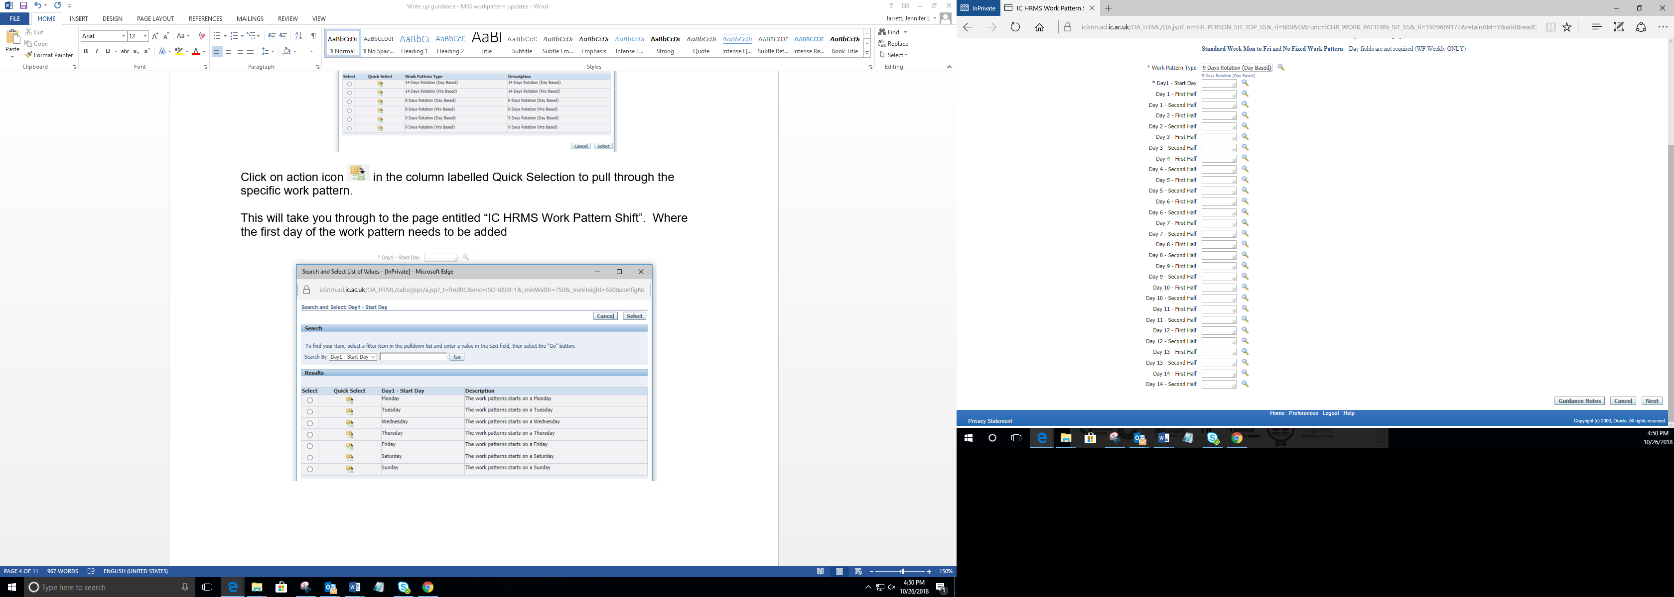

Use the magnifying glass open a blank search and this will open a pop up page entitled “Search and Select: Day1 – Start Day”.

To open the full Work Pattern list and click on the button.

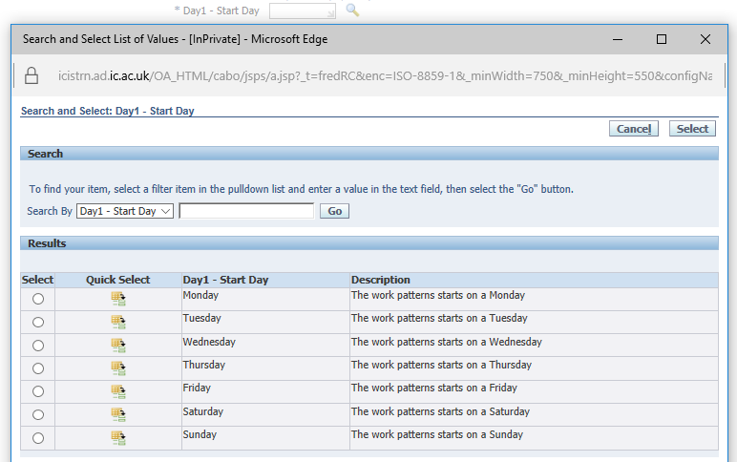

Click on action icon in the column labelled Quick Selection to pull through the start date of the work pattern.

Please note
- Day Based is broken down into morning (am) and afternoon (pm) of each working day and only require a ‘Yes’ against morning or afternoon. Any non-working morning or afternoons to be left blank.

- Hour Based is broken down into morning (am) and afternoon (pm) of each working day and will be require in hours (e.g. 1hour and 30minutes = 1.5 hours). Any non-working morning or afternoons to be left blank.

If a particular value you require is not available, please raise a query via ASK HR.

Day Based

Type in Yes in the mornings and or afternoons required and press tab. This will populate and save.

Alternatively use the magnifying glass open a blank search and click on the GO button to open the selection list.

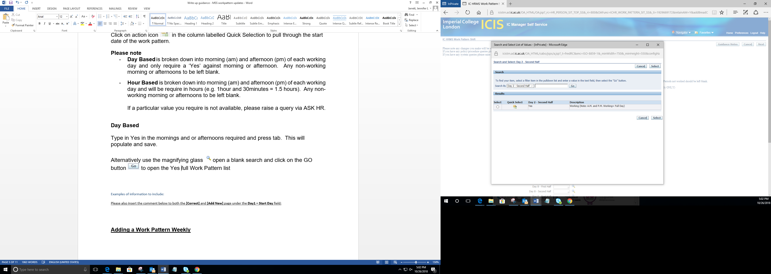

Click on action icon in the column labelled Quick Selection to pull through Yes into the morning and or afternoon required.

Example below
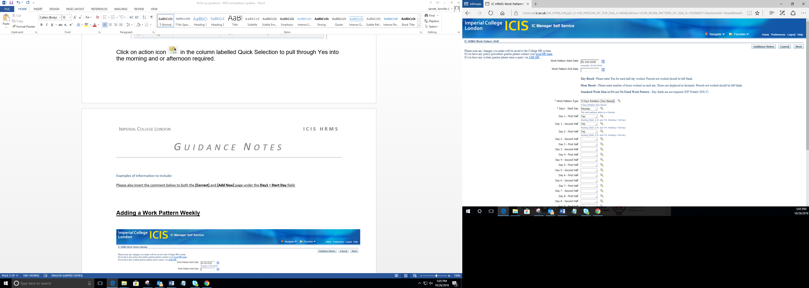

Hours Based

Type in Yes in the mornings and or afternoons required and press tab. This will populate and save or will open the “Search and Select” with the available options.

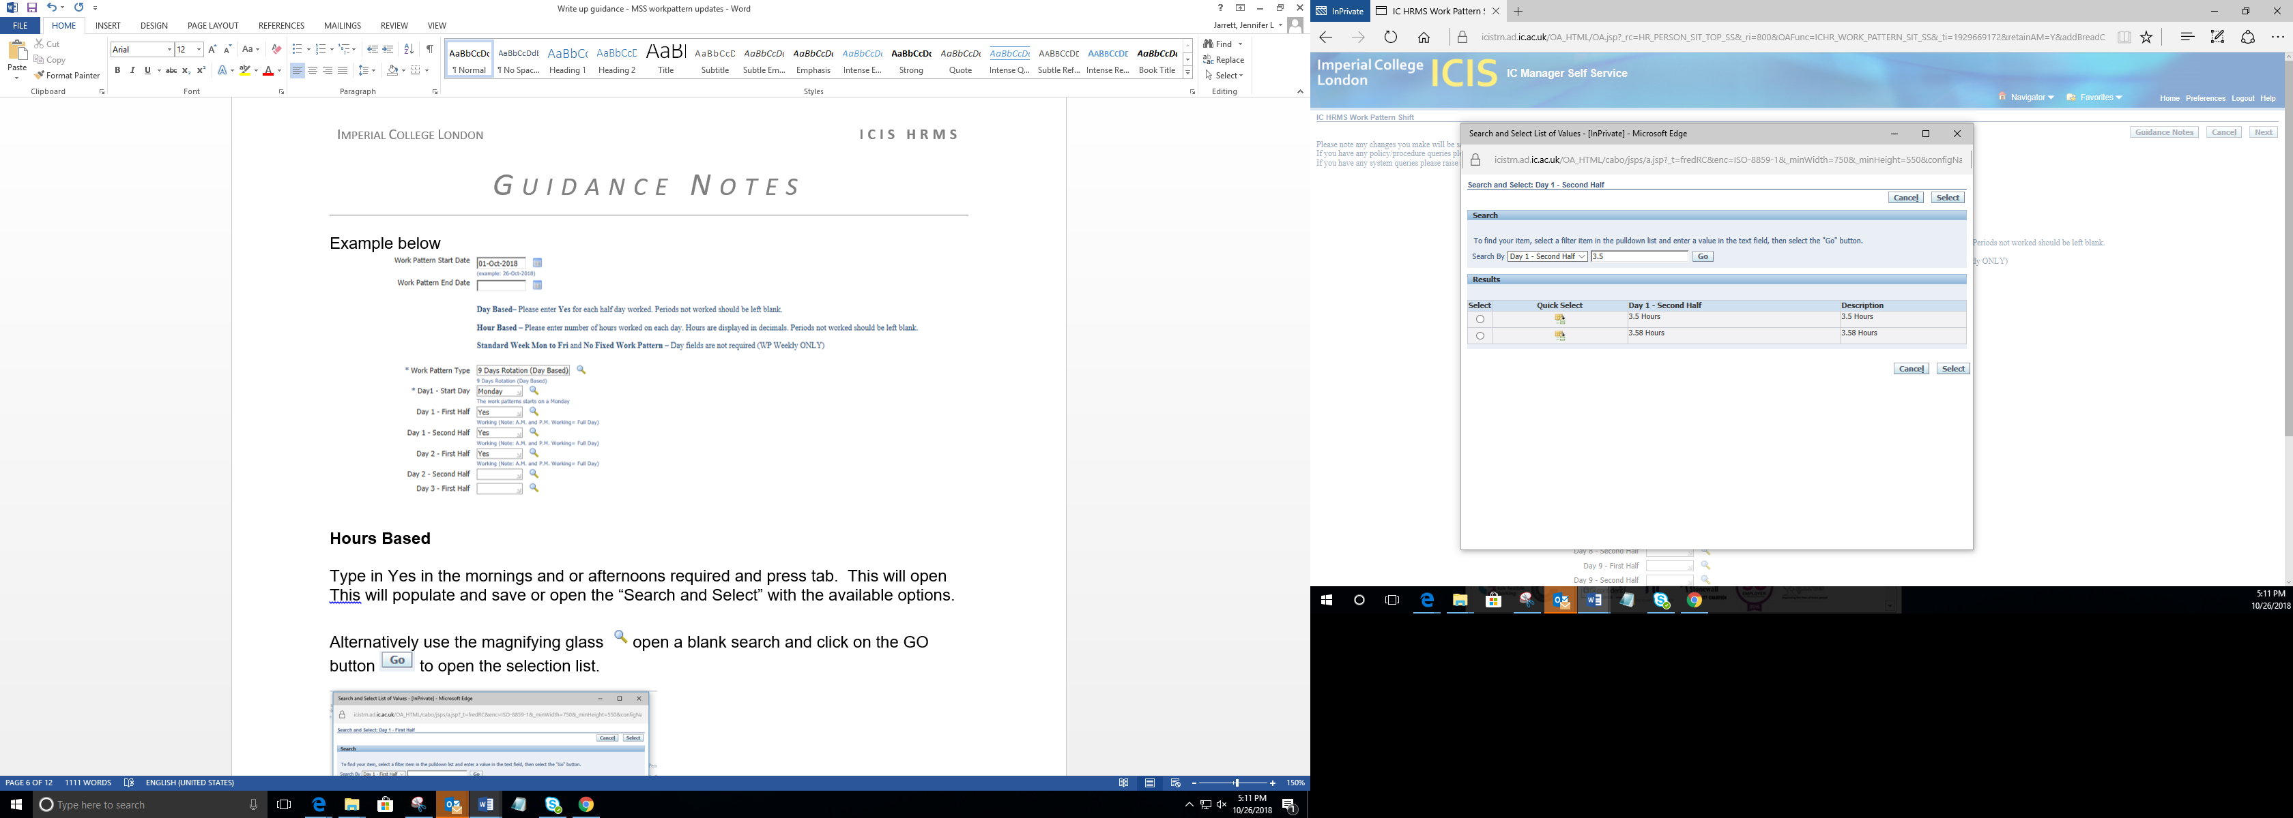

Click on action icon in the column labelled Quick Selection to pull through hours into the morning and or afternoon required.

Alternatively use the magnifying glass open a blank search and click on the GO button to open the selection list.
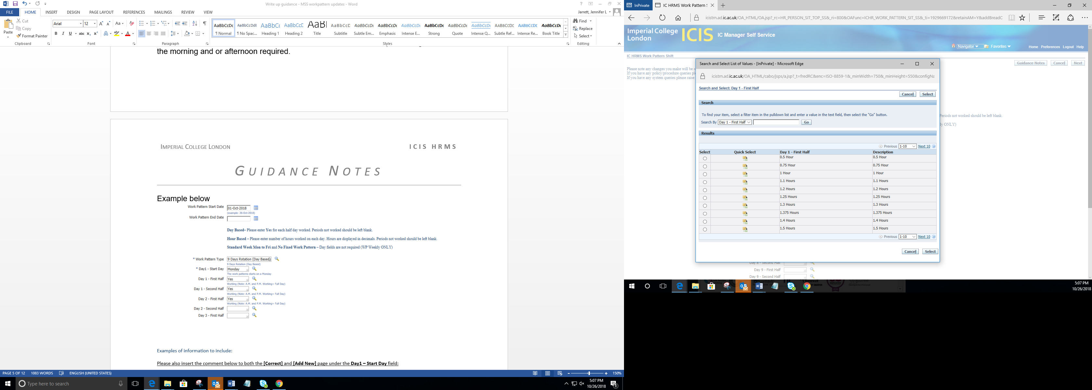
Click on action icon in the column labelled Quick Selection to pull through hours into the morning and or afternoon required.

Example:
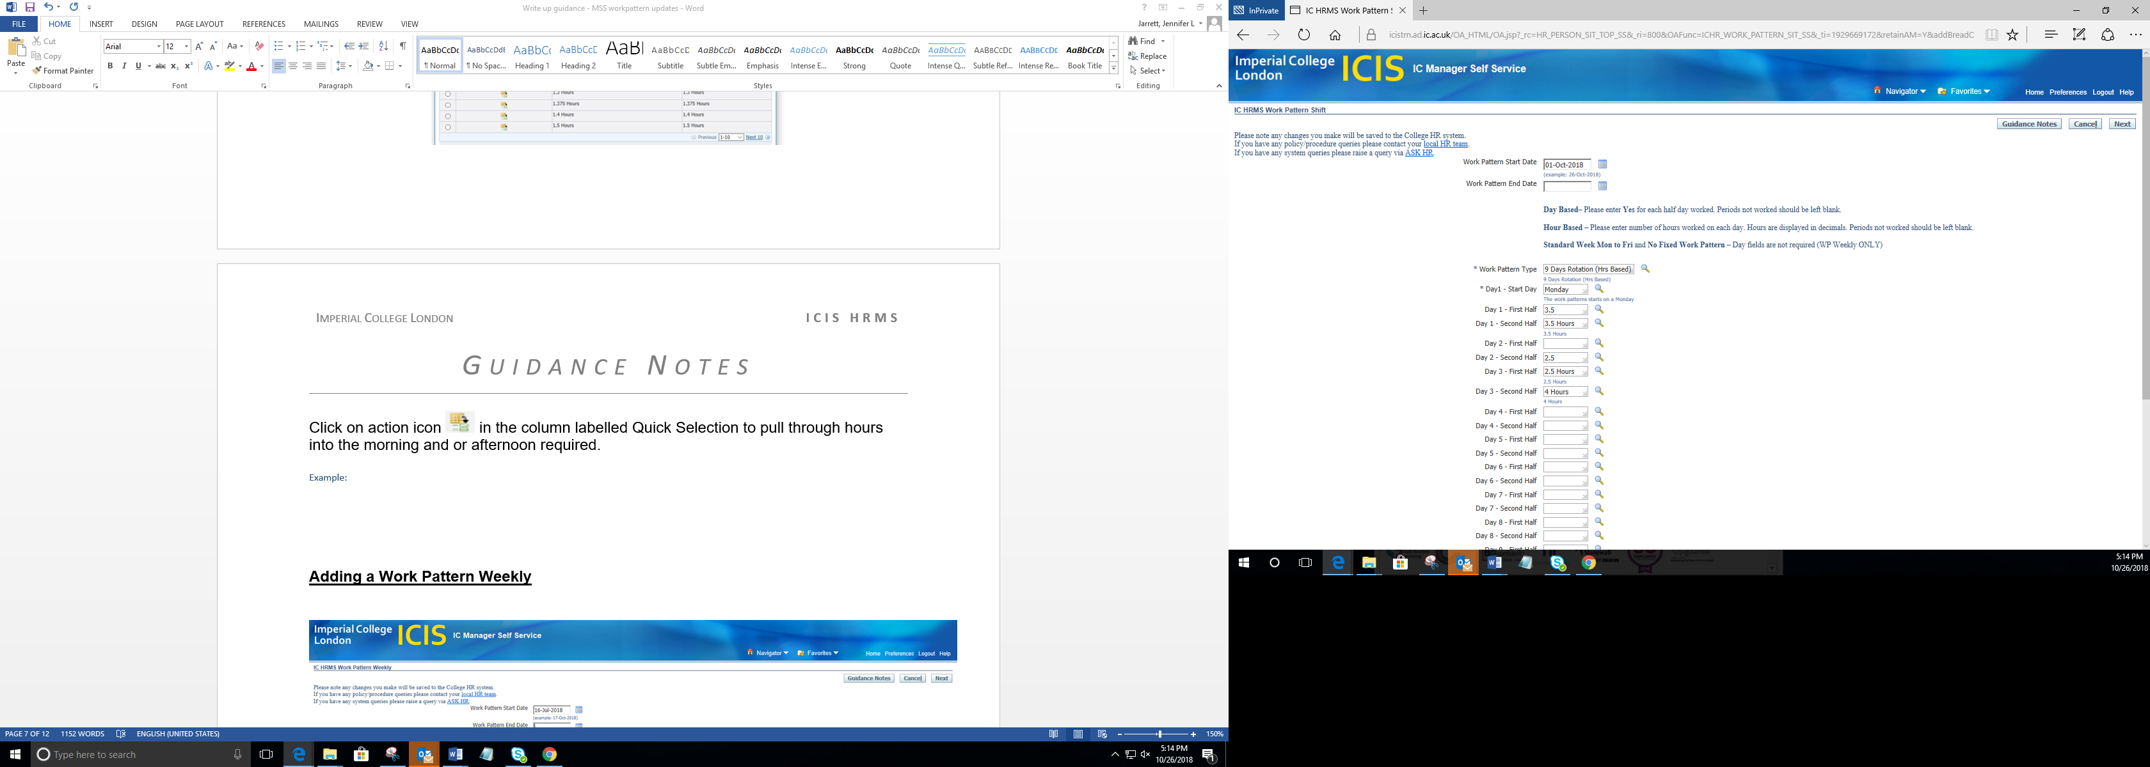

Once the work patter has been entered click on the NEXT button and this will take you through to the page entitled “IC HRNS Work Pattern Shift” with the work pattern populated.

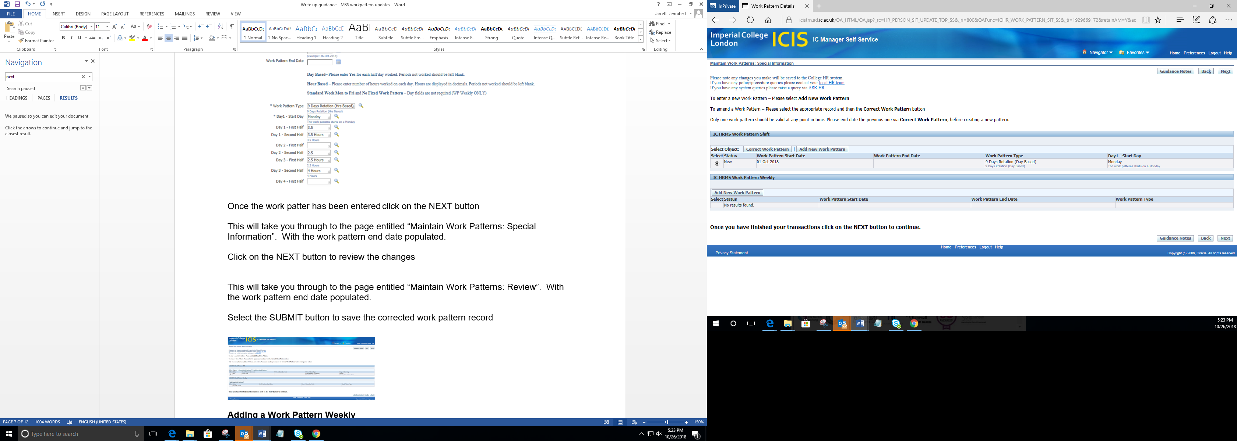

Click on the NEXT button to review the changes

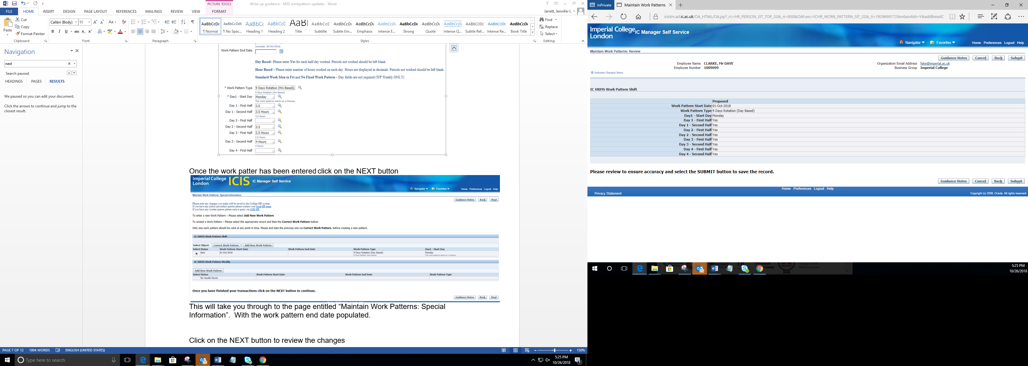

This will take you through to the page entitled “Maintain Work Patterns: Review”. With the work pattern populated.

Select the SUBMIT button to save the corrected work pattern record

Adding a Work Pattern Weekly

On the “Maintain Work Patterns: Special Information” click on the Add New Work Pattern button 

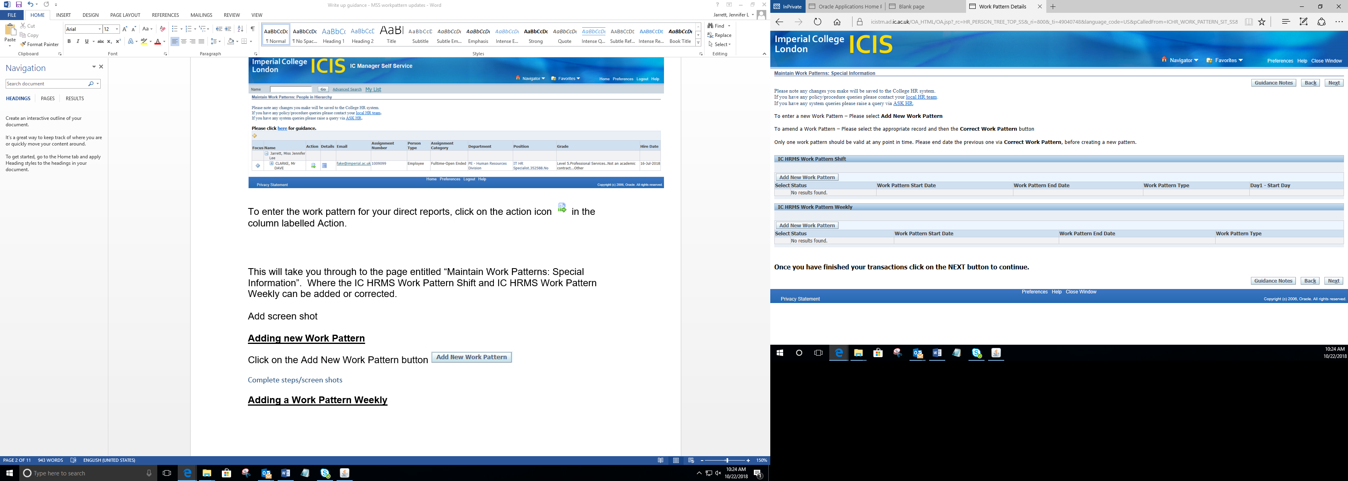

This will take you through to the page entitled “IC HRMS Work Pattern Shift”. Where the Work Pattern Shift can be added.

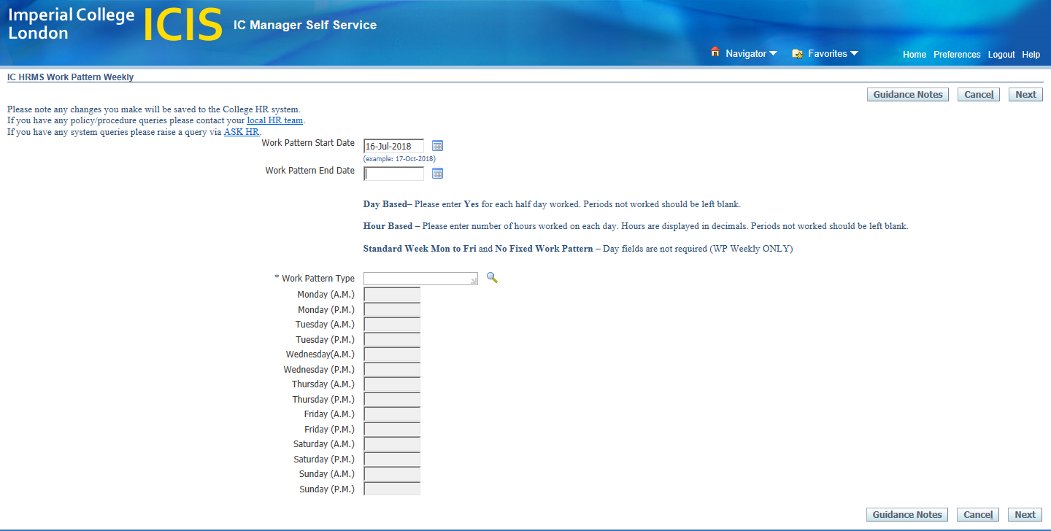

Please note for work pattern types

- Standard Week Mon to Fri Work Pattern once you have selected the standard working week please leave all day field blank.

- No Fixed Work Pattern once you have selected the No Fixed working week please leave all day field blank.

WARNING for No Fixed Work Pattern:
- ICIS would need a work pattern in place for TeamSeer to calculate the leave entitlement or you will need to liaise with your HR department to manually calculate and enter the leave entitlement into TeamSeer.

- Day Based is broken down into morning (am) and afternoon (pm) of each working day and only require a ‘Yes’ against morning or afternoon. Any non-working morning or afternoons to be left blank.

- Hour Based is broken down into morning (am) and afternoon (pm) of each working day and will be require in hours (e.g. 1hour and 30minutes = 1.5 hours). Any non-working morning or afternoons to be left blank.

If a particular value you require is not available, please raise a query via ASK HR.

Standard Week Mon to Fri Work Pattern

They system will auto populate the Work Pattern Type with the Standard Week Mon to Fri pattern.

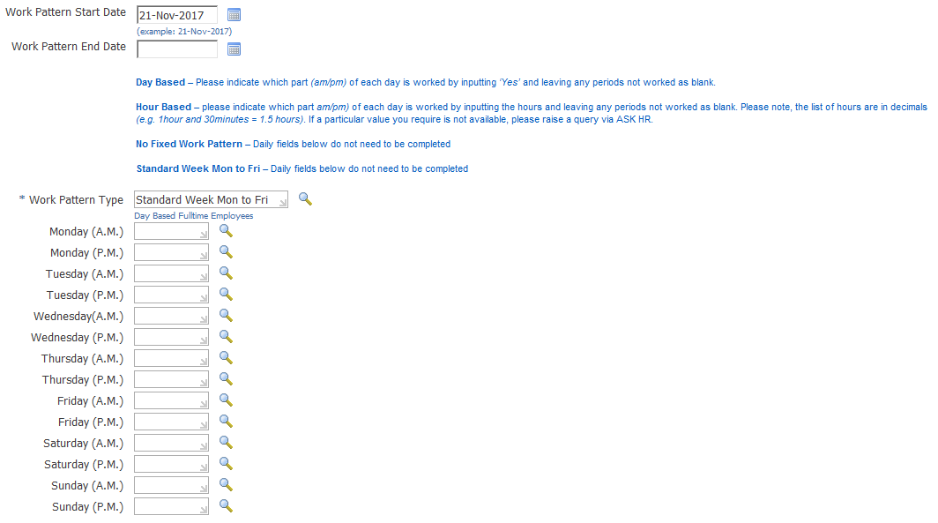

Check the Work Patter Start Date: To amend the work pattern start date click on the calendar icon and select the date from the pop up calendar.

Once Work Pattern Start date has been entered click on the NEXT button and this will take you through to the page entitled “Maintain Work Pattern: Special Information” with the populated IC HRMS weekly work pattern.

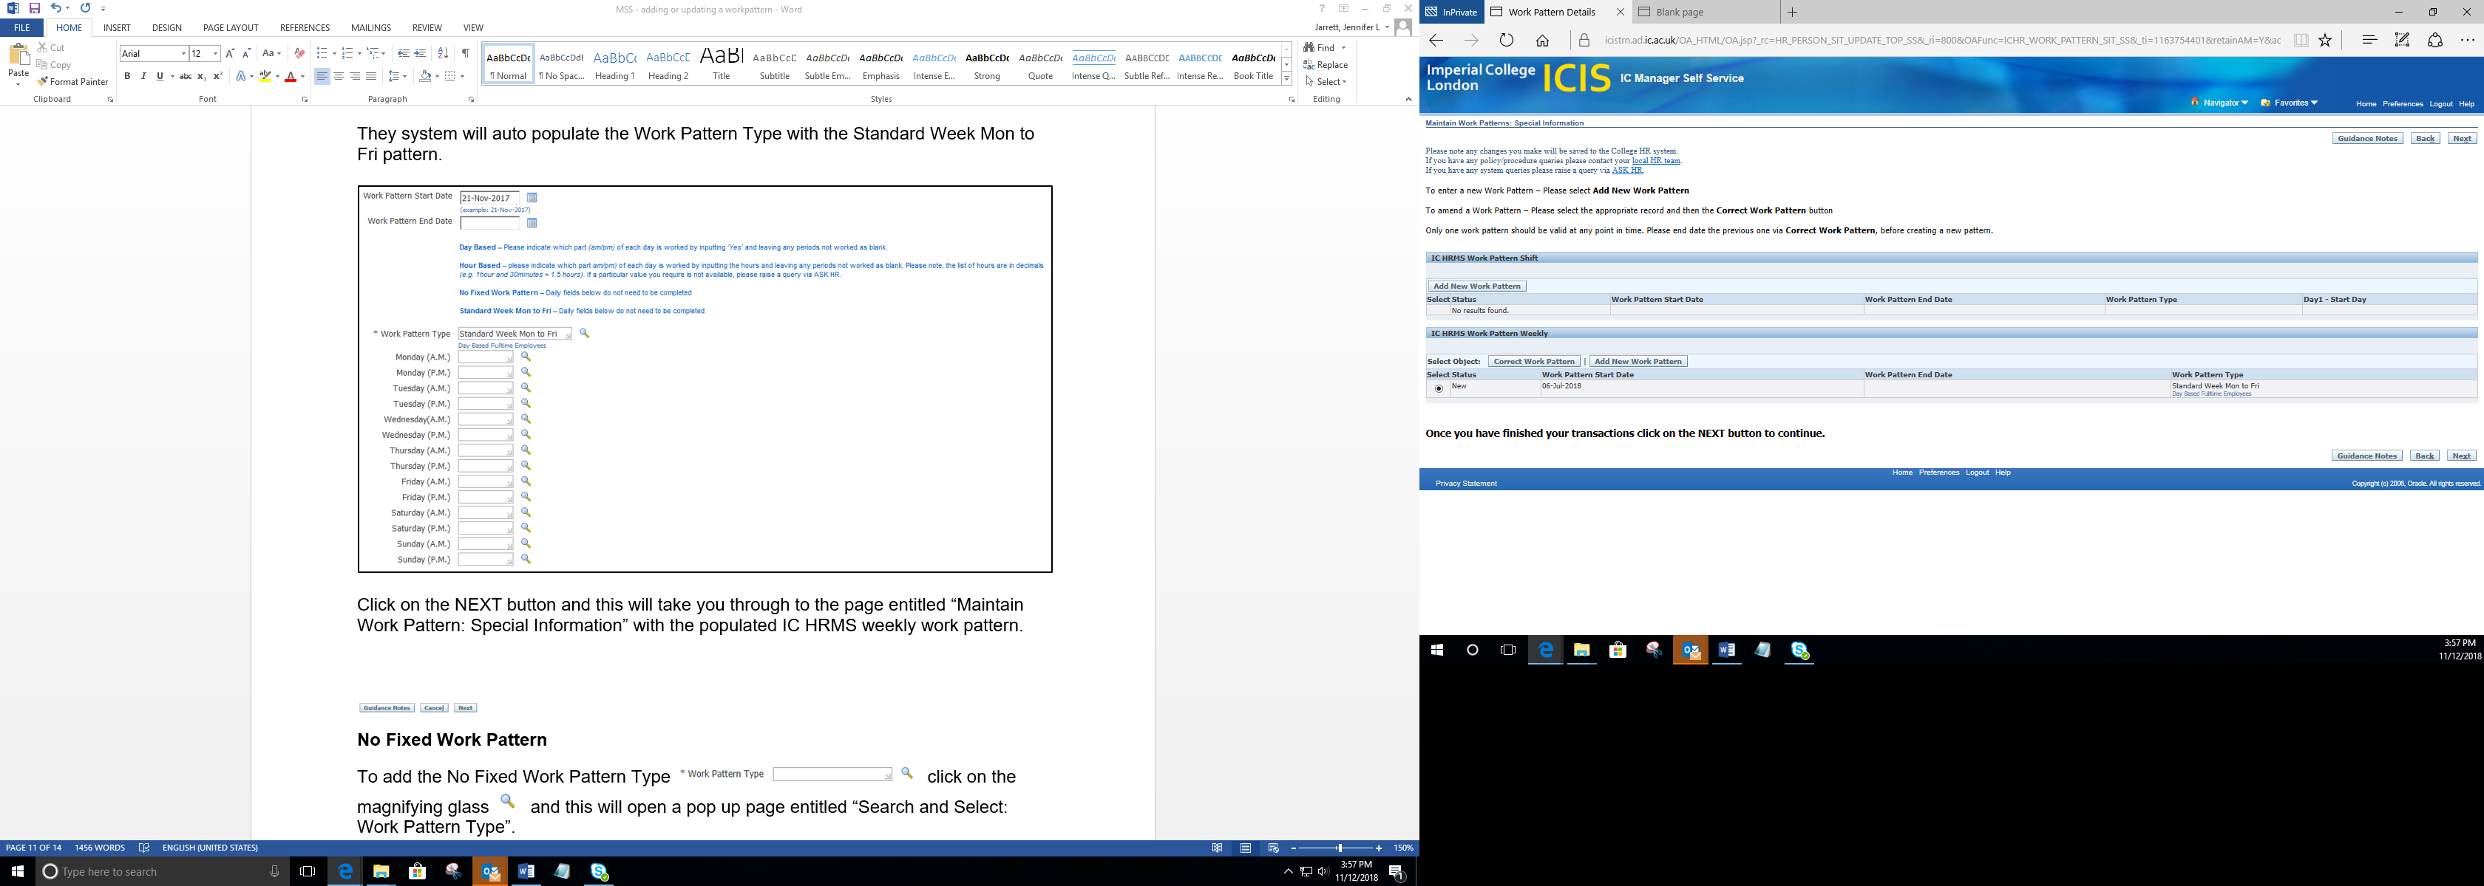

Click on the NEXT button and this will take you through to the page entitled “Maintain Work Pattern: Review” with the proposed work pattern.

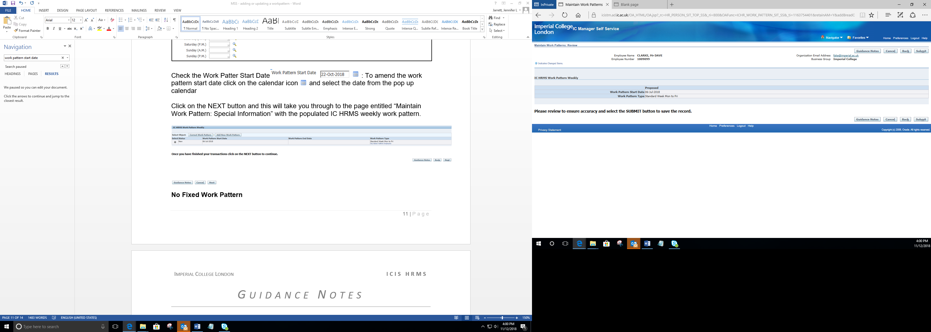
Press the submitted button and a confirmation page opens to confirm this has been actioned in Managers Self-Serve.
To return to your home page press the home button in the bottom right corner.
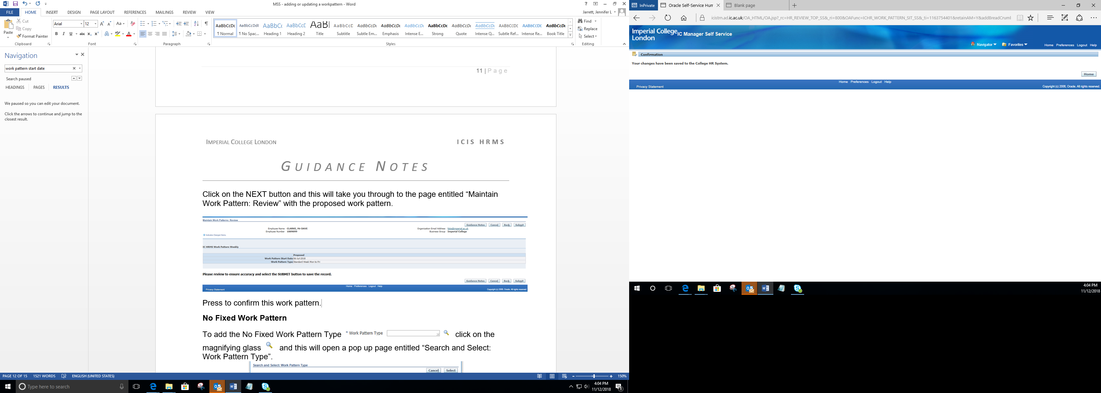

No Fixed Work Pattern
To add the No Fixed Work Pattern click on the magnifying glass of the Work Pattern Type field. This will open a pop up page entitled “Search and Select: Work Pattern Type”.

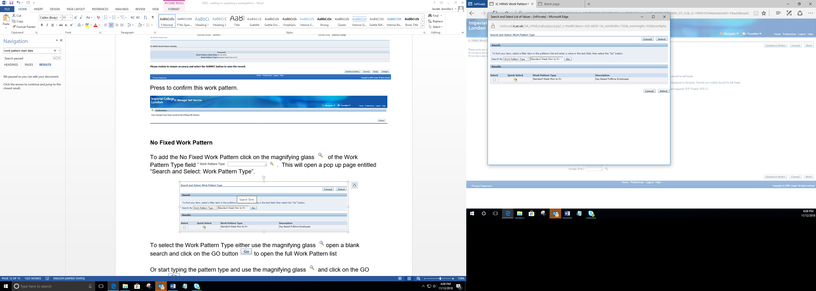

Clear the Standard Week Mon to Fri by clicking into the field and press the X to the right hand side.
To select the No Fixed Work Pattern Type either use the magnifying glass open a blank search and click on the button to open the full Work Pattern list.
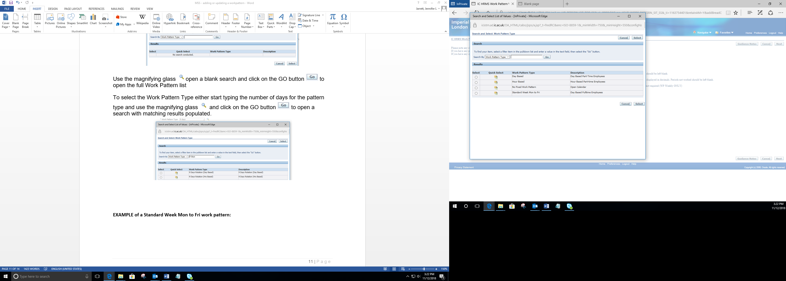

Or type in No Fixed and click the button to open the search results.

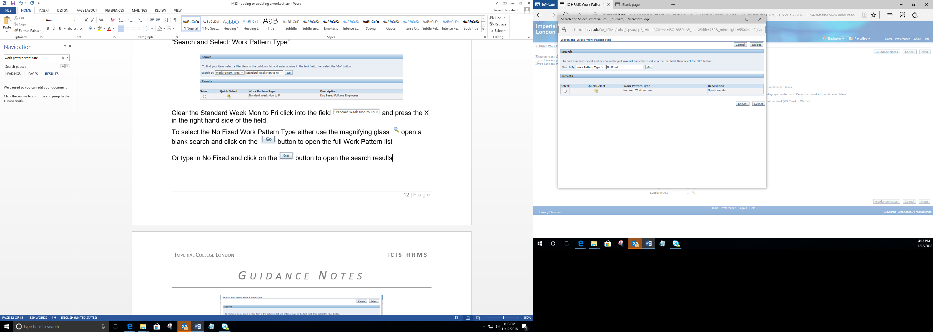

Click on action icon in the column labelled Quick Selection to pull through the No Fixed Work Patter.

Once the No Fixed Work Pattern Start date has been entered click on the NEXT button and this will take you through to the page entitled “Maintain Work Pattern: Special Information” with the populated IC HRMS weekly work pattern.

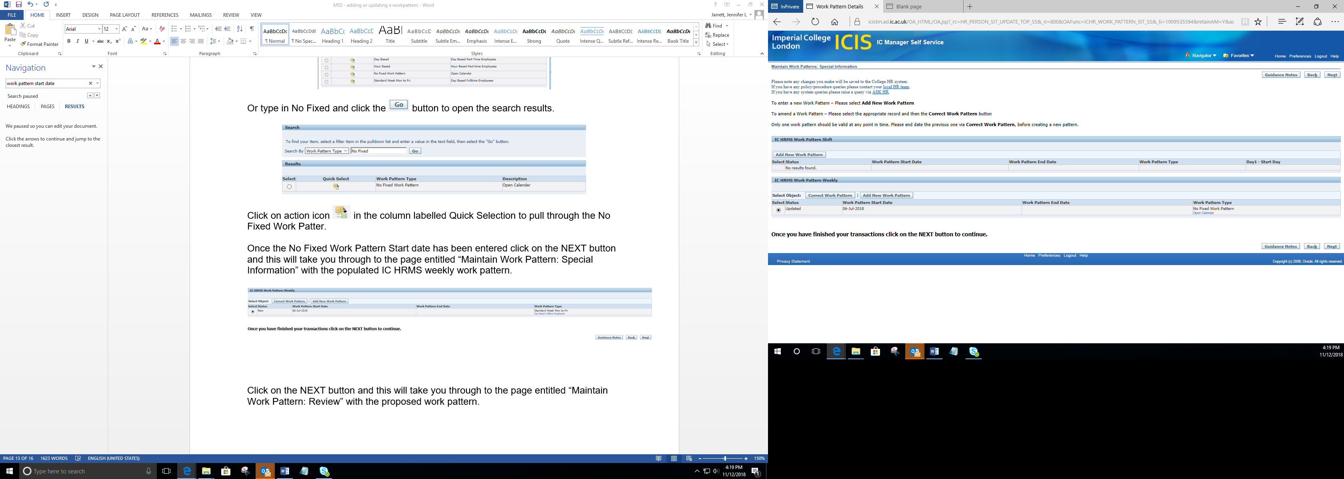

Click on the NEXT button and this will take you through to the page entitled “Maintain Work Pattern: Review” with the proposed work pattern.

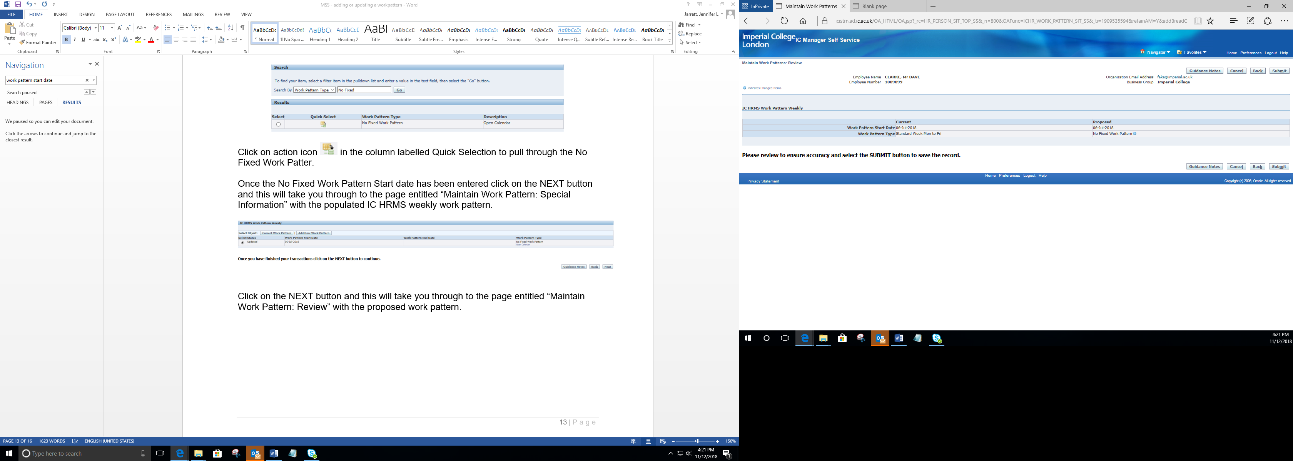

Press the submitted button and a confirmation page opens to confirm this has been actioned in Managers Self-Serve.
To return to your home page press the home button in the bottom right corner.

BEWARE of Work Pattern issue

Only one work pattern should be valid at any point in time. Please ensure you have end dated the old work pattern by selecting the Correct Work Pattern button.

A list of all existing work patterns for that individual will be displayed.
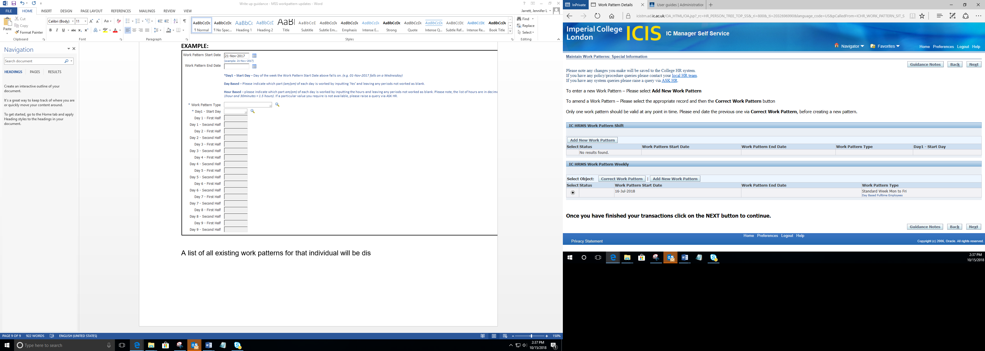

Correcting a Work Pattern:

Please select the appropriate record 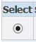

Click on the Correct Work Pattern button to amend a record 

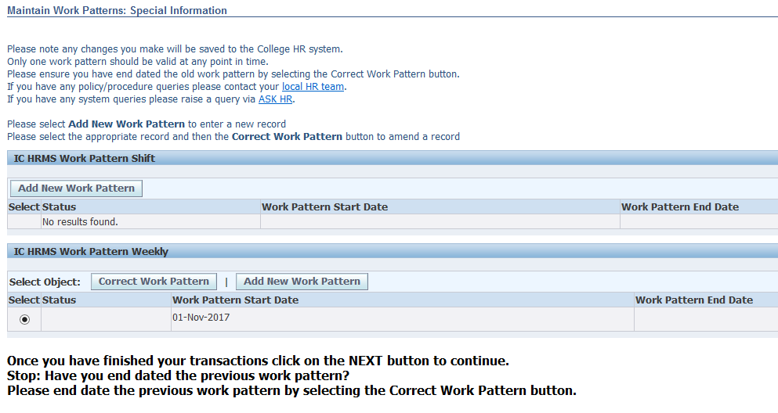

This will take you through to the page entitled “IC HRMS Work Pattern (Weekly or Shift)”.

Click on the Work Pattern End Date calendar  and select the work patterns end date

Once you have added the Work Pattern End Date click on the NEXT button

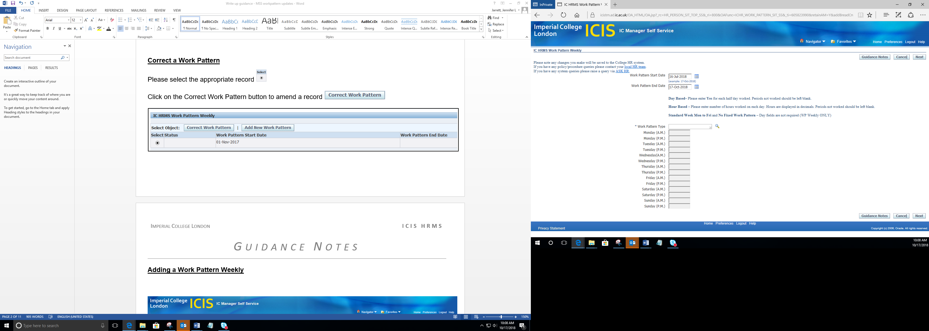

This will take you through to the page entitled “Maintain Work Patterns: Special Information”. With the work pattern end date populated.

Click on the NEXT button to review the changes

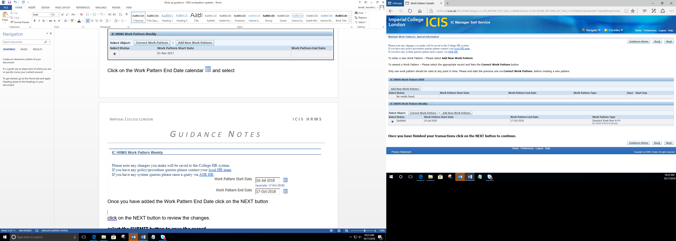

This will take you through to the page entitled “Maintain Work Patterns: Review”. With the work pattern end date populated.

Select the SUBMIT button to save the corrected work pattern record

