Request to recruit form – guidance and information

Before you start…we recommend that you have the following details to hand:
Save the form as a draft
If at any point you realise you don’t have this information, then once the Basic Information page is complete, click on this icon to save the form


- The department the role will be based in
- The location the role will be based at
- If an Occupational Health Assessment is required in order to undertake the role
- The advertising channels you wish to use (e.g. jobs, guardian, nature etc)
- The Job Family and Job Level
- The working hours and type of contract associated with the role
- Funding details including cost centre(s) and account code(s) associated with the role
- Names of the approval teams
- Names of panel members
- A completed job description and job advert
Where to find your draft Requests to Recruit
On your dashboard:
- Click on the briefcase symbol in the left navigation panel
- Select drafts from the drop down menu
- Search for the draft you are looking for
- Click on the job title to pick up where you left off

Click the Use Recommendation icon at anytime



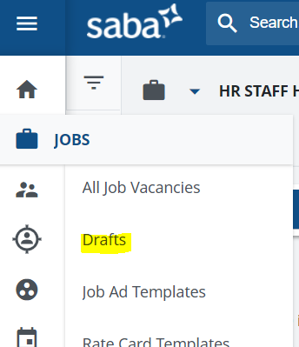
Use the auto complete functionality to create new Requests to Recruit with Speed
Either populate the job title field with a previous job number or job title and the form will self-complete the key fields based on the information you last uploaded.
See this section for further details
**Additional guidance notes are also provided above each field on the form
Logging in - the request to Recruit form is on TalentLink and can be accessed by using your college single sign on details
Select New Job – in the top right of your Dashboard to launch a new request

Basic information
Panel Chair/ Hiring Manager - Assign this to yourself. You can provide further details on Line Manager and Panel members on the next page
Job title – here you can input a previous job number or select one of your previous job titles from the drop down menu. This will then complete key sections of the form on the next page
Using the drop down options, indicate the Faculty and Department the role will be based in and the source of funding.
Contract type – Pick one of the options. “Research” is for roles on the research and clinical scales. “Professional” is to be used for roles on the PTO and teaching scales

Advertising options
All - the role will be advertised on the college jobs site and will be open to both external and internal candidates. It will automatically be posted on Indeed and Google Jobs for free.
Redeployee and Internal only - the role will be advertised on the college jobs site and will only be available to the Imperial community i.e. employees, redeployees, students, agency workers and casual workers
Redeployees only and Redeployee – Listed Department Only – You will need to follow the reployee policy, so please contact the Recruitment Hub for further guidance.

Guidance Notes

1
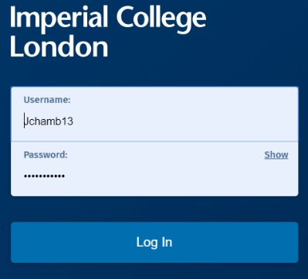

2
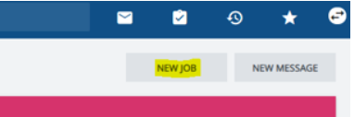
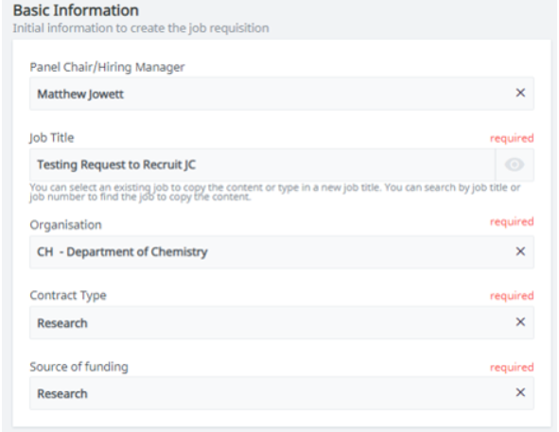

3

4

5

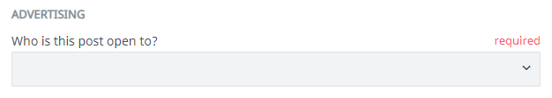
6

9
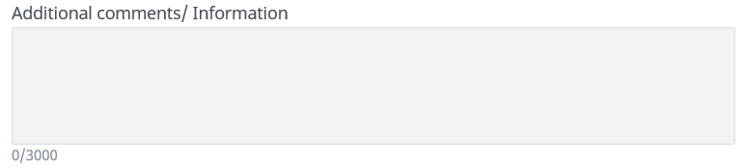
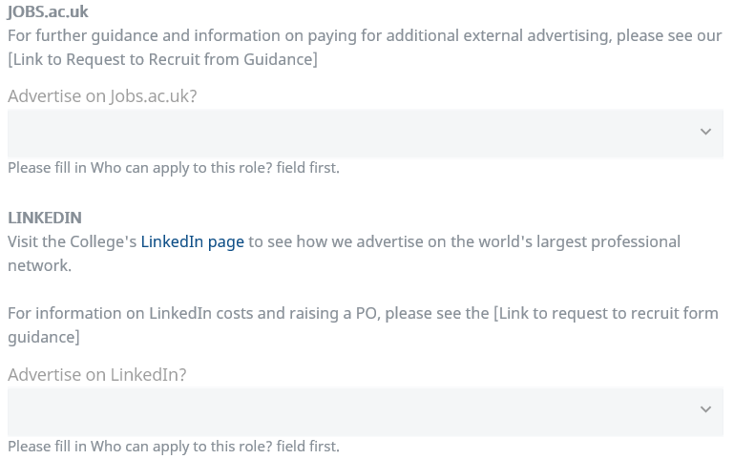
8
7

Jobs.ac.uk - If you would like to advertise on jobs.ac.uk, it would be beneficial for you to raise a PO via iProcurement. This will mean we are able to get your role live with Jobs.ac.uk as soon as possible.

Please ensure:
- The PO is raised under ‘Warwick University Services Limited’
- The intended use is listed as ‘3 – Charitable advertising’ so VAT is not added.

See jobs.ac.uk advertising prices or download the university rate card.

LinkedIn - Current costs for advertising on LinkedIn (prices are reduced for research posts for funding reasons):
- Professional/ Academic/ Teaching post £450
- Research Post £300

If you want to advertise on LinkedIn, please complete a GL Journal via ICIS by using the below information. The journal will need to be approved by your department's finance team:
- Journal description: [Job number, Job title, Department – LinkedIn Advert]
- Cost Centre: PECRP
- Activity code: G84070
- Analysis code: 162204

You can use the Advertising Additional Comments/ Information to provide any details on raised POs. If POs are raised after the form has been submitted then please email the job number and PO details to recruitmenthub@imperial.ac.uk

Please let us know about any raised POs in the Additiional Comments/ Further Information

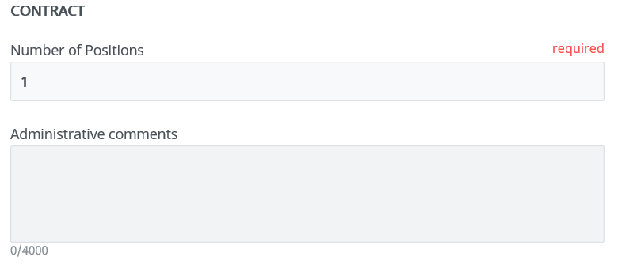
14
13
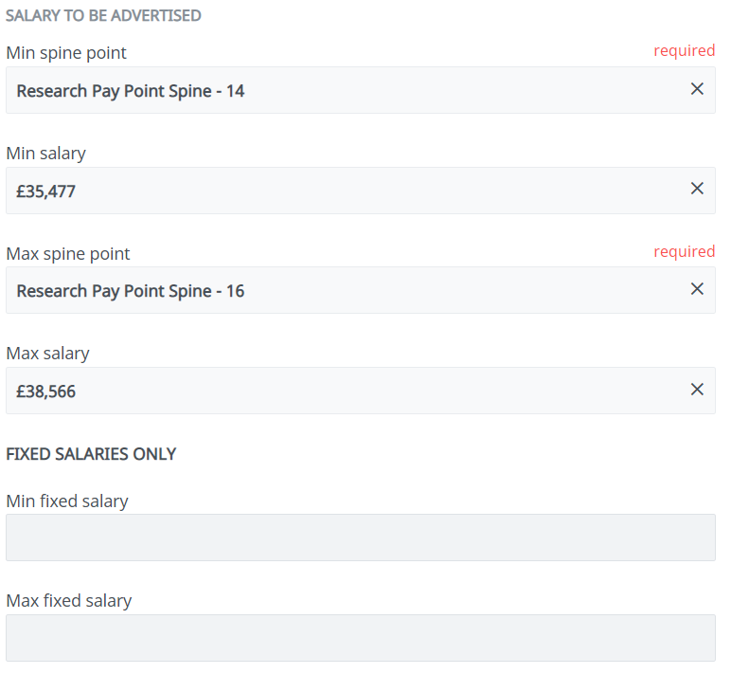
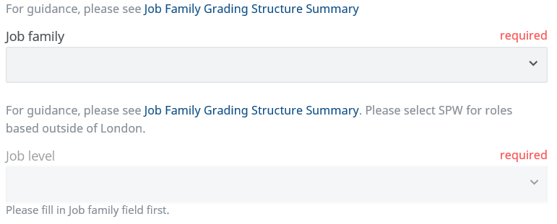
12
11
10

Number of positions – this relates to the headcount/ number of roles available

Contract Admin Comments – Please use the free text box to specify anything unique about the job details, hours, type of contract etc.

Job Family and Job Level – Please ensure these are correct since the Recruitment Hub will use these fields to generate the salary details for the job. Use the Job Family Grading Structure Summary for further guidance.

If wating to advertise a role as Research Assistant/ Associate, then please select this in the drop down menu.

Salary information – The drop down options are determined by the job family and job level that you have selected. Use the Job Family Grading Structure Summary for further guidance.

Please note, the salary selected here will be listed on the job advert.

Fixed salary roles – can be typed in. Provide the number and leave out any symbols and comma e.g 62000

18
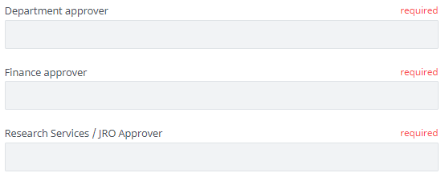

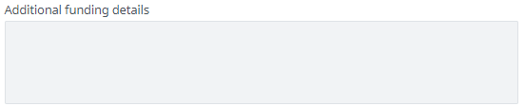
17
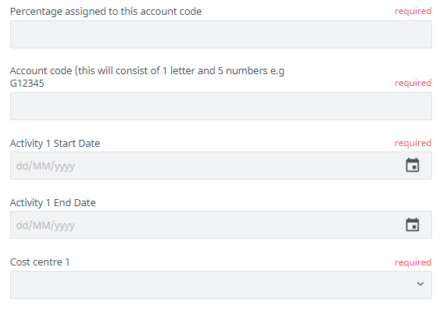
16
15

Account code information – To help you complete this, please see the following example details:
- Percentage assigned to this account code: 100%
- Account Code: G00001
- Activity start date (this will be the potential date a candidate could start, please add a rough date if unknown)
- Activity end date (only required for fixed term roles)
- Cost Centre: WHCV

Account code 2 and additional split funding details – only required for split funding posts. Please provide additional details in the above format if using the additional split funding free type box.

Shortlisting Panel members – the Recruitment Hub can update the Panel team for you at any time, so please provide any initial names or leave blank if unkown. Once added by the Recruitment Hub, Panel Members will show up under the Operational Team section on the job summary page.

Job Approvers – this information needs to be as accurate as possible. The Recruitment Hub will verify the approvers before they launch the Job Approval stage.

If a Finance or Research step is not required, then please type N/A in the box.

Attachments – please ensure that you attach a job description and job advert before submitting. You can upload files from your computer or this section also supports file drag and drop functionality.

The Recruitment Hub will then check through your attachments. They will then use the both documents to upload the job to our careers site.

Please use:
- Career Site attachements section for the Job Description
- Not Visible on Career Site Section for the job advert

For diversity and inclusion purposes, and to see our job advert bank, please use Textio. Guidance can be found on the Recruitment and Selection Procedure page.

Submitting your Request to recruit – once the details have been checked through, then you are ready to submit the form. Click “Create” and this will automatically be sent to the Recruitment Hub.

Job summary page – Once submitted, you can see an overview of the Request to Recruit form. If any details are incorrect, then please contact the Recruitment Hub and they will make the necessary changes.

The Recruitment Hub will send the request to recruit for the job approval process. A member of the Recruitment Hub will contact you if any further details are required.

Keep up to date – View the status of your request to recruit at any time by logging into your TalentLink dashboard and clicking on My Jobs.

For additional support: please contact recruitmenthub@imperial.ac.uk

For technical issues: please contact support.jobs@imperial.ac.uk

21


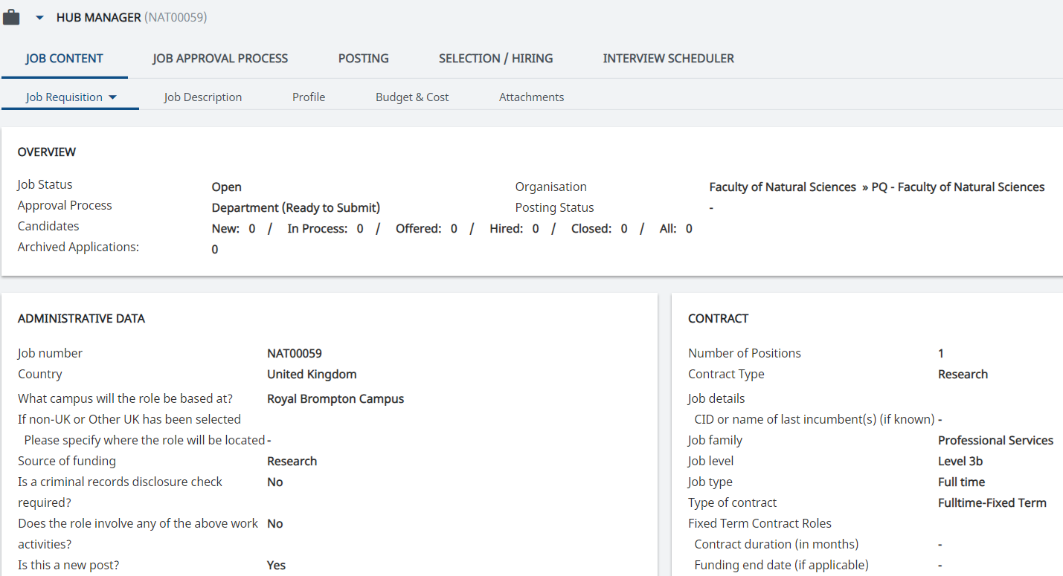
20
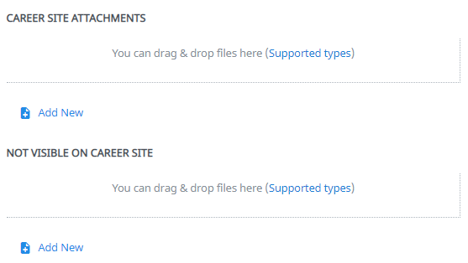
19

