**INTERNATIONAL MEMORANDA OF UNDERSTANDING**

**DUE DILIGENCE PROFORMA**

[A Memorandum of Understanding (MoU)](http://ia.ucsd.edu/content/docs/Collaborations/062909_Template_MOU.pdf) is a **non-legally binding document** that states a general desire to cooperate in certain areas.

Even though MoUs are non-legally binding, the College suggests they are only entered into if there is significant reason for them. International MoUs are widely used within Higher Education to promote and develop partnerships without entering into a more formal, legal arrangement. Whilst MoUs should not have legal ramifications, in signing such an agreement, the College is opening up the possibility that the other party might use the existence of an agreement with Imperial to gain advantage in discussions with unrelated parties. In other words, there is a brand risk for Imperial.

Section 3A of the College’s *Ethics Code* (July 2013) makes it clear that, in order to mitigate the risk of ethical issues causing damage to the College’s reputation, ability to secure funding and capacity to develop beneficial relationships in the future, the whole of the College community, including all its staff, students, governors and associates, should consider the ethical aspects of relationships and manage such issues appropriately.

More positively, international MoUs also provide the ability to map the College’s international links which can be useful in informing future international activities and demonstrating the breadth of College partnerships.

*This process is to be applied for MoU’s that are with an international partner, where the partner is not a commercial entity. (If the partner is commercial, or if it is a 3-way partnership including a corporate partner, please contact Corporate Partnerships.)*

**If you are not sure if an MoU is the correct document for your purpose, please contact your Faculty’s Contracts Manager for advice. If you are in the Faculty of Medicine, please discuss with Chris Watkins before legal advice is sought. The contacts are as follows:**

* **FoE: Christian Wright,** [christian.wright1@imperial.ac.uk](mailto:christian.wright1@imperial.ac.uk)
* **FoNS: Gary Wheeler,** [g.wheeler@imperial.ac.uk](mailto:g.wheeler@imperial.ac.uk)
* **FoM: Chris Watkins,** c.watkins@imperial.ac.uk
* **ICBS: Jon Tucker,** [j.tucker@imperial.ac.uk](mailto:j.tucker@imperial.ac.uk)

Please note: only certain members of staff have the authority to sign MoUs.  Additionally, all MoUs must be approved by the College’s Legal Team. The International Relations Office can provide more guidance on a case-by-case basis, according to the scale of the proposed MoU.

Once you have completed **parts 1-3** of this form, please return this document via email to: [international.relations@imperial.ac.uk](mailto:international.relations@imperial.ac.uk) The International Relations Office will then undertake the additional risk assessment and obtain approval from the Legal Team and other College authorities, and will keep the relevant contracts manager informed of the process.

|  |  |
| --- | --- |
| 1. **MOU SUMMARY: PROPOSED PARTNER DETAILS** | |
| **Partner full name** |  |
| **Type of organisation** |  |
| **Main postal address** |  |
| **Country of partner** |  |
| **Existing MoUs with partner (give details)** | Level: College/Faculty/Department  Status: Live/Expired/Date  Breadth/Focus: |

|  |  |
| --- | --- |
| 1. **MOU SUMMARY: COLLEGE MANAGEMENT** | |
| **Level of MoU** | Department/ Faculty/ College (please delete as applicable)  *(Please list Department / Faculty)* |
| **Brief Summary of reasons for MoU request, including principal goals/areas of focus** |  |
| **Request for MoU made by (including job title and department)** |  |
| **College Academic Lead (s)/ Link (s) (if different from above)[1]** | *If this is a multi-department MoU, please provide names of relevant academics in each department. Please note that the IRO will follow-up on an annual basis with the coordinator(s) named to request information on implementation and follow-through.* |
| **Partner Academic Lead** | *Please provide the name and email address of the relevant contact at the proposed partner institution* |

|  |  |
| --- | --- |
| 1. **STRATEGIC FIT: for completion by department/faculty if specific, or by International Relations Office if College-level** | |
| The mission of the College is: to achieve enduring excellence in research and education in science, engineering, medicine and business for the benefit of society. | |
| **Check** | **Outcome** |
| How will this MoU support the College’s mission and vision? (and note any possible links to [*College Strategy 2015 – 2020*](http://www.imperial.ac.uk/strategy/)) | *Give brief but specific details (2-3 bullet points)*  1.  2.  3. |
| What are the expected outcomes of signing this MoU? |  |
| *For College-level MoUs only:* | |
| There are existing links involving staff from at least two different Faculties (please give all known details) | *International Relations Office to supplement if additional information is available* |
| A College-level MoU is expected to consolidate existing links | *International Relations Office to complete*  *(give details, e.g. feedback from existing collaborators with partner)* |

1. **Risk management checks: for completion by International Relations Office**

|  |  |
| --- | --- |
| **Check** | **Outcome**  If concerns arise, please summarise and provide relevant URLs |
| Country | Check: corruption - <http://cpi.transparency.org/cpi2013/results/>  FCO advice - <https://www.gov.uk/government/collections/overseas-business-risk>  Google News |
| Institution | Check: other partners  Rankings  Speciality |
| Completed by: | *Name, job title, date* |
| No concerns raised  Concerns/risks identified – escalate to Provost’s Board | |
| Approved by: | *Name, Associate Provost (Academic Partnerships), date* |

1. **Outcome / Sign-off (for completion by the International Relations Office)**

|  |  |
| --- | --- |
| CHECKLIST |  |
| Has the Legal Team approved the MoU? | [Name and date of approval] |
| For **Department-level** MoUs – Head of Department approval required and DOM for information | [HoD name and date of approval]  [Department Operations Manager name and date of information] |
| For **Faculty-level MoUs** – Faculty Dean approval required and FOO for information | [Name and date of approval]  [Faculty Operations Officer name and date of information] |
| For **College-level MoUs** – Provost approval required | [Name and date of approval] |
| Expected date of MoU signing | [Date] |

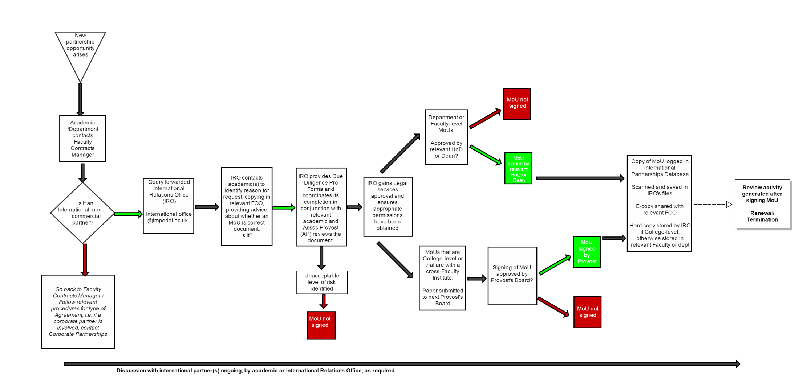

1. International engagements should have an identified champion within the College and a strong support base within the departments (as well as senior management of the College, when necessary)