
Student Route Application Guide
This document will assist you in completing the online Student Route visa application form for an application made in the UK.
If you want your application form checked before you submit, please email a PDF copy to the International Student Support team before you reach the declaration page.

You can choose to have your new BRP delivered to our office for collection
To have your BRP sent to Imperial please follow the steps below when filling in the application form:
In Section 1 of the form in the Contact Preferences section. Instead of entering your address enter the College address as follows:
- Post code: SW7 2AZ
- Click on ‘Enter address manually’
- Line 1: International Student Support, Imperial College c/o Lizzie Wright
- Line 2: Rm 327, Student Hub, Sherfield Building
- Line 3: London
- Line 4 (County) - leave this blank.
When you reach Section 2; in the ‘Personal Details’ section where you are asked “Do you live at this address?” Answer NO, then enter the address where you are currently living in the UK.
Please email our team at international@imperial.ac.uk if you have a query.

eVisas and Digital Immigration
The UKVI is moving towards a more streamlined digital immigration system that will be available to certain nationalities. Currently, this is available to EU/EEA/Swiss nationals and non-visa nationals applying inside the UK using the UK Immigration ID Check app. A list of visa nationals can be found in the Immigration Rules – if your nationality is listed as a visa national you are not currently eligible for digital immigration. Visa nationals will still be issued with a physical visa in the form of a Biometric Resident Permit (BRP).
The application will be different for those applying under the digital route, the application will start on the GOV.UK website by creating a UK Visas and Immigration account and then you will be asked to download the ‘UK Immigration ID Check’ app to verify your identity and complete the application. To use the app, you will need your Biometric Residence Card or Permit (BRC/P) if given one for your most recent grant of leave.
EU/EEA/Swiss nationals can use their biometric passport to verify their identity on the app.
When the visa is granted it will be digital, so no Biometric Resident Permit (BRP) will be issued. Anyone unable to use the ‘UK Immigration: ID Check’ app, will need to book an appointment to visit a UKVCAS Centre to provide biometrics in-person, it will be possible to book an appointment at the end of the application.
Student Route Visa application link
Please go to the GOV.UK website and scroll down the page to click on the green ‘Start Now’ button to begin the application.
Student Route Visa application form
The first step is to follow the instructions on screen and register an email address that you have access to and check regularly. You may also be directed to download an app to scan your visa.
You will be asked if you are using an immigration adviser in the UK – please answer NO to this question.
You will then be asked to provide the following information:
- A contact telephone number
- Scholarship information – this is only relevant for individuals who are in receipt of the following scholarships: Marshall, Chevening or Commonwealth scholarship. If you are receiving one of these scholarships, you can say YES and proceed. If you are not receiving any scholarship or your scholarship is not one of the one’s listed above, then answer NO and proceed.
- CAS number – you will be asked to provide the CAS number allocated to you by the College.
- The following screens will request your details: name, sex, relationship status, address where you are currently living and passport details.
- ID Card – if your country has issued you with an ID Card then you must provide those details here. If you do not have an ID Card answer NO and proceed.
- The following screens will request your details: nationality, country and date of birth.
- Other nationalities – if you hold any other nationalities then you must provide that information here. If you hold no other nationalities, please answer NO and proceed.

English language questions
- English Language assessment: As you have an offer from Imperial this means the College has assessed your English language ability. Please select YES for the option ‘Are you studying at a higher education provider with a track record of compliance?’
- Does your Confirmation of Acceptance for Studies (CAS) statement indicate that your English language ability was assessed by your institution or that you are a ‘gifted’ student? YES
Family information
You will now be asked to provide information about:
- People who may be financially dependent on you
- Your parents

Previous travel history
Please provide information about any previous visas and travel for:
- UK Travel history / Previous visas for the UK
- Travel to Australia, Canada, New Zealand, USA, Switzerland, or the European Economic Area
- World Travel history
Criminality
Please read each question carefully and answer as accurately as possible. These questions require a YES or NO response.
- For either the UK or any other country, have you ever been: refused a visa; refused entry at the border; refused permission to stay or remain; refused asylum; deported; removed; required to leave; excluded or banned from entry.
- Have you ever breach UK immigration law: entered the UK illegally; remained in the UK beyond the validity of your visa or permission to stay; breached the conditions of your leave, for example, worked without permission or received public funds when you did not have permission; given false information when applying for a visa, leave to enter, or leave to remain; breached UK immigration law in any other way.
- Convictions and other penalties in the UK or any other country
- War Crimes
- Terrorist activities, organisations and views
- Extremist organisations and views
- Employed in activities that have been dangerous to the interest or national security of the UK and its allies.
- Person of good character

Course-related questions
- For the College Sponsor license number and address please refer to the screenshot below:
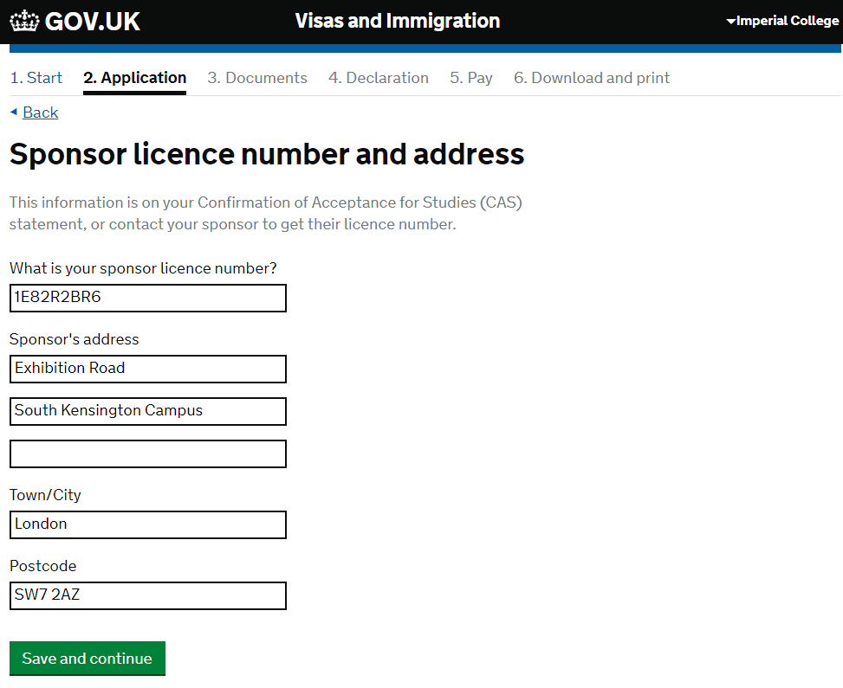
- Type of sponsor – please select ‘Higher Education Provider with a track record of compliance’
- Primary site of study – if the physical location for your studies will not be at the South Kensington Campus then please refer to our website for a list of the different campus addresses.
- UCAS details – Students studying an Undergraduate course (eg. BSc) or an integrated Masters programme (eg. MSci) will have applied for their course through UCAS. For UG students you must answer YES to this question and provide your UCAS number.
- Academic Technology Approval Scheme (ATAS) - Certain courses may require you to apply for an ATAS certificate. If applicable, this would be a condition of your offer and you would not have been issued a CAS number without first having been issued an ATAS certificate. You will have a PDF of the ATAS certificate, please refer to the certificate for the reference number.
- Future official financial sponsor – Students who are being financially by an education institution, international company, the UK Government or an overseas Government must select YES to this question about ‘financial sponsor’ and provide a scholarship letter with their visa application that provides the details of that sponsorship.
  - If you are receiving a scholarship from Imperial or through your Department at Imperial, you can request to have this information added to your CAS as a Sponsor Note. Please note that this will not automatically happen, and you must contact your Admissions team to ask for the information to be added.
  - Please note that parents or any other family member/friend are not considered an official financial sponsor for the purposes of your visa application.
- Course information
Please log into your My Imperial portal to access your course information.
The level of course and qualification is as follows:
- for a 3-year Undergraduate course, select ‘RQF6/SCQF10’
- for a 4-year Undergraduate course, eg MEng and MSci select ‘RQF7/SCQF11’
- for MBBS select ‘RQF7/SCQF11’
- for Masters studies select ‘RQF7/SCQF11’
- for PhD studies select ‘RQF8/SCQF12’
- Course dates – please log into your My Imperial portal to find this information.
- Accommodation payments – Please select NO to this question. Even if you have paid for your accommodation in Halls this will not be reflected on your CAS number.
- Course fees – please write your tuition fees for the current year of your studies here and if you have paid any money towards the fees, please write this here. To locate your fee information log into your My Imperial portal.
- Student loan – if you are being funded through a student loan, please provide the details here.
- Maintenance – please refer to our Financial Requirements webpage for detailed information to determine if you need to show financial evidence as part of your application.
What happens next?
- Check your answers – you have an opportunity now to correct any information in the form.
- Evidence showing the required maintenance funds – provide the details of your financial evidence here.
- Documents –you do not need to upload any qualifications you used to obtain your offer for Imperial. If ATAS or financial documents are required, then you must upload these documents.
- Conditions and Declaration – confirm you have read and proceed.
- Immigration Health Surcharge – you will be taken to a separate webpage to pay the IHS.
- Pay application fee

