Risk Assessment for use of Ultra Violet Radiation (UVR) Sources

Faculty/Department
Location & Room No. of Laboratory
Name of Assessor
Name of Laboratory Manager
Make and Model of Equipment
Serial Number of Equipment

Identify the UVR Hazard(s)  (delete as applicable) | Skin and eye injury possible all wavelengths
UVA (315-400nm) | 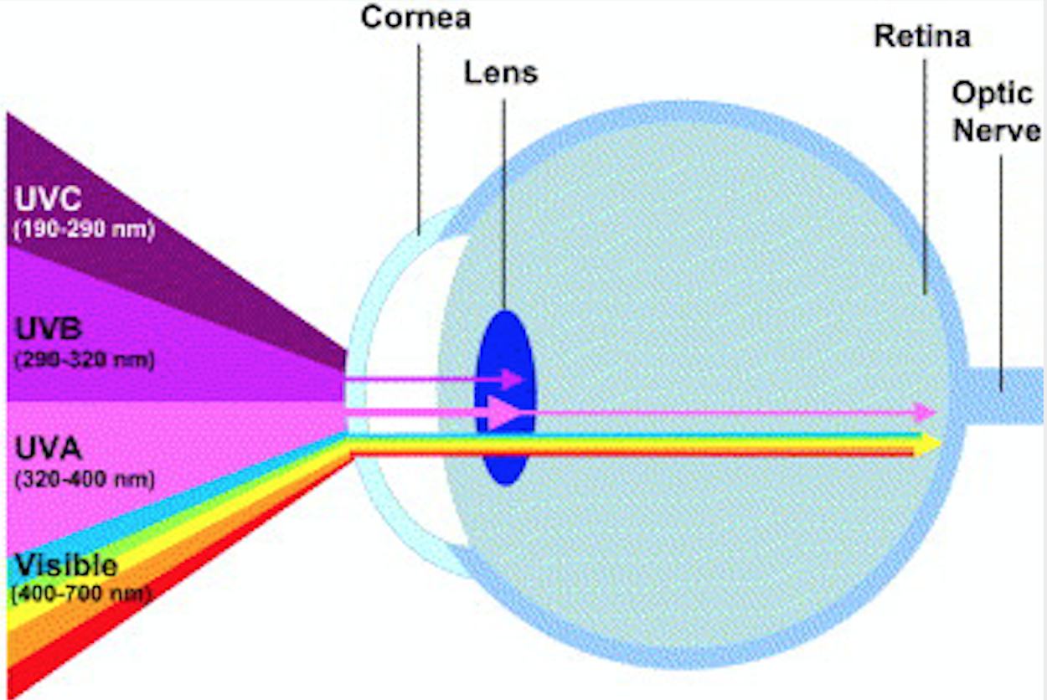
UVB (280-315nm)

UVC (100-280nm)

What is the nature and magnitude of the risk? |  | Short term (S)  /Long term (L)? | Mild (M)  /Severe (S)?
Eye | Photo-keratitis / Photo-conjunctivitis | S | S
 | Photochemical cataract | L | S
 | Other – e.g. possible photochemical retinal damage | L | M
Skin | Erythema | S | S
 | Ageing | L | M
 | Photochemical skin reactions | L | M
 | Cancer | L | S

Describe the process or work procedure

Who might be affected by this work?

Control measures to minimise the UV risk | In Use? (Y/N) | Details
Engineered safeguards (e.g. enclosures, Interlocking doors / shields): | Y/N
Warning Signs and Labels: | Y/N
Shielding and PPE | Y/N
Training and recording | Y/N
Access Control | Y/N
Local Rules (incl. Contingency Plan): | Y/N

Non–Radiological Hazards | Comments | Control Measures | Actions Required
Chemical
Electrical
Biological
Fire
Other

Assessor's Additional Comments:

This should include an assessment of exposure against the relevant ELV

UVA (315-400nm) | UVB (280-315nm) | UVC (100-280nm)
H_{eff} = 30 J/m²
H_{UVA} = 10⁴ J/m²

Assessor's Signature | Printed Name | Date

Reviewer's Signature | Printed Name | Date

Further Notes: To be reviewed within 24 months or earlier in the event of a significant accident or incident.

