Safe lifting

Lifting and carrying is a common cause of injury at work. Good manual handling techniques can significantly reduce the risk of injury.
Almost all staff and students at some time get involved in manual handling in College: whether it’s carrying a pile of books, shifting a computer or moving equipment in an office or laboratory.

This guidance describes the basic techniques of good lifting practice to help you avoid unnecessary injury

Principles of safe lifting practice

Before you start  - Think about the job  - Does it need carrying, or can a trolley or other equipment be used instead  - Think about what you are going to do before you do it:  - Where is the load going?  - Does it need more than one person to lift it safely?  - Is there enough room?  - How can you avoid having to twist when lifting or putting the load down?  - Think about you  - Are you dressed for the job? Tight clothing can restrict movement. High heels are never suitable.  - Do you have a health problem that might make you vulnerable to injury  - If you are not sure of how heavy a load is, test it out before you try to lift it. Gently rock the load to test the weight and its distribution  - If you have not been trained, you should not lift >15Kg without advice from your local Manual Handling Assessor  - Remove any obstructions/tripping hazards from the route  - Work out where and how to take a rest if moving a heavy load over a long distance  - Are there any sharp edges? If so, then you may need to wear gloves to protect yourself  - If load is too bulky, look at ways in which to break it down | 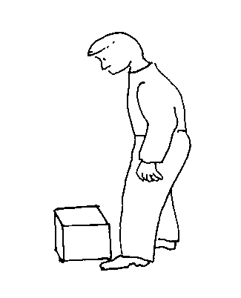
Lifting technique  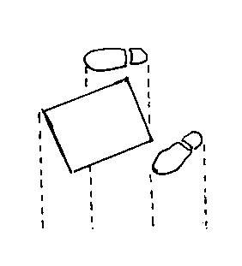  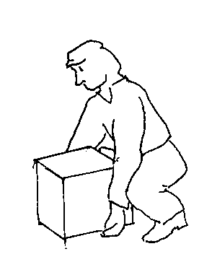 | - Place you feet apart to make a stable base for lifting  - Placing one leg forward in front of the other will help improve balance and control  - If you have to reach out to the load, try sliding it towards you before attempting to lift it  If lifting from a low height, bend your knees, NOT your back  - Stand correctly, keeping your back straight and your chin tucked in  - Keep your shoulders level and facing the same direction as your hips  - Lift smoothly, avoiding jerking movements  - Lift your head first – your back then straightens automatically  - Grip the load with your palms, rather than just your fingers – If you need to change your grip, rest the load first.  - Keep your arms close to your body to help support the load  Do not allow the load to obstruct your view – seek assistance if it is too large.
Moving the load  - When carrying, keep the load as close to the body as possible  - Keep the heaviest side of the load closest to your body  - When pulling or pushing, use your body weight to move the load – if possible, let the momentum of the load do some of the work e.g. when pushing trolleys  - When pulling, keep your back straight and your arms as close to your body centre line as possible  - Avoid twisting your body when turning | 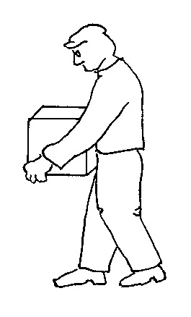

College Policy
The College has a specific safety policy on safe manual handling.

Any heavy lifting or carrying tasks in College which cannot be avoided by, for example, using lifting or transport equipment should have a risk assessment completed before it is carried out. The person in charge is responsible for this.
Each College department has a Manual Handling Assessor who can help with risk assessments and advise on safe techniques

You should always follow instructions given on how to carry out a manual handling task in accordance with its risk assessment

If you are expected to lift or move loads in your work or studies, but are unsure whether the task is within your capabilities, speak with your manager/supervisor before trying.

If you have recently strained a muscle, or have a history of back problems, or there are other personal circumstances e.g. you are pregnant, which you think means a task is outside of your capabilities and/or requires a risk assessment, speak with your manager or supervisor.

Training
If your work regularly involves manual handling then you should be trained in manual handling techniques. Your Departmental Manual Handling Assessor may provide this or recommend that you attend a courses organised by the College Safety Department.
Speak to your manager in the first instance if you think you need trained.
Information on safety department training courses is available at www.imperial.ac.uk/safety/training/courseindex

Injuries or accidents
You must always report any injuries, accidents or near misses involving manual handling to your manager or supervisor.

You can find further information on the College Policy, lifting techniques, risk assessments and manual handling aids on the Occupational Health web pages www.imperial.ac.uk/occhealth/guidanceandadvice/manualhandling

