**Soldering Notice**

**What is Rosin?**

Rosin, also called colophony, is a solid form of resin obtained from pines and some other plants. It is semi-transparent and varies in colour from yellow to black. Rosin is used for a variety of applications including commonly as a flux for electronics soldering.

**What form can Rosin flux take?**

Rosin is available in a variety of forms from powder to solid cakes. As a flux it could be sold separately or included as part of a multi core solder.

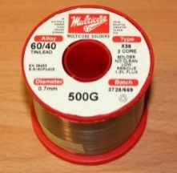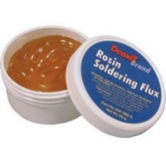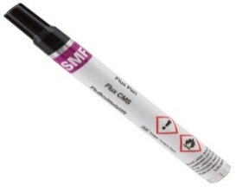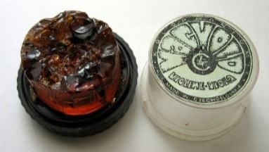

Multi core solder containing flux

Traditional Solder flux

A flux pen, commonly used for electronics rework

Rosin cake made for violinists but used here as a flux for soldering

**What are the dangers of using rosin / colophony based flux?**

Prolonged, continual exposure to fumes from heated rosin is known to cause allergies. Colophony is well recognized as a skin sensitizer and is also a significant cause of occupational asthma. There is no blood test to determine if or when or how much you were exposed to colophony.

**How to identify if your solder or flux contains Rosin?**

* Look on the product packaging to see if the product contains colophony or rosin.
* If there’s no indication on the packaging then check the safety data sheet (SDS) or material safety data sheet (MSDS) supplied with the product.
* If you don’t have the data sheet check the manufacturer / supplier web site as they are often available for view / download online. Alternatively contact the supplier directly.
* If in doubt (e.g. because the solder / flux is old, label is worn and you don’t know where it came from) – dispose of it and buy a new product. – Remember under the Control of Substances Hazardous to Health (CoSHH) regulations it is required that health hazards of any material are identified and minimised.

**My solder or flux contains rosin – What should I do?**

Unless essential to your particular work or project, dispose of them through the College hazardous waste route and substitute with rosin-free alternatives.

If your work requires the use of rosin containing substances, fill in the slip below and e-mailing as an attachment to [m.moderate@imperial.ac.uk](mailto:m.moderate@imperial.ac.uk).

Ensure that their use is covered in your COSHH risk assessment

If you need any other guidance, or help with the COSHH assessment, contact your local Departmental or Faculty Safety Officer.

**First name: Click here to enter text. Last Name: Click here to enter text.**

**Email: Click here to enter text. Location of soldering: Building & room number.**

**Does your solder / flux contain Rosin? Choose an item.**

**Roughly how often and how long for do you undertake soldering: e.g. 1hr a day**

**Briefly describe any existing controls in place to prevent exposure to fumes: e.g. Ducted or bench-top extraction unit, or carbon filter.**