IMPERIAL COLLEGE LONDON
DEPARTMENT OF COMPUTING

Deep Learning for Stratifying Fibrosis on
Histopathological Images of the Liver

Author: Supervisor:
Sneha Naik Elsa Angelini
Submitted in partial fulfillment of the requirements for the MSc degree in MSc in Artificial
Intelligence of Imperial College London
September 2, 2021
Abstract
Non-alcoholic Fatty Liver Disease (NAFLD) is one of the leading causes of chronic liver disease, affecting around 25% of people worldwide. The current gold standard for diagnosis is a semi-quantitative analysis of biopsy images by an expert histopathologist. Over the last ten years, there have been rapid advances in Deep Learning (DL) applications for analysing digitised histopathology whole-slide images (WSIs) both in a weakly and fully supervised setting, driven by the need to reduce high annotation costs and high inter- and intra- rater variability. The body of research primarily concentrates on datasets stained with Haematoxylin and Eosin (H&E) and, for the most part, are biopsies from cancerous tissues. To the best of our knowledge, for the first time, we demonstrate the efficacy of DL architectures for classification on a specialised stain, Sirius-Red, which highlights fibrosis patterns crucial to the quantification of the progression of NAFLD. This project exploits a novel retrospective cohort of n=152 WSIs, with the fibrosis stage annotated at slide-level by an expert pathologist. In this project, we tackle the binary classification task to separate severe (stage > 2) from mild (stage ≤ 2) fibrosis cases, which corresponds to a critical transition for the development of NAFLD therapies. Promising solutions were explored to handle multiple challenges: small cohort, image-level annotations, sparse pathological signs in large images, significant stain colour variability and artefacts inherent to non-curated retrospective clinical data. We made three key contributions in this thesis: (1) We first established a strong DL baseline for feature extraction in conjunction with an interpretable, attention-based multiple instance learning (MIL) framework. We achieved an accuracy of 74.32 ± 5.38%; (2) We further investigated stain normalisation and demonstrated that capsule networks, initially designed for H&E stains, have a promising performance boost in our application; (3) Finally, we developed a novel pipeline for multiple-inference MIL to address the sparsity of pathological signs, which achieved an accuracy of 78.98 ± 5.86%, an F1 score of 77.99 ± 5.64% and an AUC of 0.87 ± 0.06. These results set new state-of-the-art benchmarks for our application.
Acknowledgement
First and foremost, I would like to thank my supervisor, Dr Elsa Angelini, co-lead of the ITMAT Data Science Group (NIHR Imperial Biomedical Research Centre). This project would not have been possible without her patience and consistent support. Her in-depth understanding of the field, experience supervising MSc and PhD level students, and the amount of time she dedicated to the project was invaluable. It was a privilege to work with Dr Elsa Angelini.
Our work on the FibLivPath dataset would not have been possible without Professor Robert Goldin, who initiated the project. I would like to thank him for annotating the slides, explaining the medical intricacies of NAFLD diagnosis, and providing his expert knowledge throughout.
I would also like to warmly thank Jazz Mack-Smith for conducting the initial processing for the FibLivPath project and providing us with a starter code base. In addition, her friendly assistance with software issues throughout the project was extremely helpful.
I also want to thank Dr Rob Craven, the MSc AI course coordinator and Sam Ritter, my mentor from the Google DeepMind Scholarship program. Their enthusiasm, responsiveness, and kindness helped me make the most out of this demanding year.
Finally, I want to express my gratitude to my family and friends for supporting me and providing endless encouragement.

Contents
1 Introduction 5
2 Background and Context 7
2.1 Non-alcoholic Fatty Liver Disease (NAFLD) 7
2.1.1 Disease Characteristics 7
2.1.2 Assessment of NAFLD 7
2.2 Histopathology 8
3 Deep Learning in Histopathology 12
3.1 Literature Review 12
3.1.1 Learning from Tile-Level Annotations 13
3.1.2 Learning from WSI Level Annotations 15
3.1.3 Learning without Annotations 21
3.1.4 Transfer Learning 26
3.1.5 Conclusions from Literature 29
3.2 Additional Background 30
3.2.1 Pre-processing methods 30
3.2.2 Capsule Nets 30
3.2.3 Model Evaluation 31
4 Preparation of the Dataset with Clinicians 33
4.1 Dataset Description 33
4.2 WSI Artefacts 34
4.3 Inter and Intra WSI Variation 34
4.4 Challenging Examples 35
4.5 Test Set Construction 36
5 Experiments Description 37
5.1 Pre-Processing 37
5.1.1 Background vs Tissue Selection 37
5.1.2 Stain Normalisation 40
5.1.3 Data Augmentation 44
5.2 Construction of Bags of Instances 45
5.2.1 Dataloader 1 46
5.2.2 Dataloader 2 47
5.3 Feature Extraction 47
5.3.1 Encoder Architecture 47
5.3.2 Unsupervised Learning of Histopathology Features 48
5.3.3 Aggregation of Features 48
5.4 Implementation 49
5.4.1 Pre-processing 50
5.4.2 Models 51
5.4.3 Experiments and Evaluation 51
6 Results and Discussion 52
6.1 Reporting 52
6.2 Establishing a MIL Baseline Model 52
6.2.1 Optimised Encoder Architecture 53
6.2.2 Optimised Features Aggregation 53
6.2.3 Optimised Bag Size 54
6.2.4 Finalised Gated Attention MIL Baseline Model 54
6.3 Exploratory Experiments to Improve the MIL Baseline model 55
6.3.1 Experiment 1a: Additional Data Augmentation 56
6.3.2 Experiment 1b: Adding Dropout 57
6.3.3 Experiment 2: Unsupervised Feature Learning 57
6.3.4 Experiment 3a: Stain Standardisation Capsule (SSC) 58
6.3.5 Experiment 3b: Analysis of SSC performance 62
6.3.6 Experiment 4: Modified Dataloader 63
6.3.7 Finalised Best Model Results 64
6.4 Detailed Exploration of Failure Cases & Attention Weights 65
6.4.1 Pathological Analysis of Model Failure Modes 65
6.4.2 Analysis of Attention Coefficients 67
7 Concluding Remarks 70
7.1 Contributions 70
7.2 Limitations 71
7.3 Further work 72
7.4 Ethical Considerations 73
7.5 Conclusion 73
A Ethics Checklist 74
B Attention Analysis 75

Chapter 1

Introduction
Non-alcoholic Fatty Liver Disease (NAFLD) is currently one of the leading causes of chronic liver disease worldwide. It is typically associated with obesity, insulin resistance and diabetes [1]. In a study of over 8 million people worldwide, it was estimated that the global prevalence of NAFLD is 25% with the highest prevalence in the Middle East and South America at approximately 30% [2]. Furthermore, in the USA, NAFLD is the second most common reason for liver transplantation [3]. Given the increasing levels of world obesity, it is likely that the incidence of NAFLD in the global population will continue to rise in decades to come.
There is currently no consensus on a treatment plan for NAFLD and liver cirrhosis, except for some lifestyle changes which can slow progression [1]. Therefore, evaluation of disease progression in clinical trials is of key interest.
This project exploits a cohort of 152 digitised liver biopsy samples (whole slide images or WSIs) which are stained with Sirius-Red, (referred to hereinafter as the FibLivPath dataset).
The WSIs are annotated at a slide-level by an expert pathologist at St Mary’s Hospital, London. Many of the current assessments of liver biopsies rely on semi-quantitative evaluation by a pathologist. This leads to high variability among clinicians, alongside high annotation costs.
Consequently, this project aims to demonstrate for the first time, the capabilities of an end-to-end weakly supervised multiple-instance deep learning pipeline to accurately classify liver fibrosis stages between mild (stage ≤ 2) and severe (stage > 2) on this novel image cohort. Proposed frameworks work towards reducing human-induced uncertainty. This could eventually increase the statistical significance of clinical trial results by quantifying end-points with higher degrees of accuracy and reduce development costs of new treatment plans.
In this thesis we make many key contributions. In particular:
- We established a robust MIL baseline performance using an attention-based framework, which achieved an accuracy of 74.32 ± 5.38%.
- We demonstrated a capsule-based stain normalisation approach, Zheng et al [4] developed for H&E datasets has unique applications to the FibLivPath dataset by (1) boosting performance on certain stain appearances and (2) potentially increasing robustness to artefacts.
- We developed a novel multiple-inference MIL framework, which targets the sparsity of pathological signs inherent to NAFLD. This resulted in the overall best model, which boosts accuracy on the FibLivPath dataset to 78.98 ± 5.86%, F1 score to 77.99 ± 5.64% and achieves an AUC of 0.87 ± 0.06.
- We demonstrated, via analysis of attention coefficients with a clinician, that our model proposes discriminative patches coherent with pathological signs. Furthermore, our network detected some borderline cases that fall under the intra-observer variation expected for this application.
The remainder of this thesis is organised as follows. Chapter 2 outlines the essential medical background and context to understand the unique nature and challenges of histopathology datasets. Chapter 3 covers the relevant Deep Learning research and background in the field of digital pathology. Chapter 4 details the characteristics of the novel FibLivPath dataset along with data cleaning conducted alongside clinicians. Subsequently, Chapter 5, describes the main experiments conducted, key parameters investigated and summarises the source code for this project. Chapter 6 reports the results of our experiments and a detailed analysis of failure cases and attention coefficients. Finally, Chapter 7 provides concluding remarks, ethical considerations and proposes avenues for future exploration in this data domain.
Chapter 2

Background and Context

2.1 Non-alcoholic Fatty Liver Disease (NAFLD)

2.1.1 Disease Characteristics
NAFLD is a condition in which excess fat accumulates in the liver of a patient who does not have a history of alcohol abuse. The clinical definition of NAFLD is when steatosis (accumulation of fat droplets in cells) affects over 5% of hepatocytes in the liver [5], whereas a normal liver is devoid of fat. NAFLD can be divided into two categories, Non-alcoholic Fatty Liver (NAFL) and Non-alcoholic Steatohepatitis (NASH) as shown in Figure 2.2 [5]. While NAFL consists of only simple steatosis and is often benign, NASH is a progressive disease where chronic injury and inflammation in the liver leads to the development of fibrous tissue that can lead to liver cirrhosis and ultimately liver failure.

2.1.2 Assessment of NAFLD
Liver biopsy is the reference ’gold’ standard for the diagnosis and staging of NAFLD. The liver consists of three different zones. Zone 1 is adjacent to the portal tract, Zone 3 is next to the hepatic venule and Zone 2 is between the two structures. The liver comprises of these two tracts, hepatic cells (hepatocytes) and sinusoidal blood vessels (sinusoids). A diagram of these features is displayed in Figure 2.1 from [6].
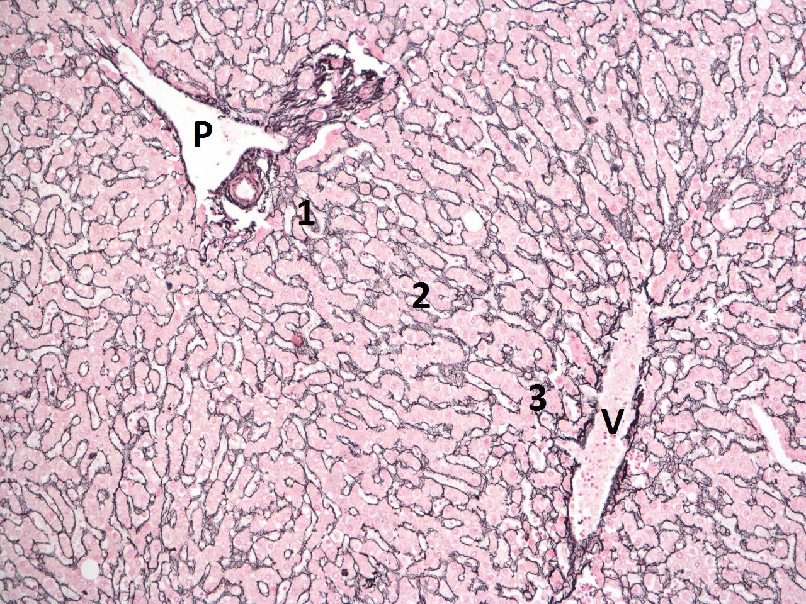
Figure 2.1: Diagram of liver tissue from [6], showing the portal tract (P), the central/ hepatic vein (V) and the location of Zones 1-3.
Histopathologists most commonly use the semi-quantitative Non-alcoholic Steatohepatitis
Clinical Research Network (NASH CRN) scoring system to stage the severity of disease seen on biopsies [7]. The scoring system (described in detail in [8, 9]) consists of four main components [6].
- Steatosis is the abnormal accumulation of fat droplets in hepatocytes liver cells (> 5%) [6], particularly around central veins. A score of 0-3 is attributed is based on proportion and location of steatosis on the biopsy slide.
- Lobular inflammation is inflammation found between the portal tracts and hepatic venules, characterised by a dense cluster of inflammatory cells (lymphocytes) [6]. A score of 0-3 is assigned based on the number of foci (per 200x field of view) of inflammation on the biopsy.
- Ballooning is a process in which hepatocytes degenerate, swell in size and have a clear, wispy cytoplasm [6]. A score of 0-2 is assigned ranging from absence of ballooned hepatocytes to ’prominent’ ballooning.
- Fibrosis is defined as the accumulation of extracellular matrix proteins e.g. collagen in the liver [10]. Fibrosis is graded from 0-4 based on the following architectural patterns visible. A schematic of the different fibrosis stages is shown in Figure 2.2.
  - Stage 0: No visible fibrosis.
  - Stage 1a: Mild, zone 3 perisinusoidal fibrosis.
  - Stage 1b: Moderate to severe, zone 3, perisinusoidal fibrosis.
  - Stage 1c: Portal / periportal fibrosis only.
  - Stage 2: Zone 3 perisinusoidal and portal / periportal fibrosis.
  - Stage 3: Bridging fibrosis, which is fibrosis extending between adjacent portal tracts or between a portal tract and an adjacent hepatic venule [6].
  - Stage 4: Cirrhosis, which can lead to cell necrosis and liver failure.
The first three components (Steatosis, Ballooning, Lobular inflammation) are combined with an unweighted sum to give the NAFLD Activity Score (NAS score) which ranges from 0-8 and is an indicator of active injury in the liver (generally thought to be reversible).
Fibrosis is scored separately to the other features as it is generally considered a result of disease activity rather than a feature of active injury and is considerably less reversible. Fibrosis is of key interest to clinicians due to the severity of resulting symptoms (liver failure requiring transplantation). The crucial disease transition is from Stages 0-2 to Stages 3-4 and is therefore the focus of this project.

2.2 Histopathology
Histopathology is the diagnosis and study of diseases of the tissues by examining cells under a microscope. Liver tissue is collected via needle biopsy using a percutaneous suction technique with ultrasound guidance, which is a minimally invasive and low cost procedure. Several tissue samples (cores) are taken, fixed in formalin to prevent degradation, sliced and stained to highlight key features and prepared on glass slides in the Histopathology laboratory [6].
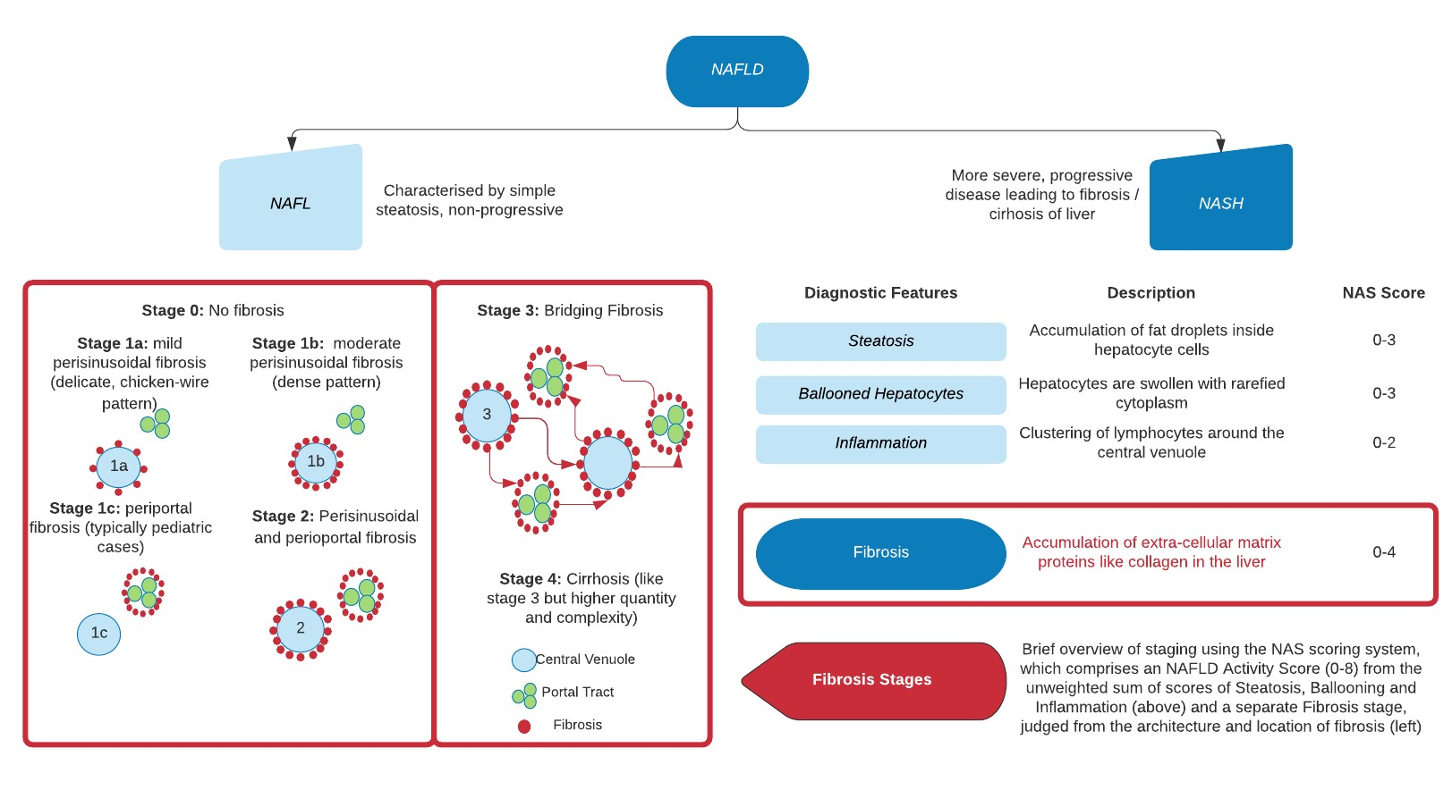
Figure 2.2: Key categories of NAFLD and diagnostic features relevant to staging.
There are many choices of stain, most commonly, Hematoxylin and Eosin (H&E), which stains nuclei blue and cytoplasm and fibrous tissue pink. H&E staining is used in almost all publicly available Histopathology datasets. A less commonly used stain is Sirius-Red. Sirius-Red is used more specifically to visualise collagen fibres. Under Sirius-Red staining, collagen is highlighted as red on a pale yellow background. This is of particular interest for analysis of fibrosis, where the complex pattern of collagen deposits are key to grading the severity of disease [6].
Once prepared, a pathologist will then analyse the slides under a microscope at various magnifications in order to make a diagnosis. This forms a basis for how the patient will be treated.

Challenges in Histopathology
One of the main challenges in traditional histopathology is the annotation cost, since the biopsy slides must be viewed under various magnifications by an expert pathologist. Secondly, the labelling of WSIs is subject to significant inter and intra-observer variability stemming from the subjective nature of the grading system. Inter-observer variability is where two independent pathologists review each specimen. Intra-observer variability is where the same pathologist re-scores each specimen.
The Kappa statistic is the proportion of agreement beyond that which would be expected by random chance given by Equation 2.1 and is used to determined the reliability of clinician’s diagnoses. For the simplest case of two pathologists (Clinician 1, Clinician 2) scoring the
same dataset for a binary task. A confusion matrix is constructed from their independent scores.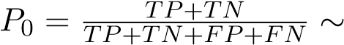accuracy and P_{c} is the random chance agreement.
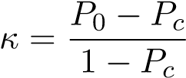 (2.1)
Davison et al [11], show that inter-reader unweighted kappas for fibrosis staging in NAFLD were around 0.310 from the scores of three hepatopathologists on 678 biopsies of NASH patients where P₀ = 50.93% and P_{c} = 28.91%. This would be regarded as modest to poor agreement (on a score of -1, total disagreement to 1 perfect agreement). Therefore, in order to quantify improvement in clinical trials on NAFLD, there is a strong need for fast and reproducible scoring of liver histopathology samples.
A supplemental concern in histopathology is the risk to the patient. Clinically significant bleeding occurs in 0.4% of cases and the mortality rate is 0.11% [6].

Digital Histopathology
In recent years, the field of digital histopathology has emerged, where traditional glass slides are scanned using a digital slide scanner to generate a whole slide image (WSI). Advances in slide scanning technology and reduction in the cost of digital storage have accelerated growth in the field [12]. Thus bringing forth the opportunity for Computer-Aided Diagnostic (CAD) tools ranging from traditional Machine Learning methods to Deep Learning.
Much like all fields in Machine Learning for Medical Imaging, pathology data suffers from small datasets with few annotations. However, due to the size of individual pathology images, this presents significant challenges in comparison to Ultrasound or MRI imaging. A WSI scanned at 40x magnification will produce an image file that is tens of gigapixels in size. Raw images cannot be directly inputted into a deep neural network and therefore, small, computationally manageable, ”tiles” or ”patches” must first be extracted from each WSI for training. A second challenge resides in a sparsity of annotations. Unlike datasets such as ImageNet, where crowd-sourcing of annotations can be used to reduce cost, histopathology datasets require extensive annotation by expert pathologists, therefore publicly available datasets are typically small (c. 400 WSIs e.g. CAMELYON16 [13]). Additionally, slides are not exhaustively annotated at a pixel level, but rather have labels either at a WSI-level or per tile in each WSI. Especially when dealing with WSI-level annotations, the learning signal is weak and this presents a key challenge for Machine Learning methods.
Depending on the institution at which the tissue samples were collected and which stain was used, the same features can have a significantly different appearance on each WSI. This presents additional challenges for CAD methods. The majority of publicly available datasets use H&E staining. However, each dataset is typically highly curated for a specific tissue type and task. Methods successful on these datasets may not necessarily transfer well directly to another dataset e.g. tumour diagnosis versus staging fibrosis hinge on very different characteristics. Intra-dataset stain variation is also a challenge. Depending on how long or how much stain is applied, there can be significant colour variations. This is discussed further in Section 4.3. Finally, artefacts commonly occur during slide preparation such as air bubbles, knife slicing irregularity, folds, cracks, and fixation problems. In addition, artefacts arise from digitisation such as blurring and striping. In each cohort there is likely only one or two examples of each and therefore, at inference, the learned information is not representative of slides that could be encountered in a clinical setting.
Specifically for analysis of Fibrosis in Sirius-Red stained WSIs, another challenge facing computational methods is the presence of natural collagen in the liver around the portal tracts and hepatic vein. Therefore, it could be challenging to distinguish between this and the fibrosis patterns that are being looked for. One of the few papers which analyse Sirius-Red stained WSIs by Forlano et al [14] utilise traditional machine learning methods and statistical analysis. The authors showed that there is significant overlap between the percentage area of collagen in a sample for different stages, emphasising that it is the structure and location of the fibrosis rather than simply the amount that is crucial. This indicates that Deep Learning, rather than traditional Machine Learning methods with manual feature extraction could be more appropriate for staging fibrosis.
Chapter 3

Deep Learning in Histopathology

3.1 Literature Review
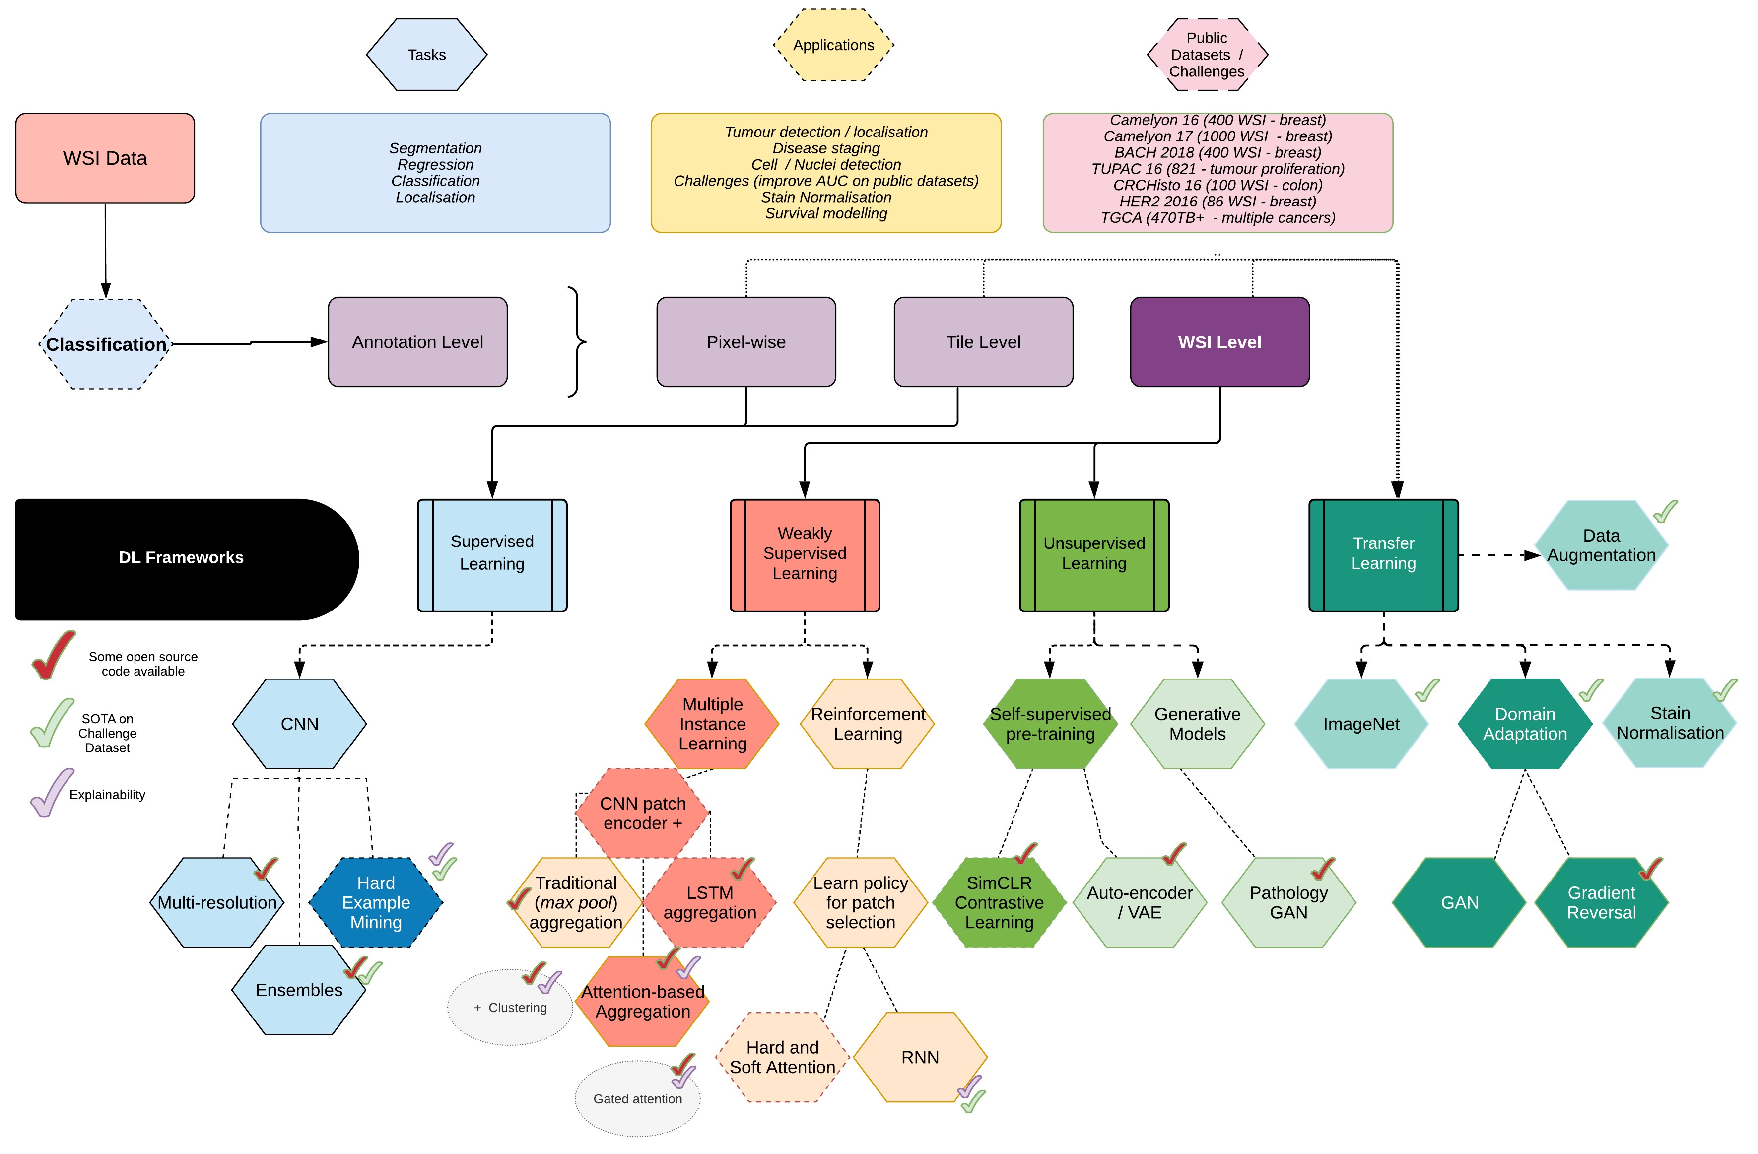
Figure 3.1: Overview of Deep Learning models in computational Histopathology.
A high-level summary of Deep Learning models in Digital Histopathology is shown in Figure
3.1. The field of research can be partitioned in several ways, for example, by tissue type (e.g. breast/colon/liver), task (e.g. classification/segmentation) , application (e.g. nuclei detection/disease grading/survival prediction) or Deep Learning framework (e.g. supervised/weakly supervised/unsupervised).
In supervised learning, we have a set of N training examples, each with a corresponding ground truth label. The goal is to train a model that predicts the label for an unseen test image by minimising a loss function via gradient descent optimisation. In weakly supervised learning, the labels available are coarse. Rather than having one ground truth label per image (patch of WSI), there instead is only one label per WSI for example (for multiple patches). The goal of the model is to infer the patch-level labels from the WSI-level labels available. The most common framework in this weakly labelled setting is Multiple Instance Learning (MIL). In a fully unsupervised learning framework, the goal is to learn patterns in the data rather than optimising a prediction based on a ground truth label. The unsupervised domain can be split roughly into representation learning, where images are transformed into a lower-dimensional subspace in which similar images are mapped to a similar location and generative modelling, where the distribution of image classes is learned based on similarities across the different samples. With generative models, the latent space is explainable through sampling to generate visualisations.
With the context of the FibLivPath dataset in mind, the focus hereinafter is on classification models and data with WSI labels only. The addition of other data sources such as medical reports or patient body mass index (BMI) information will not be considered. It is important to note some key similarities between datasets that commonly feature in the literature. Firstly, the majority are stained with Hematoxylin and Eosin (H&E), and secondly, the majority of detection tasks are related to the detection or staging of cancer. For example, the CAMELYON datasets [13, 15] are derived from lymph nodes of breast cancer patients for the detection and classification of breast cancer in WSI images; The Cancer Genome Atlas (TCGA) [16] database contains WSIs from various types of cancer. The BreaKHis [17] and BACH [18] datasets also focus on breast cancer tissue. There are several Grand Challenges based on public datasets, such as those just mentioned, in Histopathology. These are used as benchmarks upon which state-of-the-art results are reported, akin to the use of ImageNet in computer vision. However, it is important to note the potential lack of transferability of results to liver tissue stained with Sirius-Red.

3.1.1 Learning from Tile-Level Annotations
Traditionally, where patch-level annotation is available for WSIs, fully supervised Deep
Learning methods are applied to tackle whole-slide level classification tasks. As seen in Figure 3.2, each WSI is split into image patches (e.g. 100x100 pixels) with or without overlap. Patches containing mostly slide background are discarded. Patches are then passed through a CNN for classification, and can be re-constructed to display a probability map of disease in each area e.g. for classification tumour versus non-tumour. A summary of key approaches is detailed in Table 3.1.
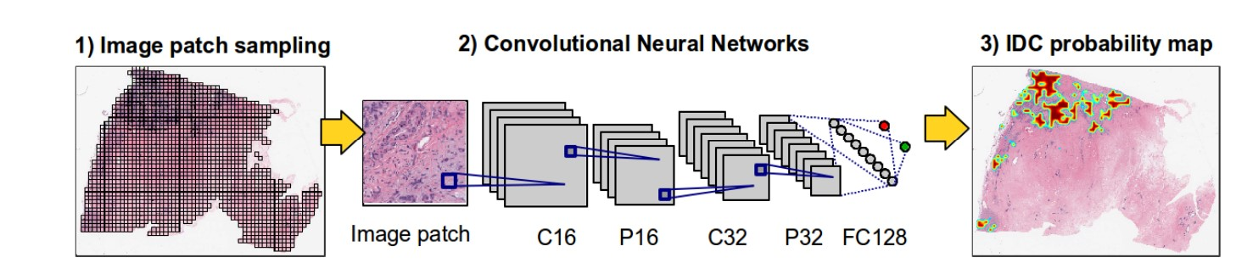
Figure 3.2: Traditional supervised learning framework from [19].

Key architectures
Typically, CNN architectures are used such as the VGGNet, InceptionNet, ResNet and MobileNet to train an end-to-end supervised patch-level classification pipeline [21, 12]. As in most supervised learning tasks, there has been shown to be benefit from ensembling of models for the task of classification. The winning entry of the CAMELYON16 challenge used an ensemble of two GoogleNet networks [13] and the subsequent CAMELYON17 challenge was won by an ensemble of three ResNet-101 networks [15]. In the 2017 challenge, five of the top twelve algorithms utilised ensembles. Three of the five used instances of the same architecture with different initialisation or aug-

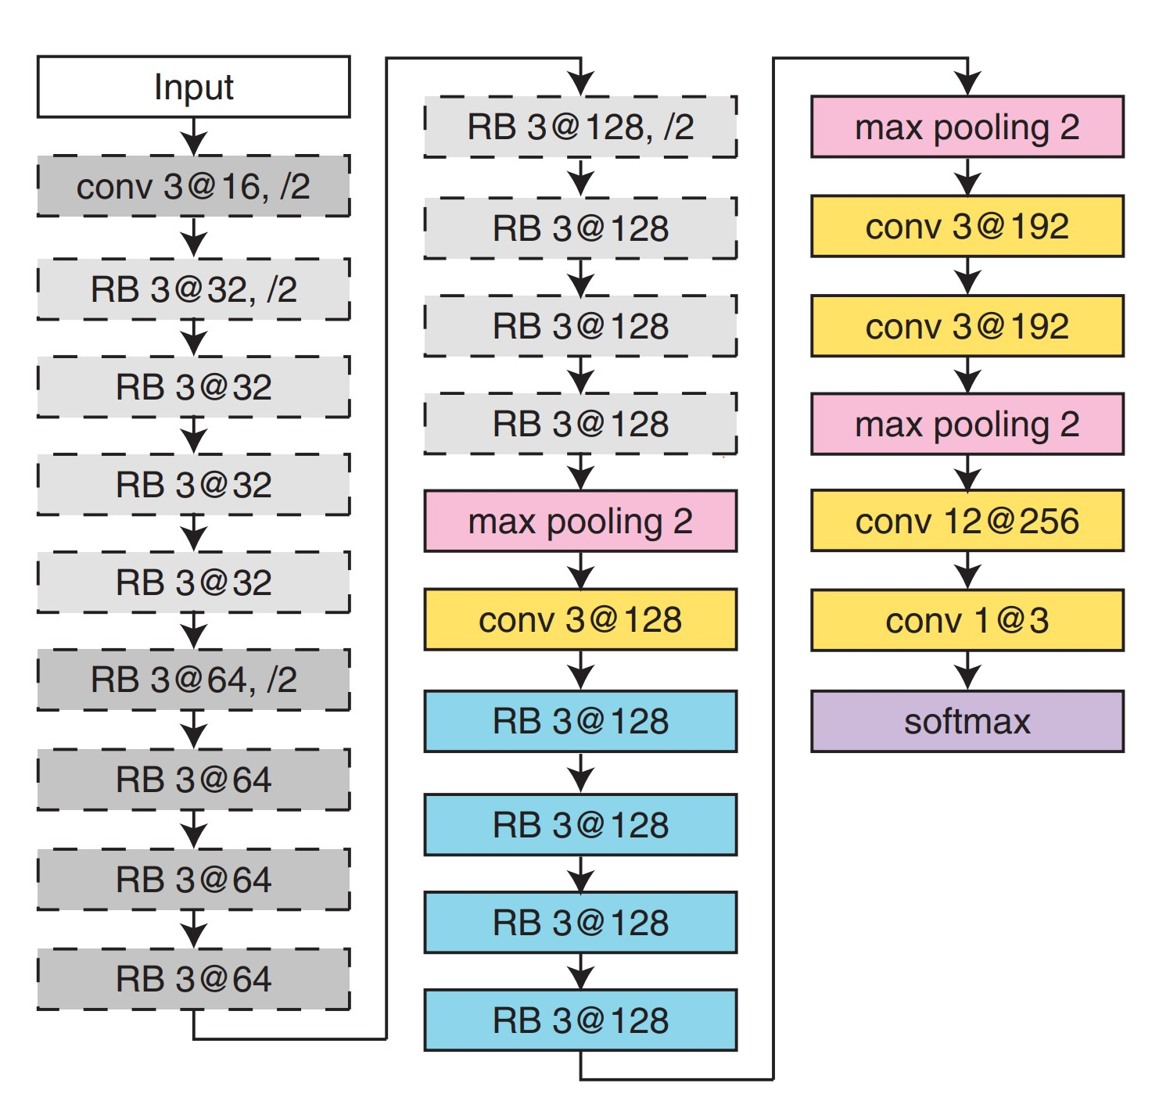
Figure 3.3: Cascade of CNNs from [20].

mentation settings, while the other two used different network architectures e.g combining two GoogLeNets and a ResNet-50.

Hard Example Mining
Hard example mining involves finding training examples for which the difference between the ground truth class and a classifier’s prediction is large and re-sampling from these to further train the classifier. This has been shown to be extremely effective in Histopathology for supervised classification tasks. Most notably, hard example mining was applied in [22] for the purpose of multi-class breast cancer WSI classification. The resulting framework won the ICIAR 2018 Grand Challenge by a large margin achieving an accuracy of 87% on Part A of the challenge (microscopy images) which was a 9% improvement over the state-of-the-art, and a score of 0.6929 on Part B of the challenge (WSI images), which was 0.14 above the second place entry. The authors’ hard example mining strategy consisted of first training an Inception-ResNet-V2 model on the Part A microscopy images. Subsequently, the Part B WSI images were tiled and the classifier was used to obtain predictions for each patch. The patches were then ranked by their ”difficulty”, defined as (ground truth class predicted class) × predicted probability. The classifier was then re-trained using the Part A microscopy images plus 40% of the most difficult patches from the WSI data subset. This hard-mining strategy contributed to the improved accuracy and convergence rate of the model. Hard example mining also featured in the successful cascade of CNNs trained by Bejnordi et al [20], which will be discussed presently.

Multi-Scale Processing
When a histopathologist analyses a WSI, they typically look across the whole slide at low resolution to identify regions of interest, and then analyse relevant tissue at high magnification. Thus combining the contextual understanding with the cell-level features. Bejnordi et al applied this concept to Histopathology by using a cascade of CNNs [20]. Firstly, a FCN (fully convolutional network) is trained to classify small patches (224x224) from the input image. Subsequently, the weights of this FCN are frozen. A second CNN is stacked atop it to form the final CAS-CNN architecture. This cascade of CNNs is subsequently trained on larger input patches (768x768) for multi-class classification, thereby increasing contextual area available while retaining detailed representations learned in the first step. The authors show that this cascade significantly outperforms the original FCN trained on only the smaller patches. The architecture used is shown in Figure 3.3.
Finally, Sirinkunwattana et al [23], conducted a study on the use of context in the segmentation of WSIs on two H&E stained datasets (Prostate, Breast). The authors concluded that architectures which integrated multi-scale features outperformed those which operated at a single resolution. In particular, the most successful architectures first encoded a single image patch at multiple resolutions, aggregated these feature vectors using an LSTM and finally classified the patch based on the multi-scale feature vector. The use of the LSTM unit improved resilience to noise and better captured dependencies across scales compared to models which aggregated using attention.
Table 3.1: Summary of papers conducting patch-wise supervised learning.
Paper | Dataset | Architecture and key params
[13] | 400 WSIs CAMELYON16, Breast, H&E | Challenge winners: pre-trained (ImageNet) GoogLeNet ensemble with stain normalisation
[15] | 1000 WSIs CAMELYON17, Breast, H&E | Challenge winners: pre-trained (ImageNet) ResNet-101 ensemble (x3) with HSV colour augmentation and flips
[20] | 221 WSIs, Breast, H&E | Stacked cascade of CNNs, multi-resolution architecture in Figure  3.3
[22] | 400 WSIs BACH2018, Breast, H&E | Inception-ResNet-V2, multi-resolution, hard example mining, HSV colour, affine and flips augmentation
[24] | 64 WSIs, Liver, H&E | Pre-trained (ImageNet) AlexNet model with affine data augmentation

3.1.2 Learning from WSI Level Annotations

Multiple Instance Learning
An overview of the Multiple Instance Learning (MIL) framework is described in Figure 3.4. The main variations between architectures across the domain stem from the aggregation methodology, which ranges from traditional max-pooling, to attention or recurrent-based aggregation. Traditionally, in a binary classification task for example, the WSI would be assigned the maximum value across the patch-level predictions. However, it was found that a simple, deterministic aggregation function lead to inferior performance in most cases [25] due to a weak learning signal from max-pooling. Furthermore, these methods were also not interpret able. Therefore, many papers have since proposed different aggregation methods to tackle this. A summary of key papers is reported in Table 3.3 and a comparison of aggregation methods is discussed in Table 3.2.
In 2018. Ilse et al proposed a gated attention mechanism for MIL [25]. For each instance in a bag, a CNN is used to obtain a low dimensional embedding and a gated attention mechanism (MLP-based) is applied to aggregate feature vectors. The authors compared gated attention to max and mean operators as well as simple, non-gated attention mechanisms. They discovered that their proposed gated mechanism was superior to max and mean aggregation and on-par with non-gated attention on the Breast and Colon cancer Histopathology dataset
Table 3.2: Advantages and disadvantages of instance aggregation methodologies [25, 26].
Aggregation | Formula | Advantages | Disadvantages
Max-Pooling (predictions) | Y = max_{k} {y_{k}} | No additional parameters | Weak learning signal, not explainable
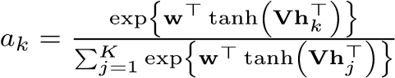
Simple z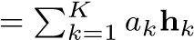 where: Explainable, Cannot model
Attentionlearnable complex functions (features)aggregation
Gated Stronger More parameters Attentionnon-linearity,
(features) |  | explainable
RNN-based  (features) | h_{i} = ReLU(W_{x}x_{i} + W_{h}h_{i}−₁ + b), Y = W_{y}h_{S} | Robust to noise | Not explainable

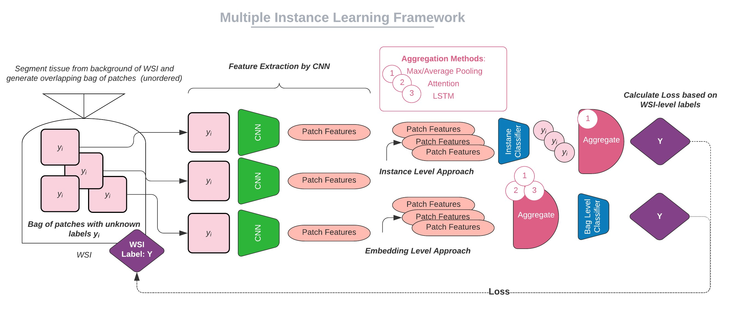
Figure 3.4: Overview of Multiple Instance Learning (MIL) frameworks.
used in terms of accuracy and F1 score.
In 2019, Li et al added to the attention-based MIL framework by incorporating hard negative mining (as first mentioned in Section 3.1.1) [28]. The authors considered a binary classification task. Bags of patches from each WSI were encoded using a CNN and the embeddings were aggregated using a fully connected network with learned attention weights. To ensure that the features of negative instances were well learned and reduce false positives, the model was re-trained using artificial bags of ’hard’ negative instances. These were constructed by looking across all bags with a false positive prediction and identifying the patches which have the highest attention weight in the bag, i.e. the patches which contributed most to the incorrect diagnosis result. New bags are constructed by sampling from these challenging negative examples. This framework outperformed that of Ilse et al [25] and achieved an AUC of 0.983% on the same Colon cancer dataset, setting a new state-of-the-art.
Another variant of attention-based MIL was proposed in 2019 [27], which incorporated patches at multiple resolutions. The proposed method incorporated a two stage pipeline, which is illustrated in Figure 3.5a.
The first stage is a binary classification task at low resolution and the second stage is multi-
Table 3.3: Summary of papers conducting Multiple Instance Learning and their advantages and disadvantages with respect to application on the FibLivPath dataset. B = methodology for MIL bag construction, T = data augmentation details, N = use of stain normalisation.
Paper | Dataset | Architecture | Key params | Advantages |  | Disadvantages
[25] | 58 WSI  Breast, 100  WSI Colon  Cancer, H&E | Gated-  Attention | - B: All patches > tissue threshold, • per WSI.  - T: H&E colour, rotate, flip •  - N: True |  | Explainable • heatmap Effective on small dataset |  | Binary task
[26] | 44k WSI, multicentre,  H&E | Step (1): Max-pool, Step (2):  RNN | - B: (1) All patches > tissue • threshold, (2) top-10 patches  ranked by step 1 •  - T: HSV colour, rotate, flip  - N: False  - Multi-scale (5x 10x 20x), class weighted loss |  | Uncurated, • diverse dataset Robust to  noise • |  | Performance drops for <  10k WSIs Trained on specialised compute  cluster
[27] | 3.5k WSI  Prostate,  H&E | Clusterbased attention | - B: All patches > tissue threshold, • per WSI (100-300)  - T: Rotate, flip •  - N: True  - p=0.5 instance dropout, 4  attention clusters, multi-scale (5x 10x) |  | Multi-class • task •  Dropout improves attention |  | Large dataset Attention maps not validated
[28] | 58 WSI  Breast, 100  WSI Colon  Cancer, H&E | Step (1): SimpleAttention, Step (2): hard negative mining | - B: (1) All patches > tissue • threshold, per WSI, (2) sample challenging patches pooled across • FP cases  - T: Rotate, flip  - N: True, histogram equalisation |  | Step (2) • reduces FP Improved convergence |  | Binary task
[29] | TGCA and  CAME-  LYON16,17, multicentre,  H&E | Multi-head attention instancelevel clustering | - B: All patches > tissue threshold, • per WSI  - T: None •  - N: False  • |  | Robust to • noise Multi-class task Effective on small dataset |  | Clustering assumes mutually exclusive classes
[30] | 15k Prostate  and Basal  Cell  Carcinoma,  H&E | K-means clustering & concatenation of centroid features | - B: 100 patches > tissue threshold, • per WSI  - T: None •  - N: False  - k=8 clusters, train on 8 feature vectors per WSI |  | Efficient to • compute Transferable to survival regression, classification |  | Small datasets may need  additional annotations
class classification at higher resolution. In the first stage, a CNN (VGG-11) is applied to low resolution patches (5x) for feature extraction followed by PCA to reduce dimensionality of the embeddings. K-means clustering is applied to the latent representations to identify similar patches within the WSI. Each cluster is assigned an attention score (using MLP attention), based on its importance for the binary classification task, thus localising the most informative tiles in the WSI. For the second stage of the pipeline, these informative tiles are re-sampled at a higher resolution (10x). The sampled tiles are applied to a more challenging multi-class (3-class) final classification problem (using a very similar CNN-based pipeline as stage 1).
Results showed that the multi-resolution pipeline and the clustering attention contributed to significant improvement (+5% in accuracy) versus the attention method proposed by Ilse et al [25], achieving an accuracy of 85.11% on the 3-class prostate cancer grading task. Additionally, they showed that using instance level dropout (hiding random image patches during training) improved the diversity of patches attended to (per Singh and Lee 2017, [31]). Li et al also explored the impact of Transfer Learning from a small, finely annotated WSI dataset to pre-train the VGG-11 feature extractor used but found little improvement in accuracy.
Campanella et al [26] undertook an extremely interesting study in 2019. The authors achieved an AUC above 0.98 in detecting four types of cancers on an extensive, uncurated dataset of 44,732 WSIs, showing extremely strong generalisation performance. Artefacts such as bubbles, folds etc. were not removed from the dataset. Therefore, the model performance is a true test of the real-world applicability of the framework. The training pipeline is shown in Figure 3.5b. Step 1 trained a classifier (ResNet-34) using traditional MIL, where all slides were tiled and a bag of instances was constructed per WSI (with labels 0, 1). Step 2 consisted of an inference pass of all the data through the trained classifier from Step 1, followed by ranking of the N most interesting tiles in each bag (the ones with ’highest’ probability of correct label). The N top ranked tiles were identified, and their feature representations were treated as sequence of data and passed into an RNN. The final hidden state (at the N’th ”time” step) was passed through an output linear layer to get the final WSI binary prediction. The authors also investigated integrating multiple resolutions, but did not find improvement over the best performing single resolution model. The authors’ results are comparable to patch-wise supervised learning after training with only slide-level labels, and the results would have won the CAMELYON16 classification challenge. Applying this model could allow a pathologist to exclude 65-75% of data while maintaining 100% sensitivity [26].
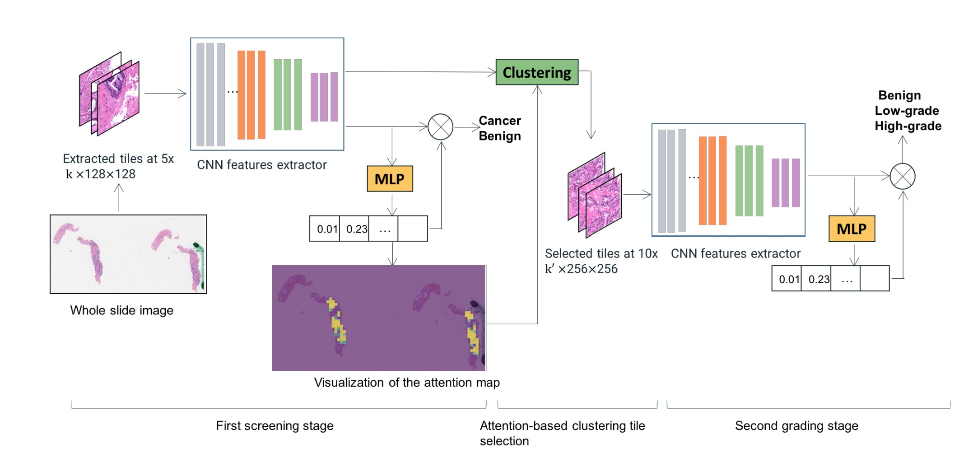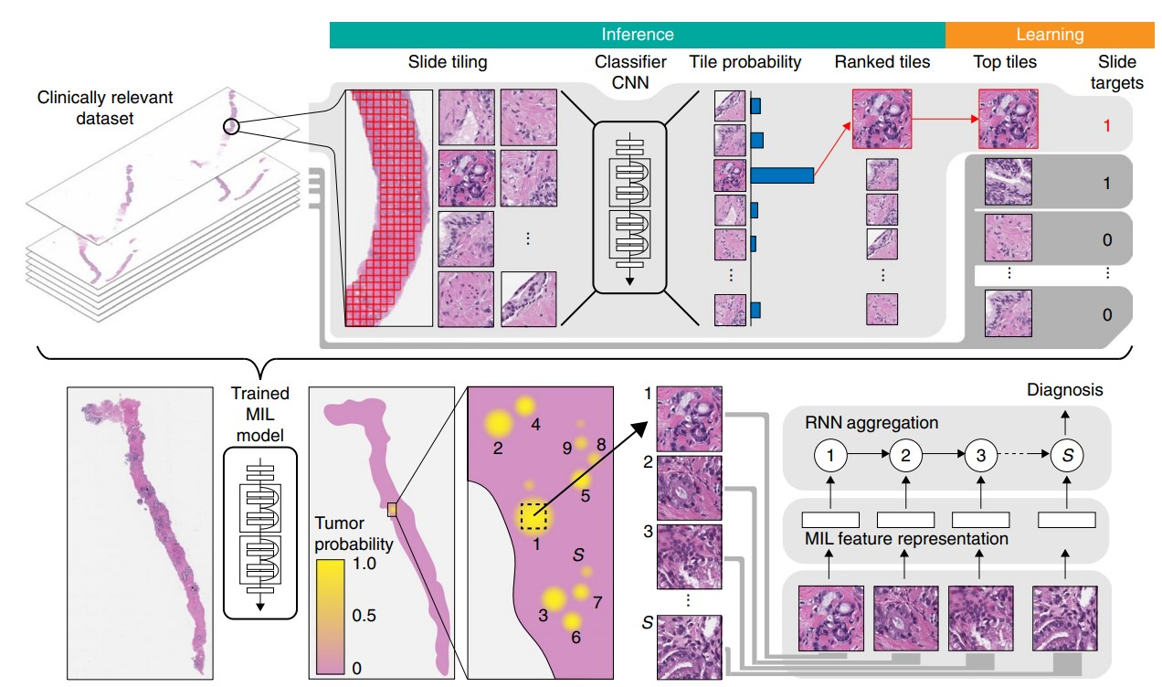
(a) (b)
Figure 3.5: (a) Multi-resolution, cluster-based attention aggregation framework from [27]. (b) MIL framework by Campanella et al from [26].
Xie et al [30] proposed a framework called End2End Part Learning (EPL). All tiles in the WSI dataset were encoded into feature space and mapped to k global centroids (k ”parts”). Thus aggregating tiles with similar features. Only the tiles closest to each cluster centroid were subsequently used for Multiple Instance Learning, rather than randomly sampling tiles from the WSI to generate a bag of instances of size k. The features from the k tiles were concatenated and passed to a classifier for WSI level prediction. A joint objective function was used to firstly minimise cross-entropy loss with respect to the predicted WSI label and secondly to minimise the MSE loss between each cluster centroid and the features of tiles assigned to that cluster. Results of this model were compared directly to that of Campanella et al [26]. The EPL framework was able to achieve comparable results to a max-pooling-based MIL framework, achieving an AUC of 0.986 on Prostate and Basal Cell Carcinoma (BCC) classification datasets. However, the method underperformed that of Campanella et al [26] which achieved AUCs of 0.991 and 0.988 on the Prostate and BCC classification tasks using the MIL-RNN framework.
A more data-efficient approach to MIL was proposed in 2020 by Lu et al [29]. The Clusteringconstrained Attention Multiple Instance Learning (CLAM) pipeline extracted patches from the tissue regions of each WSI and encoded each patch using pre-trained ResNet-50 (ImageNet). For multi-class classification, n parallel attention branches are applied to each WSI bag. The score from each branch is interpreted as evidence for one of the classes. The key differences to Ilse et al’s attention-based MIL are the extension to multi-class problems, and the introduction of additional supervision from a clustering layer which encourages each class representation to be linearly separable from the others in feature space. Furthermore, the authors demonstrated the pipeline could achieve reasonable performance as dataset size was reduced. The instance level clustering approach is based on the assumption that the n classes are mutually exclusive (which is the case for most cancer subtypes). However, in NAFLD, as described by Forlano et al [14], there is significant overlap between the different Fibrosis stages and therefore, characteristic features of each class are not mutually exclusive and application of clustering to NAFLD staging may not improve performance.

Sequential Tile Sampling
Table 3.4: Summary of papers conducting Sequential Weakly Supervised Learning and their advantages and disadvantages with respect to application on the FibLivPath dataset.
Paper | Dataset | Architecture and Key params | Advantages Di |  | sadvantages
[32] | 400 WSI  CAMELYON16,  Breast, H&E | - CNN + Recurrent visual • attention (3 ’time’ steps) per Figure 3.6a  - Sequence of attended features aggregated via single linear layer to get slide-level prediction |  | Efficient, few locations • processed per WSI | Simple attention aggregation cannot model complex functions
[33] | 172 WSI  HER2,  Breast, H&E | - ResNet + RNN per •  Figure 3.6b. Attended 6 • patches per WSI  - Multi-scale (40x and 20x patches, plus 16x downsampled WSI image for context)  - Applied random rotations, flips |  | Explainable •  Scalable to large tile size from WSI | Stores uncompressed representation of all tiles from WSI in memory (c. 56Gb estimate)
[34], [35] | 7,909 images BreaKHis,  Breast, H&E | - Hard attention + LSTM • for selection of 5 regions  in WSI •  - Soft attention mask • applied to feature maps for classification of selected regions  - Applied random rotation, flips |  | Suitable for smaller • datasets Fast inference Explainable soft-attention heatmap | Complex architecture and training procedure
While Multiple Instance Learning randomly samples a WSI to generate unordered bags of instances with a single bag label, the second prominent class of methods treat the sampling of tiles from a WSI as a sequential one. In 2018, BenTaib et al [32] proposed a recurrent spatial attention mechanism (Figure 3.6a). At each timestep, the location of the next patch to be sampled is predicted by the recurrent model. Given a sequence of selected patches, an
MLP combines their feature representations (obtained using a CNN) and predicts a probabilistic score for the slide level label. The system is trained by minimising a joint loss function. The first component of the loss function comprises the slide-level classification loss (cross entropy) and the second is a patch-level classification loss which uses the WSI level label as a proxy (noisy) ground truth for each patch. There are also two regularisation terms, the first encourages the network to favour patches which result in high prediction probabilities and the second enforces large distances between successive predictive centres. The network is optimised using gradient descent. The results of this model on the
CAMELYON16 dataset gave an AUC of only 1% lower than winners of challenge [13], using only slide-level (rather than patch-level) labels.
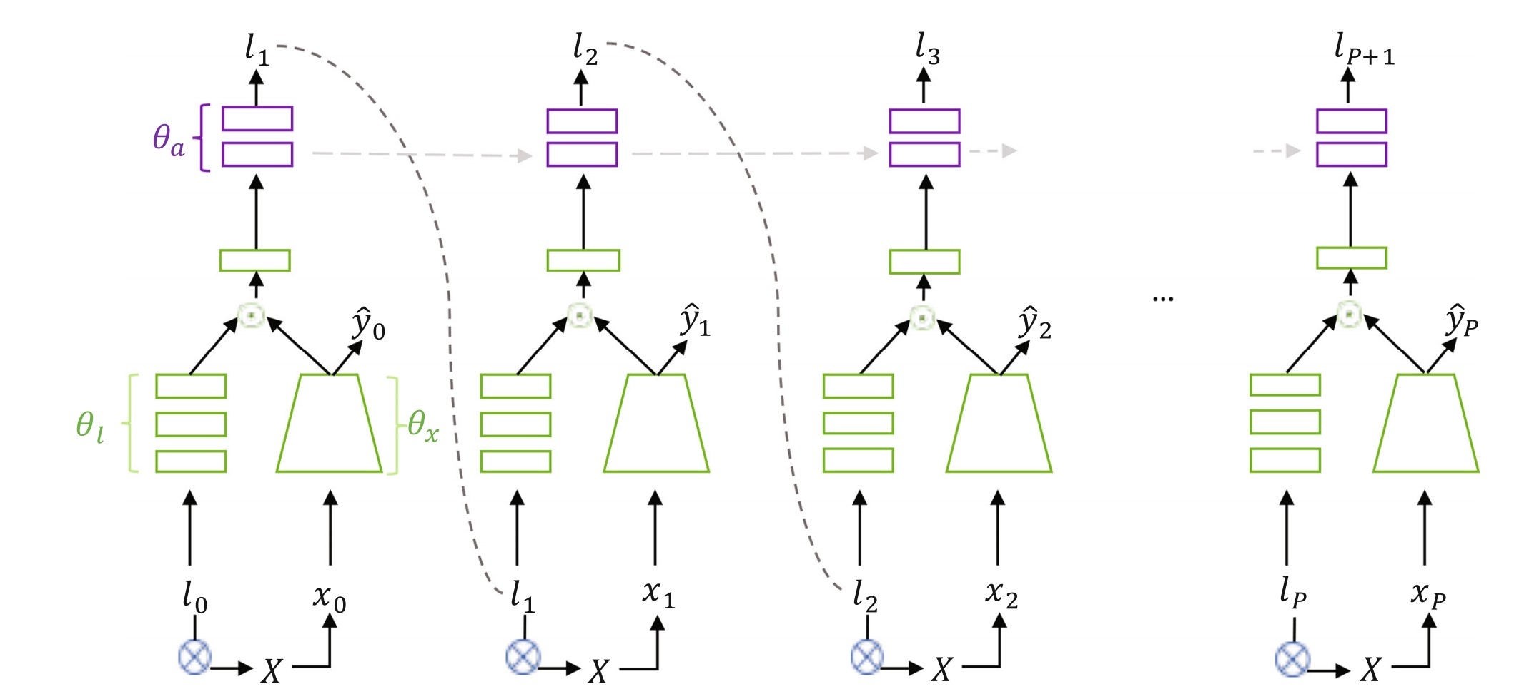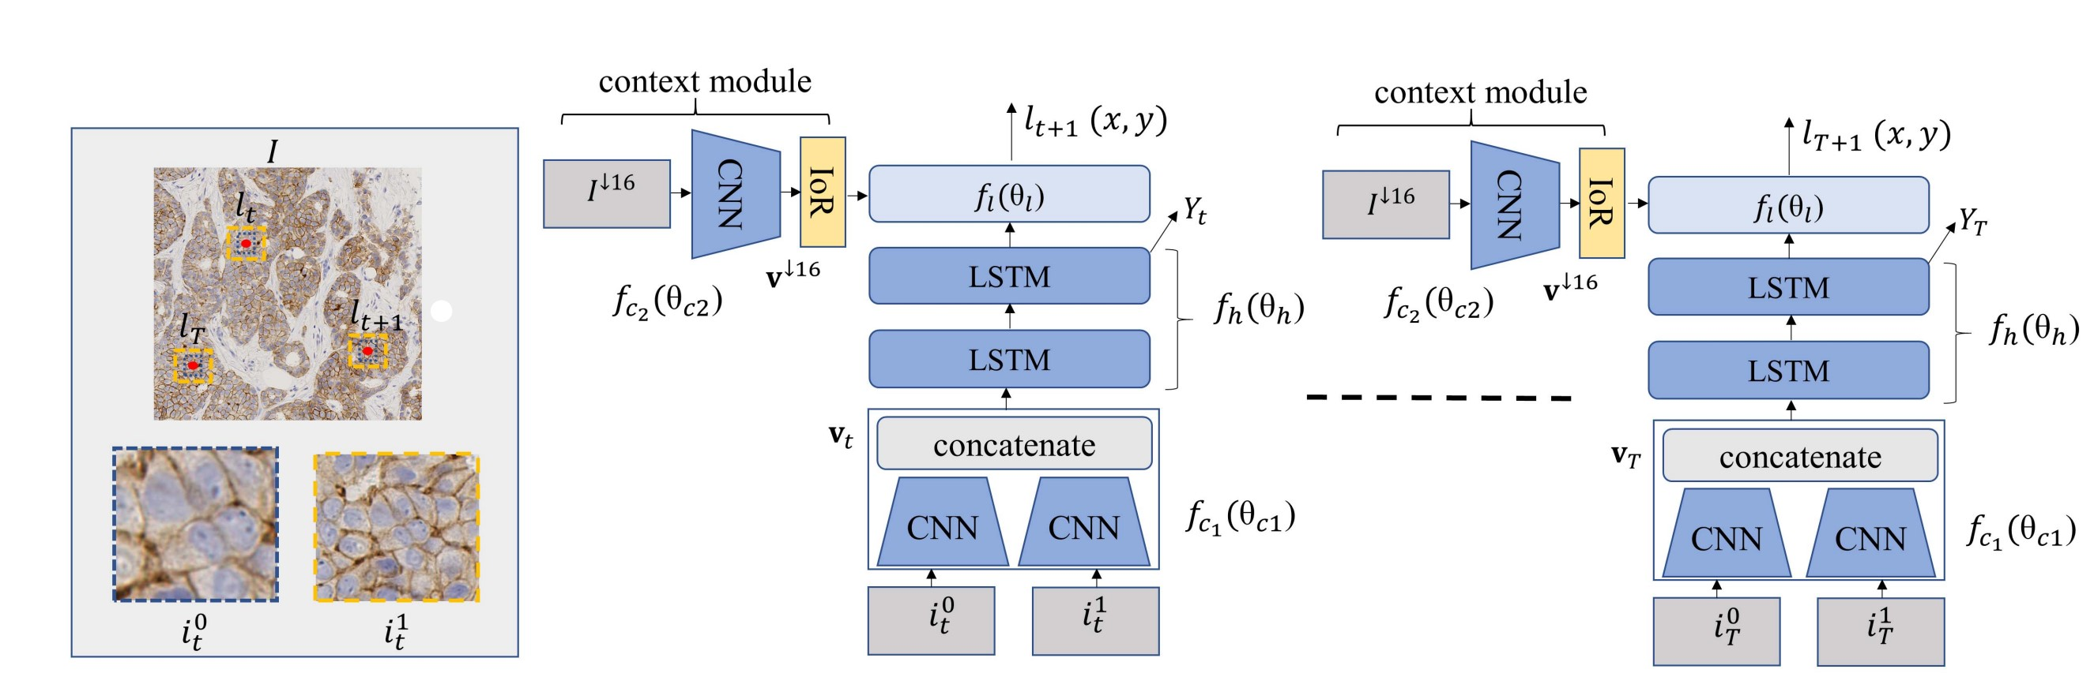
(a) (b)
Figure 3.6: (a) Recurrent visual attention model from [32]. (b) Recurrent, multi-scale model from [33].
Quaiser and Rajpoot [33] applied a similar recurrent selection method in 2019, however, rather than training through backpropagation and stochastic gradient descent as in [32], they applied a deep reinforcement learning framework for optimisation. Similarly to [32], a recurrent network is used to sequentially analyse features (encoded by a ResNet) and predict both a class label for the WSI and the next location for patch selection (Figure 3.6b). The authors include an ’inhibition of return’ penalty in the loss function to encourage model to attend to non-overlapping diagnostically relevant regions. More emphasis is applied on incorporating context into predictions by using multi-resolution ROIs around central location at 20x and 40x resolution and also a combining information from a 16x sub-sampled coarse representation of the whole input image. The framework outperformed state-of-theart methods on the HER2 Challenge contest [36] for scoring of breast cancer tissue WSIs.
Finally, in 2019-2020 Xu et al [34, 35] proposed another method that combines recurrent and attention-based models utilising both hard and soft attention. The framework uses two components. Firstly, a hard-attention-based DeNet which includes an LSTM to iteratively select patches from WSI and decide whether or not these should be classified. The second component is the SaNet which is a soft-attention-based classifcation model. The two networks are trained simultaneously using a combination of gradient descent with crossentropy loss for the SaNet and RL policy gradients (with a baseline) for training the DeNet as the hard-attention mechanism is non-differentiable. Compared to the author’s previous model in 2019 [35], this framework reduces the number of patches that the classifier is trained on to only those that will improve its discriminative power, rather than all ’discriminative’ patches themselves. This is akin to training on hard examples as described in [22], [28] and discussed in Section 3.1.1. This proposed method leads to more stable training and higher accuracy than [35] on the BreaKHis dataset.

3.1.3 Learning without Annotations
In Histopathology, and other domains where the annotation cost is high, there is a vast quantity of unlabelled data, therefore, the value-add from successful utilisation of this data could be significant. The unsupervised frameworks below are an alternative to traditional Transfer Learning from natural image datasets described in Section 3.1.4 below. Typically, in Histopathology, there are two main ways of utilising unlabelled data. The first pathway uses self-supervised learning to pre-train a patch-wise encoder and subsequently conducts task-specific supervised fine-tuning. The second pathway utilises generative models to learn the data distribution. Methods explored include the use of auto-encoders, variational autoencoders, generative adversarial networks and contrastive representation learning. A summary of key approaches is detailed in Table 3.5.

Representation Learning
The concept of pre-training models on a large unlabelled dataset and subsequently finetuning for a specific task on a smaller labelled dataset was popularised in Natural Language Processing with transformer-based models such as BERT and T5 [37, 38]. A large, unlabelled body of text is passed into the models, which learn high-quality word representations by training on hand crafted auxiliary tasks. In BERT for example, pre-training is conducted using two such tasks. Firstly, randomly masking 15% of input words and predicting what the masked word should be in the context of the sentence given and secondly looking at two sentences together and predicting whether the second sentence actually proceeds the first or whether an unrelated sentence has been substituted. Therefore, the original unsupervised learning problem has been transformed into a supervised learning problem using surrogate labels from the unlabelled dataset. Similar concepts have been applied in computer vision, typically to tasks-based on the ImageNet dataset which have shown that pre-training on unlabelled image datasets can lead to improved downstream performance on supervised learning tasks [39, 40, 41]. In Histopathology specifically, there is growing interest in the area due to the extremely prohibitive annotation costs.
Contrastive Learning:
Gildenblat et al [42] apply self-supervised pre-training on the CAMELYON16 dataset with the end goal of performing an image-retrieval task to identify tumour areas within a WSI. The authors construct a self-supervised pre-training task that exploits the inherent spatial continuity within a Histopathology image, i.e. that neighboring tissue patches are likely more similar in appearance than distant tissue pathches in a WSI. Therefore, pairs of similar and non-similar patches are automatically generated based on their spatial proximity within the slide (L2 distance). A Siamese architecture is used for training. This consists of two identical instances of the same model, which share all weights and parameters. The architecture operates on pairs of input patches. One image is fed to each network simultaneously, the similarity of the feature outputs is computed (L2 difference between output vectors). A contrastive loss function is used for training pairs of images per Equation 3.1.
Lcontrastive (3.1)
where f_{i} are the outputs of the siamese networks and y is the ground truth label 1 if the inputs are similar (difference less than threshold m) or 0 if the inputs are dissimilar. The authors compared performance on the downstream tumour retrieval task between a ResNet-50 pre-trained on ImageNet versus pre-training on the unlabelled dataset itself using the above methodology. Training was conducted for for 24hrs using 8 V100 GPUs. The results showed that the self-supervised pre-training outperformed the ImageNet pre-trained model by 8% in terms of the ratio of correctly retrieved tumour tiles.
Tellez et al (2018) conducted a study using the CAMELYON16 dataset, using three different convolutional architectures for unsupervised pre-training. Subsequently, the featureextractor was frozen and applied to both a weakly supervised learning task for WSI-level binary classification (tumour / no tumour) and a patch-level classification task. The best performing architecture utilised a contrastive loss function and used a 5-layer convolutional encoder. Much like for [42], an artificial training set was constructed. The positive example pairs were with two different augmentations applied to the same patch from a WSI, and the negative example pairs were patches from a) completely different locations within a WSI and b) neighboring, non-overlapping patches. The use of strong data augmentation encouraged the encoder to learn abstract features, which lead to improved downstream performance. However, it is important to note that the architecture under-performed an equivalent encoder architecture trained in a fully supervised fashion by more than 6% [43] in terms of area under ROC curve.
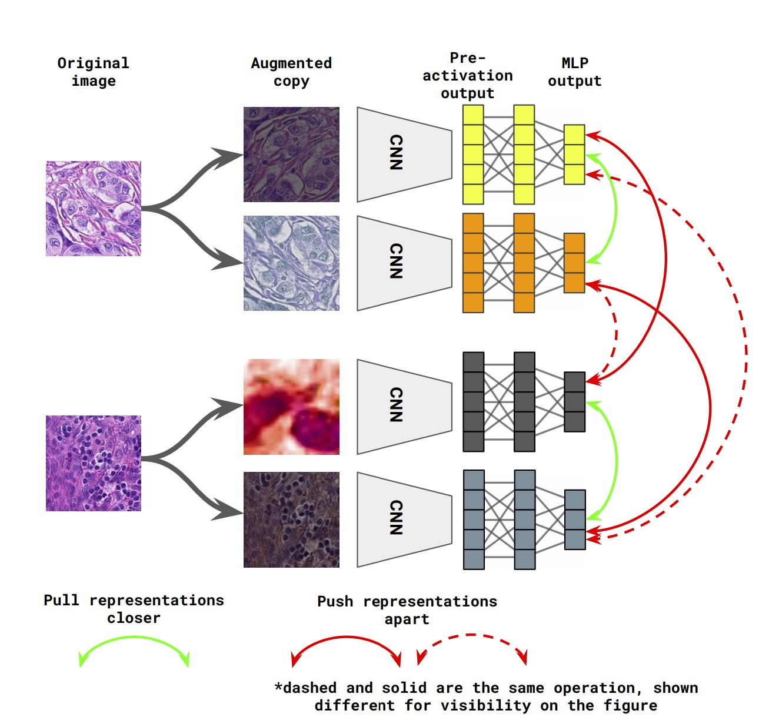
Another framework based on the contrastive loss function that has been applied to Histopathology is SimCLR, a ”Simple framework for Contrastive Representation Learning”, which was published in July 2020 and has since received over 900 citations after the authors achieved 85.8% top-5 accuracy on ImageNet using only 1% of the labels in the ImageNet, ie. outperforming a fully supervised AlexNet model with 100x fewer labels. Ciga et al [44] subsequently applied this framework to Histopathology images, as shown in Figure 3.7. The backbone of the architecture in [44] is a ResNet18 with an MLP projection layer on top. The network is trained to maximise agreement between feature representations of two different stochastically augmented views of the same underlying image using a normalised Figure 3.7: SimCLR architecture [44].
temperature scaled cross-entropy loss per Equation 3.2.
`i,j = −log ^{P}2kN=1 exp(sim(1_{[k}6_{=i]} exp(sim(zi,zj)z/τ_{i},z) _{k})/τ) (3.2)
where z_{i}, z_{j} are a correlated example, i.e. views of the same image and z_{k} are data points which are dissimilar. N is the batch size used, therefore there are N pairs of images to be considered (2N in total). The similarity measure used sim() is dot product similarity and τ is a hyperparameter to be optimised.
The data augmentations were ascertained through an ablation study and were a combination of randomly resized crops, 90◦ rotations, flips, colour jittering and gaussian blurring. The pre-training was conducted across 60 datasets with different organs and staining, and the model was trained for 24 hrs on 4 Tesla P100 GPUs for 1000 epochs.
The authors tested the pre-trained models on a variety of downstream tasks (5 classification, 3 segmentation and 1 regression dataset including patch-CAMELYON, BACH, BreaKHis). They conducted an extensive comparison between their model (SimCLR trained ResNet-18) and randomly initialised and ImageNet pre-trained ResNets 18, 34, 50 and 101. They trained both with full network fine-tuning and using a frozen encoder for the downstream task. Overall, for the classification and regression tasks, self-supervised pre-training outperformed ImageNet, however, the reverse was true for segmentation tasks. The authors showed as much as a 7.5% increase in accuracy on downstream supervised classification tasks after pretraining a ResNet-18 using the SimCLR methodology. Some of the more notable conclusions from [44] are as follows. Firstly, that using stronger augmentation and a more diverse set of stains, tissue types during pre-training incentives the convolutional network to learn richer representations. Secondly that self-supervised pre-training was found to be most beneficial for downstream tasks with limited labelled data available.
The advantage of this framework relative to that in [42, 43] is that it does not rely on any human-engineered auxiliary task, which could have flaws, for example, the task designed in [42] is based on the tissue continuity assumption in a WSI, and this may not always hold for adjacent patches, thereby disrupting the learning signal. Additionally, the SimCLR framework is simple and easy to use, there is no initial dataset construction step required and the results obtained are comparable to fully supervised training. Furthermore, the pre-trained model weights for the ResNet-18 encoder trained by Ciga et al are publicly available. The authors did not explore the SimCLRv2 framework [45], given its significantly higher parameter count relative to the improvement demonstrated on ImageNet. An interesting avenue of exploration could be the more recent unsupervised learning frameworks such as SEER [40], or SwAV [41], given the strong transferability of SimCLR to the medical domain that was evidenced here.
Encoder-Decoder Architectures:
Another subset of unsupervised methods focuses on Encoder-Decoder architectures for representation learning. As mentioned above, Tellez et al [43] explored various unsupervised training methodologies. While the best architecture was based on minimisation of a contrastive loss function, the other two architectures tested were based on reconstruction loss. The first architecuture was a 5-layer Convolutional Auto-encoder (CAE), where the goal was to reconstruct each input patch and minimise the MSE loss between the original and reconstructed image. The second architecture was a very similar Variational Auto-encoder, trained using both reconstruction loss and KL divergence. After pre-training, the frozen encoder was applied to the CAMELYON16 dataset for downstream classification tasks. The two architectures showed comparative performance to the aforementioned contrastive architecture on the downstream patch-level classification task, and slightly underperformed the contrastive framework by up to 2% on the WSI level weakly supervised binary classification task. The authors attributed this to the fact that the reconstruction loss did not encourage learning of abstract features relative as much as the contrastive loss function did.
Encoder-Decoder-based frameworks were also used in [46, 47]. Muhammad et al used a Deep Clustering Convolutional Auto-encoder for survival modelling on WSI images from patients with liver cancer. The authors applied a ResNet-18 encoder with a 5-convolutional layer decoder. They trained on unlabelled patches using a reconstruction-clustering loss.
This loss function enforces clustering of samples with similar morphology in the latent space. The authors subsequently treat the clusters formed as sub-types of cancer and use this to train a survival model. The generalisibility of this methodology to a classification task is not proven. However, there is potential applicability due to the parallels that can be drawn to the performance of the model in [30] (End2End Part Learning) described in Section 3.1.2 on weakly supervised learning. Hou et al [47], also apply an Encoder-Decoder architecture for representation learning, however, it is very specific to nucleus detection on a WSI slide and therefore likely will not generalise well to other tasks.
Self-supervised learning on CT Images:
While not on Histopathology images, Jana and Qu (2021) conducted unsupervised learning on CT images for NALFD classification [48]. Their pre-text task was context restoration. The goal was restoration of corrupted image that was created by swapping around a number of patches in original image. The network was trained using a reconstruction and an adversarial loss. This self-supervision task lead to better learning due to understanding neighborhood of pixels and learning texture specific features of disease. It was suitable for a small dataset (in the CT form).

Generative Models
The use of generative adversarial networks (GANs) [49] is relatively nascent in the field of Histopathology. Some papers use GANs for colour transfer and stain and normalisation [50], some for generation of tissue samples [51, 52] and they are also used for a few very specific tasks such as learning representations of cells [53] from very small patches of WSIs.
For the purpose of a downstream classification tasks, GAN related architectures can be used to learn representations of different tissue morphology and sub-types. Generative models have an advantage over the self-supervised methods mentioned in Section 3.1.3 in terms of explainability. The Generator in a GAN model learns to transform a noise vector into image samples that mimic the true data distribution, therefore interpretable visual representations can be generated from the latent space learned to assist with physician understanding.
Hu et al [53] proposed an architecture which based on the InfoGAN, to learn cell representations in an unsupervised manner from small patches extract from a WSI. After training their GAN architecture, the authors apply the model to calculate the proportion of each type of cell in a given WSI and thereby classify at a WSI level using an SVM or k-means. While this paper is very specific to learning cell-level representations rather than broader features, the idea of applying an InfoGAN style architecture is intriguing for practical downstream classification tasks.
The original GAN architecture passes a noise vector into the Generator, which outputs an image. Simultaneously, the Discriminator aims to distinguish between samples from the true data distribution and the fake images produced by the Generator. The architecture is trained using an adversarial, minmax, loss function per Equation 3.3.
minmaxV (D,G) = Ex_{∼Pdata} [logD(x)] + Ez_{∼ noise} [log(1 − D(G(z)))] (3.3)
G D
In this formulation however, there is no restriction on the latent noise space. Therefore, it is likely that two noise vectors which are very close to one another in the latent space will result in significantly different images produced by the Generator. The InfoGAN [54], combats this by feeding the Generator a concatenation of the noise vector and a latent code c which will represent some structured semantic features of the data e.g. on the MNIST dataset, 10 categorical vectors can be used to represent the 10 different classes in the dataset. Thus, the aim would be that if we cycled through the categorical vectors, with the noise vector z remaining fixed, images of each of the different classes would be produced in turn. To ensure that the GAN uses the information provided in the latent code, the loss function is amended to maximise the mutual information between the codes and the Generator distribution G(z,c), i.e that a large amount of information is learned about the generated image G(z,c) from the code c. The minmax objective function is therefore amended to include the mutual information, I(c;G(z,c)) per Equation 3.4.
minmaxV_{I}(D,G) = V (D,G) − λI(c;G(z,c)) (3.4)
G D
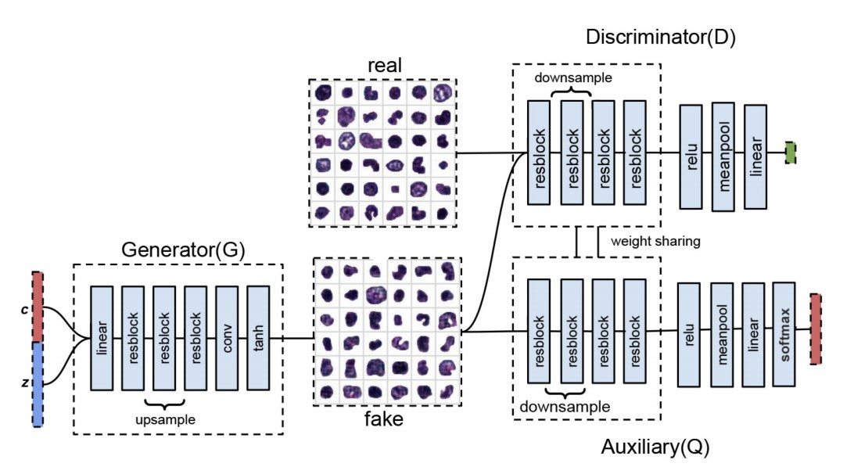
This is implemented by adding a third Auxiliary neural network, Q, which is tasked with predicting the latent code from the generated image G(z,c). In addition to the Discriminator (D) which predicts whether the image G(z,c) is real or fake. The auxiliary network Q shares all convolutional layers with D thus minimising additional computation required. A diagram of the training set-up is shown in Figure 3.8. Once the training has converged, the trained auxiliary network Q can be used as a classifier to predict the latent code of an unseen real test image, thus clustering the test data in an unsupervised manner. The semantic meaning of each category can be identified by generating an image for each latent code using the trained Generator. Thus producing a highly interpretable classifier.
However, like all GAN architectures, the
models are notoriously unstable to train, Figure 3.8: InfoGAN training framework from hence why the traditional InfoGAN archi- [53].
tecture in [53] was amended to use the
Wasserstein-GAN with gradient penalty (WGAN-GP) loss function which uses the ”Earth movers distance” between two probability distributions rather than a binary cross entropy loss function in the traditional DCGAN architecture for the Discriminator to provide a continuous, and more informative learning signal.
Another GAN related implementation in Histopathology is Pathology GAN [52]. In this paper, the authors trained the GAN on H&E stained WSI images of breast and colorectal cancer tissue. Their pipeline utilised the BigGAN [55] and StyleGAN [56] architectures to ensure once again that the latent space is semantically meaningful. The authors successfully managed to generate high quality images such that pathologists could not reliably distinguish whether the slide presented to them was real or fake. The authors envision that PathologyGAN could be used as an educational tool or to generate synthetic examples of different classes of tissue to artificially increase the size of a training set and boost classifier performance. However, at this early stage, the main focus of the research is to display high fidelity synthetic images. In a similar way to the InfoGAN discussed above, the trained PathologyGAN architecture, which is available open source, could be used to cluster test images by their latent codes and thus act as an unsupervised classifier with interpretable clusters.
Table 3.5: Summary of papers conducting Unsupervised Learning and their advantages and disadvantages with respect to application on the FibLivPath dataset.
Paper | Dataset | Architecture and Key params | Advantages Di |  | sadvantages
[42] | 400 WSI CAMELYON16,  Breast, H&E | - Contrastive loss •  (adjacent /  non-adjacent patches) •  - Resnet-50 |  | WSI-specific • pre-training  Outperforms •  ImageNet | Dataset construction required Harder to learn abstract features
[43] | 400 WSI CAMELYON16,  Breast, H&E | - Contrastive loss •  (patch with different  transformations)  - 5-layer CNN • |  | Augmentation • encourages abstract feature learning  Outperformed CAE, VAE (reconstruction  loss) | Underperformed fully supervised training
[44] | 60k datasets, multi-organ, H&E | - Contrastive loss •  (SimCLR)  - ResNet-18 + 2-layer  MLP projection head •  • |  | Augmentation • encourages abstract feature learning  Outperforms ImageNet  Simple training setup | Best results with large, diverse datasets
[46] | 246 WSI, Liver, H&E | - Reconstruction- • clustering loss  - ResNet-18 encoder,  5-layer CNN decoder |  | Clustering yields • interpretable latent space | Applied to survival modelling
[47] | 400 WSI, TGCA, lung,  H&E | - Reconstruction loss •  - Sparse CAE |  | Strong performance • on nuclei detection | Unlikely to generalise to other tasks
[53] | c. 150 WSI multi-centre, bone marrow, H&E | - Adversarial loss •  - InfoGAN  • |  | Interpretable • visualisations  Small training cohort | Specific to cell representations
[52] | c. 300k patches, multi-centre, colon + breast,H&E | - Adversarial loss •  - BigGAN, StyleGAN |  | Interpretable • visualisations | Designed for FID score not classification

3.1.4 Transfer Learning
Transfer Learning, either from natural image datasets such as ImageNet, or from pre-training on diverse Histopathology datasets is widely used and found to perform better than full training on a single dataset alone. Pan and Yang [57] define Transfer Learning as: ”Given a source domain D_{s} and a corresponding learning task T_{s}, a target domain D_{t} and learning task T_{t}, Transfer Learning aims to help improve the learning of the target predictive function f_{t}(·) in D_{t} using the knowledge in D_{s} and T_{s} where D_{s} 6= D_{t} or T_{s} =6 T_{t}”. They further distinguish between Inductive and Transductive Transfer Learning. Inductive Transfer Learning is where the source and target domain are the same but the source and target tasks are different (but related), and Transductive Transfer Learning where the source and target domains are different but related, however the source and target tasks are the same. One could argue that the self-supervised representation learning covered in Section 3.1.3 are a form of Inductive Transfer Learning, especially in the cases where a specific pre-training task is defined, therefore, there is some overlap in terms of terminology.
In the context of image classification, the most widely used form of Transfer Learning is pre-training models for supervised classification on natural image datasets such as ImageNet and transferring the model to a classification task on Histopathology images as is seen in [13, 18, 15]. Transductive Transfer Learning also includes Domain Adaptation, where a task is learned from one or more source domains for which labels are available and the aim is to obtain similar performance on the target domain for which label information is limited or unavailable.

Pre-training on Natural Images
In a supervised learning setting, the winners of the CAMELYON16 [13], CAMELYON17 [15] and ICIAR2018 breast-cancer Histopathology challenges [18], for example, all utilised networks pre-trained on ImageNet, as did most of the participants. Specifically for NAFLD biopsy images, Arjmand et al concluded that an ImageNet pre-trained AlexNet model improved the AUC for the classification task relative to a custom CNN which was trained only on the single Histopathology dataset [24].

Pre-training on Histopathology Images
It is relatively rare to find successful architectures that benefited from direct supervised pretraining on Histopathology datasets since typically, the datasets are a size of c. 100-1000 WSIs e.g. CAMELYON17, BACH, BreaKHis [13, 17, 19], which is extremely little data compared to what can be achieved on natural image datasets. In addition, features on a WSI are extremely stain, tissue and task specific. This limits learning of generalisible features. Therefore, as evidenced by Li et al [27], supervised pre-training on a Histopathology dataset only marginally improved model performance versus training from scratch. The authors argue that more powerful Transfer Learning techniques, such as Domain Adaptation (discussed in the following section), may lead to significant improvements.

Domain Adaptation
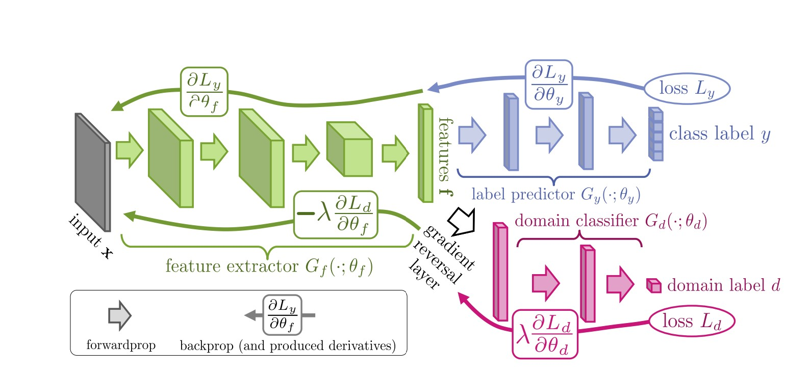
Domain Adaptation is a type of Transductive Transfer Learning, where a task is learned from one or more source domains with labeled data, and the aim is to achieve similar performance on the same task on a target domain, which is related to the source domain by some domain shift [59]. Domain Adaptation can be supervised, where there are labels available for the target domain and unsupervised, where there are no labels
 | Figure 3.9: Domain adaption with gradient rever-
available for the target domain. The crux | sal from [58].
is to learn domain-invariant representations from the source and target images such that
the source domain classifier can be directly used in the target domain despite having been trained on only source samples. Unsupervised domain adaptation can be achieved via an architecture detailed in Figure 3.9.
In the field of Histopathology, a Domain Adaptation methodology based upon [58] was successfully implemented by Ciga et al [60] to get state-of-the-art results on the BACH segmentation challenge by reducing the impact of stain variation among WSIs.
There were two key modifications to the traditional architecture in Figure 3.9. Firstly, multiple domain classifiers were applied both at the final output layer and also at intermediate layers within the feature extractor to combat gradient vanishing in deeper networks. The authors apply average pooling to the intermediate layer outputs of shape X ∈ R^{H0×W0×C0} to generate a feature vector f ∈ R^{C0} to be fed into a domain classifier for that layer. Secondly, the authors used Wasserstein distance-based domain loss to improve training stability. The the binary domain classifier is replaced with a domain ”critic”. The ”critic” learns a mapping f_{w} : R^{d} → R from feature representations to a real number, thus generating realvalued probability distributions for the source domain features and target domain features respectively. Subsequently, the Wasserstein-1 distance can be calculated between the two distributions [61]. During optimisation, the network will be trained iteratively to learn representations with a lower Wasserstein distance i.e. domain invariant features.
Another example of the successful use of Domain Adaptation in Histopathology is Ren et al to predict the Gleeson score from prostate cancer WSIs [62]. The source domain distribution contained 736 labelled prostate Histopathology images from the TGCA dataset and the target domain distribution contained 83 WSIs from a local prostate WSI dataset from the Cancer Institute of New Jersey. This was a Multiple Instance Learning framework, where patches from each WSI were extracted and fed to the network. The WSI level label was then computed using majority voting. The authors implement Domain Adaptation using an adversarial GAN loss function and further construct an auxilliary task loss in the target domain to ensure that different patches from the same WSI are assigned the same Gleeson score. The authors report statistically significant improvement in classification results on the target dataset after applying Domain Adaptation.
Both of these methods showed that enforcing learning of domain-invariant features is highly desirable for classification or segmentation performance.

Stain Normalisation
As mentioned in Section 2.2, colour variation among WSIs is extremely common in histopathology. To improve generalisiblity of models in the presence of stain variability, stain colour normalisation methods or stain colour augmentation can be used. Stain normalisation is a pre-processing step in which the staining properties of an input image are directly modified so that features extracted from it will be invariant to the original stain appearance [63]. It can be viewed as a Transfer Learning task where stain properties of a source image must match that of a target image, with the added complication that the transformation must preserve the histopathological features of the source domain.
There are 3 key variants of stain normalisation methods. Firstly, global methods based on template colour transfer, such as Reinhard stain normalisation [64]. Secondly, staindeconvolution which first separates stain components and then decomposes stain values into concentrations and colours before normalising each stain independently [65]. Thirdly, deep learning architectures such as Sparse Auto-encoders [66], GANs [67], and the recent Stain Standardisation Capsule (SSC) architecture [4]. The SSC was trained end-to-end with a classifier and outperformed both colour augmentation and state-of-the-art normalisation methods on three tumour classification tasks on H&E stained datasets.
A disadvantage of methods that rely on manual selection of a reference ’well stained’ image or a reference stain vector for each dye is the lack of robustness in the presence of severe stain variation. Additionally, these methods tend to utilise only colour information rather than structural information about the tissue to be analysed [68], which can lead to visually appealing, but not necessarily performance enhancing normalisation.
Stain colour augmentation involves synthetically generating a training cohort that is representative of stain variation that could be encountered during testing [21]. Tellez et al [63] reviewed multiple methods of improving generalisibility across hospitals and concluded that it was beneficial to use some form of colour augmentation during training on H&E datasets. However, too much perturbation could add noise during training and result in poor model performance on test WSIs which are very similar to those in the training set [63].

3.1.5 Conclusions from Literature
In conclusion, we can draw some key themes from each of the learning frameworks detailed above in light of our intended goal to classify the stage of liver fibrosis on the FibLivPath dataset.
- Learning with tile-level annotations: Firstly, the selection of rare, challenging examples to re-train models is key to success in many papers. Secondly, it cannot be concluded from the literature whether there is an advantage to using a multi-scale framework over a single, well-chosen scale and that the architecture choice in this regard likely hinges on the dataset at hand.
- Learning from WSI level annotations: Comparing across different aggregation methodologies, when considering an uncurated / partially curated data, RNN aggregation is most robust, but performance is poor on smaller datasets. Attention-based methods are more unstable to train, however, yield interpretable predictions and perform better on small datasets. Cluster-based attention weights increase stability. Instance-level dropout increases diversity of tiles attended given similarity of tissue appearance across a WSI.
- Learning without annotations: There is a clear success of contrastive learning methodologies over training with a reconstruction loss, as models are more incentivised to learn abstract features. A more generalised pre-training approach appears to yield superior performance relative to a human-engineered pre-training task. GANbased frameworks are seen to be challenging to train, especially on noisy histopathology datasets, which dampens the promise of these methods to deliver interpretable, unsupervised classification.
- Transfer Learning: Domain Adaptation methodologies are particularly effective given the stain variation inherent to histopathology datasets, which limits the success of traditional Transfer Learning in this regard. ImageNet pre-trained models seem to perform very well on WSI classification, as is evidenced by the winners of most Grand Challenges in the field. This is likely due to the scale of pre-training that can take place on natural image datasets, which far exceeds that which is possible on histopathology datasets where annotated data is scarce. Stain normalisation is used in a number of papers to standardise image appearance ahead of training, using varied methods.

3.2 Additional Background

3.2.1 Pre-processing methods
Based on the review of literature in Section 3.1, the tiling strategy is not commonly discussed since the majority of public datasets are already curated.
Otsu Thresholding [69] involves generating a histogram of the grey-scale image intensities and finding a threshold to separate this into two clusters such that the weighted variance between the two clusters is minimised. This method is relatively simplistic. The two-class assumption is not robust to artefact and more complex tissue structures.
Another method seen in the literature and applied to the Camelyon dataset is manual conversion of each patch to HSV space, and removal of patches if their mean saturation was lower than 0.07 (range 0–1) or higher than 0.1. These thresholds were empirically chosen to give satisfactory results [70] on H&E images. However, on datasets with stain colour inconsistency, this methodology would be challenging to implement.

3.2.2 Capsule Nets
The CapsuleNet [71] is relatively nascent neural network architecture first demonstrated for MNIST classification by Hinton et al in 2017 (Figure 3.10a). The purpose of the architecture is to address two key disadvantages of traditional CNNs. Firstly, the max-pooling operation in a traditional CNN results discards precise information about an object’s location. Secondly, a CNN does not account for the spatial relations between simpler and more complex objects in an image. To address this, unlike a traditional neuron, a Capsule has a vector output. The length of this vector represents the probability of a detected features (equivalent to the scalar output of a neuron in a traditional neural network), and the vector direction encodes the ’pose’ or ’orientation’ of the detected feature.
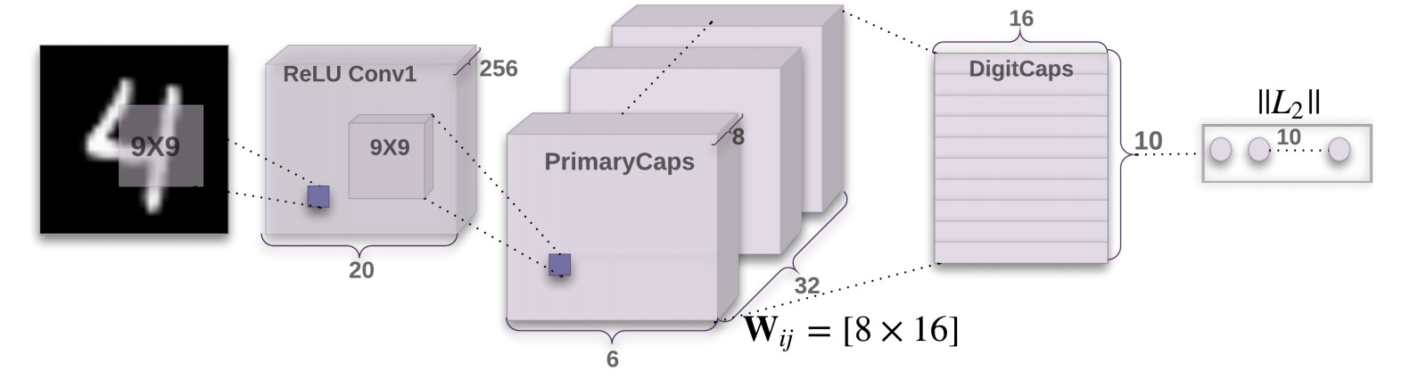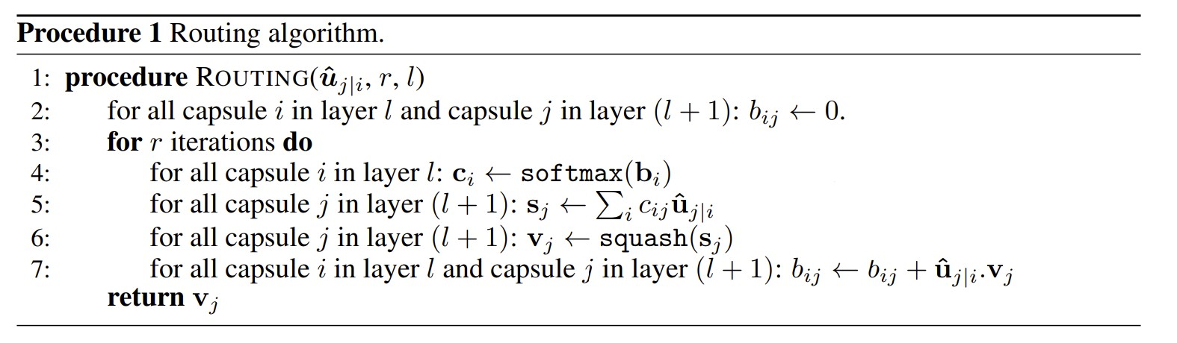
(a) (b)
Figure 3.10: (a) CapsNet Architecture for MNIST classification and (b) Dynamic Routing Algorithm from [71].
Unlike a traditional MLP, in a capsule the input from a single neuron in the previous layer is a vector rather than a scalar. For a single capsule in layer j, the vector input u_{i} from each of the capsules in layer i first is multiplied by a weight matrix W_{ij} to get the inputs to the higher level capsule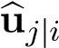. This weight matrix applies an affine transformation to the input vector. These transformed input vectors are then combined in a weighed sum by scalar coupling coefficients c_{ij}. A non-linear vector to vector activation function, called the ’squash’ function is then applied to get the final output of the capsule v_{j}. The key formulas for the matrix multiplication, scalar weighted sum and vector non-linearity are given in Equation 3.5 from [71].
s_{j} = Xcijuˆj|i, uˆj|i = Wijui
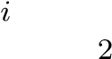 (3.5)
ks_{j}k s_{j}
v_{j} = ² ks_{j}k

1 + ks_{j}k
Unlike the weights used to aggregated inputs from a previous layer in a traditional neural network, which are learnable parameters optimised through gradient descent, the coupling coefficients in a CapsuleNet are instead reset and iteratively calculated at every forward pass using a dynamic routing algorithm detailed in Figure 3.10b from [71]. At the first iteration, all c_{ij} are equal. The output of the capsule v_{j} is computed and the dot product similarity of the input vectors ub_{j|i} is determined. The coupling coefficients are then updated to upweight the contribution of inputs that ’agree’ with the output of the capsule and downweight those that ’disagree’. This ensures that lower level capsules only route their outputs to higher level capsules which have a similar output, rather than all higher level capsules receiving equal contributions from all lower level capsules [71].

3.2.3 Model Evaluation
There are several metrics used to compare classification models. Metrics are reported based on a confusion matrix for the binary classification task. The four elements of the confusion matrix are the number True Positive (TP), False Positive (FP), True Negative (TN) and False Negative (FN) predictions by the model.
- Accuracy is the proportion of correctly classified examples in the dataset. Since the FibLivPath dataset is balanced with respect to the binary classification task, this is a strong metric for evaluating overall performance.
Accuracy 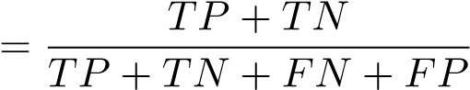
- Precision measures the trustworthiness of the model when it predicts a case of severe fibrosis. A highly precise model gives rise to few False Positive predictions.
Precision 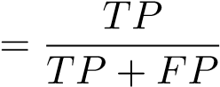
- Recall or Sensitivity is the proportion of cases of severe fibrosis that are correctly retrieved by the model. A model with poor recall is overly optimistic about the severity of fibrosis, frequently misdiagnosing serious cases as mild.
Recall 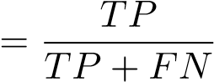
- Specificity or True Negative Rate is the percentage of mild fibrosis cases that are correctly classified. A model with a poor specificity is overly pessimistic about the severity of fibrosis, frequently misdiagnosing mild cases as severe.
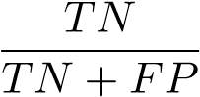
- F_{β} score is a weighted combination of precision and recall. Common values are β = 1 which gives the harmonic mean of precision and recall and β = 2, which considers recall to be twice as important as precision to model performance.
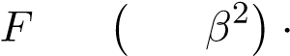
precision · recall
β = 1 + ² · precision ) + recall
(β
- Mathews Correllation Coefficient is a reliable, balanced measure of binary classification performance. The scores range between -1 (inverse prediction) to + 1 (perfect prediction). A high score can only be achieved with good performance in all four categories of prediction (TP, TN, FN, FP) in proportion to the total number of positive and negative examples in the dataset. It is the most reliable metric for binary classification on an unbalanced dataset [72].
MCC 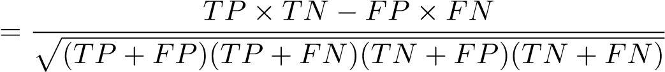
- Receiver Operating Characteristic (ROC) Curve and the Area under the ROC curve (AUC) [73] represents the trade-off between the true positive rate (plotted on y-axis) and false positive rate (plotted on x-axis) as the threshold of a binary classifier is varied between 0 and 1. For the perfect model, the TPR will be 1.0 and the FPR will be 0.0, leading to a perfect AUC score of 1. Random chance will give TPR = FPR for all thresholds, leading to an AUC of 0.5.
Chapter 4

Preparation of the Dataset with Clinicians

4.1 Dataset Description
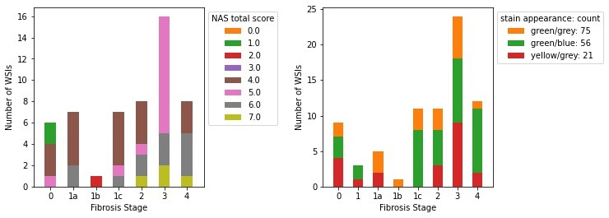
Figure 4.1: Distribution of fibrosis stages, corresponding NAS Scores and colour variability in the FibLivPath dataset.
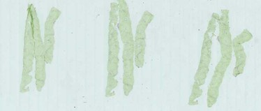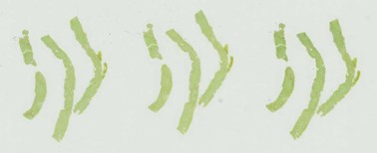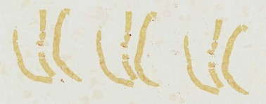
Figure 4.2: Illustration of colour variation between WSIs in FibLivPath dataset.
The novel FibLivPath dataset comprises 152 labelled WSI images of liver biopsy tissue stained with Sirius-Red, collected between 2008 and 2016. All WSIs were prepared at St Mary’s Hospital, London, with a single Hamamatsu scanner model NanoZoomer2.0 HT digital slide scanner at 40x magnification. Each WSI image contains three cores of tissue. An expert pathologist with 35 years of clinical experience, affiliated with St Mary’s Hospital,
London, annotated the WSIs at a slide-level with the corresponding fibrosis stage (0, 1a, 1b,
1c, 2, 3, 4). A stage of 0 represents healthy samples with no fibrosis activity, and a stage of 4 represents liver cirrhosis as described in Section 2.1. In addition to the fibrosis stage, the NAS activity scores for steatosis, ballooning, inflammation, and the total NAS activity score are annotated for the majority of WSIs. The distribution of classes is shown in Figure 4.1. For the binary classification task separating mild (stage ≤ 2) from severe (stage > 2), there are an equal number (n = 76) of WSIs per class. When scoring a WSI, a pathologist will analyse all tissue cores as there is likely significant variation in features between them. The clinician will assign the slide label based on the most advanced feature visible across tissue cores. Therefore, there is an overlap between features visible on WSIs graded as stage 3 or 4 and milder cases. In Figure 4.6, we provide examples of stage 2 and stage 4 fibrosis from the FibLivPath dataset.

4.2 WSI Artefacts
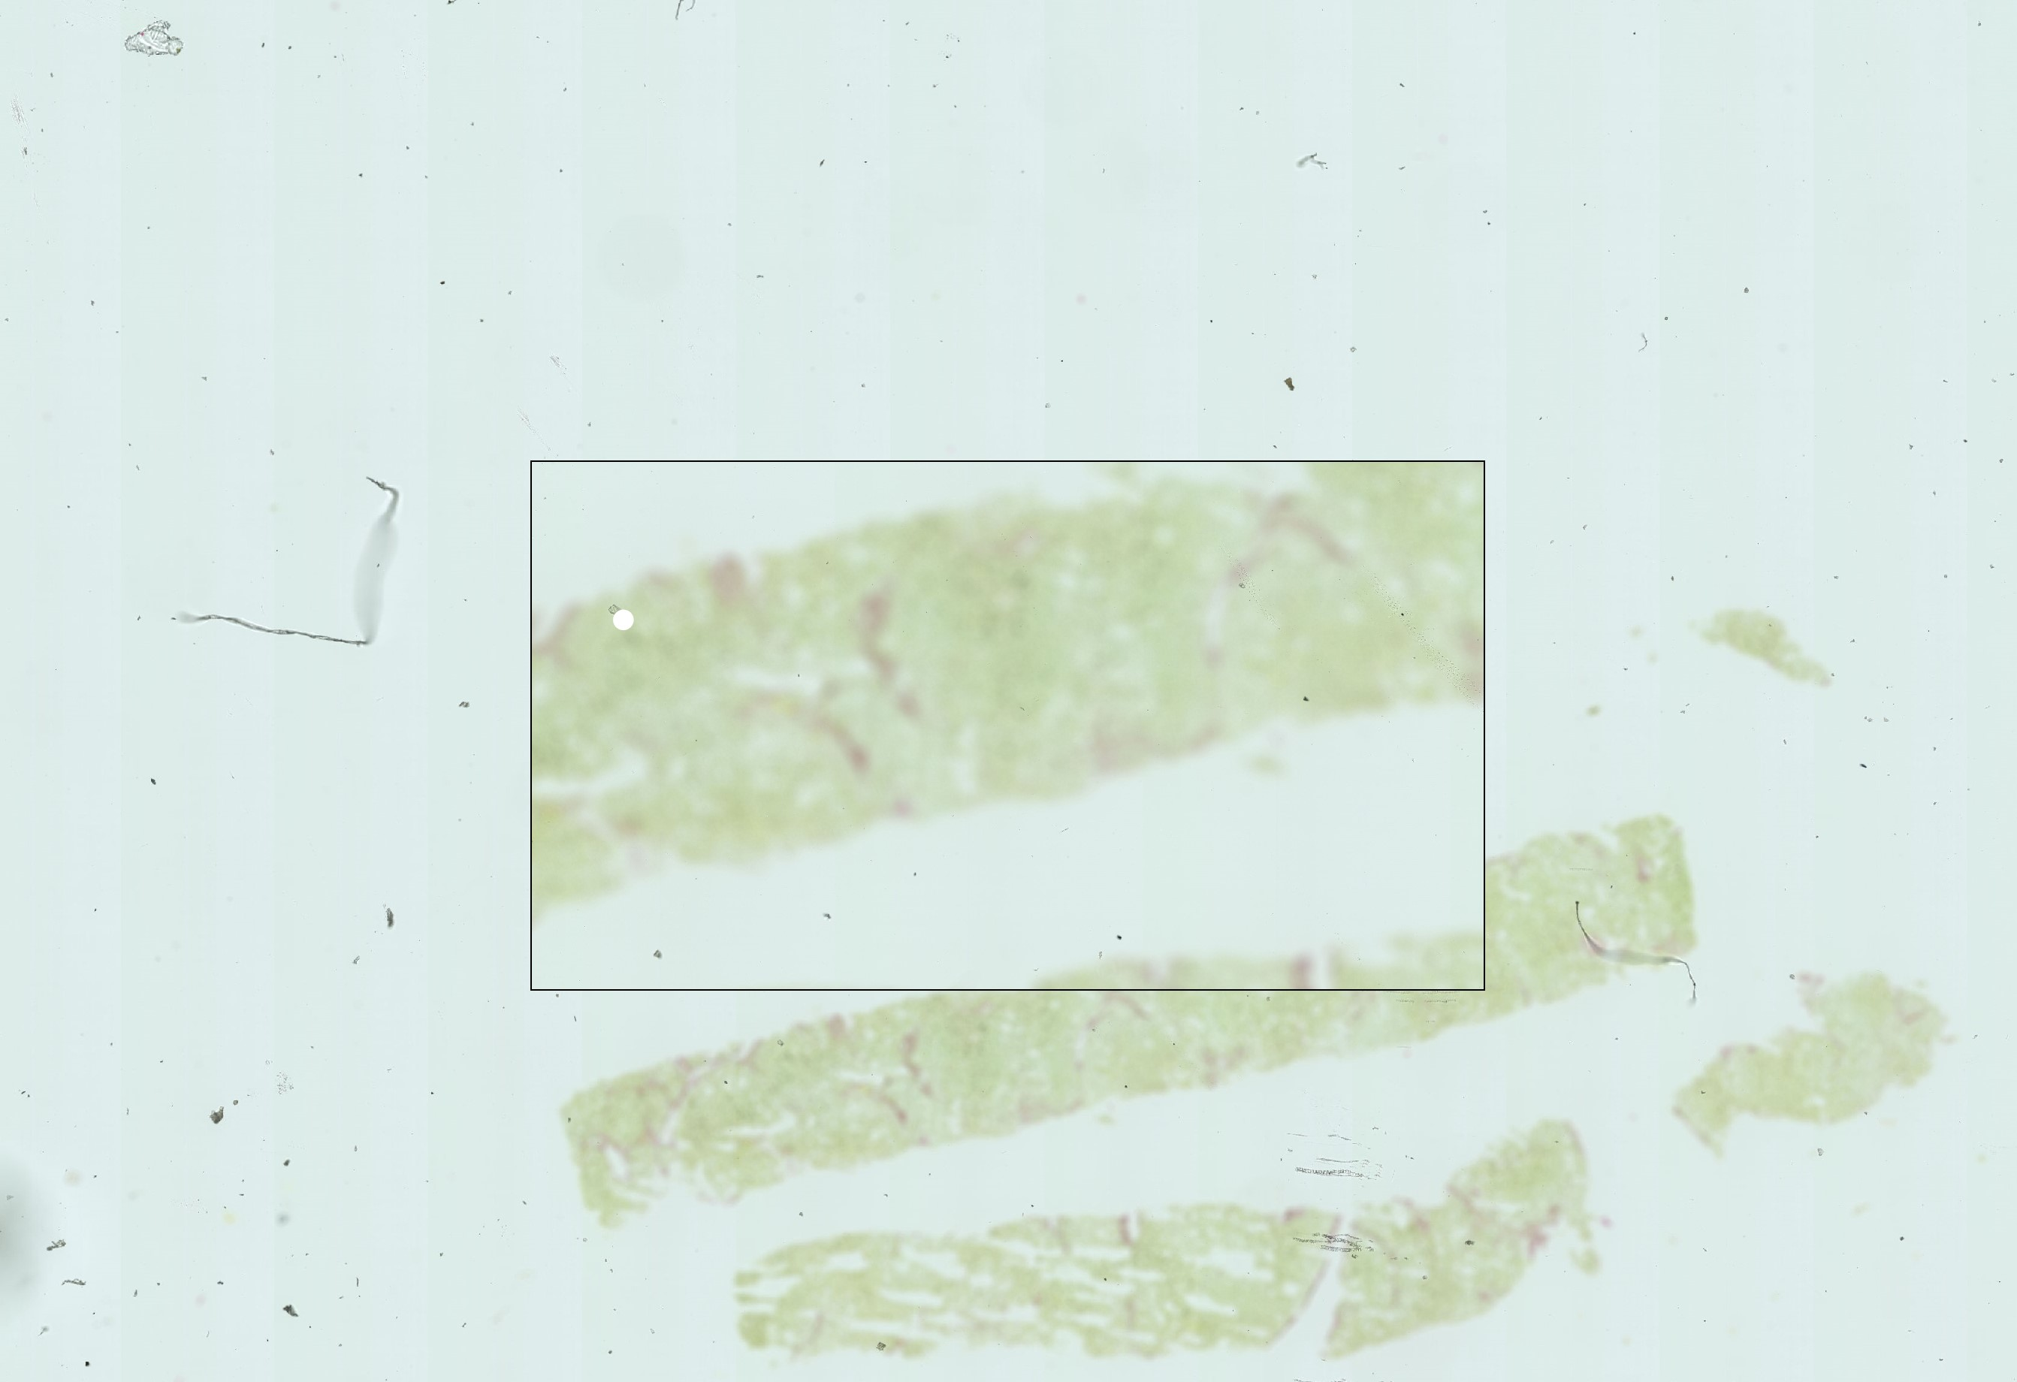
Firstly, thorough data cleaning was carried out alongside clinicians to ensure that the dataset was of sufficient quality to train a Deep Learning model. Initially, there were c. 190 WSIs, out of which we selected 152 for model training. Various common artefacts from slide preparation in a pathology laboratory can impact the dataset’s quality. Training on wholly uncurated data would significantly impact learning. Therefore, we
first visually inspected each WSI. Based on Figure 4.3: WSI showing digitisation artefact rethe severity of artefacts, we excluded n=26 sulting in blurring. slides from training: (n=16) slides with
digitisation artefacts such as blurring were sent back to clinicians for re-scanning (e.g. Figure 4.3); (n=3) slides had severe stain discolouration; (n=7) slides had severe artefacts (air bubbles, folds and cracks in the tissue). We did not remove slides with artefacts that only impact a small percentage of the overall image. After initially training on a cohort of 166 WSIs, we further excluded n = 14 slides with a grey tissue appearance to aid model stability. Hereinafter all reported results are based on 152 labelled WSIs.

4.3 Inter and Intra WSI Variation
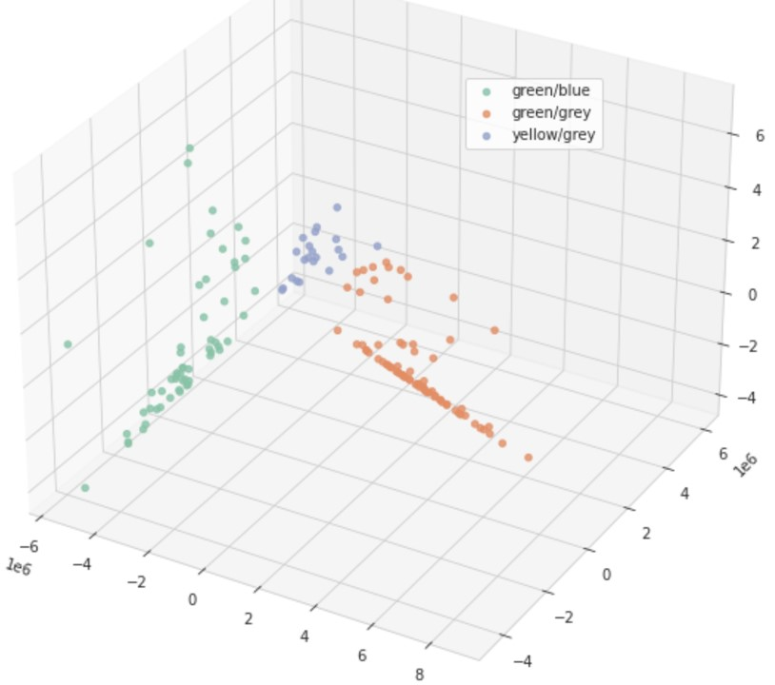
We noted significant colour variation between, and within each WSI, due to variations in staining techniques and manufacturers over multiple years. On visual inspection, there are four distinct colour categories: (1) green tissue on a grey background (n= 75), (2) green tissue on a blue background (n=56), (3) yellow tissue on a grey background (n=21) and (4) grey tissue on a grey background (n=14). As described in 4.2, we removed the slides with grey tissue. In all cases, collagen and fibrosis components of the tissue are a shade of red. However, in older WSIs, the stain is more faded. Figure 4.1 shows the distribution of different colour categories across all the WSIs
in the dataset, and Figure 4.2 displays examples of each category. | Figure 4.4: PCA showing inter-WSI colour variation on the FibLivPath dataset.
To analyse inter-slide variability, we transformed the
WSI images from RGB to HSV space and performed PCA on the hue-histogram for each slide with four components. Figure 4.4 displays the first three principal components of the hue histograms, and from this, a logistic regression classifier can fully separate the visual image categories.
When analysing variation in colour between tiles generated from a single WSI, we computed the chi-squared histogram distance in HSV space between each potential tile extracted from the WSI and the mean histogram for the slide. While the majority of WSIs had low intraslide distances, there were few outliers (e.g. Figure 4.5). In these examples, there is a visible difference in colouring between tiles from the same WSI.
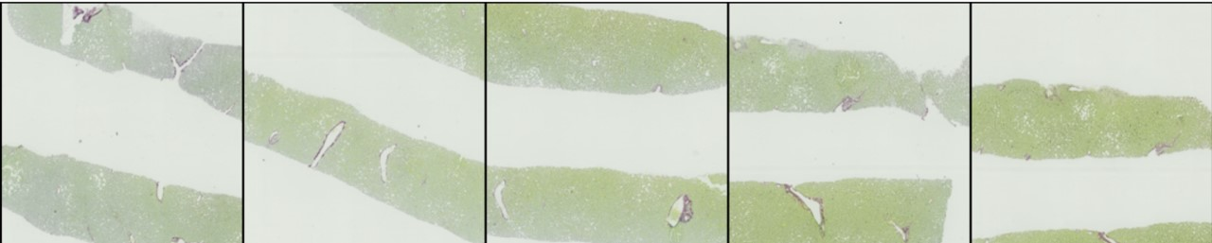
Figure 4.5: Visualisation of intra-WSI variability.

4.4 Challenging Examples
Histopathology datasets typically suffer from relatively high inter and intra observer variability due to clinician subjectivity in grading. Figure 4.7 illustrates some features which could be challenging for CAD systems. Figure 4.7a shows a section of a WSI graded 1a. The image displays a healthy portal tract cut longitudinally so that the collagen in the vessel looks very similar to thick bridging fibrosis. Figure 4.7b shows a case of stage 3 bridging fibrosis from a patient screened in 2016. The quality of the biopsy is faded, and therefore the contrast between the red stain and green tissue has largely disappeared, making it hard to identify the delicate bridging structure.
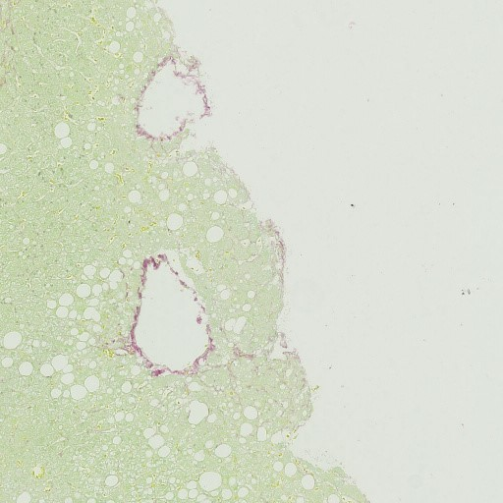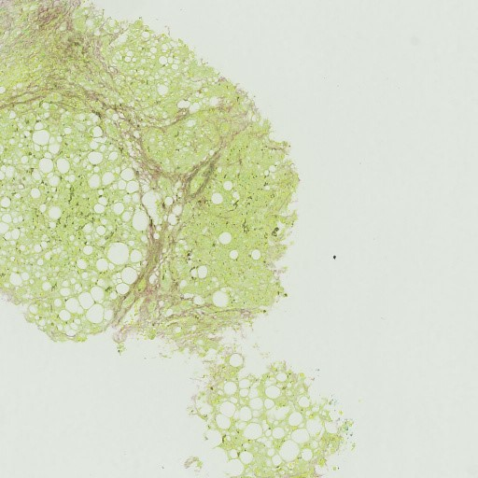
(a) (b)
Figure 4.6: Two patches from a single slide showing signs of (a) fibrosis stage 2 and (b) fibrosis stage 4.
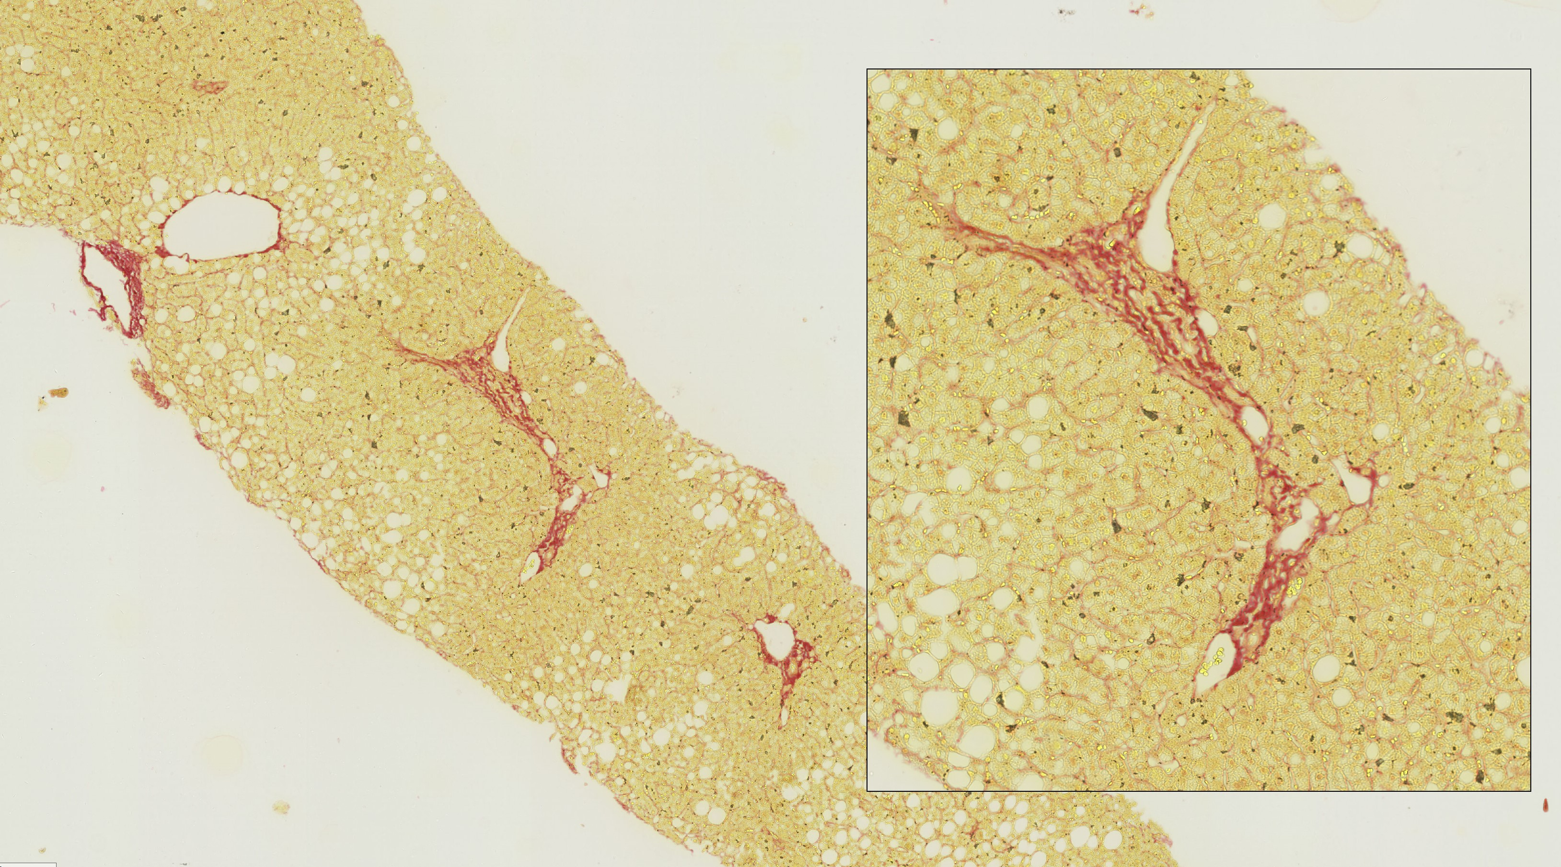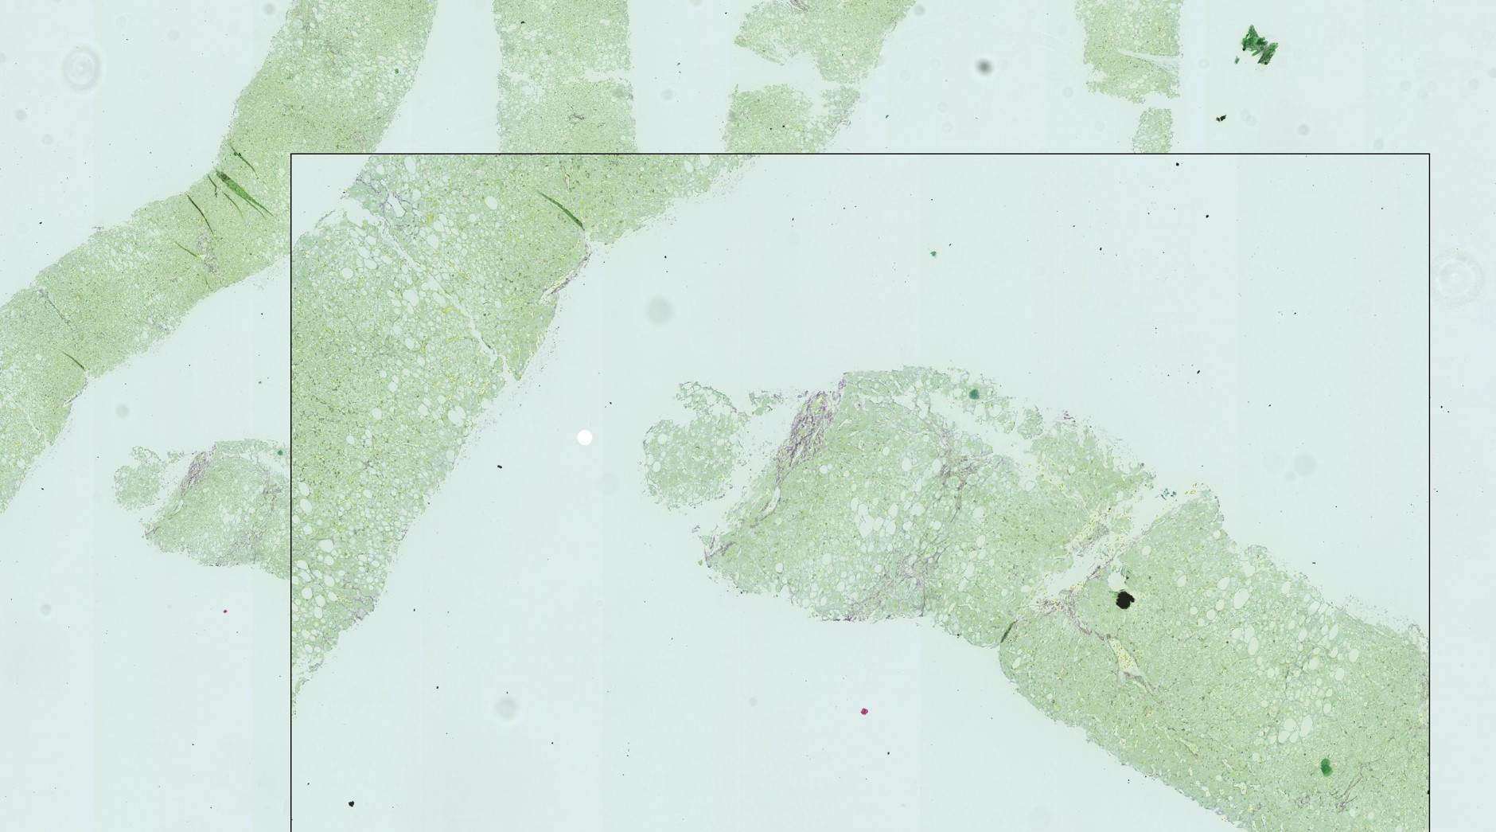
(a) (b)
Figure 4.7: Challenging examples: (a) Fibrosis stage 1a showing ”bridge-like” patterns from a vessel cut longitudinally. (b) Fibrosis stage 3 with very small bridging patterns.

4.5 Test Set Construction
No curated test set or benchmark results exist for this dataset. Therefore, we pay particular attention to constructing a test set that will reliably evaluate model performance. There is only one biopsy per patient. Therefore all data points are deemed uncorrelated, and the dataset is randomly shuffled and split into the train, and test sets, stratifying on colour categories and fibrosis scores. We constructed five independent test sets for cross-validation. We test a model on the full dataset and report the mean and standard deviation values of performance metrics.
Chapter 5

Experiments Description
The goal of this project was to identify a suitable framework to classify the novel FibLivPath dataset into severe (stage 3,4) and mild (stage ≤ 2) fibrosis cases. The main challenges we had to overcome were:
- To the best of our knowledge, no research papers apply deep learning models to classify fibrosis on Sirius-Red stained tissue. It was unknown how successfully methods in literature would transfer to this novel domain.
- The FibLivPath dataset is of clinical quality rather than being curated for Machine Learning research. Therefore, significant attention must be paid to pre-processing and standardisation of images to stabilise training.
- The pathological signs on the FibLivPath dataset are sparse. Therefore, significant attention must be paid to learning discriminative featrues during training.
Several paradigms are considered in the design of the deep learning architectures: domain transfer and unsupervised pre-training to improve the representation learning, multiple instance learning (MIL) on patches, and attention mechanisms for explainability. Hereinafter we describe our experimentation in each of these areas.

5.1 Pre-Processing

5.1.1 Background vs Tissue Selection
For model training, we must first extract patches/tiles from each WSI slide. The WSI data is stored in Hamatsu NanoZoomer Slide format (NDPI), which stores an image pyramid at magnifications factors [40.0, 20.0, 10.0, 5.0, 2.5, 1.25, 0.625, 0.3125]x in TIFF directory entries. Figure 5.1 describes the tiling procedure we employed.
We extract patches by uniformly sliding a window across the WSI and identifying ’valid’ tiles for training. The key parameters in the tiling process are:
- Tissue size (mm): This is the most important parameter, equivalent to the field of view (FOV) a histopathologist would use when viewing the tiles.
- Overlap between tiles (%): Higher overlap leads to a larger but less diverse training set. Lower overlap can result in information loss as a single feature may extend between tiles.
- Edge threshold (%): The size of each candidate tile is computed. If the edge threshold is 100%, only full square tiles are allowed, no tiles with cropped borders.
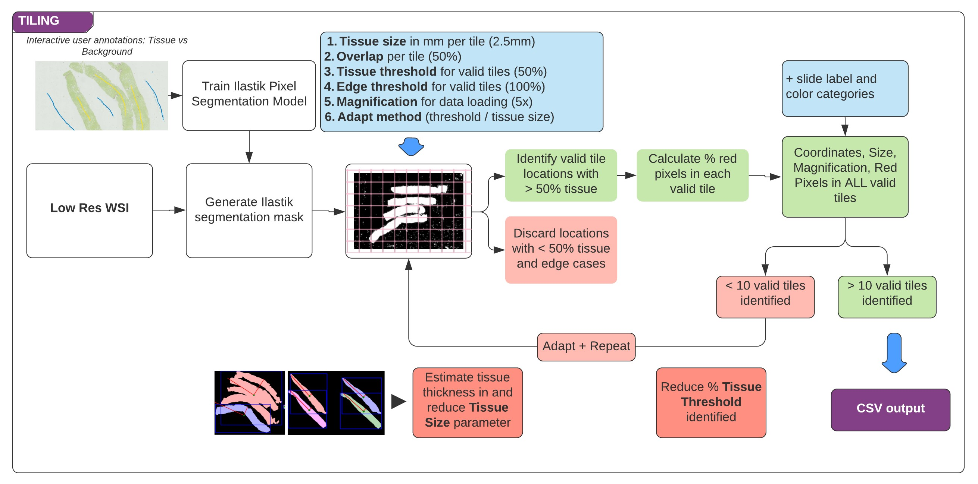
Figure 5.1: Pre-processing: Tiling strategy.
- Tissue threshold (%): From the images of sample WSIs in Figure 4.2, it is clear that the majority of patches contain little to no tissue. We only consider candidate tiles with a percentage of tissue higher than the threshold for model training. A higher threshold will extract fewer valid tiles. A lower threshold will have less information per tile for the downstream model.
- Magnification factor (from [40.0, 20.0, 10.0, 5.0, 2.5, 1.25, 0.625, 0.3125]x): Less detail is visible at lower magnifications, however higher magnifications increase memory requirements.
To measure the tissue content of each tile, we must initially segment the WSI into tissue and background regions and generate a mask for each slide. On discussion with clinicians, we noted the following key challenges specific to the FibLivPath dataset, which informed our segmentation strategy.
- Cirrhotic liver tissue was much more challenging to biopsy as the tissue would likely crumble while being sliced and prepared on a slide. Therefore, we must ensure that our tiling quality does not differ between severe and mild disease cases.
- For extremely severe disease, liver tissue is sampled by inserting a wire through a blood vessel rather than taking a needle biopsy, resulting in pieces of vein visible in the WSI. The artefact poses a challenge to effective background-tissue segmentation.
- WSI artefacts are diverse in size, colour and locations. Therefore the segmentation algorithm must be flexible and easy to modify to account for more challenging biopsy slides.
Initial experiments using methods found in the literature review, such as Otsu thresholding [69] and ad-hoc thresholding of mean saturation values in HSV space (as done on the Camelyon dataset [70]) led to poor segmentation results on our data.
Therefore, we experimented with Ilastik’s Pixel Classification workflow [74]. This workflow takes as input a low-resolution snapshot of the WSI. After manually providing few brush annotations on background and tissue areas on a few training cases, the workflow trains a Random Forest classifier to assign labels to pixels based on features such as smoothed pixel intensity, edge filters and texture descriptors which the user can choose. The trained classifier then generates a probabilistic or binary segmentation map to show the location of tissue and background classes in each WSI. After experimentation with the different features and amount of annotation per WSI, we achieved visually accurate segmentation for most WSIs after annotating only 3-4 WSIs. For challenging slides, it was extremely fast to add a few additional annotations to improve the model.
After generating binary WSI masks, we tile the image uniformly with the pre-set tiling parameters described above. Our pipeline generates a CSV file with the locations, sizes and magnifications of valid tiles, alongside the percentage of red pixels in each tile (to speed up the dataloading process described in Section 5.2). Only a single segmentation mask (.h5 format) is saved to disk per WSI. Therefore, the pipeline is space efficient and flexible since changing parameters such as Tissue size, Overlap etc. can be achieved in a few minutes using the saved masks.
Based on clinician’s feedback we used the following parameters for the initial tiling: Tissue size of 2.5mm, Overlap of 50%, Edge threshold of 100%, Tissue threshold of 50%, Magnification factor of 5x. The results of this are shown in Figure 5.3a. This initial tiling strategy lead to 0 valid tiles for 20 cases, and less than 10 valid tiles for 30 additional cases. Upon investigation, we found that most of these cases suffered from artefacts and crumbling tissue. Therefore, we introduced another parameter:
• Adapt method (threshold / tissue size): If less than 10 valid tiles are generated for a WSI, we either change the Tissue size parameter of the Tissue threshold parameter to increase the number of patches selected.
We investigate adapting tissue size because we observed that the width of each ’core’ of tissue varied within and across WSIs from just under 1mm to 2.5mm wide. Therefore, if the original tiling parameters are unsuccessful, we aim to compute the mean tissue width of cores on the slide, which would be a more appropriate FOV to use in tiling. We used the skimage library to find connected components (CC) on the Ilastik mask (after removing small objects and small holes) and compute the major and minor axes of the ellipse fitted around the CC of tissue ’cores’. The minor axis is an approximation of tissue width. However, Figure 5.2 illustrates the variability in the estimated tissue width due to the curled shape of the tissue, touching cores and small tissue fragments which impacts the ability to distinguish valid CCs from the background mask. Therefore, we applied a few heuristics to remove outliers. Firstly, we discarded any major / minor axis measurements over 5mm since this is likely because of two touching cores or a curved piece of tissue that is difficult to measure. Secondly, we discarded any CC with width below 0.5mm since this is likely artefact. The mean tissue width is then computed from the remaining CCs and bounded between 1mm and 2.5mm to further reduce impact of outliers. Tiling of the whole WSI is then performed at the lower tissue width to generate more valid tiles.
Adapting the tissue threshold is simpler and faster. We reduce the tissue percent threshold from 50% downwards until at least 10 valid tiles are selected. However, since there is less tissue per tile, there is also less information for a downstream model to learn from.
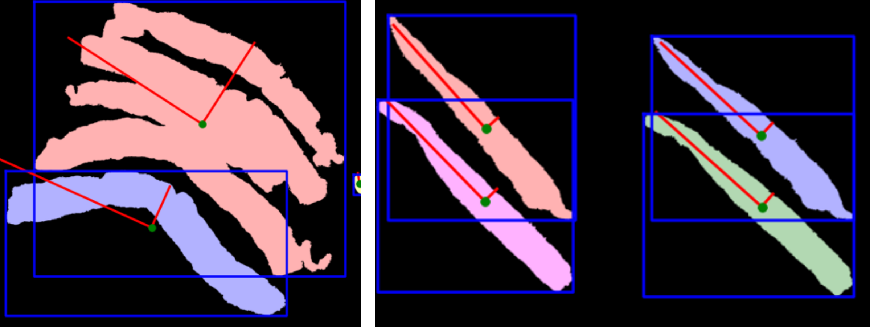
Figure 5.2: Illustration of variations in tissue width measurements from background masks. CCs are colour coded, and fitted ellipse axes are shown in red.
Additionally, when tissue width is small, fibrosis features also appear smaller and therefore, are harder for a model to ’see’ at constant magnification.
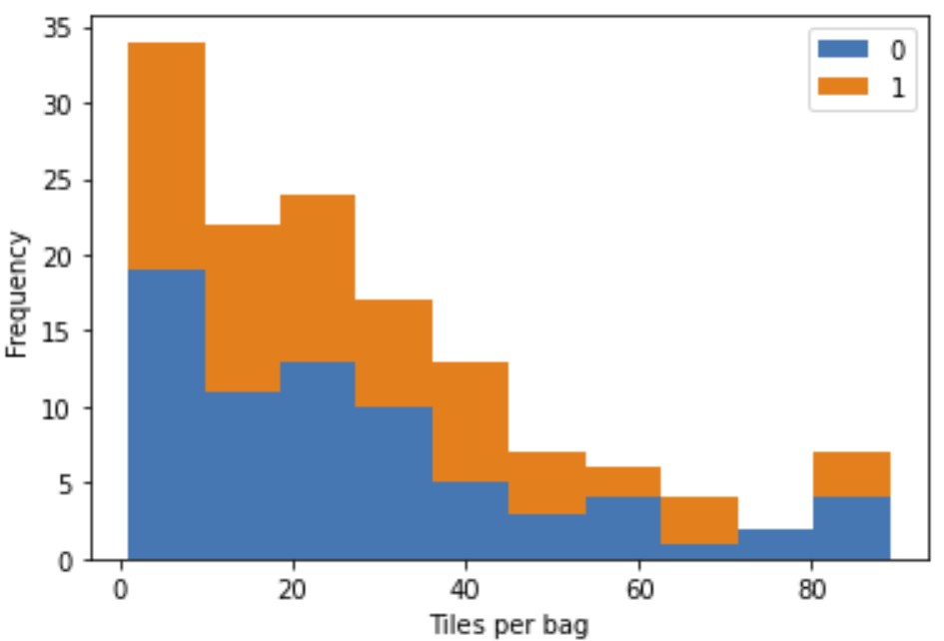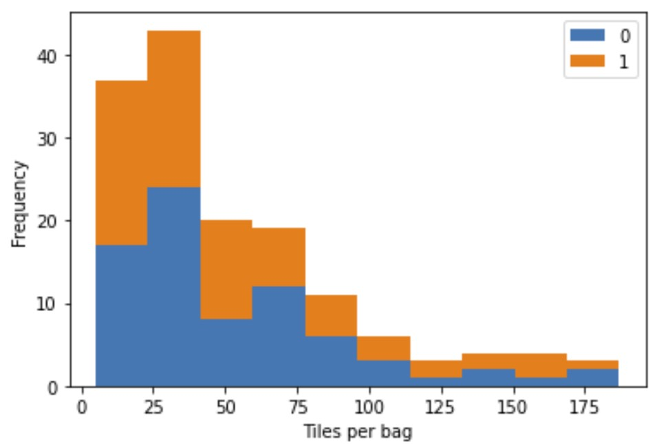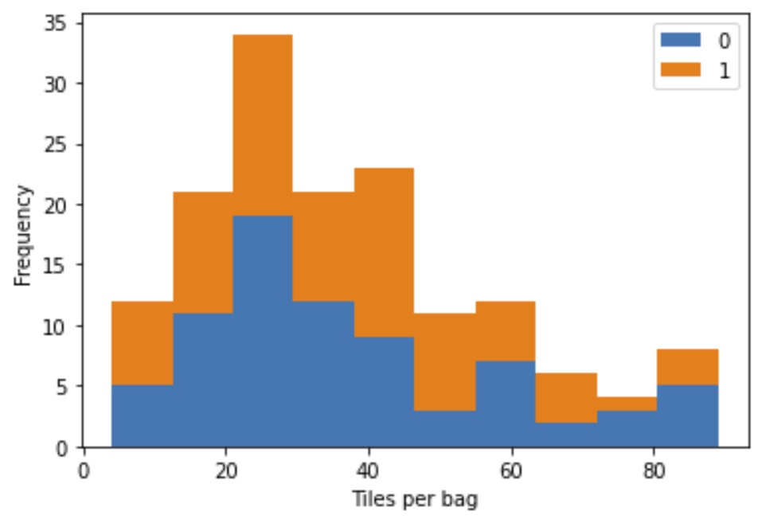

(a) (b) (c)
Figure 5.3: Number of valid tiles per WSI generated at 2.5mm tissue size, 50% overlap, 100% edge threshold at 5x magnification. (a) Adapt method = None. Average bag size of 25 ± 23. (b) Adapt method = tissue size. Average bag size of 53 ± 39 and a minimum bag size of 10. (c) Adapt method = tissue threshold. Average bag size of 37 ± 19 with a minimum bag size of 10.
Figure 5.3 shows results from the three tiling strategies using parameters of 2.5mm tissue size, 50% overlap, 100% edge threshold, 50% initial tissue threshold and 5x magnification for the final tiles. The bar graphs highlight that tiling using adaptive thresholding results in the most normally distributed values for the number of tiles with the smallest standard deviation across WSIs (37 ± 19 tiles), which would likely lead to the most stable downstream training.
For all three methods, the mean and standard deviation was within ±1 tile per bag when considering each class individually. Therefore our tiling method appears robust to the lower biopsy quality in severe disease cases.

5.1.2 Stain Normalisation
As quantified in Section 4.3, there is significant variation in stain appearance in the FibLivPath dataset. Application of the Stain Standardisation Capsule [4] to Sirius-Red stained images could allow learning multiple distinct transformations for the different colour categories. We experimented with this architecture and compared performance to Reinhard stain transfer [64] and colour augmentation.

Reinhard Stain Transfer
Reinhard Stain Transfer [75, 64], measures the key colour characteristics of a chosen well-stained WSI (target domain) and applies these to all the other WSIs (source domain) in the cohort. The RGB images first are transformed to lαβ-colour space where l = r+g +b, α = r + g − b and β = r − g. Subsequently, a linear transformation is applied to scale the source WSI such that the mean and the standard deviation per-channel (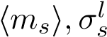) matches that of the target WSI (hl_{t}i,σ_{t}^{l}). The following formula is applied to each of the lαβ colour channels before the final image is converted back to RGB space as shown in Equation 5.1.
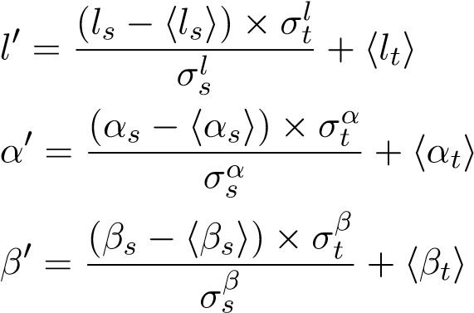 (5.1)

Stain Deconvolution
Stain deconvolution separates the independent contributions of H&E stains on RGB slides.
Based on Beer-Lambert Law, each pure stain is linearly separable in optical density space [65]. Therefore, the RGB images are first transformed using Equation 5.2, where OD_{C} is the optical density per channel and (I_{C}/I_{0,C}) is the ratio of incident to transmitted light. The optical density of the image decomposes into the product of a stain colour appearance matrix (W ∈ R^{3×r}, where each of r independent stains has a 1x3 vector that represents its characteristic RGB triplet in optical density space) and a stain concentration matrix (H ∈ R^{r×n}, where n is the number of pixels in the image, where each entry represents the concentration of one of the r stains). These matrices can be determined either using empirical, stain-specific knowledge of the stain-colour matrix [65], or using methods such as Singular Value Decomposition (SVD) [76] and Non-negative Matrix Factorisation (NMF) [77]. Stain normalisation is subsequently achieved by combining the stain colour appearance matrix of a target image with the stain concentration matrix of the source image [75].
ODC = −log10 (IC/I0,C)
(5.2)
OD = W × H

Stain Standardisation Capsule (SSC)
The SSC [4] utilises grouped 1x1 convolutions to apply linear colour transformations and learn multiple unique stain normalisation candidates for a particular WSI. These candidates are then assembled into a single normalised input to a downstream classifier using a dynamic routing algorithm during a forward pass.
Key parameters outlined in Figure 5.4 based on [4] are:
- Number of stains (S): In the original SSC module, this is set to 2, to separate the H&E stains. Sirius-Red is a single stain, therefore, we could use S = 1. However, due to background pixels not considered in the original architecture, there are still two distinct classes that a pixel can belong to. Therefore, S = 2 could still be appropriate to handle the complexity of the patches.
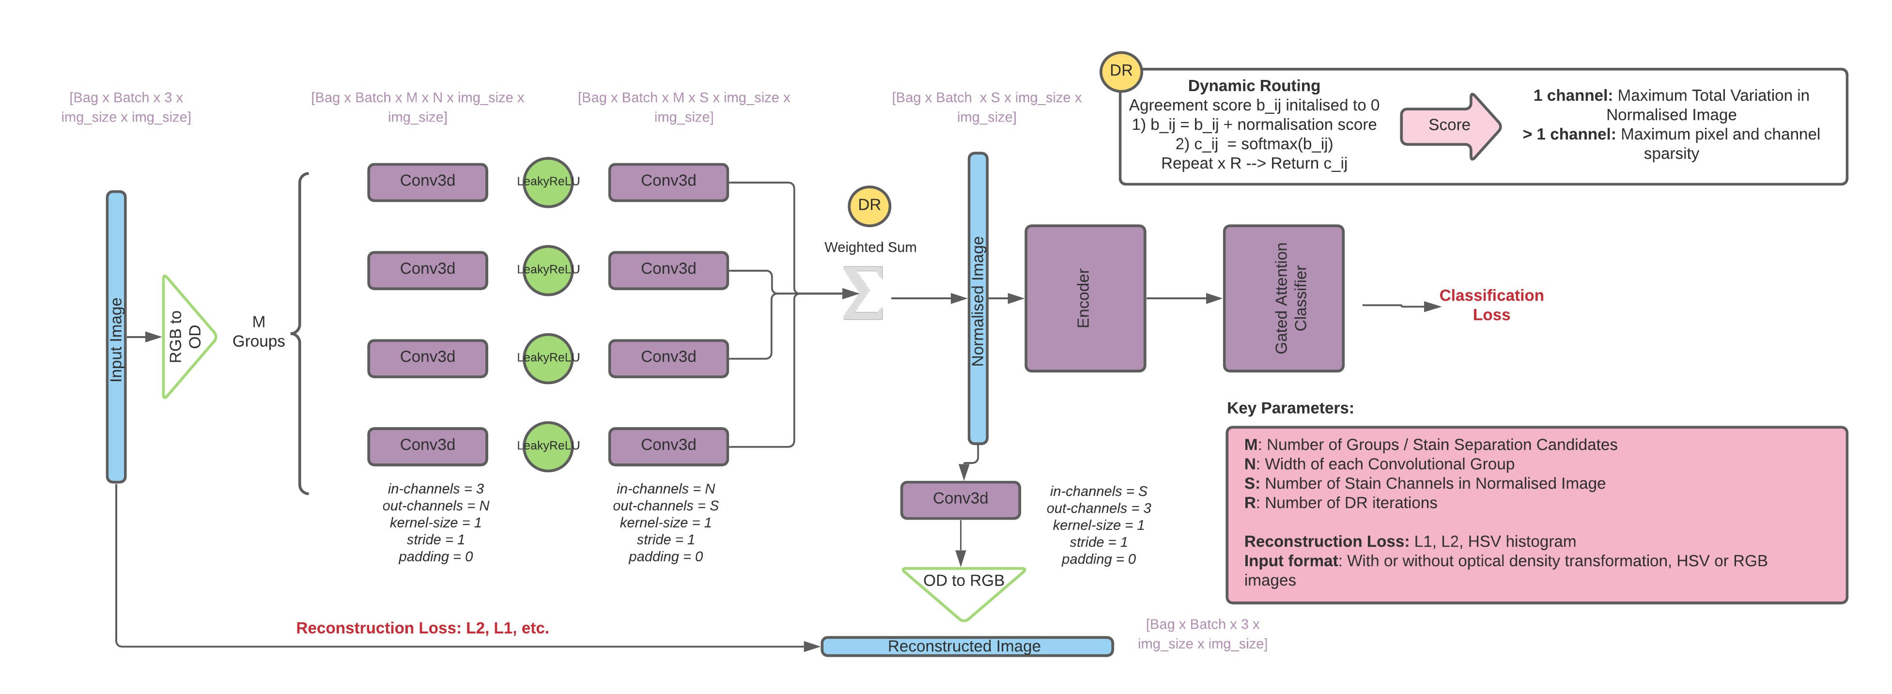
Figure 5.4: Stain Standardisation Capsule (SSC) architecture and key parameters.
- Number of Groups (M): The number of parallel group convolution operations i.e. the number of different stain colour transformations learned by the model. Grouped convolutions are both parameter efficient and increase representation capacity due to lower correlation between filter kernels [78]. Given the considerable stain variation, it is likely that the higher end of the range (3-8) tested in [4] would be appropriate.
- Width of each group (N): The number of channels in each parallel convolution group. In each parallel route, there are N transformations applied. These N channels are then compressed to the S-channel normalised output. High N leads to more redundant computations. We explore the range (3-8) tested in [4].
- Routing iterations (R): The number of iterations of dynamic routing conducted at each forward pass. As R increases, the coupling coefficients c_{ij} (Equation 3.5) become more sparse. Thus the normalised output is dominated by a single path, leading to overfitting. As R decreases, the model tends to average rather than discriminate between ’good’ and ’poor’ normalisation candidates. We fix R = 3 as was in [4, 71] during our experiments.
- Score for Dynamic Routing: Rather than looking at the similarity between the ’squashed’ output of a higher level capsule and its input, since the output of the SSC module is fed directly to a CNN based encoder for classification and the whole network is trained end-to-end, a different ’score’ is used to adjust the coupling coefficients for each of the M stain separation candidates.
  - S ≥ 2: The original SSC module uses a Sparsity Score (= Pixel Sparsity + Channel Sparsity) to increase the coupling of coefficients of high-quality normalisation candidates. For stain separation, a well separated image will be both pixel-wise and channel-wise sparse, as derived in Sparse-NMF from [79]. Intuitively, pixel-sparsity ensures that the power of a single pixel maps to only ONE of the stain channels and channel-sparsity ensures that not ALL of the pixels map to a single stain channel.
  - S = 1: The Sparsity Score is only appropriate when conducting stain or tissue separation across multiple channels. When utilising only a single stain, another way of scoring different normalisation candidates must be considered. A high-quality normalisation candidate must preserve the edges and delicate fibrosis structure of the original RGB image. Therefore, we propose an alternative score for a 1-channel normalisation to ensure that the forward differences between neighbouring pixels are maintained. We compute the total variation of each normalised image as a score.
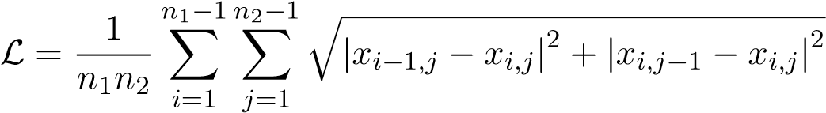
A low total-variation would indicate that the normalised input to the downstream classifier is ’smoothed’ or more piece-wise constant, reducing the contrast and definition of the important fibrosis features.
- Reconstruction Loss: As was used in [71], a reconstruction constraint is applied to the SSC output to ensure that the structural information between the normalised output and the original image is preserved. The constraint acts as a regulariser and encourages the mean colour properties of the normalised images to be close to the centre of the training distribution. The SSC module is trained with the combined reconstruction loss and downstream classification loss. We explore multiple reconstruction loss functions used in computer vision:

– L1 Loss: loss(x,y) = |x − y|
The L1 norm has less of a ’smoothing’ effect on reconstructions compared to the L2 norm, which could lead to better preservation of delicate fibrosis features in the normalised outputs.
- L2 Loss:
loss(x,y) = (x − y)²
Penalises large discrepancies in reconstructions while allowing small deviations. This is the reconstruction loss used in the original SSC module [4, 71].
- Weighted L1/L2 Loss: The L1 or L2 loss is calculated per RGB channel and the overall loss function is a weighted average. Given that Sirius-Red highlights fibrosis as Red and healthy tissue as Green, in the RGB format, it is likely that the importance of the R,G channels is greater than that of the B channel when optimising reconstructions for the classification task. Therefore, we explore weighting the different R, G, B channels to increase the importance of preserving Red pixel features.
- Hue-Net Loss: For general Computer Vision colour transfer tasks, the Hue-Net minimises a combination of the HSV-histogram distance and Mutual Information between reconstructions and the original images [80].
- No Reconstruction constraint: While regularisation via reconstruction loss was suggested to be beneficial for generalisation and boosted classification performance in [4, 71], capsule layers can also be effective without this constraint as was shown in Iesmantas et al [81] for breast cancer classification.
• Input format:
- Optical Density Transformation: The OD transformation in the original SSC architecture was shown to be important for classification performance [4].
However, this is based on the assumption of stain deconvolution to construct the S-channelled normalisation candidate. OD may not be relevant when transferring the use-case from H&E stained patches without background to Sirius-Red stained images including background pixels. Unlike stained-tissue, the background material does not absorb light but rather scatters it. Therefore, Beer-Lambert law does not apply to background pixels. The log transformation from RGB to OD space ahead of separation may not be crucial to the model’s success in our case. On the other hand, the non-linearity introduced and the suppression of extreme values by the log function could still be beneficial, as could the partial applicability to the SR-stained tissue (ignoring the background pixels). Therefore, we explore the SSC module with and without the OD transformation.
- Colour Space: As mentioned, the colour deconvolution theory uses an RGB image transformed to optical density space for linear stain separation. If the OD transform is not essential in this use-case, then other input formats could be explored such as CMYK or HSV colour spaces. It can be seen in papers mentioned in Table 3.1, that most Challenge-winning models apply transformations in HSV space to improve generalisibility. The HSV colour space separates the ’color’ (hue) component from the brightness and black-white contrast (saturation and value) components of the pixel intensity and is therefore widely used in colour transfer tasks [80].

5.1.3 Data Augmentation
Data augmentation is applied to synthetically increase the size of the dataset by transforming images to represent the entire data distribution observed at deployment. Given the small size (152 WSIs) of the FibLivPath dataset, data augmentation will likely play a key role in increasing model generalisability.
We conduct patch-wise augmentation within each WSI bag as described in Section 5.2. We experimented with the following data augmentation techniques from the Torchvision library, illustrated in Figure 5.5:
- RandomRotation: Orientation of ’core’ of tissue varies widely both across and within WSIs from 0 to 360 degrees due to differences during biopsy fixation and slicing. Therefore, during training, we apply rotations to every image patch. The angle of rotation is chosen uniformly, at random, from a range of ±max rotation degrees. We rotate about the centre of the image and pad borders with the mean RGB values of the patch.
- RandomHorizontalFlip, RandomVerticalFlip: We reflect 50% of image patches along the x or y axes to improve model invariance to tissue orientation further.
- RandomResizedCrop: We take a random crop of a portion of the image and resize the crop to the original image size. The transform applies a random variation in the scale at which the model views features. Fibrosis bridging can be as narrow as one cell thick. Therefore, applying this random zooming could improve the generalisability of features and mimic the advantages of using a multi-resolution architecture. Crop size is chosen uniformly from a range of [min crop%,100%] of the
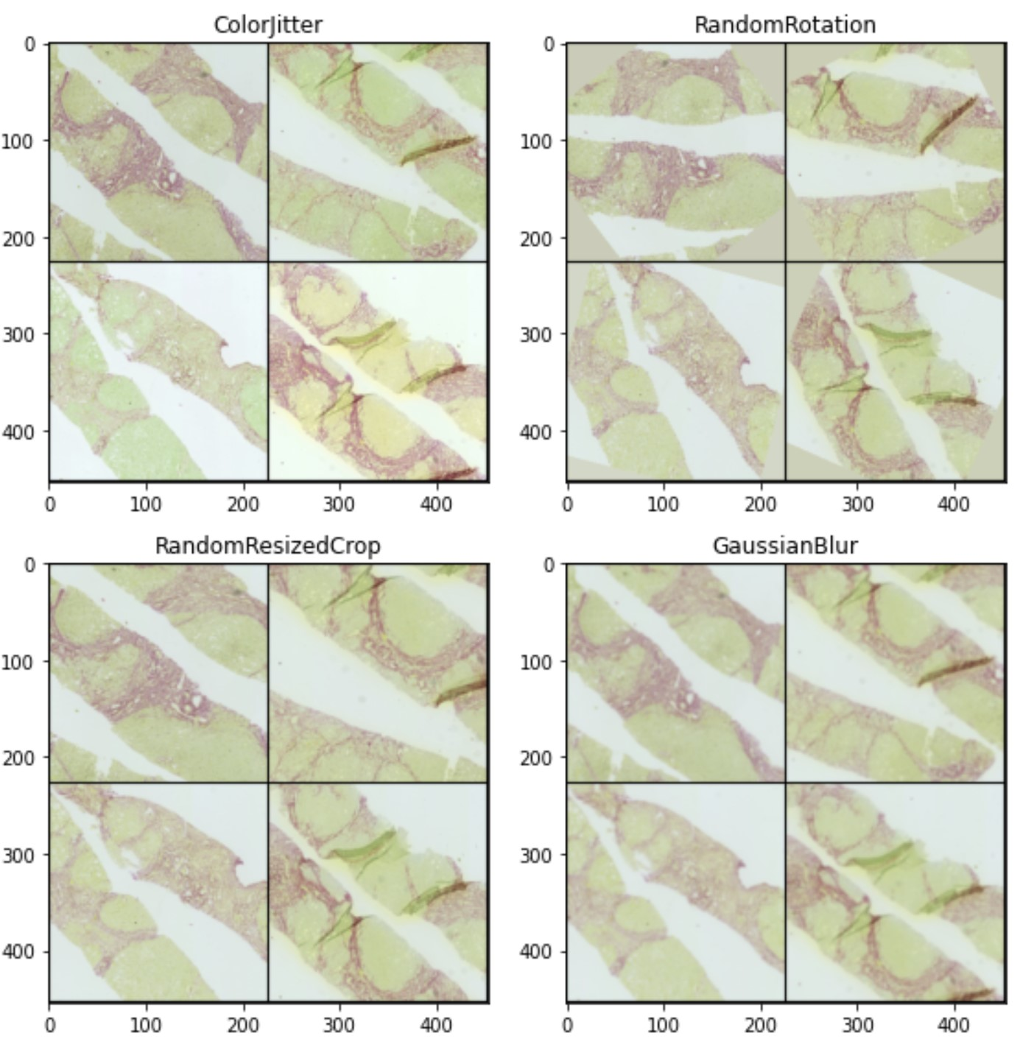
Figure 5.5: Illustration of four independent Data Augmentation techniques described. ColorJitter value = 0.1, Rotation max rotation = 50◦, GaussianBlur kernel, σ = (19, 1.0), RandomResizedCrop min crop = 50%.
image size. There is a trade-off between multi-scale feature learning and information loss as min crop reduces.
- GaussianBlur: We apply a Gaussian blur kernel to 50% of image patches to represent the impact of common scanning artefacts. Dust particles can cause WSIs scanned to be out-of-focus, and blurring can range from slight to quite severe. Although manual data cleaning was applied to remove the worst impacted slides, to make the model more robust at test time, we explore blurring kernels of kernel size ∼ [1,20] pixels with a random standard deviation chosen uniformly from range σ ∼ [0.1,2.0]. The L2 norm of the image before and after the transformation is conserved.
- ColorJitter: We augment 50% of image patches by varying their brightness, contrast, saturation and hue. The factor with which perturbation was applied was chosen randomly between [max(0,1 − value),1 + value] for brightness, contrast and saturation. For the hue, or colour component, the factor was chosen between [−value,+value] On experimentation, we used value = 0.1 for all four components to mimic the visual range of tissue colour in the dataset as described in Section 4.1.

5.2 Construction of Bags of Instances
The design of the Dataloader went through multiple iterations during the project. Achieving stable training results was challenging due to the weak learning signal, variation in the informativeness of patches in each WSI, and limited computing power leading to a trade-off between bag size and batch size that could be loaded at once to the GPU.
The CSV file output from the tiling process is the main input to the Dataloader. As shown in Section 5.1.1, depending on tiling parameters chosen, some WSIs will generate hundreds of valid tiles and others will have only 10.
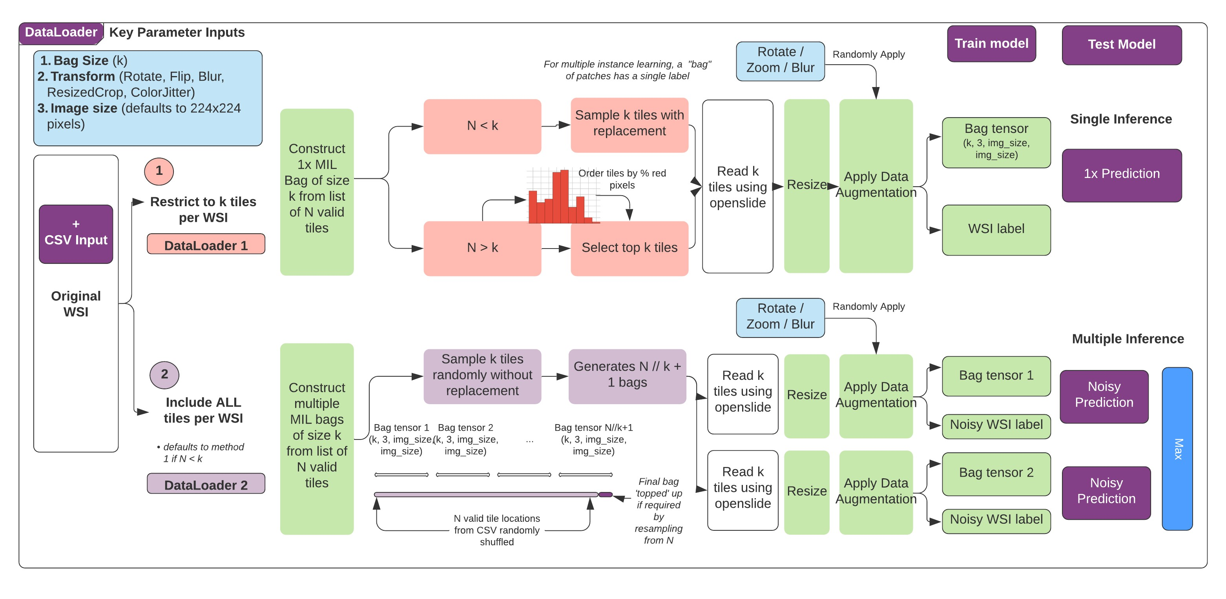
Figure 5.6: Pre-processing: Dataloader 1 and 2. Dataloader 2 uses multiple inference with a one-wins-all aggregation.

5.2.1 Dataloader 1
Based on discussions with clinicians, we learned that a histopathologist would largely ignore the patches containing only green tissue and focus very quickly on areas of the WSI on which the red fibrosis stain was visible. While we know from analysis by [14], there is little correlation between the percentage of red pixels in a WSI and the fibrosis score, using a heuristic to favour tiles with red pixels would allow the deep learning model to focus on the tiles which display the structural pattern of fibrosis that is key to diagnosis. Therefore, we accounted for this in our approach to dataloading for the majority of the project, per the schematic of ’Dataloader 1’ in Figure 5.6.
The key hyperparameter to investigate for this dataloader is the bag size (k). If there are more than k valid tile locations in the WSI, then all tiles are ordered by the percent of red pixels in each tile and the top k are selected, since these are likely to contain the most interesting features. If there are fewer than k valid tile locations, we sample k times with replacement to artificially increase the bag size.
After identifying the instances to be included in the WSI bag, locations are read from the NDPI file and images are resized to the chosen image size (default 224) for training. Then random data augmentation is applied to each patch. Finally, the images are converted to RGB, or HSV or CMYK format to output the final bag tensor and corresponding bag label.
We explored a range from k = 5 to 20. Tiling generated 53 ± 40 tiles per WSI. Due to the sparsity of pathological signs in all but the most severe cirrhosis WSIs, c. 50% of the valid tiles will likely be uninformative. Therefore an upper bound for k was chosen at 20 tiles per bag. We did not explore larger bags due to GPU constraints. Smaller sized bags incur more information loss, and therefore a lower bound for k was chosen at five tiles per bag. We hypothesise that the optimum bag size will lie in this range.

5.2.2 Dataloader 2
In the latter stages of the project, we revisited the approach to dataloading and experimented with the pipeline shown as Dataloader 2 in Figure 5.6. This methodology addresses the information loss incurred in Dataloader 1 from selecting only a small proportion of tiles from each WSI. Dataloader 2 now utilises every valid tile location per WSI.
Once again, due to GPU constraints, we cannot load bags of size more than 20 while maintaining a reasonable batch size. Therefore, we use the following pipeline: (1) we choose a fixed bag size, k, as in Dataloader 1. (2) We sample from the pool of valid tiles ranging from c. m = 10 to m = 100 as in Figure 5.3c) randomly, without replacement. This generates n = m/k bags of size k per WSI. The value n varies across WSIs. (3) Each of the n bags are given the label of the overall WSI, as a proxy ground truth. (4) The remainder of the dataloading process is identical to Dataloader 1 as shown in Figure 5.6.
Training: The length of the dataset is artificially increased from 150 bags (one per WSI) each with the corresponding ground-truth label to 631 bags each with the proxy ground-truth label. The class balance is maintained in the artificial dataset because the patching quality is independent of the severity of fibrosis. We train on 313 bags of mild disease and 318 bags of severe disease.
Testing: rather than conducting a single inference pass for each WSI, we apply multiple inferences with a one-wins-all aggregation. The number of inference passes varies across WSIs. Each test WSI generates n bags as described above. The model will predict the class of every bag. We gather the n predictions, and the final WSI-level prediction will be the maximum of the per-bag predictions. If there are only ten valid tiles, a Dataloader 2 may generate only one bag for the WSI, in which case the training/inference process reverts to

that in Dataloader 1.

5.3 Feature Extraction

5.3.1 Encoder Architecture
Given the small size of the dataset, we experimented with two lightweight, state-of-the-art feature extractors: ResNet-18 and SEResNet-18 [82]. Both have c. 11 million tunable parameters (as compared to the ResNet-34 used by Campanella et al [26], which has c. 21 million parameters).
We chose the ResNet architecture because the residual connections help to alleviate the gradient vanishing problem and allow for feature learning even with the small gradients and weak learning signals from the FibLivPath dataset.
The SEResNet architecture shown in Figure 5.7 outper-
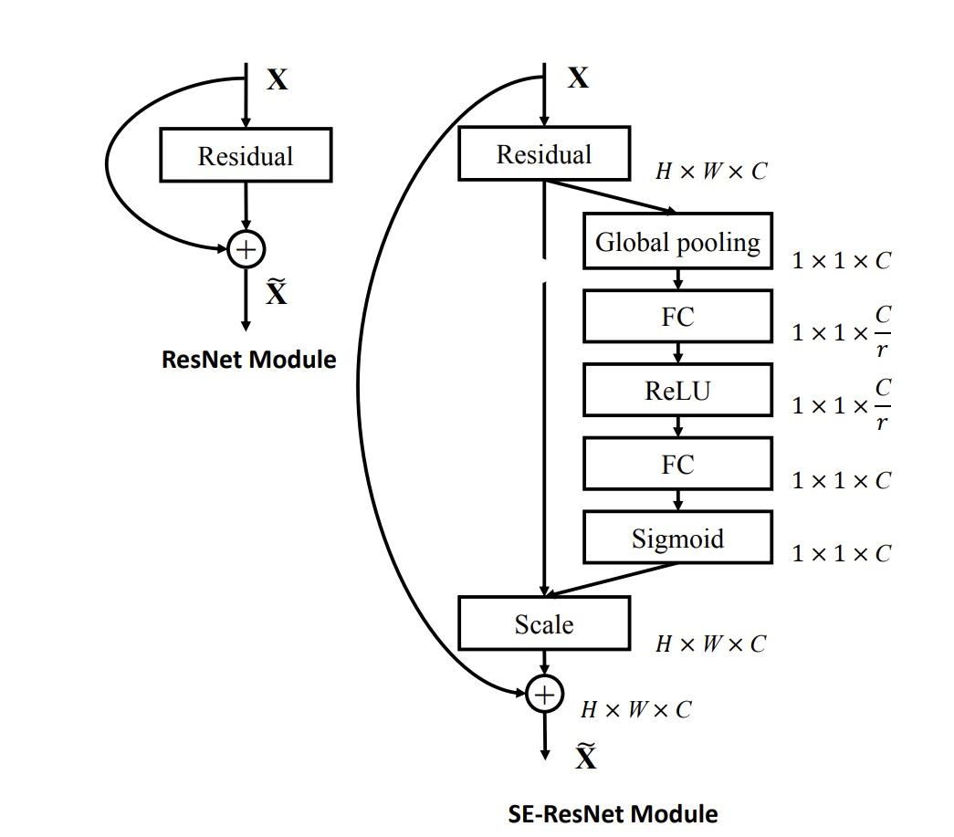
Figure 5.7: ResNet and SEResNet building blocks from [82].

forms ResNet on Imagenet. The authors attribute this to two key components of the architecture [82]:
- Squeeze: Global average pooling is applied to feature maps to generate a single descriptor per channel.
- Excite: The channel-wise descriptors are passed through a bottleneck of two fully connected layers, followed by a sigmoid gating mechanism to generate per-channel weights. Multiplying the feature maps with these weights suppresses redundant channels and boosts informative channels ahead of the residual connection.
We hypothesise that the addition of Squeeze-and-Excite modules could improve feature extraction in the FibLivPath dataset by diminishing features from artefact and up-weighting the sparse pathological signs.

5.3.2 Unsupervised Learning of Histopathology Features
Based on the success of applying SimCLR [83] to H&E stained histopathology datasets to improve downstream model performance versus Imagenet pre-trained feature extractors [44] as discussed in Section 3.1.3. Therefore, we investigated the application of the SimCLR architecture (Figure 3.7) on the FibLivPath dataset.
The key experiments we conducted were as follows:
- Unsupervised pre-training: Ciga et al demonstrated best downstream model performance from pre-training the SimCLR model with stronger data augmentations in the contrastive loss function. We aimed to test this on the FibLivPath dataset. We implemented the augmentations (reflection, rotation, blur, cropping) as in [44] and varied only the strength of the ColorJitter parameter (Section 5.1.3):
  - Light: brightness=0.4, contrast=0.4, saturation=0.4, hue=0.2.
  - Medium: brightness=0.8, contrast=0.8, saturation=0.8, hue=0.2.
  - Strong: brightness=0.8, contrast=0.8, saturation=0.8, hue=0.4.
- Fine-tuning method: We investigated freezing the pre-trained encoder or training all layers for the downstream classification task.
- Transfer learning from histopathology datasets vs ImageNet: We investigated transfer learning using the publicly available weights from Ciga et al which were trained on 60 H&E histopathology datasets [44]. We aimed to compare this to using ImageNet pre-trained weights or using the weights from SimCLR pre-training on the FibLivPath dataset.

5.3.3 Aggregation of Features
The range of aggregation methodologies is described in Table 3.2 in Section 3.1.2.
We investigated max-pooling because it is intuitive and matches the methodology used by a histopathologist, who will rank a WSI according to the most severe fibrosis feature seen. We investigated Gated Attention [25] because attention mechanisms strengthen the learning signal and are therefore favourable for small datasets [29]. Attention also adds a level of interpretability desirable for clinician end-users.
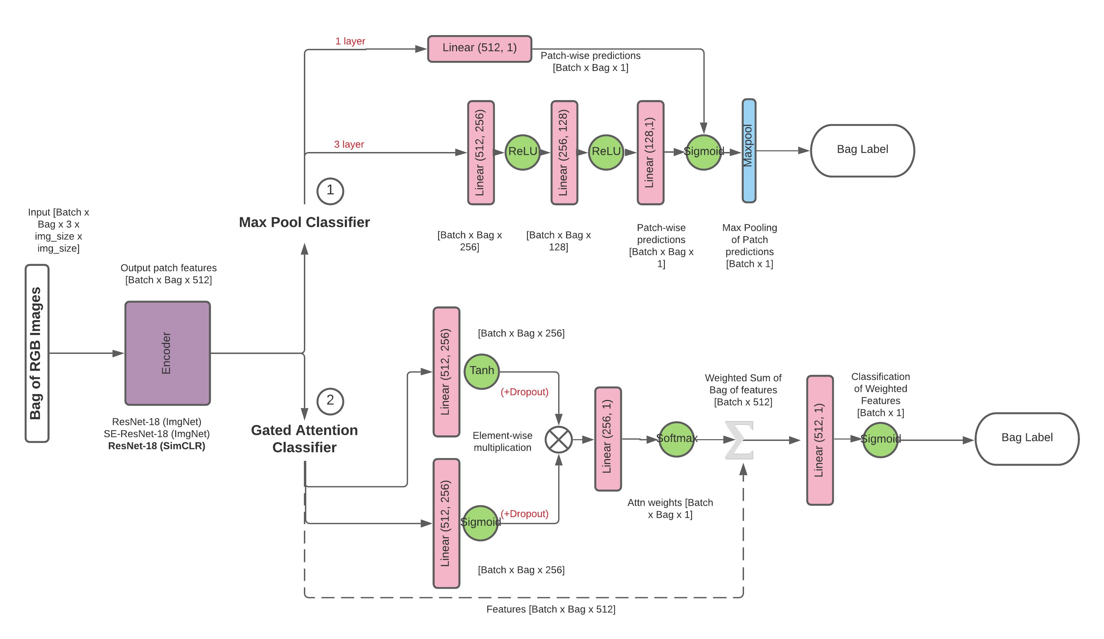
Figure 5.8: Aggregation architectures.
The architectures explored are detailed in Figure 5.8 and key formulas are recapped below [25]:
- Max Pooling:
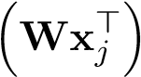
y_{k} = sigm
(5.3)
Y = max_{k} y_{k}
– Number of layers: We explored using a single linear layer, and multiple linear layers interspersed with ReLU non-linearity ahead of patch-level prediction.
- Gated Attention:
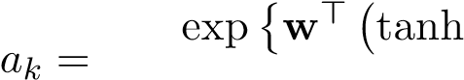 Vx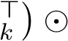sigm Ux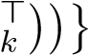
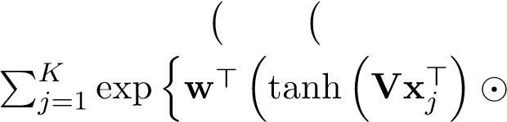 sigm Ux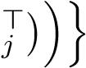
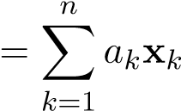
(5.4)
z

Y = sigm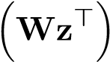
– Dropout: We explored the addition of Dropout (p = 0.25) after both of the sigm and tanh gated linear layers, which we hypothesised would reduce overfitting.

5.4 Implementation
The following section summarises the structure of the GitHub repository that accompanies this project.
The project was built with Python version 3.8.8 and extensively uses PyTorch, Scikit-learn, Pandas, OpenCV, Pillow, and OpenSlide for NDPI and TIFF file manipulation. All experiments were run on NVIDIA GeForce RTX 2080 Ti graphics cards and an Intel(R) Core(TM) i9-9900X CPU @ 3.50GHz. The dependencies are all specified in the requirements final.txt file and the install packages.sh script. Some functions, notably the SSC module and the Gated attention architectures, were developed from the following Github repositories: https:// github.com/Zhengyushan/ssc and https://github.com/AMLab-Amsterdam/AttentionDeepMIL.
After discussions with my supervisor, we agreed that the entirety of the codebase would not be uploaded alongside the report submission. Some final optimised ML architectures are held private as a research paper is expected to be produced from this project. Once published, all code will be shared on a public GitHub.

5.4.1 Pre-processing
Hereinafter we detail the high-level functionality of python modules used for converting raw NDPI digital slides into usable patches for downstream model training. Jazz MackSmith conducted initial matching of annotations and anonymous biopsy ids to the raw data provided by clinicians. Relevant scripts are detailed in https://github.ic.ac.uk/jms3/ sirius_red. We significantly modified the ndpi slide module, detailed below.
- ndpi slide/ This module contains class wrapper for OpenSlide object for manipulating NDPI files. The main function used in pre-processing is tile and save jpg ilastik().
- create patches.py This script is run with command line arguments to control the key parameters of the patching process as detailed in Section 5.1.1, such as tissue size (mm), overlap (%), magnification (5x) and adapt method (threshold) which all have default values suitable for the FibLivPath dataset. The script first saves down lowresolution JPEGs for each WSI in the project root directory, feeds these to the pretrained Ilastik model (Ilastik pixel segmentation.ilp) provided and generates a .h5 background mask. Information on all valid patches for training are output in a CSV file.
- dataset generic/ This module contains three customised PyTorch dataset classes to load bags for multiple instance learning. The CustomDataset class loads bags per Dataloader 1 and MultipleInferenceDataset loads bags per Dataloader 2 as detailed in Section 5.2. The key difference between the two classes is the form bags() function in the MultipleInferenceDataset which synthetically generates a dataset with noisy labels from all valid tiles generated from the tiling process. The final class CustomPairDataset applies two random transforms to each patch for unsupervised pre-training with a contrastive loss for experiments detailed in Section 5.3.2. All dataset classes take as input a dataframe from the tiling CSV, the location of the raw NDPI files from which tiles will be read and the augmentation or normalisation parameters detailed in data augment and Reinhard.py.
- data augment/ This module contains class used to apply random affine and colour augmentations from the Torchvision library.
- Reinhard.py contains code for applying Reinhard Colour Transfer adapted from StainTools https://staintools.readthedocs.io/.

5.4.2 Models
The following modules and scripts describe the implementation of Deep Learning architectures and training functions for our proposed multiple inference framework.
- model zoo/ This module contains deep learning architectures to specify the Encoder class, which modifies and builds ResNet-18, ResNet-34, and SEResNet-18 and SEResNet34 feature extractors. There are also three instance aggregation architectures GatedAttention, SimpleAttention and MaxPoolClassifier. in the forward() functions, predictions and either attention weights per bag or the instance which triggered the bag label in the case of the Max-Pool architecture are output. The final architecture in this module is the SimCLRModel which contains a ResNet-18 encoder, and 2-layer MLP projection head. All models can be instantiated with ImageNet weights using the img net=True flag.
- ssc utils/ This module contains the model architecture for our SSC experiments alongside modified training, evaluation and reconstruction loss functions to evaluate the Stain Standardisation Capsule [4].
- utils.py This script contains general utility functions for conducting machine learning experiments.
- training.py This script contains training and testing functions for our baseline model.

5.4.3 Experiments and Evaluation
The following scripts are initialize and run experiments detailed in Chapter 6. We utilise the Weights and Biases [84] software for logging metrics and visualisations. Hyperparameters can be adjusted using the configuration dictionaries under if name == ´ main ´:.
- unsupervised training.py contains code to load a configuration dictionary and run unsupervised pre-training of the SimCLR model with a ResNet-18 base.
- scc test.py This script contains the training and evaluation loop, which loads parameters from a configuration dictionary, builds the model, and then trains and tests the model for each cross-validation fold and outputs the results to the Weights and Biases [84] platform. We use this script for all fine-tuning experiments. The configuration dictionary contains information on training parameters such as batch size, the number of cross-validation folds, whether to train with early stopping, which dataloader to use. Architecture configuration parameters are also included (SSC module, feature extractor and MIL aggregation architecture).
- test set summary.ipynb This notebook contains code to load pre-trained models for each test fold, visualise the training bags, model predictions and attention coefficients per instance. The notebook generates a word document to analyse a full inference pass of the dataset with a given model.
Chapter 6

Results and Discussion

6.1 Reporting
Given the variation in stain appearance, artefacts and features across the FibLivPath dataset, we train and test models based on 5-fold cross-validation. The degree of variation across folds is key to understanding model stability and generalisability at the time of deployment. This leads to mean and standard deviation values for the accuracy and F1 score. All experiments are conducted with the same random seed since the variation across seeds is significantly less than that generated from the dataset diversity.
Given the exploratory nature of the project, the potential uses of deep learning models for classification on the FibLivPath dataset are open-ended. Therefore, it is essential to compare models across a range of metrics (detailed in Section 3.2.3). We choose to report mean accuracy and F1 scores, as well as overall precision, recall, specificity, F2 and MCC scores from the total confusion matrix across folds. For all models, since class proportions are balanced, accuracy is a strong indication of classification performance. However, if used as an initial screen by clinicians, a model with highest recall might be preferred not to miss any disease case. In contrast, a model with the highest precision might be preferred to direct attention to only the most severe cases.

6.2 Establishing a MIL Baseline Model
To establish our baseline model, we investigated the following three key aspects of a MIL deep learning pipeline trained for binary classification of the dataset into mild (Fibrosis stage ≤ 2) versus severe disease (Fibrosis stages 3 and 4):
- Encoder architecture
- Feature aggregation method
- MIL bag size
We report the best results at each stage.
Firstly, we applied the most simple MIL framework detailed in Figure 5.8, in Section 5.3.3, using bags built with Dataloader 1 (Section 5.2).
The training was extremely unstable, with accuracy varying by over 20% across folds. The two most important parameters tuned to improve stability were the encoder learning rate and batch size.
We experimented with small architectures to limit overfitting problems. Our initial stable baseline model uses a ResNet-18 encoder with Max-Pooling instance-level aggregation. We identified a batch size of 6 as a good compromise between GPU capacity and training stability.
We noted that encoders with randomly initialised weights showed poor convergence properties given the small training cohort. We therefore initialised the encoder with ImageNet pre-trained weights available in the Torch library.
We conducted full fine-tuning with a constant learning rate of 0.0001 for all model parameters and weight decay of 0.0001 with an Adam optimizer, batch size of 6 and bag size of 10. We trained with vertical and horizontal flips and tuned the degree of random rotation to 50 degrees. Based on the training and validation loss curves, it was immediately apparent that our models were overfitting the small training dataset. Therefore, we implemented early stopping based on a 10% validation set that selected the lowest validation error model. Early stopping was crucial in improving model stability across the 5 test folds.

6.2.1 Optimised Encoder Architecture
We compare baseline ResNet-18 with the SEResNet-18 model (cf. Section 5.3.1), both initialised with ImageNet pre-trained weights.
Table 6.1: Comparison of two ResNet-18 based encoders. Training parameters: ImageNet pretrained weights, Max Pooling aggregation (one linear layer), batch size=6, bag size =10, learning rate=0.0001, weight decay=0.0001, Adam optimiser, trained with early stopping on 10% validation set.
Encoder | Accuracy | F1 | Recall | Specificity | Precision | F2 | MCC
SEResNet-18 | 72.37% ± 4.51% | 69.18% ± 7.84% | 64.47% | 80.26% | 76.56% | 66.58% | 45.31%
ResNet-18 | 69.03% ± 6.37% | 63.66% ± 10.57% | 56.58% | 81.58% | 75.44% | 59.56% | 39.41%
The test results of these preliminary experiments are shown in Table 6.1. The ResNet-18 model, with 6.37% standard deviation in accuracy and the 10.57% standard deviation in F1 score, leads to some folds performing only slightly better than random chance (50%) which was very poor. The application of the Squeeze-and-Excitation (SE) modules to this feature rich dataset showed some promise, achieving an accuracy of 72.37 ± 4.51% and a F1 score of 69.18 ± 7.84%. Hence channel-wise attention seems important for the extraction of salient features from noisy, artefact-heavy WSI patches. Therefore, we conducted all subsequent experiments using a SEResNet-18 encoder.

6.2.2 Optimised Features Aggregation
We explored here the impact of adding further non-linearity to the Max-Pooling part by increasing the number of fully-connected layers from 1 (baseline) to 2 and 3 before patch-level classification. Secondly, we explored the Gated Attention architecture detailed in Figure 5.8 and Section 3.1.2.
Table 6.2: Comparison of features aggregation methods. Training parameters: SEResNet-18 (init with ImageNet), batch size=6, bag size=10, learning rate=0.0001, weight decay=0.0001, Adam optimiser, trained with early stopping on 10% validation set. Max Pooling (n) uses n fully-connected layers
Aggregation | Accuracy | F1 | Recall | Specificity | Precision | F2 | MCC
Gated Attention | 74.32% ± 5.38% | 70.18% ± 10% | 64.47% | 84.21% | 80.33% | 67.12% | 49.66%
Max Pooling (1) | 72.37% ± 4.51% | 69.18% ± 7.84% | 64.47% | 80.26% | 76.56% | 66.58% | 45.31%
Max Pooling (2) | 66.54% ± 13.21% | 54.54% ± 25.54% | 48.68% | 84.21% | 75.51% | 52.41% | 35.19%
Max Pooling (3) | 68.43% ± 9.74% | 60.2% ± 18.26% | 53.95% | 82.89% | 75.93% | 57.26% | 38.49%
The test results from these aggregation experiments are reported in Table 6.2. When comparing the Max Pooling models, we can see that performance significantly deteriorates when adding fully-connected layers. Across all metrics, Gated Attention outperforms all variations of Max-Pooling, in line with the conclusions of Ilse et al. [25]. Therefore, we conducted all subsequent experiments using Gated Attention for features aggregation.

6.2.3 Optimised Bag Size
We explored the effect of bag size (k), i.e. the number of tiles used per WSI during training, in a range of 5 to 20. Our hypothesis was that the model performance could be low at both ends of this range with an optimum in the middle. Intuitively, having bags too small could lead to information loss and bags too large to a reduction in the strength of the learning signal due to the sparsity of pathological signs in each WSI.
Table 6.3: Comparison of bag sizes (Dataloader 1). Training parameters: SEResNet-18 (ImageNet), Gated Attention aggregation, batch size=6, learning rate=0.0001, weight decay=0.0001, Adam optimiser, trained with early stopping on 10% validation set.
Bag Size | Accuracy | F1 | Recall | Specificity | Precision | F2 | MCC
5 | 66.43% ± 4.99% | 61.94% ± 9.5% | 56.58% | 76.32% | 70.49% | 58.90% | 33.55%
10 | 74.32% ± 5.38% | 70.18% ± 10% | 64.47% | 84.21% | 80.33% | 67.12% | 49.66%
15 | 64.45% ± 9% | 49.43% ± 23.3% | 40.79% | 88.16% | 77.50% | 45.06% | 32.87%
20 | 65.76% ± 6.2% | 55.75% ± 17.93% | 50.00% | 81.58% | 73.08% | 53.37% | 33.28%
From results in Table 6.3, we can see that our hypothesis was confirmed using Dataloader 1, where the top 5-20 tiles are selected for training based on their red-pixel content (used as a noisy proxy for the informative fibrosis feature content). A bag size of 10 was found optimal and therefore selected for subsequent experiments.

6.2.4 Finalised Gated Attention MIL Baseline Model
The final baseline architecture established on the FibLivPath dataset is detailed in Table 6.4 which achieves a mean accuracy of 74.32 ± 5.38% and a mean F1 score of 70.18 ± 10.08%. A this stage we are concerned with two types of issues:
- Poor recall (64.47%): We suspect that this is mostly due to the sparsity of pathological signs and the tile selection method in Dataloader 1, to be revisited.
- Performance variability (10% in F1):
  - variability in performance is large across the different colour categories in the dataset. Developing a model which is either invariant to stain appearance, or biased to perform better on a particular stain appearance could be beneficial.
  - The model seems to struggle in distinguishing between fibrosis features and some artefacts. Methods that enable more discriminative features to be learned could be a powerful tool to identify salient information from a WSI bag peppered with artefacts.
Table 6.4: Gated Attention MIL Baseline Model pyperparameters.

Parameter - Value
Encoder | SEResNet-18 (ImageNet)
Aggregation | Gated Attention
Total # params | 11,526,978
Patch size | 224 x 224
Epochs | 100
Early stopping criterion | min validation error / loss
Learning rate | 0.0001
Weight decay | 0.0001
Optimizer | Adam
Batch size | 6
Bag size | 10 (Dataloader 1)
Flip | along x and y axis
Rotation | 50°

6.3 Exploratory Experiments to Improve the MIL Baseline model
To improve model accuracy and attempt to address the limitations of our Gated Attention Baseline, we explored the following hypotheses:
- Further regularisation via data augmentation and dropout could reduce overfitting on the training set by reducing reliance on any single patch within a WSI bag.
- Unsupervised pre-training on the FibLivPath dataset or use of transfer learning from large histopathology datasets may improve the learning of discriminative features over ImageNet pre-trained weights.
- Stain normalisation could improve performance. We compared the following strategies seen in literature to address stain colour variation: Reinhard stain normalisation, Stain Standardisation Capsules and Data Augmentation.
- Re-engineering Dataloader 1 to reduce information loss.
The following experimental results utilise all the hyperparameters from the Gated Attention Baseline MIL model in Table 6.4 unless otherwise stated. Given the breadth of the problem, time constraints and the uncertainty about which of the above hypotheses would be successful, the subsequent experiments were conducted independently. Therefore, the results of the following experiments only highlight some promising avenues for further exploration rather than providing a single optimised solution to classify the complex FibLivPath dataset.

6.3.1 Experiment 1a: Additional Data Augmentation
Baseline experiments only explored image rotation in addition to vertical and horizontal flips. We explored here addition of Gaussian blur (GaussianBlur), and random resizing and cropping (RandomResizedCrop) as transforms on the training set. We conducted experiments to test the impact of the presence or absence of each transform in turn. The parameter size for each transform remained fixed at visually realistic values. We use RandomRotation with value = 50◦, RandomResizedCrop where we crop a random area between min crop = 80% to 100% and resize it to the original image size, and GaussianBlur with (kernel,σ) = (5,1.0). All experiments applied horizontal and vertical flips as a base transformation.
Results are displayed in Table 6.5. The best average accuracy was achieved in Experiment 1 which uses all three augmentation transforms (75.61 ± 7.65% and F1 to 72.67 ± 7.47%). It improves the Gated Attention Baseline model (Experiment 2) by ∼ 1% accuracy and ∼ 2% F1 score.
We see that removing all added transforms in Experiment 3 only reduces the mean accuracy by 0.6%, but increases mean F1 by 2.8% via a recall increase by 8.1% and precision decrease of 6%. The tested data augmentation transforms make the inference more precise at the cost of missing more disease cases.
Table 6.5: Adding transforms in data augmentation. Training parameters: RandomRotation max value = 50◦, RandomResizedCrop min crop = 80% of image size, GaussianBlur (kernel,σ) = (5,1.0). All experiments applied horizontal and vertical flips as a base transformation.
Experiment | Blur / Rotate / ResizedCrop | Accuracy | F1 | Recall | Specificity | Precision | F2 | MCC
Exp 1 | Y \Y \Y | 75.61% ± 7.56% | 72.67% ± 7.47% | 65.79% | 85.53% | 81.97% | 68.49% | 52.35%
Exp 2 (baseline) | N \Y \N | 74.32% ± 5.35% | 70.18% ± 10.03% | 64.47% | 84.21% | 80.33% | 67.12% | 49.66%
Exp 3 | N \N \N | 73.66% ± 5.68% | 72.99% ± 7.19% | 72.37% | 75.00% | 74.32% | 72.75% | 47.38%
Exp 4 | Y \N \Y | 72.3% ± 7.68% | 69.92% ± 9% | 67.11% | 77.63% | 75.00% | 68.55% | 44.99%
Exp 5 | Y \N \N | 71.72% ± 4.79% | 66.75% ± 12.53% | 61.84% | 81.58% | 77.05% | 64.38% | 44.29%
Exp 6 | Y \Y \N | 69.7% ± 4.12% | 67.43% ± 6.94% | 64.47% | 75.00% | 72.06% | 65.86% | 39.69%
Exp 7 | N \N \Y | 68.47% ± 5% | 60.23% ± 9.34% | 50.00% | 86.84% | 79.17% | 53.98% | 39.63%
Exp 8 | N \Y \Y | 68.39% ± 6.67% | 62.48% ± 11.42% | 56.58% | 80.26% | 74.14% | 59.39% | 37.92%
We looked at the linear correlation and parameter importance (second-order dependence) of each of the transforms with respect to the mean accuracy. We used the Weights and Biases software [84], which fits a Random Forest with the transform parameters as the input and the mean accuracy as the target output. We note that this is likely unreliable due to the small number of experiments. Indicatively, we observed a positive correlation between Blur and Rotation and a slight negative correlation between the use of ResizedCropping and the mean accuracy. The parameter importance of Blur is higher than that of the other two transforms.
A full hyperparameter sweep would be required to identify a global optimum configuration. For example, stronger ResizedCropping (e.g. < 10% image size) could still be beneficial to learn more generalisable features as seen in [44].

6.3.2 Experiment 1b: Adding Dropout
We apply dropout to randomly inactivate neurons in the attention layers with probability p = 0.25. Table 6.6, shows clear benefits of using dropout as it increases baseline accuracy by 2.4%, F1 score by 4.8% with an increase of recall (+6.6%) and stable precision.
Table 6.6: Effect of adding dropout to baseline MIL model. Training parameters: Gated Attention Baseline with the addition of dropout after each of the attention linear layers with dropout probability = 0.25.
Dropout | Accuracy | F1 | Recall | Specificity | Precision | F2 | MCC
Y | 76.7% ± 4.7% | 74.96% ± 6.72% | 71.05% | 82.89% | 80.60% | 72.78% | 54.33%
N | 74.32% ± 5.35% | 70.18% ± 10.03% | 64.47% | 84.21% | 80.33% | 67.12% | 49.66%

6.3.3 Experiment 2: Unsupervised Feature Learning
We applied the SimCLR model to the FibLivPath dataset with the aim of reducing model variance by learning more robust features. The architecture, hyperparameters and augmentation settings we used are detailed in Table 6.7 and are based on those used in [44]. We determined that for the small FibLivPath dataset, only the model pre-trained with ’Light’ colour augmentation was worth exploring to search for improvements in downstream model performance given time and resource constraints. Our models being pre-trained on a single NVIDIA GeForce RTX 2080 Ti GPU, we could only explore batch sizes up to 32. Chen et al [83] showed that large batch sizes facilitated convergence of contrastive loss function by providing more negative examples. The small batch size significantly limited our ability to explore stronger data augmentation settings as these increase the difficulty of the unsupervised pre-training task as evidenced by the loss curves in Figure 6.1. The final SimCLR pre-trained encoder used for experiments in Table 6.8 was trained for 8600 epochs.
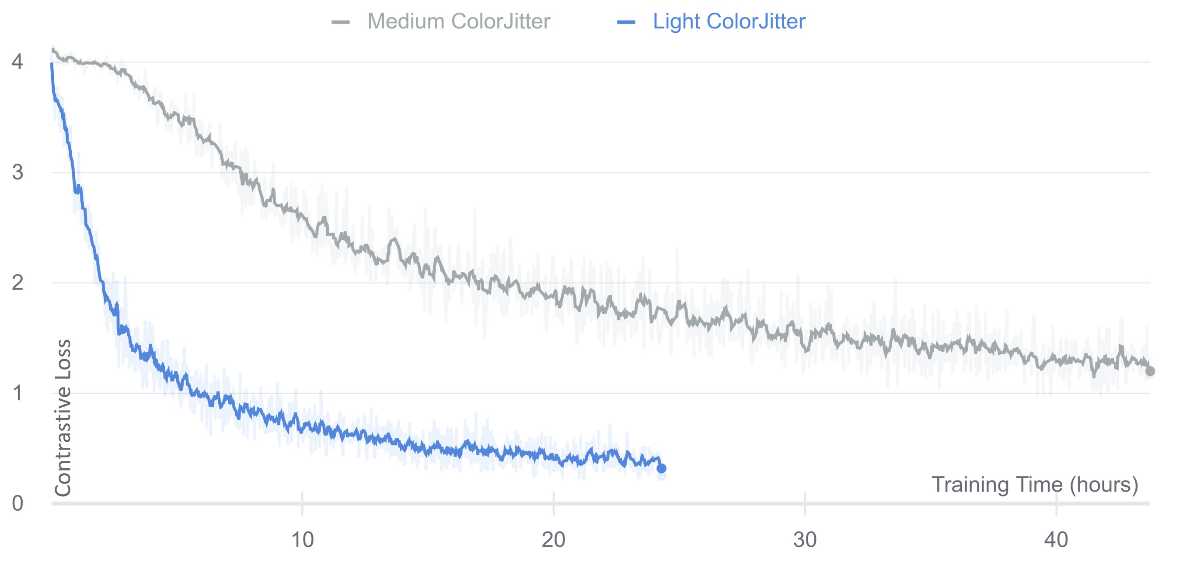
Figure 6.1: Unsupervised feature learning: Training loss curves for the two best SimCLR models explored. Poor convergence of the contrastive loss function is seen for the ’Medium’ colour augmentation setting detailed in Table 6.7 despite over 40 hours of training time.
After exploring both full-fine-tuning of the encoder and using a fully-frozen encoder in the
Gated Attention Baseline model framework, the best accuracy achieved was
71.08% ± 2.10% with a F1 score of 68.6% ± 4.90%. While the standard deviation of the results across the cross-validation folds is lower than that of the ImageNet pre-trained model, this method under performs the baseline by 3 % in terms of accuracy.
Table 6.7: Unsupervised feature learning: SimCLR Parameters - Values.

SimCLR pre-training Parameters
Base Encoder | ResNet-18 (output 512-dim)
Projection Head | 2-layer MLP (output 128-dim)
Total # params | 11,333,312
Patch size | 224x224
Temperature | 0.1
Learning rate | 1.00E-06
Weight decay | 1.00E-04
Optimizer | Adam
Batch size | 32
Flip | along x and y axis
Rotation | (0 , 90, 180 , 270)
Gaussian Blur | kernel 24, σ ∼ (0.1,2.0)
RandomResizedCrop (min crop) | 1%
ColorJitter (light) | brightness=0.4, contrast=0.4, saturation=0.4, hue=0.2
ColorJitter (medium) | brightness=0.8, contrast=0.8, saturation=0.8, hue=0.2
Ciga et al [44] pre-trained using 60 datasets and 48k image patches. We hypothesised that the large staining variation in the FibLivPath dataset might mimic the diversity in features obtained from multiple datasets and help to outweigh the impact of the small dataset size. However, the 13.6% under performance in accuracy in Experiment 3 shows that despite stain variation, SimCLR pre-training on a dataset of only 150 WSIs is inferior to the large scale pre-training available on natural image datasets. While it is still unknown to what extent the batch size hindered pre-training, it is unlikely to overcome the limitations on dataset size.
Given that Sirius-Red stained datasets are rare in comparison to H&E datasets, and machine learning papers on Sirius-Red NAFLD biopsies are extremely scarce, the closest large scale pre-training that could be conducted on histopathology data would be on H&E, largely cancer specific datasets such as was done by Ciga et al [44]. The authors made their pre-trained encoder (ResNet-18) weights publicly available. Therefore, in Experiment 4, we assessed the efficacy of direct transfer learning from these weights. As expected, the results were extremely poor (random chance) due to the large domain shift. We therefore conclude, given GPU constraints, that the application of SimCLR to this use case is not promising compared to using Imagenet pre-trained models due to the dearth of relevant Sirius-Red stained WSI data.
Table 6.8: Comparison of unsupervised pre-trained encoders. Training parameters: Gated Attention Baseline model. Ozan Ciga ResNet-18 uses pre-trained weights from [44].
Encoder | Accuracy | F1 | Recall | Specificity | Precision | F2 | MCC
SimCLR ResNet-18 (full fine tuning) | 71.08% ± 2.1% | 68.6% ± 4.9% | 64.47% | 77.63% | 74.24% | 66.22% | 42.47%
SimCLR ResNet-18 (frozen) | 60.7% ± 12.09% | 57.96% ± 12.68% | 53.95% | 67.11% | 62.12% | 55.41% | 21.24%
Ozan Ciga ResNet-18 (frozen) | 52% ± 11.6% | 49.1% ± 8.36% | 44.74% | 60.53% | 53.13% | 46.20% | 5.33%

6.3.4 Experiment 3a: Stain Standardisation Capsule (SSC)
The SSC module was designed for stain deconvolution and normalisation of H&E stained WSI patches without background pixels [4]. Therefore, it was unknown whether a direct application of the module to the FibLivPath dataset would be promising. Given the vast, partly continuous, hyperparameter search space, a thorough investigation was infeasible in the allotted time frame. Therefore, we aimed to investigate whether few tested configurations could outperform the Gated Attention Baseline.
Table 6.9: Stain Standardisation Capsule (SSC) hyperparameters.

SSC Module (M, N, R) Hyperparameters
SSC Module | (M, N, R, S=2), L2 reconstruction loss
Encoder | SEResNet-18
Aggregation | Gated Attention
Total params | 11,523,965
Patch size | 224 x 224
Epochs | 100
Early stopping criterion | min validation error / loss
Encoder learning rate | 0.0001
SSC initial learning rate | 0.1
SSC learning rate schedule | x 0.1 every 30 epochs
SSC input | RGB image, with OD transform
Weight decay | 0.0001
Optimizer | Adam
Batch size | 6
Bag size | 10
Reflection | along x and y axis
Rotation | 50°
The Gated Attention Baseline model remained fixed and a random hyperparameter search was conducted across the SSC architecture with parameters (M, N), learning rates for the SSC module, and affine data augmentations (Section 5.1.3). The search was designed to stop once a few promising configurations were identified that outperformed either the mean accuracy or the mean F1 score of the Gated Attention Baseline model. This lead to two promising configurations reported in Table 6.10 that can be tuned and investigated further in future work. The SSC (6,3,3) configuration was more stable to perturbations in parameters despite the lower overall performance compared to SSC (5,3,3).
Table 6.10: Promising SSC (M,N,R) results. Training Parameters SSC (6,3,3)= base parameters and SSC (5,5,3) = base with addition of strong Gaussian Blur (kernel 37) applied with 50% probability and strong RandomResizedCropping (up to 7% image size) applied with 50% probability.
Model | Accuracy | F1 | Recall | Specificity | Precision | F2 | MCC
Gated Attention Baseline | 74.32% ± 5.38% | 70.18% ± 10% | 64.47% | 84.21% | 80.33% | 67.12% | 49.66%
SSC (5,5,3) | 77.7% ± 6% | 71.9% ± 11% | 60.53% | 94.74% | 92.00% | 64.97% | 58.81%
SSC (6,3,3) | 73.1% ± 7.09% | 71.86% ± 6.87% | 68.42% | 77.63% | 75.36% | 69.71% | 46.25%
We now describe few further investigations using SSC(6,3,3) to test the importance of SSC-specific reconstruction loss, number of stain channels and input format.
Reconstruction Loss: Results using different SSC reconstruction losses are reported in Table 6.11 and confirm that the use of the L2 loss is most suitable. Comparing reconstructed images in Figures 6.2 and 6.3a, one can see that the green-red colour contrast is best preserved using the L2 loss. Removing the reconstruction constraint is detrimental to performance. This shows that the SSC module does not learn ’useful’ features for the downstream classification task without the additional learning signal.
Minimising the HSV distance between histograms only preserves the global colour properties, and does not maintain the integrity of the tissue structures, which also results in poor downstream performance. While we briefly investigated applying the Hue-Net [80] loss function, which combines the hue-histogram distance with a mutual information loss to preserve structural integrity, we suspect that there were some issues in the implementation and therefore, this avenue has been left for future work due to time constraints.
Table 6.11: Comparison of reconstruction loss functions. Training parameters: SSC (6,3,3) model.
Loss | Accuracy | F1 | Recall | Specificity | Precision | F2 | MCC
L2 | 73.1% ± 7.1% | 71.9% ± 6.9% | 68.42% | 77.63% | 75.36% | 69.71% | 46.25%
L1 | 69.78% ± 4.5% | 67.35% ± 6.5% | 63.16% | 76.32% | 72.73% | 64.86% | 39.82%
Weighted L2 (R=1, G=2, B=1) | 66.14% ± 5.86% | 65.3% ± 5.66% | 63.16% | 69.74% | 67.61% | 64.00% | 32.97%
Weighted L1 (R=1, G=2, B=1) | 67.1% ± 1.7% | 65.5% ± 4.7% | 64.47% | 69.74% | 68.06% | 65.16% | 34.26%
Weighted L2 (R=2, G=1, B=1) | 63.08% ± 9.91% | 66.62% ± 6.15% | 72.37% | 53.95% | 61.11% | 69.80% | 26.77%
None | 63.78% ± 7.38% | 54.49% ± 18.47% | 50.00% | 77.63% | 69.09% | 52.92% | 28.75%
HSV | 65.12% ± 3.99% | 61.94% ± 6.64% | 61.84% | 64.47% | 63.51% | 62.17% | 26.32%
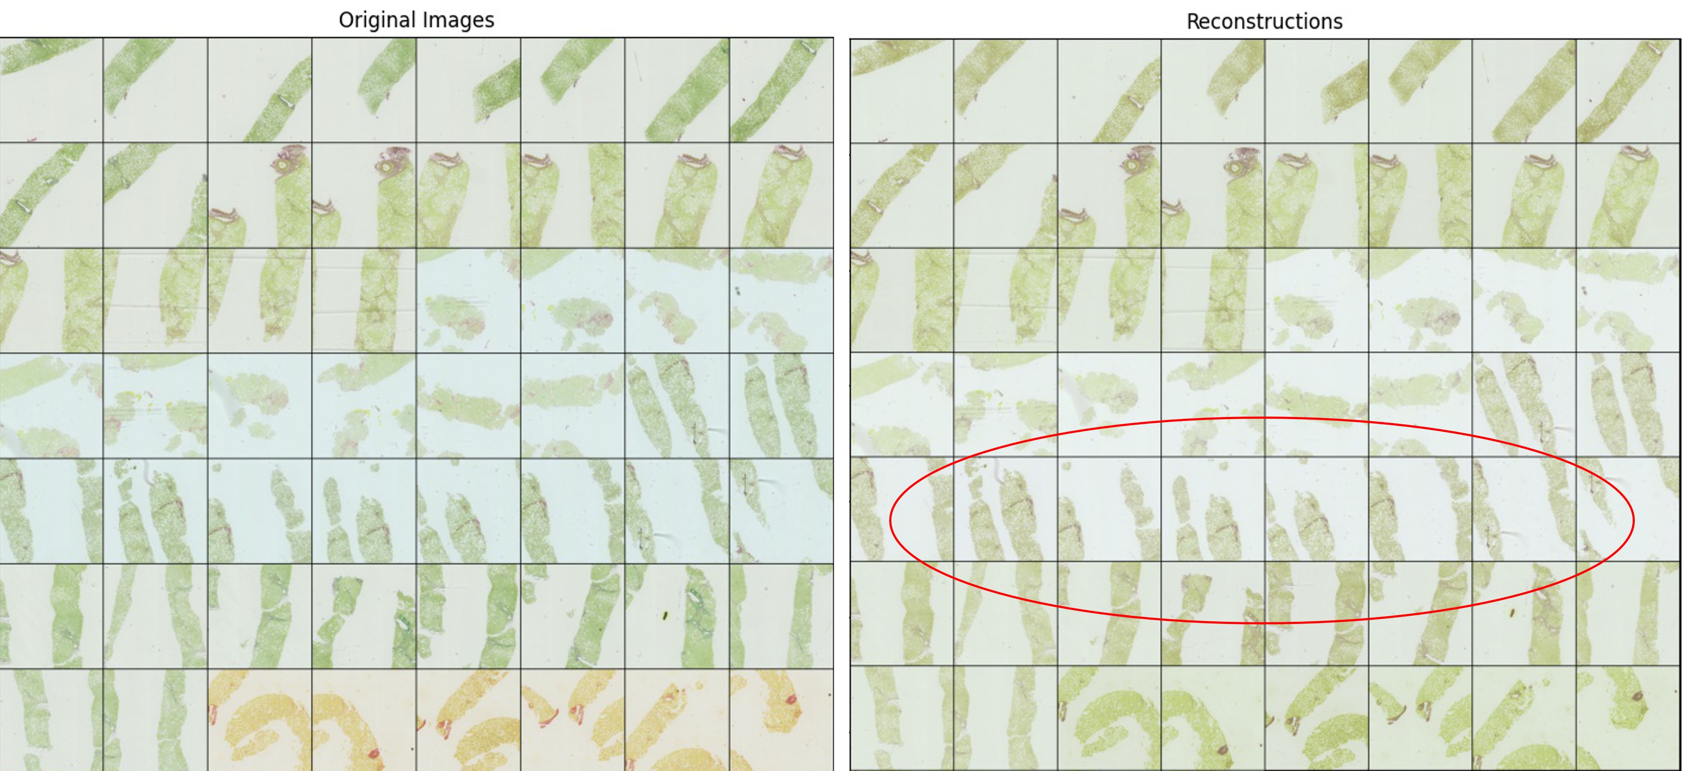
Figure 6.2: Reconstructions generated by SSC (6,3,3) module with L2 reconstruction loss. Smoothing is seen on tiles of colour category (2) (green tissue, blue background).
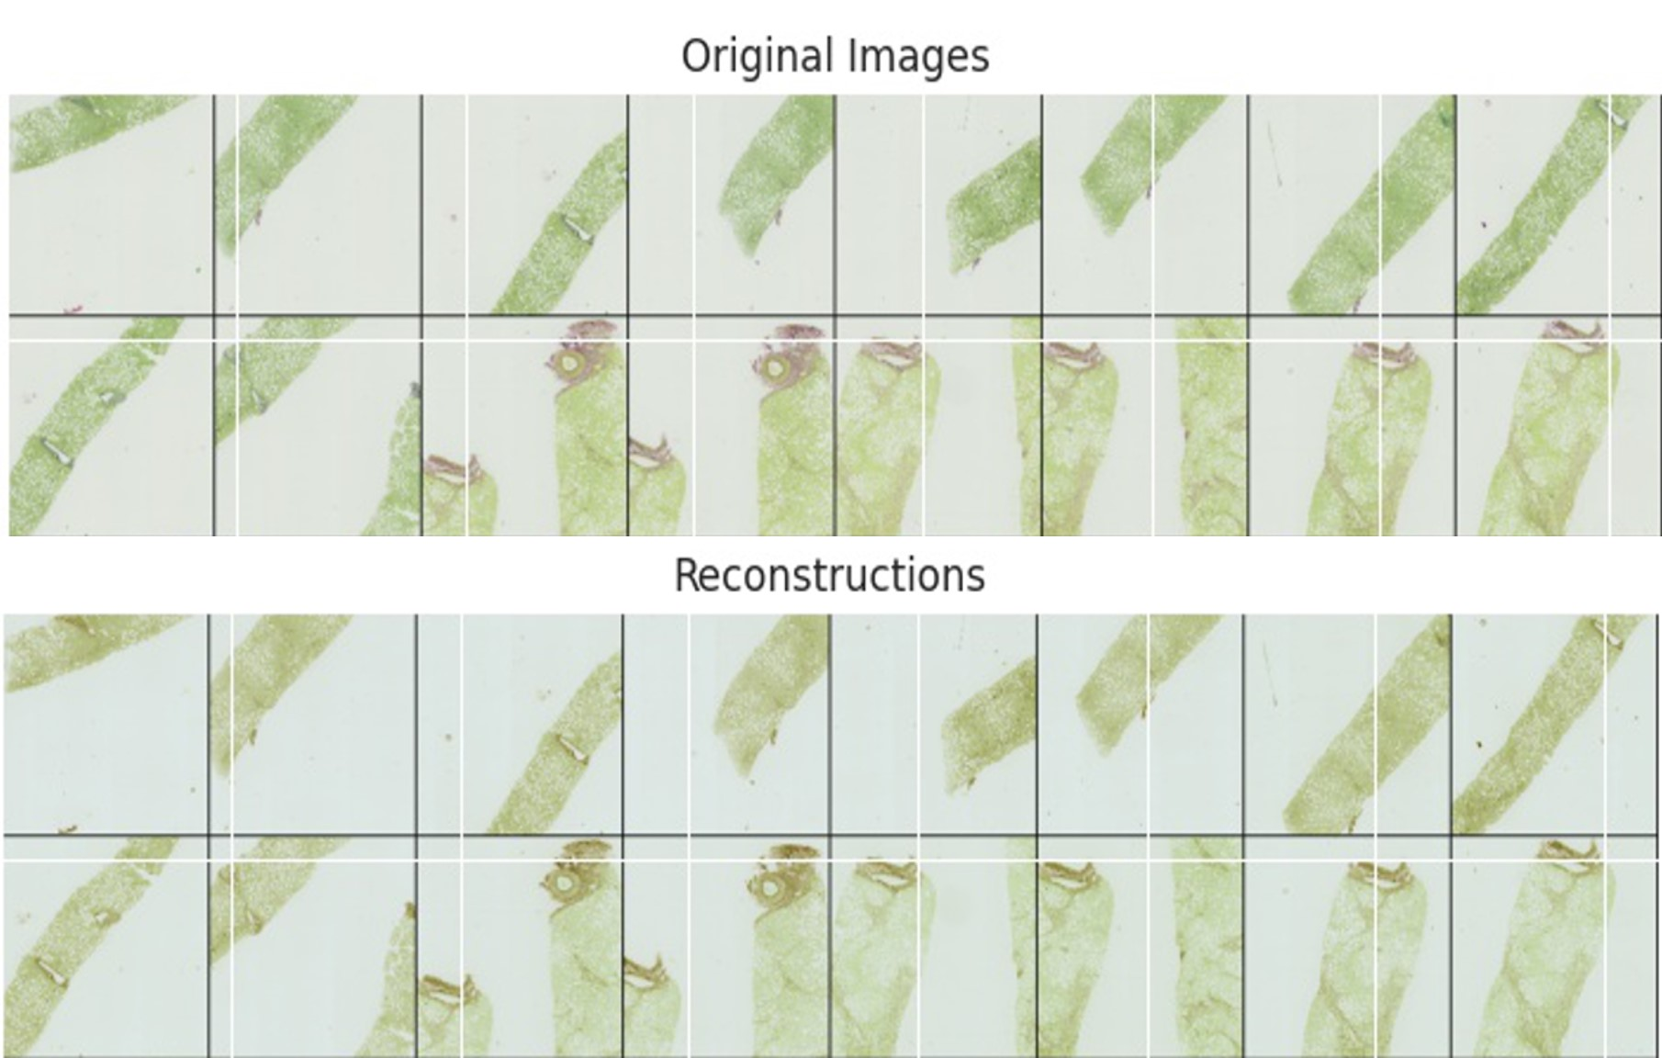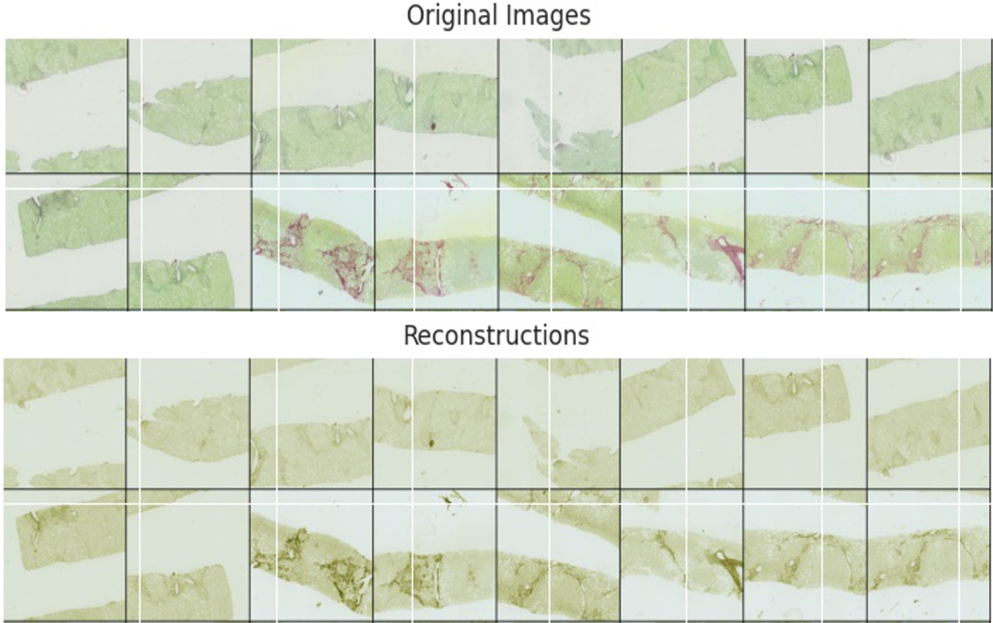
(a) (b)
Figure 6.3: Reconstructions generated by SSC (6,3,3) module with a L1 loss (a) and a weighted L1 loss function (b) with R,G,B weights = 1,2,1.
Stain Channels: We tested SSC with S=1,2 and 3 channels. Based on the experimental results in Table 6.12, we can see that the 2-stain architecture, despite Sirius-Red being only a single stain, works significantly better for the FibLivPath dataset. Despite maximising the total variation when assembling the normalised 1-channel SSC output, using S = 1 leads to significant smoothing between background and tissue. Smoothing leads to severe information loss, as seen in Figure 6.4a and unsatisfactory downstream performance. One might anticipate that using S=3 for the normalised output would learn the identity mapping and have little impact on downstream performance. However, we see a degradation in performance from 73.10% to 65.23% accuracy, potentially due to the Sparse Score used in dynamic routing. We see in Figure 6.4b significant degradation in the reconstructions. Since the Sirius-Red stain is naturally confined to the Red and Green channels in an RGB image, enforcing sparsity across all three normalised channels might prohibit identity mapping.
Table 6.12: Comparison of # of stain channels in SSC. Training parameters: SSC (6,3,3) model.
# Stain Channels (Dynamic Routing Score) | Accuracy | F1 | Recall | Specificity | Precision | F2 | MCC
S=1 (Total Variation) | 59.29% ± 7.53% | 54.86% ± 14% | 55.26% | 63.16% | 60.00% | 56.15% | 18.48%
S=2 (Sparse Score) | 73.1% ± 7.1% | 71.9% ± 6.9% | 68.42% | 77.63% | 75.36% | 69.71% | 46.25%
S= 3 (Sparse Score) | 65.23% ± 8.28% | 59.22% ± 13.4% | 53.95% | 76.32% | 69.49% | 56.47% | 31.05%
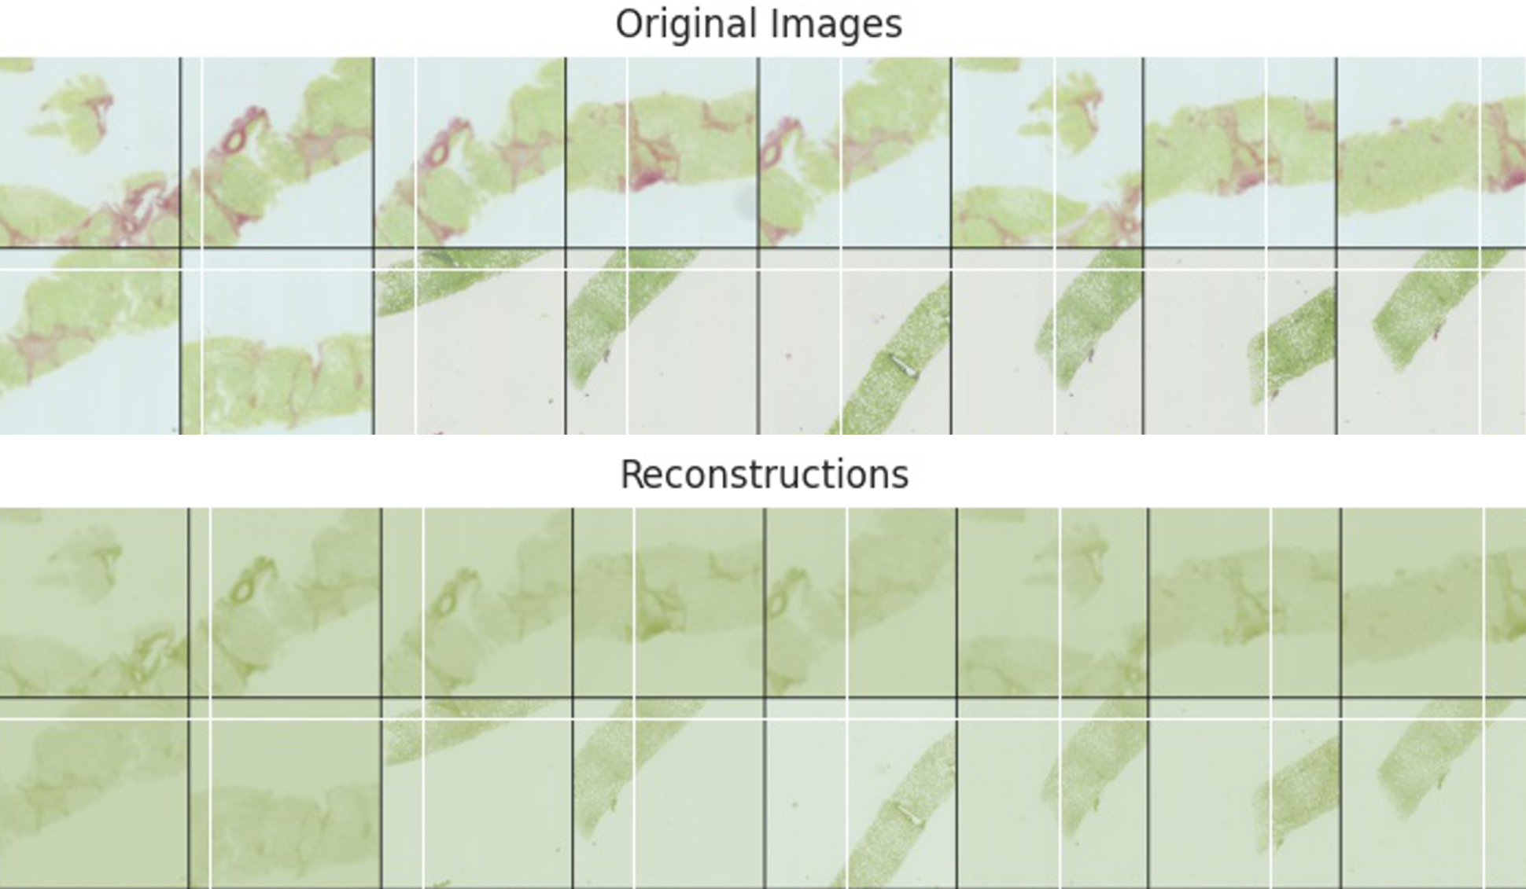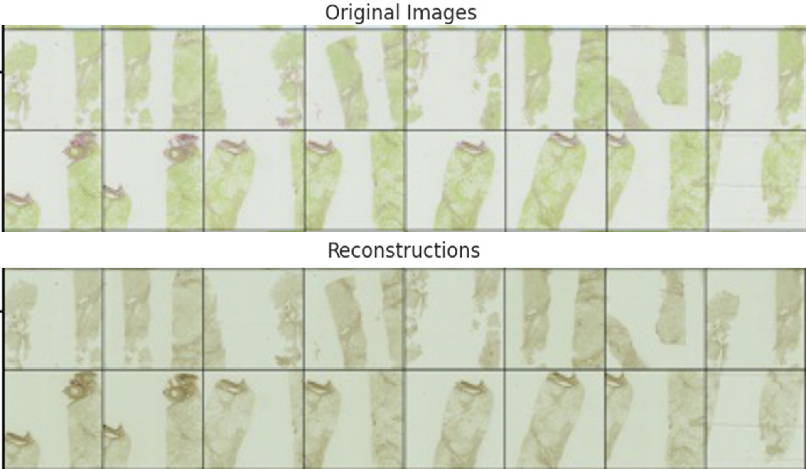
(a) (b)
Figure 6.4: Reconstructions generated by varying the number of stain channels in the SSC (6,3,3) module, with (a) S =1 and (b) S=3.
Colour Space: We tested the SSC model on RGB, HSV and CMYK colour spaces and with or without Optical density (OD) transform. Based on the experimental results in Table 6.13, we draw two key conclusions. Firstly, the OD transform is beneficial to model performance, despite the invalidity of the stain deconvolution theory for single stain Sirius-Red images. This could potentially be due to some non-linearity in intensity and suppression of extreme values from the log operation applied to the input images, which increases the efficacy of the SSC module. Removal of the OD transformation reduced model accuracy on RGB input images by 7.94%. Secondly, the results indicate that RGB is superior to CMYK and HSV input formats. The Sirius-Red stain is fully mixed across all four input channels in the CMYK format rather than being concentrated in the R-G channels. The SSC module is less effective at separating the fibrosis features in this format to generate the 2-channel normalised output. The HSV input space is the worst performing across the input formats. Another potential reason behind the efficacy of the RGB input format is better transfer learning from the ImageNet (RGB images) pre-trained feature extractor.
Table 6.13: Comparison of input colour space formats and use of optical density (OD) transform. Training parameters: SSC (6,3,3) model.
Input Format | Accuracy | F1 | Recall | Specificity | Precision | F2 | MCC
RGB + OD | 73.1% ± 7.1% | 71.9% ± 6.9% | 68.42% | 77.63% | 75.36% | 69.71% | 46.25%
RGB | 65.16% ± 7.8% | 56.4% ± 12% | 47.37% | 82.89% | 73.47% | 50.99% | 32.38%
HSV | 51.91% ± 4.9% | 22.4% ± 19.3% | 17.11% | 86.84% | 56.52% | 19.88% | 5.51%
CMYK + OD | 66.43% ± 3.96% | 62.96% ± 8% | 59.21% | 73.68% | 69.23% | 60.98% | 33.24%
CMYK | 55.2% ± 16.44% | 54.23% ± 16.99% | 53.95% | 56.58% | 55.41% | 54.23% | 10.53%

6.3.5 Experiment 3b: Analysis of SSC performance
We analyse the performance of the SSC module compared to the Gated Attention Baseline model and other methods for stain colour invariance.
Comparison to Gated Attention Baseline Model: From the SSC (5,5,3) model with the highest accuracy of 77.63 ± 6.00% we can infer the following key differences between the models. (1) Smoothing effect from the L2 reconstruction loss resulted in poorer performance of SSC (5,5,3) model on poorly stained images or those with extremely delicate fibrosis. This lead to poor recall. However, in severe disease cases, the SSC model is highly precise with a precision of 92% across the whole dataset. This might be due to the positive impact of the smoothing on WSIs with artefacts. (2) Decomposing the performance of the SSC module for individual stain colour categories in Table 6.14, we see large improvements from SSC on the 75 WSIs with stain appearance 1 (green tissue, grey background) and the 21 WSIs with appearance 3 (yellow tissue, grey background) across all metrics (accuracy over 80%). However, we see a performance decrease on the colour category 2 images (green tissue, blue background). This category has a larger proportion of stain contrast issues which might have lead to severe deterioration in recall. (3) Overall, when looking at the balanced MCC metric, we see an improvement across all colour categories with precision always improved.
Table 6.14: Comparison between SSC (5,5,3) model performance and Gated Attention Baseline model with respect to colour categories (1 = green tissue on grey background, 2 = green tissue on blue background, 3 = yellow tissue on grey background) in the FibLivPath dataset. Improvements with SSC model over baseline are highlighted.
Model
WSI Colour Category
# WSIs in Category
Accuracy
Specificity
Recall
F1
MCC
F2
Precision
74.67
%
58.33
62.13
%
%
68.85
Gated Attention Baseline
%
50.95
%
84.00
%
89.74
%
SSC (5,5,3)
(1)
75
81.33
%
64.60
%
%
94.87
%
92.31
%
%
77.42
66.67
%
70.59
Improvement
6.67
%
8.57
%
8.33
%
5.13
%
8.31
%
%
8.46
13.65
%
Gated Attention Baseline
%
73.21
%
73.68
%
72.41
%
75.00
%
74.07
72.92
%
%
46.46
SSC (5,5,3)
56
(2)
71.43
%
63.64
%
48.28
%
93.33
%
96.30
%
53.44
%
50.29
%
Improvement
-1.79
%
-10.05
%
%
-24.14
22.22
%
18.33
%
-19.48
%
%
3.83
55.16
%
67.31
%
%
87.50
Gated Attention Baseline
76.19
%
63.64
%
90.00
%
73.68
%
SSC (5,5,3)
21
(3)
80.00
%
%
72.73
%
80.95
90.00
%
88.89
%
75.47
%
63.31
%
Improvement
%
4.76
%
6.32
9.09
%
0.00
%
1.39
%
8.16
%
8.14
%
Gated Attention Baseline SSC (5,5,3) | Total 152 | 74.34%  77.63% | 71.53%  73.02% | 64.47%  60.53% | 84.21%  94.74% | 80.33%  92.00% | 67.12%  64.97% | 49.66%  58.81%
Comparison to Reinhard and Colour Augmentation: We also compared the performance of the SSC module to two other methods seen to address colour variation: (1) Reinhard stain normalisation and (2) HSV colour augmentation, as described in Sections 5.1.2 and 5.1.3. The results are displayed in Table 6.15.
Reinhard stain normalisation was applied using the colour category 1 (green tissue, grey
background) as the target colouring. We show in Figure 6.5 that this form of global normalisation cannot handle the considerable stain variation across the FibLivPath dataset, and in fact, increases the variety in stain appearance. This leads to a deterioration in downstream model accuracy and specificity. Application of HSV Colour Jitter is the worst performing method, likely due to the additional noise introduced during colour augmentation resulting in a training distribution that no longer represents the test set.
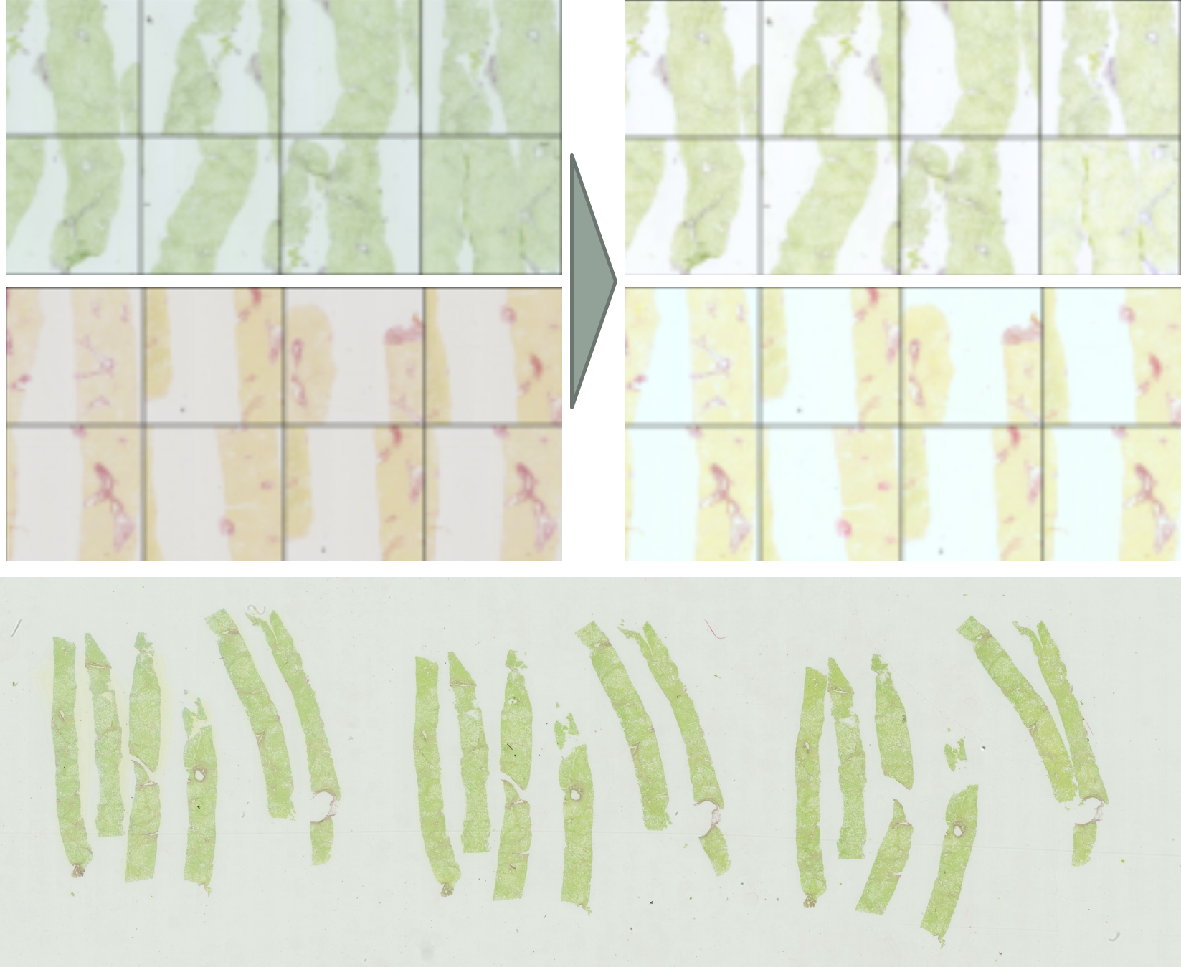
Figure 6.5: Application of Reinhard stain normalisation. Normalisation based on global characteristics of category 1 (green tissue, grey background) as target colouring leads to poor patchwise normalisation of category 3 images (yellow tissue, grey background).
Table 6.15: Comparison of different colour normalisation methods applied to Gated Attention Baseline model. Reinhard stain normalisation per target image in Figure 6.5. HSV colour jitter as described in Section 5.1.3 with value = 0.1
Colour Method | Accuracy | F1 | Recall | Specificity | Precision | F2 | MCC
Gated Attention Baseline | 74.32% ± 5.38% | 70.18% ± 10% | 64.47% | 84.21% | 80.33% | 67.12% | 49.66%
HSV Colour Jitter | 69.08% ± 3.9% | 63.16% ± 11.2% | 57.89% | 80.26% | 74.58% | 60.61% | 39.15%
Reinhard Stain Normalisation | 71.08% ± 9.9% | 72.39% ± 6.6% | 73.68% | 68.42% | 70.00% | 72.92% | 42.16%
SSC (5,5,3) | 77.7% ± 6% | 71.9% ± 11% | 60.53% | 94.74% | 92.00% | 64.97% | 58.81%
SSC (6,3,3) | 73.1% ± 7.09% | 71.86% ± 6.87% | 68.42% | 77.63% | 75.36% | 69.71% | 46.25%
Therefore, based on these preliminary experiments, we conclude that only the SSC module bears promise for our dataset and should be explored further in future work.

6.3.6 Experiment 4: Modified Dataloader
We compared the performance of the Gated Attention Baseline model using two data loading methods: (1) the original Dataloader 1 (DL1), in which only the most ’feature rich’ tiles are trained and tested on, and (2) an updated Dataloader 2 (DL2), which uses all patches generated during tiling and multiple inferences with one-wins-all aggregation. The number of inferences per WSI varied from 1–10 across the dataset depending on the number of valid tiles generated.
Table 6.16 shows that utilising Dataloader 2 for both training and testing the model results in significant performance gains with accuracy increasing 4.6% and F1 score increasing 7.8%.
Table 6.16: Comparison of Dataloader 1 (DL1) and Dataloader 2 (DL2) for model training and inference. Training parameters: Gated Attention Baseline model.
Dataloader Train / Test | Accuracy | F1 | Recall | Specificity | Precision | F2 | MCC
DL1/ DL1 | 74.32% ± 5.38% | 70.18% ± 10% | 64.47% | 84.21% | 80.33% | 67.12% | 49.66%
DL1/ DL2 | 73% ± 8% | 72% ± 9% | 69.74% | 76.32% | 74.65% | 70.67% | 46.15%
DL2/ DL2 | 78.92% ± 5.8% | 77.99% ± 5.64% | 75.00% | 82.89% | 81.43% | 76.20% | 58.08%
The most significant increase in model performance is the 9.5% increase in recall, which could be attributed to the prevention of information loss at inference by utilising every patch in a WSI.
The model’s precision also increases by just over 1%. Given that the presence of artefacts drives the vast proportion of false-positive classifications, this improvement in precision could indicate that training via Dataloader 2 increases the model’s ability to distinguish genuine fibrosis features from artefacts. Additionally, the standard deviation in F1 score is approximately half, showing more consistency across training sets.
We originally thought training with multiple inferences would result in instability as the weak learning signal could be further diminished. However, it proved no longer to be the case once a robust baseline architecture was established.

6.3.7 Finalised Best Model Results
Across the exploratory experiments reported previously, the highest performing model overall is the Gated Attention Baseline model (parameters in Table 6.4) trained and tested using Dataloader 2 (Section 5.2.2).
The model achieves an accuracy of 78.9 ± 5.8% and F1 score for positive class of
78.0 ± 5.6%. Figure 6.6a displays the distribution of accuracy and F1 score across the five independent test cohorts. Figure 6.6b displays the total confusion matrix aggregated across folds. The model achieves a AUC of 0.87 ± 0.06, shown in Figure 6.7. This is an extremely promising result given the minimal data curation conducted.
As described in Section 2.2, Davison et al [11] showed that inter-reader unweighted kappas for fibrosis staging were quite poor at 0.310. If drawing parallels to our model’s performance, we take the single expert pathologist annotations on the FibLivPath dataset as Clinician 1 and consider our best model as Clinician 2. The agreement between the scores would be P₀ ∼ accuracy = 78.89%, and the random chance agreement on the balanced dataset P_{c} = 50% would result in an unweighted kappa of 0.578 by Equation 2.1. This result should be interpreted with caution as we cannot directly compare since [11] is based on H&E stained datasets and multi-class classification.
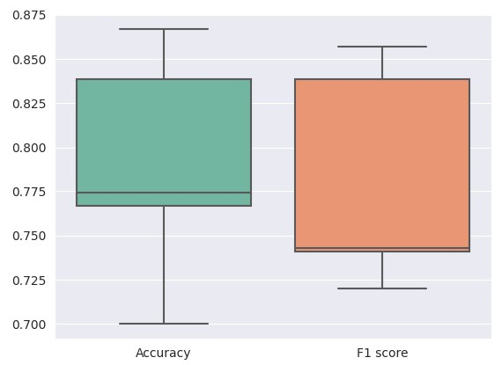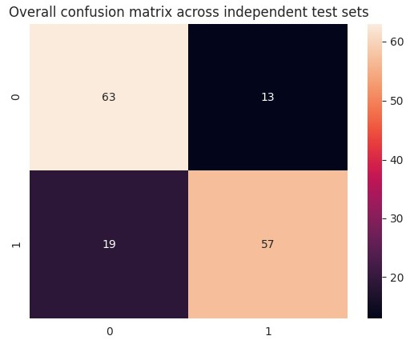
(a) (b)
Figure 6.6: Finalised best model results on 5 independent test sets (20% test size). Training parameters: Gated Attention Baseline model and Dataloader 2. Overall, accuracy = 78.9 ± 5.8% and F1 score = 78.0 ± 5.6%. (a) Distribution of accuracy and F1 scores across the five test sets. (b) Total confusion matrix for an inference pass of the whole dataset (summed across the 5 independent test sets).
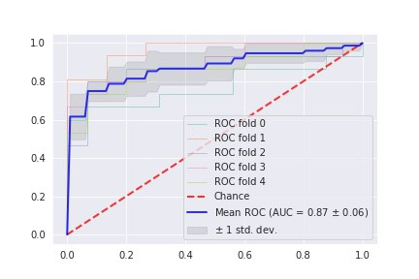
Figure 6.7: Finalised best model ROC curve. Training parameters: Gated Attention Baseline and Dataloader 2. AUC = 0.87 ± 0.06 across the 5 cross-validation folds.

6.4 Detailed Exploration of Failure Cases & Attention Weights

6.4.1 Pathological Analysis of Model Failure Modes
We conducted a qualitative analysis of all failure cases with the collaborating clinician. We identified several common characteristics that explain the majority of cases classified incorrectly by our model.
False negative characteristics:
• Stain quality: Figure 6.8a shows an example where the stain has faded from a red colour to grey/blue, which can occur on older WSIs with colour categories 1, 2. Such loss of colour contrast makes the fibrosis pattern significantly more challenging to identify.
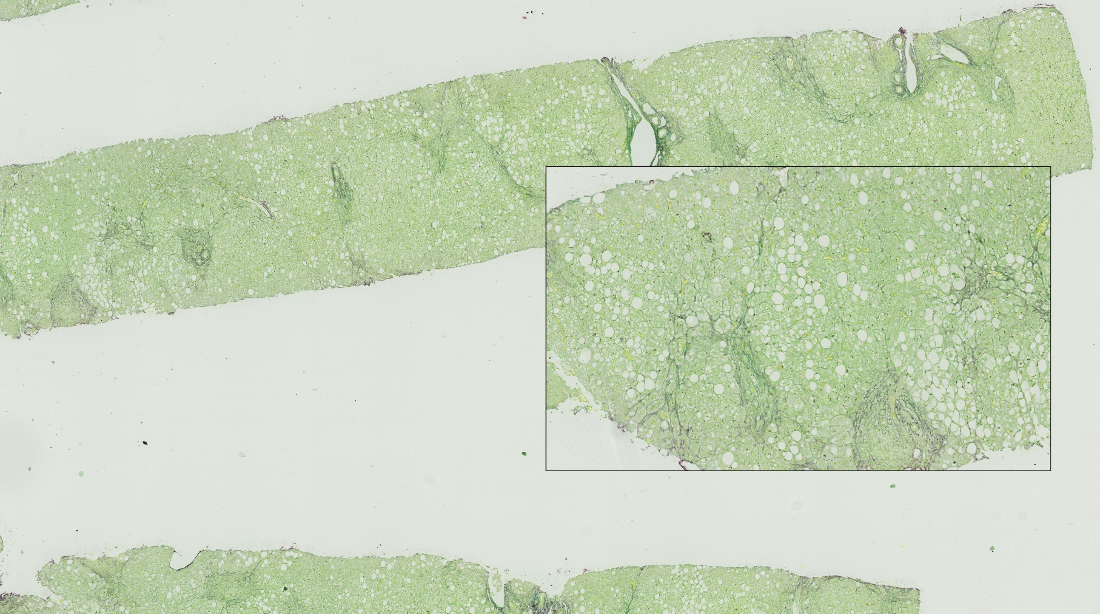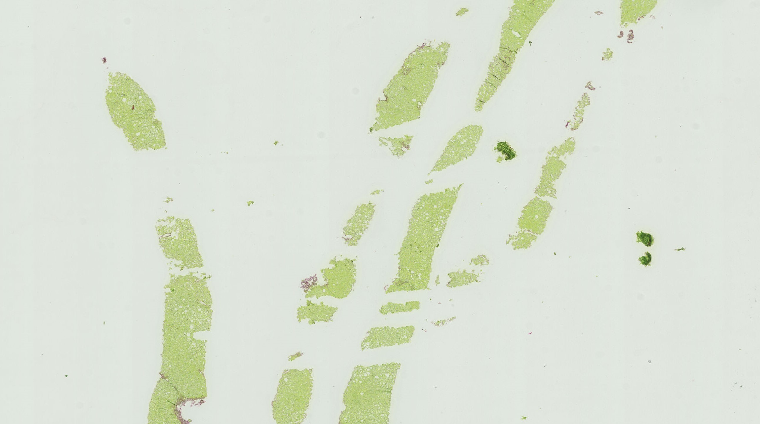

(a) (b)
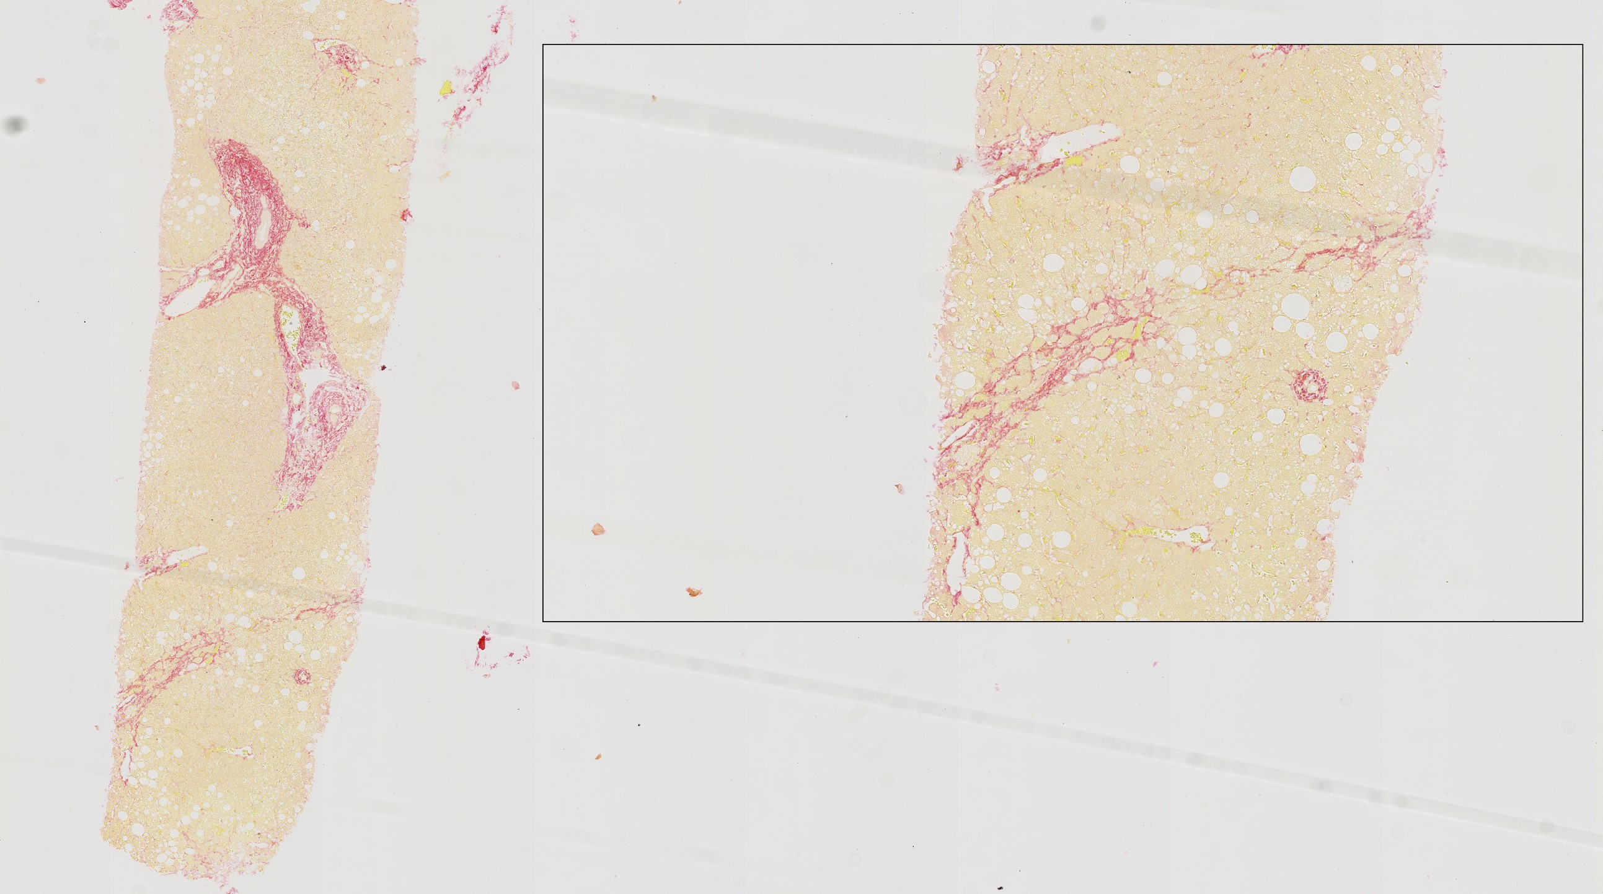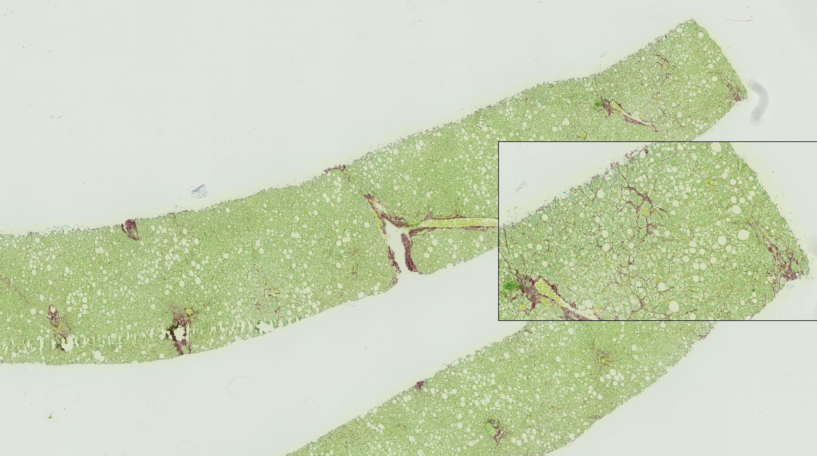

(c) (d)
Figure 6.8: False Negative failure modes: (a) Faded stain color; (b) Incomplete Biopsy; (c) Borderline bridging and sparse pathological signs. The remaining red stain in the image is due to healthy portal tracts sliced longitudinally; (d) Delicate fibrosis pattern
- Patching: Figure 6.8b shows the biopsy of an advanced case of fibrosis. Tissue crumbling reduces the information per tile.
- Borderline Diagnoses: Figure 6.8c shows a portion of a WSI which is overall healthy except for the single bridge highlighted in the zoomed box. On discussion with the expert pathologist, this is a very delicate, borderline bridge. Sparsity of the pathological signs on the WSI and the borderline classification as severe fibrosis explains the False Negative result for this case. Figure 6.8d shows a challenging case where the fibrosis pattern is very delicate. Bridging fibrosis can range from strong bridging (which is almost always detected by the model) to bridges that are even one cell thick. These are cases that could benefit from analysis at multiple magnification factors.
- Rare category: Occasionally, for the 21 WSIs with stain appearance category (3), we see the model misclassifies fibrosis features as ’healthy’ tissue. The model likely needs more data from this category to learn features properly.
False positive characteristics:
- Red Artefacts: The Deep Learning models can often not discriminate between red artefacts and fibrosis. This was particularly apparent with Dataloader 1. Occasionally, a bag generated from a mild stage WSI is dominated by red artefacts and little healthy tissue resulting in a false positive classification. This is alleviated somewhat by the use of Dataloader 2. However, the ubiquity of red artefacts in the FibLivPath dataset still poses a challenge for our best model. Figure 6.9 illustrates the use of attention coefficients to identify the cause of False Positive predictions, and we can see that the most attended tiles are dominated by red artefacts.
- Borderline diagnoses: The WSI in Figure 6.10, was identified as a positive (severe) case by the model, however, the ground truth label was mild. On secondary review with the clinician of the highest attention weight patches, the WSI was reclassified as a severe case.
Given the high inter- and intra- clinical expert variability, our model could have applications beyond acting as an initial screening tool. A pathologist could score a dataset alongside the trained Deep Learning model. Any false positive predictions could then be re-considered by the pathologist. This could identify cases as in Figure 6.10 which fall within the inter and intra-observer variation and thus potentially increase the quality and agreement of pathologists scores.
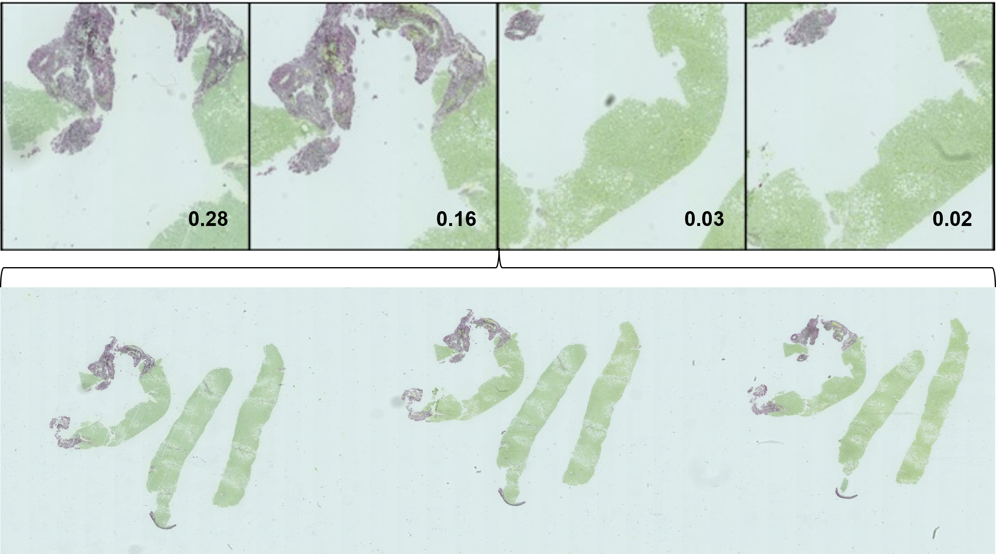
Figure 6.9: False positive failure mode: red artefacts. Tiles with the highest and lowest attention weights are shown. FP is due to red artefacts due to a vein cut with the tissue.
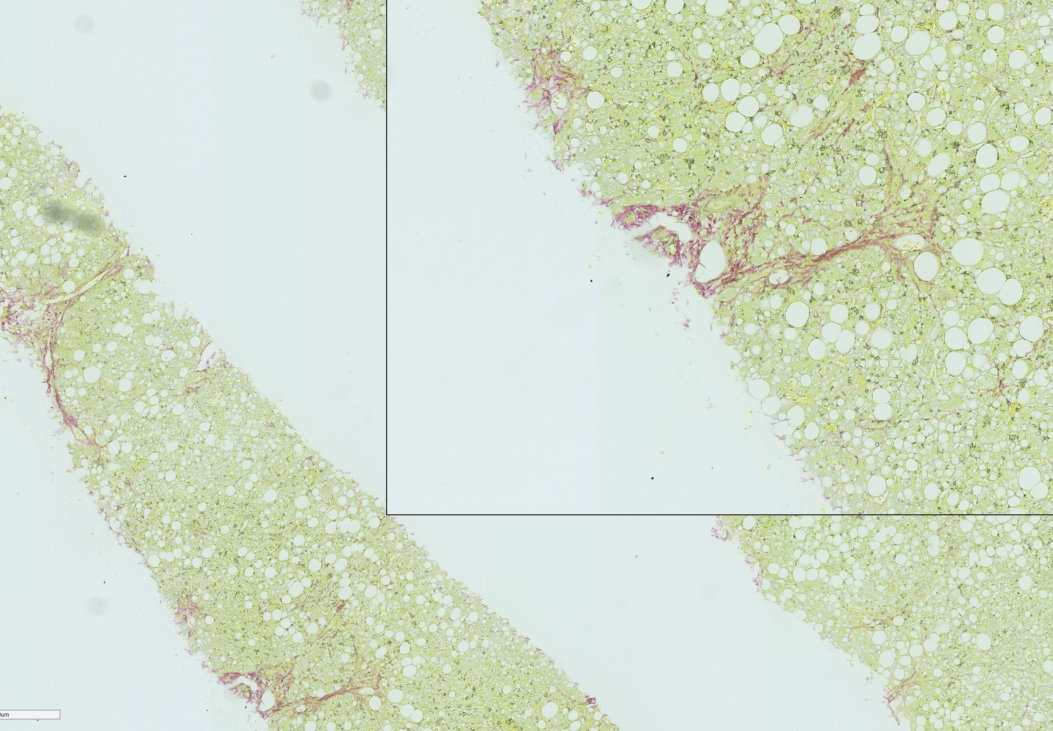
Figure 6.10: False positive failure mode: Borderline mild disease. This case was reconsidered to be a potential severe case by the collaborating clinician.

6.4.2 Analysis of Attention Coefficients
Analysis of attention coefficients in severe disease WSI bags can highlight whether the features deemed discriminative by Deep Learning models are consistent with relevant pathological signs.
We observed that the spread of attention coefficients amongst tiles in a bag varied across WSIs. As one might expect, bags with sparse pathological signs or noticeable artefacts typically have attention coefficients across instances with > 0.2 for the most attended and ∼ 0.05 for the least attended tiles, such as in Figure 6.11f. Bags with a more uniform appearance have all ten coefficients around 0.1 (due to the softmax operation used) as in Figure 6.11e. We additionally include in Appendix B the distribution of attention weights on bags built with Dataloader 1 and Dataloader 2 as predicted by our finalised best model (detailed in Section 6.3.7).
In Figure 6.11, we illustrate a range of examples of the attention coefficients from severe disease WSIs correctly scored by our best model.
- Figures 6.11a and 6.11d highlight regions of delicate fibrosis successfully identified.
- Figure 6.11b shows strong model performance even in an example where stain contrast is poor.
- Figure 6.11c displays a bag generated from a cirrhotic liver biopsy with significant artefacts due to biopsy challenges faced in the most advanced NASH cases. Our model has seen only one or two cases with this degree of severity in the dataset. It is extremely encouraging that the model attends to tiles where relevant fibrosis patterns are present with 4.7x the attention coefficient of tiles containing only artefacts.
- Figure 6.11g however shows that despite our model correctly predicting this case as severe, the sparsity of pathological signs means that in this particular bag of 10 tiles, there are no signs of fibrosis disease. The red features that were mistaken by our model originate from portal tracts sliced longitudinally, as evidenced by the clear lumen visible inside the red outline. This is a challenging example in the dataset as identified in Section 4.4.
- Figure 6.11h shows another example where there is room for model improvement. This bag suffers from digitisation artefacts and blurring. While it is encouraging that our model is robust enough to classify this case correctly, the attention coefficients are not as uniform as would be expected from visual analysis of the fibrosis features in the bag.
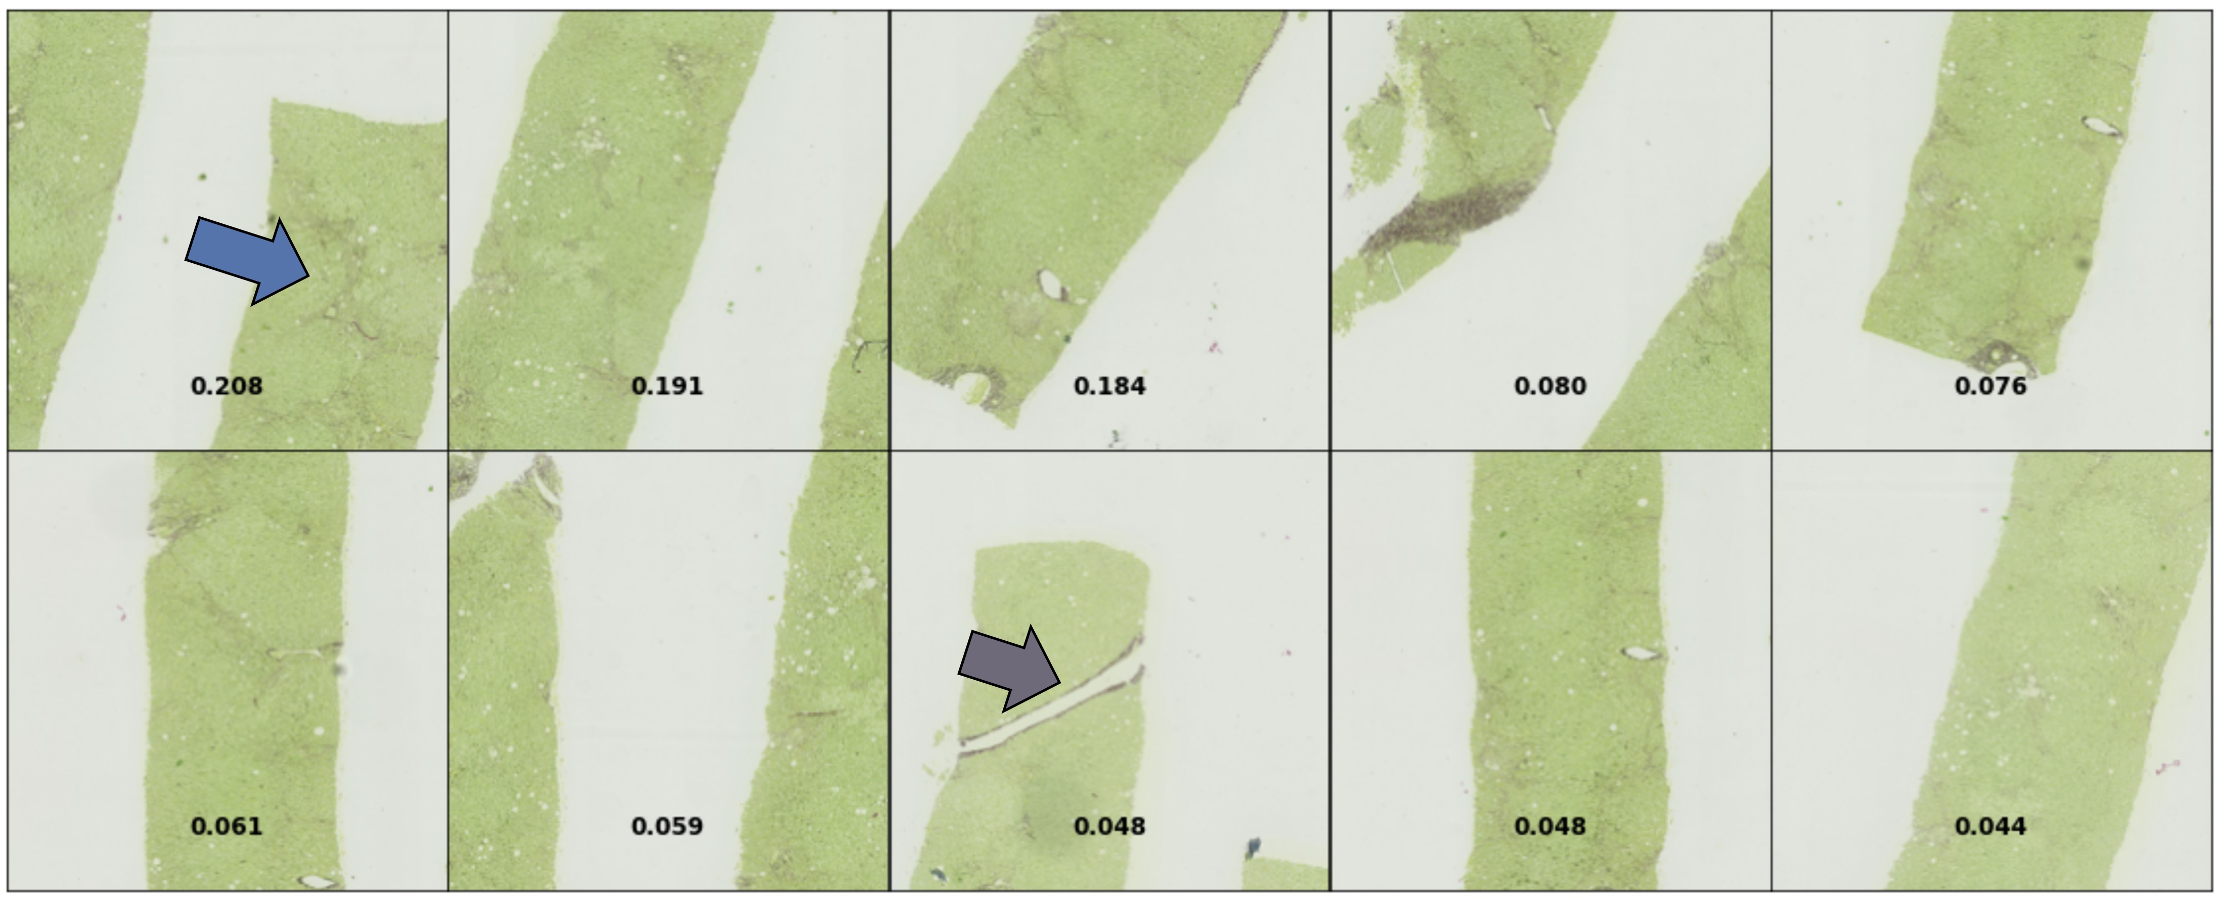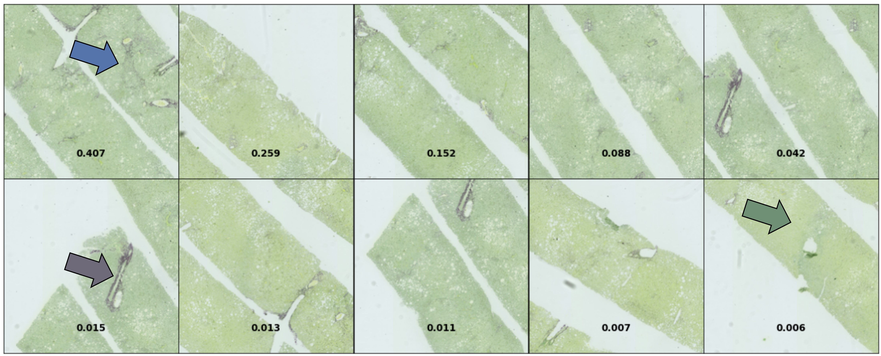

(a) (b)
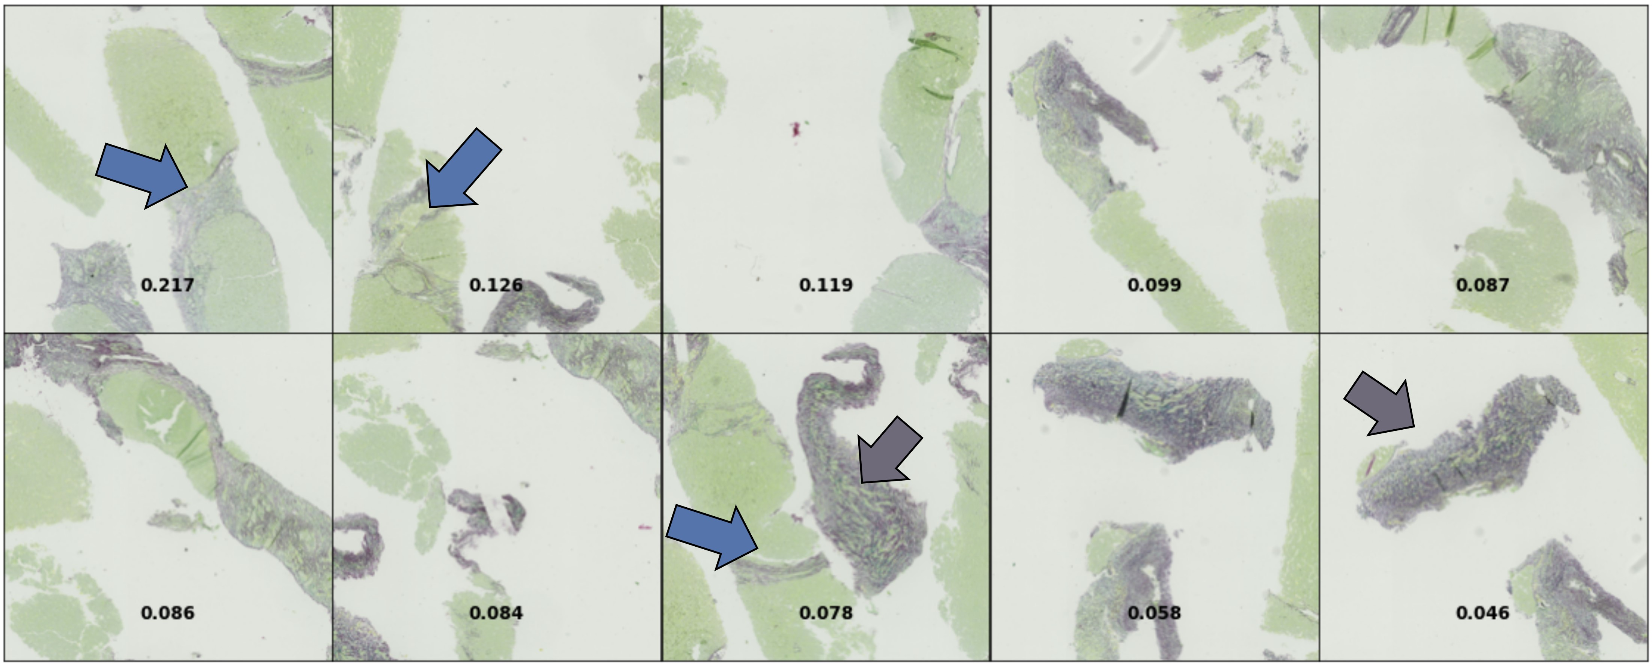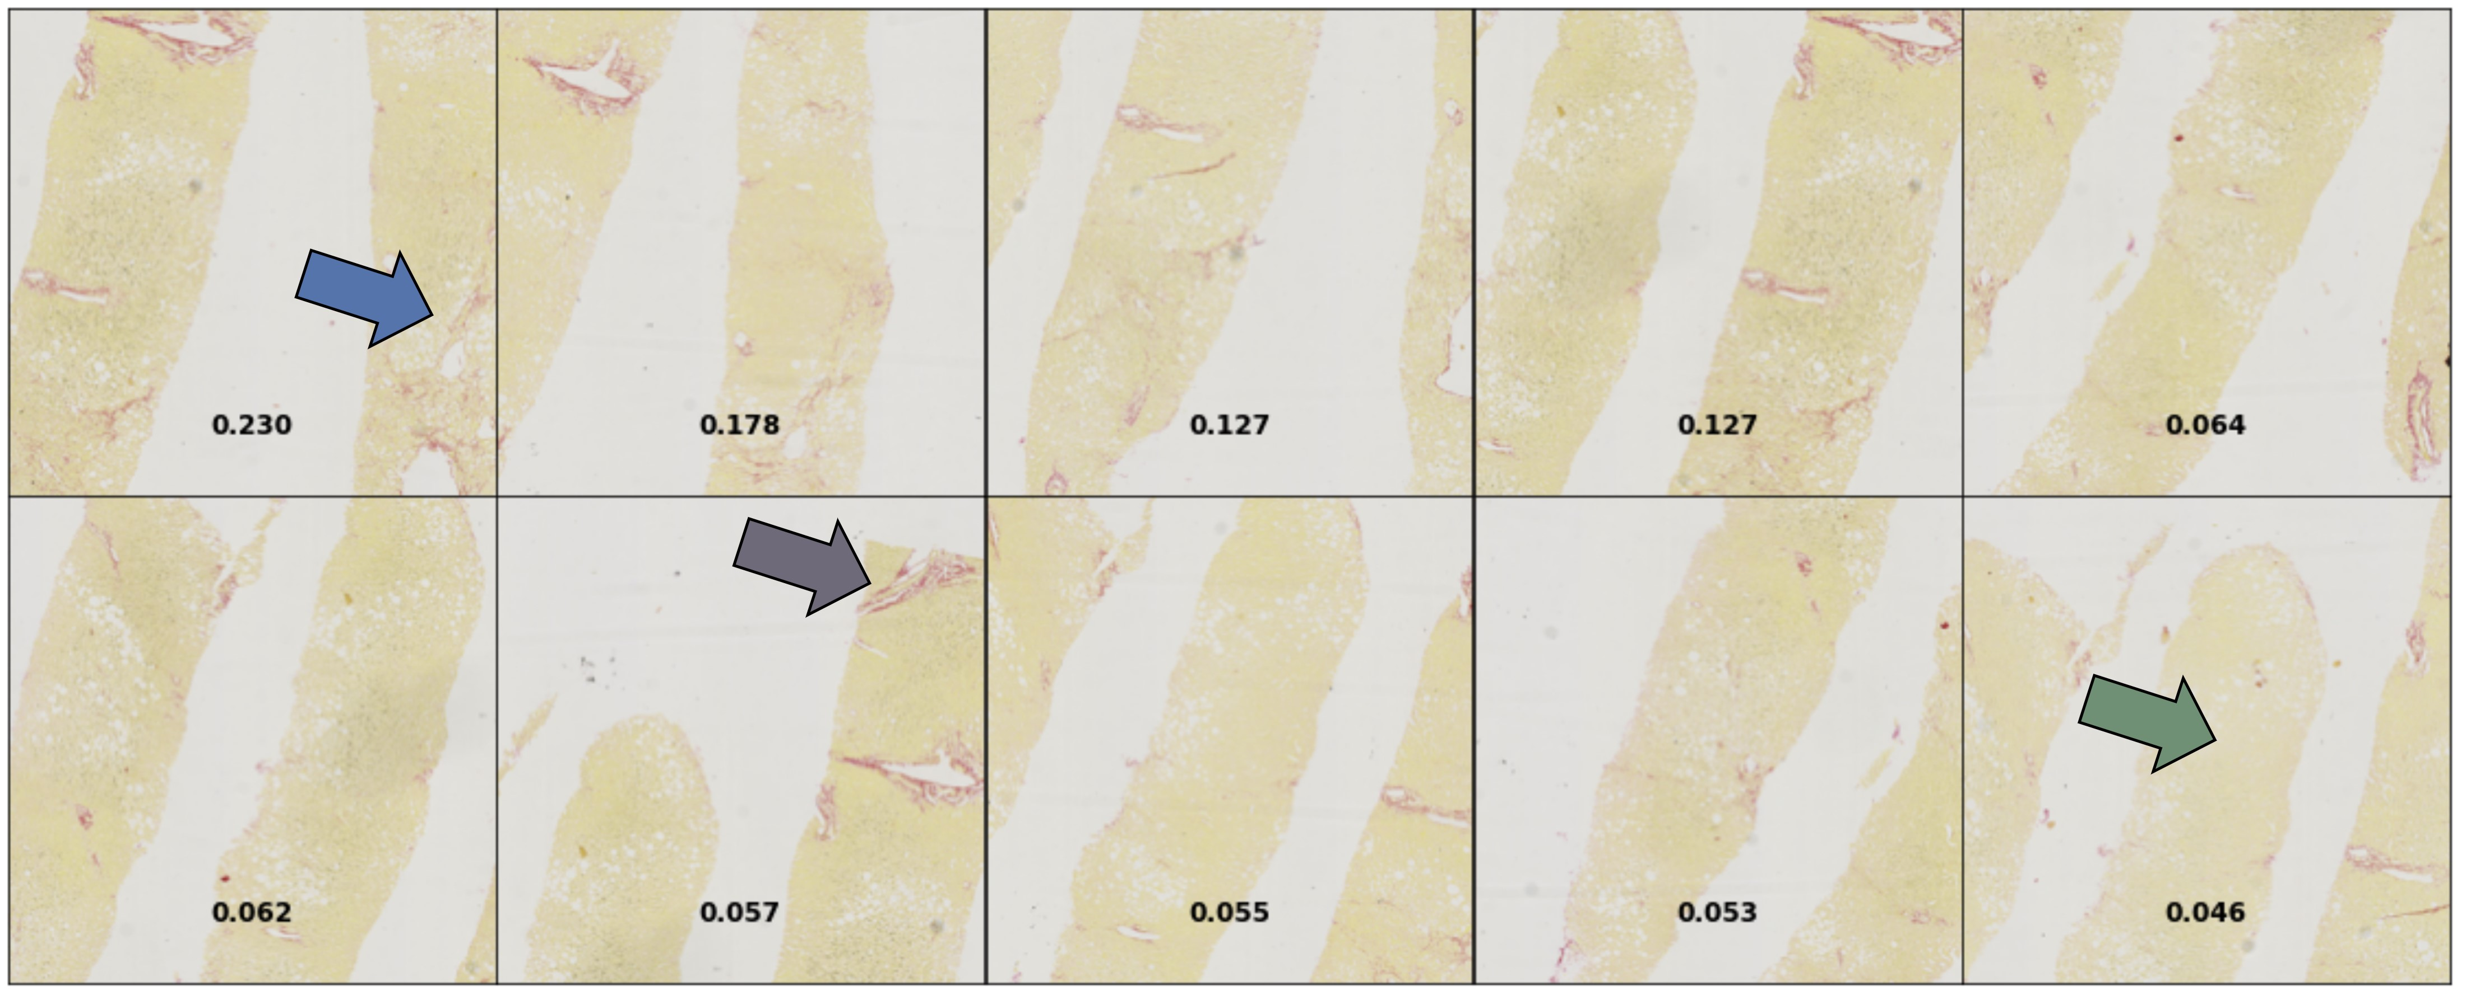

(c) (d)
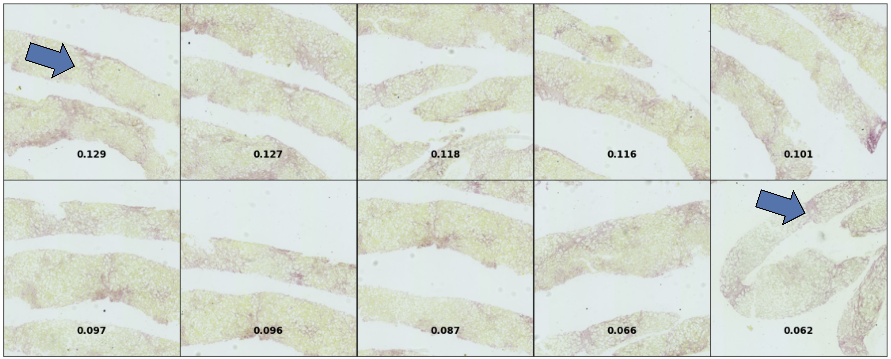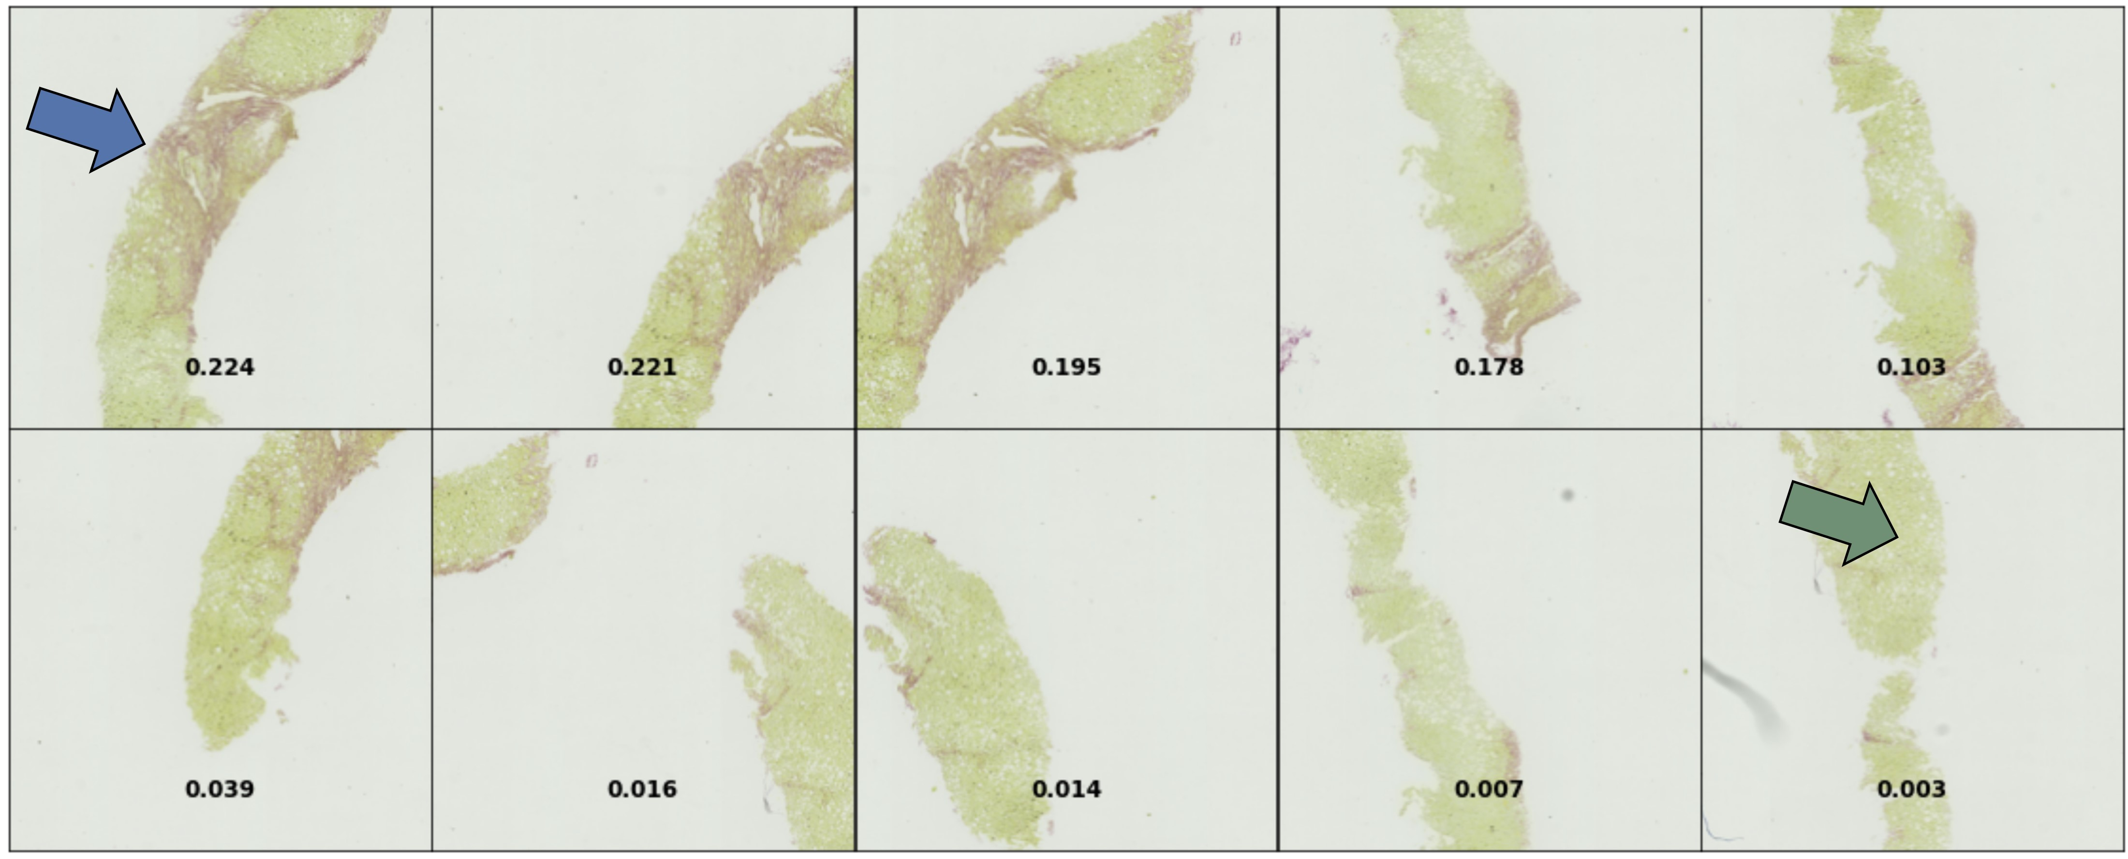

(e) (f)
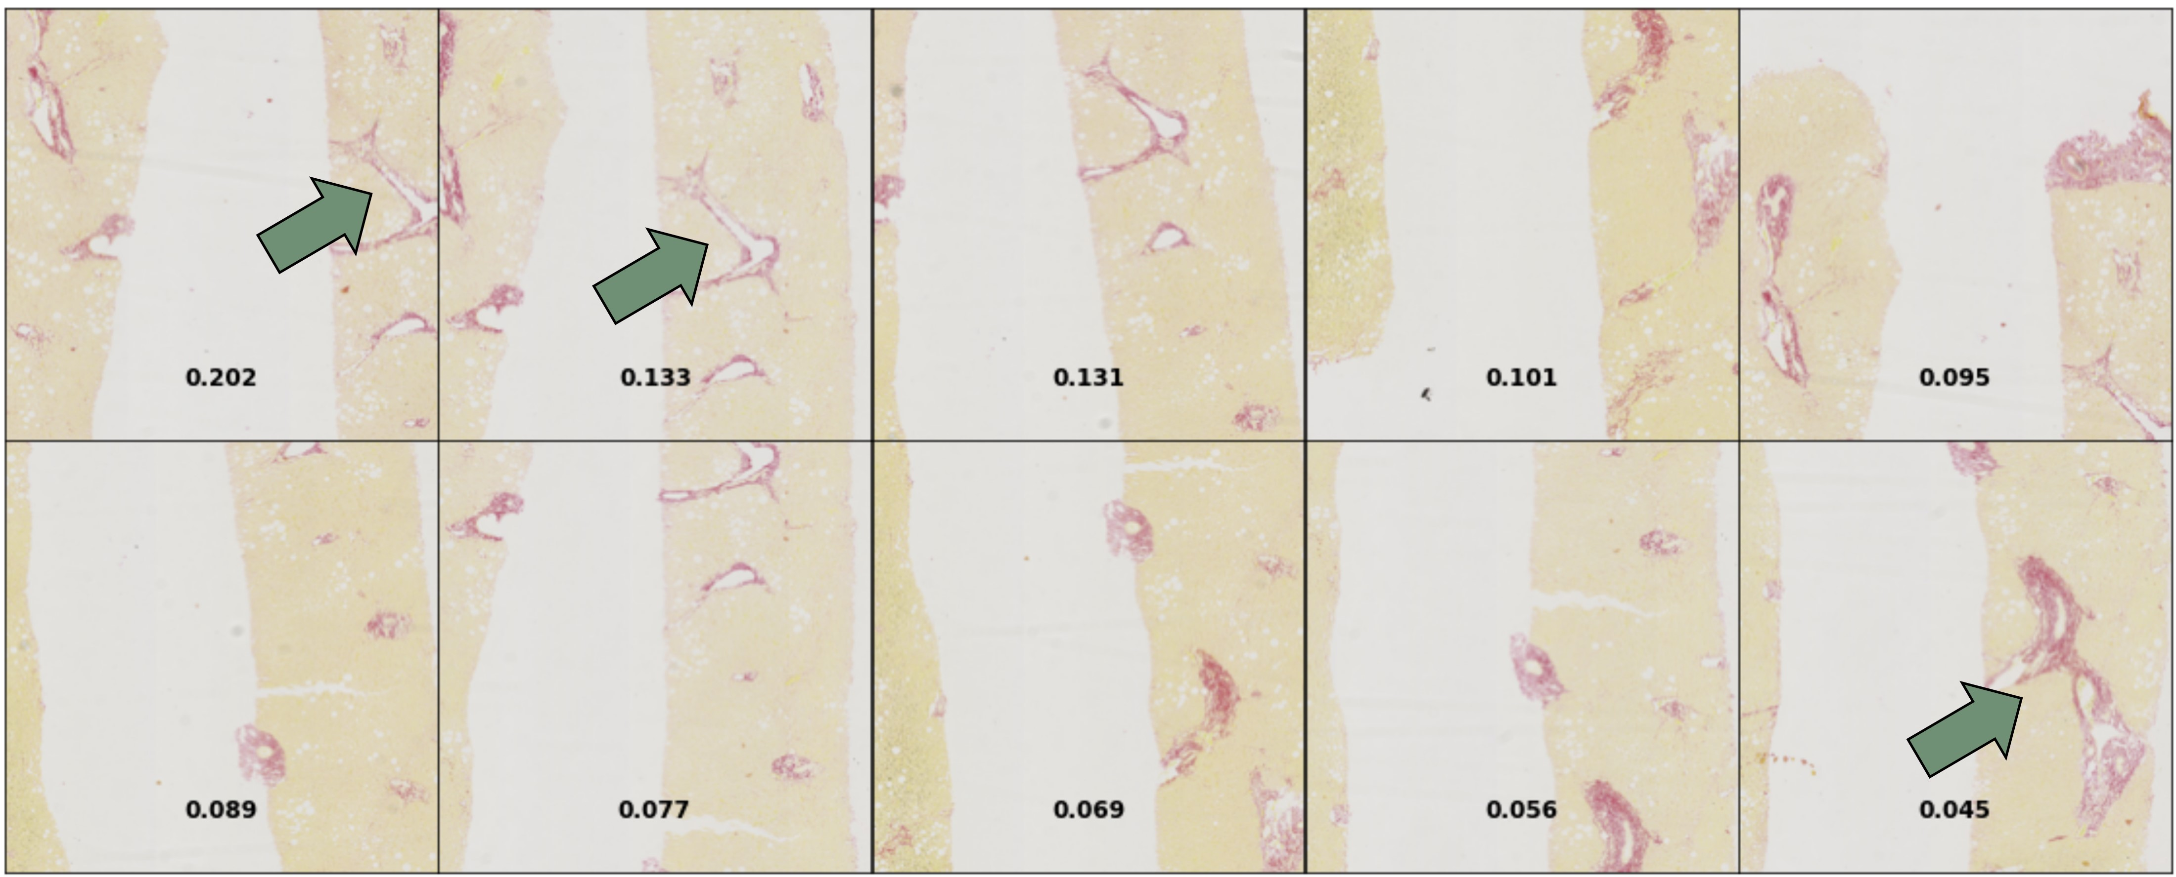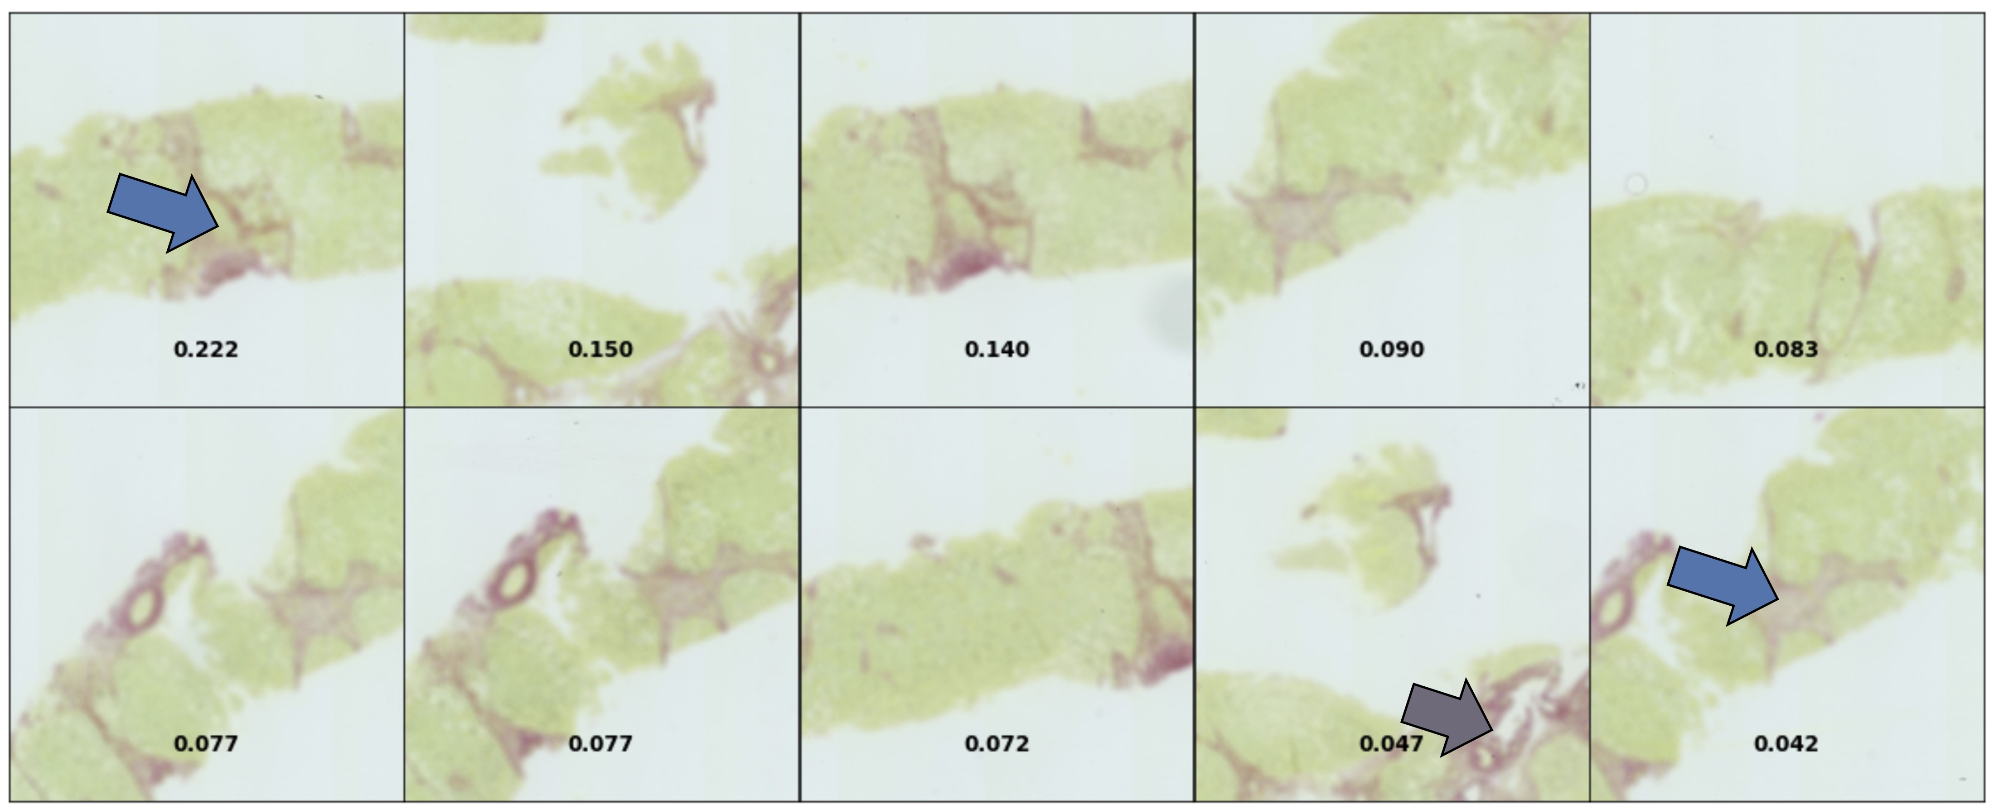

(g) (h)
Figure 6.11: True positive cases (i.e. severe fibrosis) illustrated on tiles with the 5 highest attention weights. Blue arrows = relevant pathological signs of bridging fibrosis. Purple arrows = artefacts. Green arrows = absence of severe fibrosis. (a-f) Cases with strong feature localisation performance. (g-h) More challenging cases.
Chapter 7

Concluding Remarks

7.1 Contributions
The goal of this project was to demonstrate that end-to-end weakly supervised multiple-instance deep learning could distinguish severe from mild fibrosis on WSI histopathological images from a novel dataset stained with Sirius Red (that we refer to as the FibLivPath dataset) to aid clinicians in diagnosing NAFLD liver biopsies.
Quantifying the severity of fibrosis from ’real-world’ NAFLD biopsies is a challenging task because of the following reasons:
- NAFLD often shows very sparse pathological signs that are hard to localise on digitised slides, which are tens of gigapixels in size.
- The different fibrosis stages have significant overlap in pathological signs.
- Scoring fibrosis in NAFLD via the NASH CRN system suffers from large inter- and intra- pathologist variation.
- Images shows significant variation in stain appearance, which poses a challenge for deep learning models.
- The dataset contains a variety of biopsy and digitisation artefacts that worsen with fibrosis severity.
- To the best of our knowledge, no research is published applying Deep Learning to Sirius-Red stained WSIs to stage fibrosis. It was unknown how well methods applied on the more ubiquitous H&E stain or for different diseases would transfer to this novel dataset.
Despite the challenges posed above, we managed to demonstrate a promising framework for tile selection from WSIs, feature extraction, and aggregation using an attention-based multiple instance learning (MIL) model. Our key contributions are as follows:
- We conducted a thorough review of related work, summarised in Figure 3.1.
- We quickly managed first to establish a robust MIL baseline model for the dataset, which achieved reasonable accuracy of 74.32 ± 5.38% on the FibLivPath dataset.
- Further to this, we demonstrated that Stain Standardisation Capsules (SSC) [4], designed for H&E image standardisation, have promising applications to single-stain Sirius-Red WSIs and can be trained in a weakly supervised framework. We showed that the use of the SSC has unique applications in boosting performance on certain stain appearances and could potentially increase robustness to artefacts leading to higher precision models. Using SSC, we were able to achieve an accuracy of 77.63 ± 6.00% and an F1 score of 71.90 ± 11% on the FibLivPath dataset, with accuracy on the majority stain category 1 (n=75), reaching 81.33% and accuracy on the minority stain class 3 (n=21) reaching 80.95%.
- Some preliminary investigation suggests that the application of unsupervised pre-training directly on the FibLivPath dataset is unlikely to result in usable generic features due to the small dataset size and dearth of similar publicly available histopathology datasets. However, this could not be thoroughly investigated, given time and resource constraints.
- We demonstrated the efficacy of multiple inference in classifying images with sparse pathological signs in a MIL framework, which resulted in the overall best model, which achieves an accuracy of 78.98 ± 5.86%, a F1 score of 77.99 ± 5.64% and an AUC of 0.87 ± 0.06 on the FibLivPath dataset.
- We demonstrated, through a review of our results with a clinician and the use of patch-wise attention coefficients, that discriminative regions proposed by our Deep learning pipeline for classification of severe disease are coherent with relevant pathological signs. Moreover, the network detected some borderline cases that fall under the intra-observer rating variation expected for this application.
While the above results show promise for Deep Learning approaches to stage fibrosis on Sirius-Red stained NAFLD biopsies, the work is preliminary and exploratory. We highlight several approaches for resolving the challenges we faced, from stain standardisation, improvements of MIL data preparation, to unsupervised pre-training, with varying degrees of success. Depending on the direction that clinicians would like to take, we believe there could be room for improvement in the above results to more robustly score NAFLD biopsies.

7.2 Limitations
We acknowledge three key limitations in our approach. First, we only have single scores as our ’Ground Truth’ annotation from an expert pathologist. To truly assess the performance of our machine learning models, we need an estimation of the inter- and intra- observer variability inherent to the FibLivPath dataset. More annotations could be gathered in future work.
Second, our dataset is of clinical quality rather than being specifically curated for machine learning applications. The ubiquity of diverse artefacts, poor or incomplete biopsy quality in some cases and variation in stain appearance posed a significant challenge for preprocessing. Due to time limitations, we only conducted a small degree of pre-processing. The impact was noticed on systematic errors made by the model with respect to red artefacts (FP) and faded stain appearance (FN). Therefore, there is likely a ceiling to the achievable model performance without a significant degree of further pre-processing.
Third, the GPU constraints limited the size of the tested architectures, batch sizes and MIL bag sizes that could be investigated without compromising training stability. It is unknown to what extent performance could have been improved via training with larger batch sizes. This is especially the case for the unsupervised pre-training experiments conducted.

7.3 Further work
Given the exploratory nature of our project on a novel dataset, our conclusions and the limitations above highlight many avenues for further work outlined here:
- Pre-processing is an extremely active field in digital histopathology, and there is significant promise to improve on our results by more thorough investigations into this aspect of the pipeline:
  - Background vs Tissue segmentation: We could explore using supervised learning to separate usable tissue from artefacts as was done recently by Taylor et al [85] on a large H&E dataset for NASH staging. Additionally, more investigations could be done on the impact of re-scaling patches based on global tissue width and extracting patches aligned with the main orientation of tissue samples to reduce the patch background content as was experimented with in Section 5.1.1.
  - Data calibration: Further exploration into colour transfer methods such as the Hue-Net [80] and utilisation of colour transfer algorithms for better colour normalisation [67, 66] are certainly of interest. Additionally, more exploration into the optimal colour space for input images could also be conducted.
  - Stain Standardisation Capsule: Reconstructions from the SSC module suffer from information loss. Therefore, performance could be significantly improved with more investigation into reconstruction loss functions.
  - Domain adaptation: Training with domain adaptation for stain invariance was briefly investigated but would have required significantly more time to explore fully. This method has been applied extremely successfully to the Bach dataset [60].
- Further investigations into architectural choices could also be very promising:
  - Multiple inference tuning: More investigations could be conducted on bag sizes, bag constructions and inference aggregation when utilising multiple inferences per WSI given the significant performance improvement already seen from work in this area.
  - Multi-resolution architectures: Multi-resolution architectures could be explored to address the need for more global or more focused contexts on borderline cases, especially if the task was extended beyond binary classification as in [20].
  - Hard example mining: This technique was used very successfully by Kwok et al. [22]. This could be applied to the FibLivPath dataset, with care so as not to focus on patches with artefacts, to improve performance
  - The MILD-Net:: This architecture was designed specifically for histopathology datasets [86]. It does not use max-pooling layers so that more detailed spatial information is not discarded during feature extraction. This could be an interesting avenue of exploration to improve the classification of borderline cases with extremely delicate fibrosis patterns.
- Finally, if more detailed annotations were available, further work into explainability for clinicians could be investigated based on the current attention-based model.

7.4 Ethical Considerations
We evaluated the ethical considerations relevant to this project Appendix A. This project consists of retrospective rather than prospective analysis on an already existing dataset. No human participants are directly involved in the project. Only anonymised histopathological images and associated fibrosis scores (numerical values) were provided. Hence, no patient information (such as age, sex, date of exam) nor any written comment on individual scorings can be inferred.
Although the data processed is sensitive health data used for diagnosis (biopsy images), no identifying characteristics were provided. The image data was fully anonymous and in a format without header information. Therefore, it is impossible to trace back any subject or hospitalisation information from them.
Furthermore, the image data is stored securely and solely on the Imperial College network, thus limiting security risk. If the pipeline were deployed in a clinical setting, the input data and output diagnoses would fall under sensitive personal data. However, this is not the current intention of any involved parties and should therefore be revisited at later stages should the issue arise.
Additionally, from a legal perspective, we encountered no licensing issues when utilising open-source codebases from GitHub.
Finally, we considered the environmental impact our research has due to prolonged GPU usage. Due to the exploratory nature of the project, we conducted many unsuccessful or unstable training runs. The Weights and Biases software [84] tracks the GPU power usage and duration of every run conducted. Due to memory storage constraints on the platform, we deleted information from the worst-performing runs throughout the project. However, based on the remaining runs at this time, we can estimate a lower bound for the total runtime at 717h 32min. The mean GPU power usage across a sample of 100 runs was 90 ± 16W, which is around 40% utilisation on average. This gives an energy usage in the range of 53 to 76kWh. Based on the UK Government Greenhouse Gas Conversion Factors for Company Reporting, the CO2 equivalent (CO2e) indicates the global warming potential (GWP) of greenhouse gasses generated (CO2, CH4, N2O) by energy consumption expressed in terms of the GWP of one unit of carbon dioxide. For 2021, the conversion factor for UK electricity is 0.21233 kg CO2e per kWh [87]. Therefore, we estimate our research generated in the range of 11 to 16kg of CO2.

7.5 Conclusion
In this thesis, we have established benchmark results on the Sirius-Red stained FibLivPath dataset to classify NAFLD liver fibrosis stage between severe and mild. We achieved an overall accuracy of 78.98 ± 5.86% and AUC of 0.87 ± 0.06 using a multiple-inference MIL framework. We have also experimented with potential solutions to handle significant stain variations as faced in many histopathology datasets and have generated very promising results using the recent Stain Standardisation Capsule [4]. Finally, we illustrated the value of attention-based methods for discussing with clinicians borderline cases where expert annotation might vary.
Appendix A

Ethics Checklist
Table A.1: Ethics checklist.
If your project involves low and/or lower-middle income countries, are any benefit-sharing actions planned?
Yes
No
Section 1: HUMAN EMBRYOS/FOETUSES
Does your project involve Human Embryonic Stem Cells?
Does your project involve the use of human embryos?
Does your project involve the use of human foetal tissues / cells?
X
Section 2: HUMANS
Does your project involve human participants?
Section 3: HUMAN CELLS / TISSUES
Does your project involve human cells or tissues? (Other than from “Human Embryos/Foetuses” i.e. Section 1)?
Section 4: PROTECTION OF PERSONAL DATA
Does your project involve personal data collection and/or processing?
X
Does it involve the collection and/or processing of sensitive personal data (e.g. health, sexual lifestyle, ethnicity, political opinion, religious or philosophical conviction)?
X
Does it involve processing of genetic information?
X
X
Does it involve tracking or observation of participants? It should be noted that this issue is not limited to surveillance or localization data. It also applies to Wan data such as IP address, MACs, cookies etc.
Does your project involve further processing of previously collected personal data (secondary use)? For example Does your project involve merging existing data sets?
X
Section 5: ANIMALS
Does your project involve animals?
X
Section 6: DEVELOPING COUNTRIES
Does your project involve developing countries?
X
X
Could the situation in the country put the individuals taking part in the project at risk?
X
Section 7: ENVIRONMENTAL PROTECTION AND SAFETY
Does your project involve the use of elements that may cause harm to the environment, animals or plants? X
Does your project deal with endangered fauna and/or flora /protected areas? X
Does your project involve the use of elements that may cause harm to humans, including project staff? X
Does your project involve other harmful materials or equipment, e.g. high-powered laser systems? X
Section 8: DUAL USE
Does your project have the potential for military applications? X
Does your project have an exclusive civilian application focus? X
Will your project use or produce goods or information that will require export licenses in accordance with legislation on dual use items? X
Does your project affect current standards in military ethics – e.g., global ban on weapons of mass destruction, issues of proportionality, discrimination of combatants and accountability in drone and autonomous robotics developments, incendiary or laser weapons? X
Section 9: MISUSE
Does your project have the potential for malevolent/criminal/terrorist abuse? X
Does your project involve information on/or the use of biological-, chemical-, nuclear/radiological-security sensitive materials and explosives, and means of their delivery? X Does your project involve the development of technologies or the creation of information that could have severe negative impacts on human rights standards (e.g. privacy, stigmatization, discrimination), if misapplied? X Does your project have the potential for terrorist or criminal abuse e.g. infrastructural vulnerability studies, cybersecurity related project? X
SECTION 10: LEGAL ISSUES
Will your project use or produce software for which there are copyright licensing implications?
X
Will your project use or produce goods or information for which there are data protection, or other legal implications?
X
SECTION 11: OTHER ETHICS ISSUES
Are there any other ethics issues that should be taken into consideration?
X
Appendix B

Attention Analysis
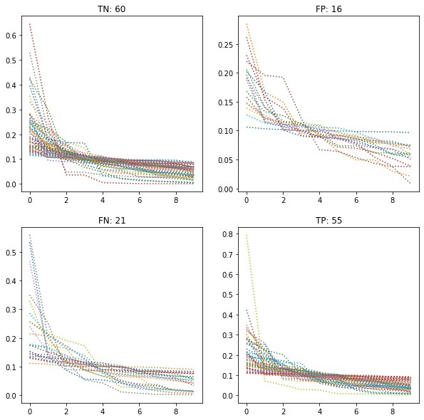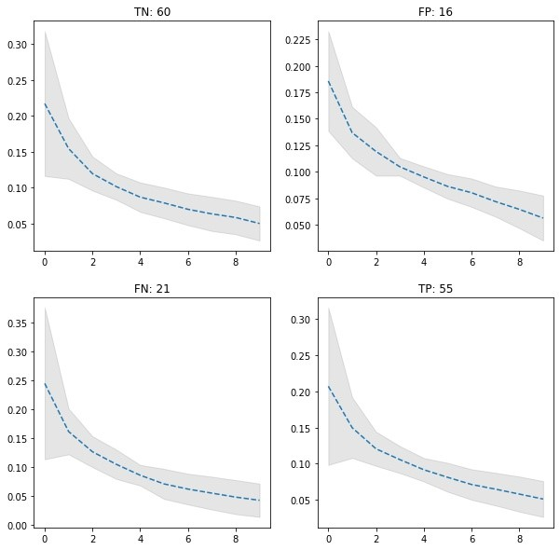
(a) (b)
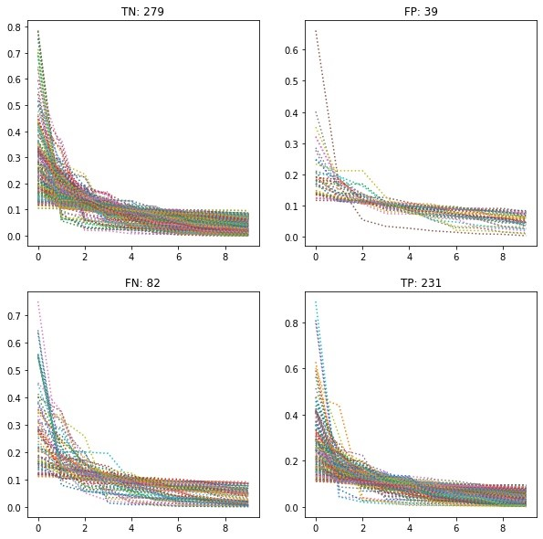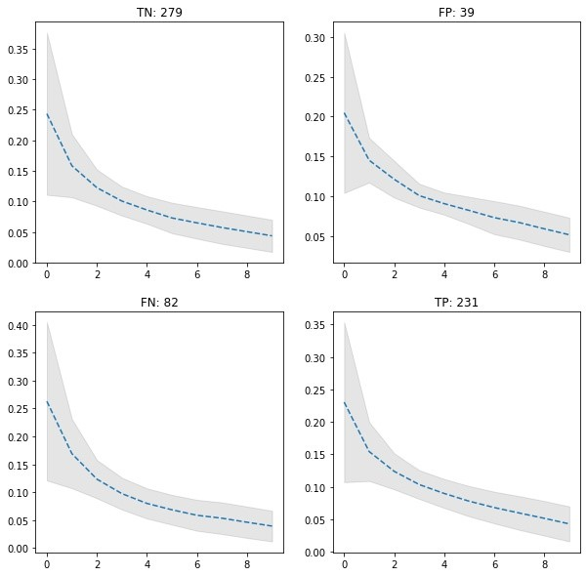
(c) (d)
Figure B.1: Plot of Attention coefficient (y-axis) versus ’rank’ of instance in bag (x-axis). Rank 1 =most attended, Rank 10 =least attended instance in bag. Illustrated per-run alongside the mean and standard deviation of results. Results shown for Dataloader 1 (152 WSIs with bag size 10) and Dataloader 2 (631 bags from 152 WSIs with bag size 10 and noisy labelling) generated by Final best model. (a) Illustration of each run DL1 (b) Mean and standard deviation of results DL1. (c) Illustration of each run DL2 (d) Mean and standard deviation of results DL2.
Bibliography
- Godoy-Matos AF, Junior WSS, and Valerio CM. NAFLD as a continuum: from obesity´ to metabolic syndrome and diabetes. Diabetol Metab Syndr 2020; 12(1):1–20
- Younossi ZM, Koenig AB, Abdelatif D, Fazel Y, Henry L, and Wymer M. Global epidemiology of nonalcoholic fatty liver disease—meta-analytic assessment of prevalence, incidence, and outcomes. Hepatology 2016; 64(1):73–84
- Wong RJ, Aguilar M, Cheung R, Perumpail RB, Harrison SA, Younossi ZM, et al. Nonalcoholic steatohepatitis is the second leading etiology of liver disease among adults awaiting liver transplantation in the United States. Gastroenterology 2015; 148(3):547– 55
- Zheng Y, Jiang Z, Zhang H, Xie F, Hu D, Sun S, et al. Stain standardization capsule for application-driven histopathological image normalization. IEEE J Biomed Health Inform 2020; 25(2):337–47
- Takahashi Y and Fukusato T. Histopathology of nonalcoholic fatty liver disease/nonalcoholic steatohepatitis. World J Gastroenterol 2014; 20(42):15539
- Boyd A, Cain O, Chauhan A, and Webb GJ. Medical liver biopsy: background, indications, procedure and histopathology. Frontline Gastroenterol 2020; 11(1):40–7
- Brunt EM, Janney CG, Di Bisceglie AM, Neuschwander-Tetri BA, and Bacon BR. Nonalcoholic steatohepatitis: a proposal for grading and staging the histological lesions. Am J Gastroenterol 1999; 94(9):2467–74
- Kleiner DE, Brunt EM, Van Natta M, Behling C, Contos MJ, Cummings OW, et al. Design and validation of a histological scoring system for nonalcoholic fatty liver disease. Hepatology 2005; 41(6):1313–21
- Nascimbeni F, Ballestri S, Machado MV, Mantovani A, Cortez-Pinto H, Targher G, et al. Clinical relevance of liver histopathology and different histological classifications of NASH in adults. Expert Rev Gastroenterol Hepatol 2018; 12(4):351–67
- Bataller R and Brenner DA. Liver fibrosis. J Clin Invest 2005; 115(2):209–18
- Davison BA, Harrison SA, Cotter G, Alkhouri N, Sanyal A, Edwards C, et al. Suboptimal reliability of liver biopsy evaluation has implications for randomized clinical trials. J Hepatol 2020; 73(6):1322–32
- Li C, Li X, Li X, Rahaman MM, Li X, Wu J, et al. A state-of-the-art survey of artificial neural networks for whole-slide image analysis: from popular convolutional neural networks to potential visual transformers. ArXiv 2021; 2104.06243
- Bejnordi BE, Veta M, Van Diest PJ, Van Ginneken B, Karssemeijer N, Litjens G, et al. Diagnostic assessment of deep learning algorithms for detection of lymph node metastases in women with breast cancer. JAMA 2017; 318(22):2199–210
- Forlano R, Mullish BH, Giannakeas N, Maurice JB, Angkathunyakul N, Lloyd J, et al. High-throughput, machine learning–based quantification of steatosis, inflammation, ballooning, and fibrosis in biopsies from patients with nonalcoholic fatty liver disease. J Clin Gastroenterol Hepatol 2020; 18(9):2081–90
- Bandi P, Geessink O, Manson Q, Van Dijk M, Balkenhol M, Hermsen M, et al. From detection of individual metastases to classification of lymph node status at the patient level: the camelyon17 challenge. IEEE Trans Med Imaging 2018; 38(2):550–60
- Tomczak K, Czerwinska P, and Wiznerowicz M. The Cancer Genome Atlas (TCGA): an´ immeasurable source of knowledge. Contemp Oncol (Pozn) 2015; 19(1A):A68
- Spanhol FA, Oliveira LS, Petitjean C, and Heutte L. A dataset for breast cancer histopathological image classification. IEEE Trans Biomed Eng 2015; 63(7):1455–62
- Aresta G, Araujo T, Kwok S, Chennamsetty SS, Safwan M, Alex V, et al. Bach: Grand´ challenge on breast cancer histology images. Med Image Anal 2019; 56:122–39
- Cruz-Roa A, Basavanhally A, Gonzalez F, Gilmore H, Feldman M, Ganesan S, Shih N,´ Tomaszewski J, and Madabhushi A. Automatic detection of invasive ductal carcinoma in whole slide images with convolutional neural networks. Proceedings of SPIE Medical Imaging: Digital Pathology. 2014 :904103
- Bejnordi BE, Zuidhof G, Balkenhol M, Hermsen M, Bult P, Ginneken B van, et al. Context-aware stacked convolutional neural networks for classification of breast carcinomas in whole-slide histopathology images. J Med Imaging (Bellingham) 2017; 4(4):044504
- Srinidhi CL, Ciga O, and Martel AL. Deep neural network models for computational histopathology: A survey. Med Image Anal 2020; 67:101813
- Kwok S. Multiclass classification of breast cancer in whole-slide images. Proceedings of Image Analysis and Recognition (ICIAR). 2018 :931–40
- Sirinukunwattana K, Alham NK, Verrill C, and Rittscher J. Improving whole slide segmentation through visual context-a systematic study. Proceedings of Medical Image Computing and Computer-Assisted Intervention (MICCAI). 2018 :192–200
- Arjmand A, Christou V, Tzallas AT, Tsipouras MG, Angelis CT, Tsoumanis G, et al. Transfer learning versus custom CNN architectures in NAFLD biopsy images. Proceedings of Telecommunications and Signal Processing (TSP). 2020 :480–3
- Ilse M, Tomczak J, and Welling M. Attention-based deep multiple instance learning. Proceedings of International Conference on Machine Learning (ICML). 2018 :2127–36
- Campanella G, Hanna MG, Geneslaw L, Miraflor A, Silva VWK, Busam KJ, et al. Clinicalgrade computational pathology using weakly supervised deep learning on whole slide images. Nat Med 2019; 25(8):1301–9
- Li J, Li W, Gertych A, Knudsen BS, Speier W, and Arnold CW. An attention-based multi-resolution model for prostate whole slide imageclassification and localization. ArXiv 2019; 1905.13208
- Li M, Wu L, Wiliem A, Zhao K, Zhang T, and Lovell B. Deep instance-level hard negative mining model for histopathology images. Proceedings of Medical Image Computing and Computer-Assisted Intervention (MICCAI). 2019 :514–22
- Lu MY, Williamson DF, Chen TY, Chen RJ, Barbieri M, and Mahmood F. Data-efficient and weakly supervised computational pathology on whole-slide images. Nat Biomed Eng 2021; 5(6):555–70
- Xie C, Muhammad H, Vanderbilt CM, Caso R, Yarlagadda DVK, Campanella G, et al. Beyond classification: whole slide tissue histopathology analysis by end-to-end part learning. Proceedings of Medical Imaging with Deep Learning (MIDL). 2020 :843–56
- Singh KK and Lee YJ. Hide-and-seek: forcing a network to be meticulous for weaklysupervised object and action localization. Proceedings of IEEE International Conference on Computer Vision (ICCV). 2017 :3544–53
- BenTaieb A and Hamarneh G. Predicting cancer with a recurrent visual attention model for histopathology images. Proceedings of Medical Image Computing and ComputerAssisted Intervention (MICCAI). 2018 :129–37
- Qaiser T and Rajpoot NM. Learning where to see: a novel attention model for automated immunohistochemical scoring. IEEE Trans Med Imaging 2019; 38(11):2620– 31
- Xu B, Liu J, Hou X, Liu B, Garibaldi J, Ellis IO, et al. Attention by selection: a deep selective attention approach to breast cancer classification. IEEE Trans Med Imaging 2019; 39(6):1930–41
- Xu B, Liu J, Hou X, Liu B, Garibaldi J, Ellis IO, et al. Look, investigate, and classify: A deep hybrid attention method for breast cancer classification. Proceedings of International Symposium on Biomedical Imaging (ISBI). 2019 :914–8
- Qaiser T, Mukherjee A, Reddy Pb C, Munugoti SD, Tallam V, Pitkaaho T, Lehtim¨ aki T,¨ Naughton T, Berseth M, Pedraza A, et al. HER2 challenge contest: a detailed assessment of automated HER2 scoring algorithms in whole slide images of breast cancer tissues. Histopathology 2018; 72(2):227–38
- Devlin J, Chang MW, Lee K, and Toutanova K. Bert: Pre-training of deep bidirectional transformers for language understanding. ArXiv 2018; 1810.04805
- Raffel C, Shazeer N, Roberts A, Lee K, Narang S, Matena M, et al. Exploring the limits of transfer learning with a unified text-to-text transformer. ArXiv 2019; 1910.10683
- Chen X, Fan H, Girshick R, and He K. Improved baselines with momentum contrastive learning. ArXiv 2020; 2003.04297
- Goyal P, Caron M, Lefaudeux B, Xu M, Wang P, Pai V, et al. Self-supervised pretraining of visual features in the wild. ArXiv 2021; 2103.01988
- Caron M, Misra I, Mairal J, Goyal P, Bojanowski P, and Joulin A. Unsupervised learning of visual features by contrasting cluster assignments. ArXiv 2020; 2006.09882
- Gildenblat J and Klaiman E. Self-supervised similarity learning for digital pathology. ArXiv 2019; 1905.08139
- Tellez D, van der Laak J, and Ciompi F. Gigapixel whole-slide image classification using unsupervised image compression and contrastive training. 2018
- Ciga O, Martel AL, and Xu T. Self supervised contrastive learning for digital histopathology. ArXiv 2020; 2011.13971
- Chen T, Kornblith S, Swersky K, Norouzi M, and Hinton G. Big self-supervised models are strong semi-supervised learners. ArXiv 2020; 2006.10029
- Muhammad H, Sigel CS, Campanella G, Boerner T, Pak LM, Buttner S, et al. Unsu-¨ pervised subtyping of cholangiocarcinoma using a deep clustering convolutional autoencoder. Proceedings of Medical Image Computing and Computer-Assisted Intervention (MICCAI). 2019 :604–12
- Hou L, Nguyen V, Kanevsky AB, Samaras D, Kurc TM, Zhao T, et al. Sparse autoencoder for unsupervised nucleus detection and representation in histopathology images.
Pattern Recognit 2019; 86:188–200
- Jana A, Qu H, Minacapelli CD, Catalano C, Rustgi V, and Metaxas D. Liver fibrosis and NAS scoring from CT images using self-supervised learning and texture encoding. Proceedings of International Symposium on Biomedical Imaging (ISBI). 2021 :1553–7
- Goodfellow IJ, Pouget-Abadie J, Mirza M, Xu B, Warde-Farley D, Ozair S, et al. Generative adversarial networks. ArXiv 2014; 1406.2661
- Zanjani FG, Zinger S, Bejnordi BE, van der Laak JAWM, and de With PHN. Stain normalization of histopathology images using generative adversarial networks. Proceedings of International Symposium on Biomedical Imaging (ISBI). 2018 :573–7
- Levine AB, Peng J, Farnell D, Nursey M, Wang Y, Naso JR, et al. Synthesis of diagnostic quality cancer pathology images by generative adversarial networks. J Pathol 2020; 252(2):178–88
- Quiros AC, Murray-Smith R, and Yuan K. PathologyGAN: learning deep representations of cancer tissue. ArXiv 2019; 1907.02644
- Hu B, Tang Y, Eric I, Chang C, Fan Y, Lai M, et al. Unsupervised learning for cell-level visual representation in histopathology images with generative adversarial networks. IEEE J Biomed Health Inform 2018; 23(3):1316–28
- Chen X, Duan Y, Houthooft R, Schulman J, Sutskever I, and Abbeel P. Infogan: interpretable representation learning by information maximizing generative adversarial nets. ArXiv 2016; 1606.03657
- Ding R, Guo G, Yan X, Chen B, Liu Z, and He X. BiGAN: collaborative filtering with bidirectional generative adversarial networks. Proceedings of SIAM International Conference on Data Mining. 2020 :82–90
- Karras T, Laine S, and Aila T. A style-based generator architecture for generative adversarial networks. Proceedings of the IEEE Conference on Computer Vision and Pattern Recognition (CVPR). 2019 :4401–10
- Pan SJ and Yang Q. A survey on transfer learning. IEEE Trans Knowl Data Eng 2009; 22(10):1345–59
- Ganin Y and Lempitsky V. Unsupervised domain adaptation by backpropagation. Proceedings of International Conference on Machine Learning (ICML). 2015 :1180–9
- Wang M and Deng W. Deep visual domain adaptation: a survey. Neurocomputing 2018; 312:135–53
- Ciga O, Chen J, and Martel A. Multi-layer domain adaptation for deep convolutional networks. Proceedings of Domain Adaptation and Representation Transfer (DART). 2019 :20–7
- Shen J, Qu Y, Zhang W, and Yu Y. Wasserstein distance guided representation learning for domain adaptation. Proceedings of AAAI Conference on Artificial Intelligence. 2018
- Ren J, Hacihaliloglu I, Singer EA, Foran DJ, and Qi X. Adversarial domain adaptation for classification of prostate histopathology whole-slide images. Proceedings of Medical Image Computing and Computer-Assisted Intervention (MICCAI). 2018 :201–9
- Tellez D, Litjens G, Bandi P, Bulten W, Bokhorst JM, Ciompi F, et al. Quantifying the´ effects of data augmentation and stain color normalization in convolutional neural networks for computational pathology. Med Image Anal 2019; 58:101544
- Reinhard E, Adhikhmin M, Gooch B, and Shirley P. Color transfer between images. IEEE Comput Graph Appl 2001; 21(5):34–41
- Ruifrok AC and Johnston DA. Quantification of histochemical staining by color deconvolution. Anal Quant Cytol Histol 2001; 23(4):291–9
- Janowczyk A, Basavanhally A, and Madabhushi A. Stain normalization using sparse autoencoders (StaNoSA): application to digital pathology. Comput Med Imaging Graph 2017; 57:50–61
- Cho H, Lim S, Choi G, and Min H. Neural stain-style transfer learning using gan for histopathological images. ArXiv 2017; 1710.08543
- Bejnordi BE, Litjens G, Timofeeva N, Otte-Holler I, Homeyer A, Karssemeijer N, et al.¨ Stain specific standardization of whole-slide histopathological images. IEEE Trans Med Imaging 2015; 35(2):404–15
- Otsu N. A threshold selection method from gray-level histograms. IEEE Trans Syst Man Cybern B Cybern 1979; 9(1):62–6
- Veeling BS, Linmans J, Winkens J, Cohen T, and Welling M. Rotation equivariant cnns for digital pathology. Proceedings of Medical Image Computing and Computer-Assisted Intervention (MICCAI). 2018 :210–8
- Sabour S, Frosst N, and Hinton GE. Dynamic routing between capsules. ArXiv 2017; 1710.09829
- Chicco D and Jurman G. The advantages of the matthews correlation coefficient (MCC) over F1 score and accuracy in binary classification evaluation. BMC genomics 2020; 21(1):1–13
- Fawcett T. An introduction to ROC analysis. Pattern Recognit Lett 2006; 27(8):861–74
- Berg S, Kutra D, Kroeger T, Straehle CN, Kausler BX, Haubold C, et al. ilastik: interactive machine learning for (bio)image analysis. Nat Methods 2019; 16(12):1226–32
- Roy S, Jain A kumar, Lal S, and Kini J. A study about color normalization methods for histopathology images. Micron 2018; 114:42–61
- Macenko M, Niethammer M, Marron JS, Borland D, Woosley JT, Guan X, et al. A method for normalizing histology slides for quantitative analysis. Proceedings of International Symposium on Biomedical Imaging (ISBI). 2009 :1107–10
- Rabinovich A, Agarwal S, Laris C, Price J, and Belongie S. Unsupervised color decomposition of histologically stained tissue samples. Adv Neural Inf Process Syst 2003; 16:667–74
- Ioannou Y, Robertson D, Cipolla R, and Criminisi A. Deep roots: improving cnn efficiency with hierarchical filter groups. Proceedings of IEEE Conference on Computer Vision and Pattern Recognition (CVPR). 2017 :1231–40
- Hoyer PO. Non-negative matrix factorization with sparseness constraints. J Mach Learn Res 2004; 5(9)
- Avi-Aharon M, Arbelle A, and Raviv TR. Hue-Net: intensity-based image-to-image translation with differentiable histogram loss functions. ArXiv 2019; 1912.06044
- Iesmantas T and Alzbutas R. Convolutional capsule network for classification of breast cancer histology images. Proceedings of Image Analysis and Recognition (ICIAR). 2018 :853–60
- Hu J, Shen L, and Sun G. Squeeze-and-excitation networks. Proceedings of the IEEE
Conference on Computer Vision and Pattern Recognition (CVPR). 2018 :7132–41
- Chen T, Kornblith S, Norouzi M, and Hinton G. A simple framework for contrastive learning of visual representations. Proceedings of International Conference on Machine Learning (ICML). 2020 :1597–607
- Biewald L. Experiment tracking with weights and biases. [cited 2021 Sep 2]. 2020.
Available from: https://www.wandb.com/
- Taylor-Weiner A, Pokkalla H, Han L, Jia C, Huss R, Chung C, et al. A machine learning approach enables quantitative measurement of liver histology and disease monitoring in NASH. Hepatology 2021
- Graham S, Chen H, Gamper J, Dou Q, Heng PA, Snead D, et al. MILD-Net: Minimal information loss dilated network for gland instance segmentation in colon histology images. Med Image Anal 2019; 52:199–211
- Department for Business Energy and Industrial Strategy. UK government energy conversion factors. [cited 2021 Sep 2]. 2021. Available from: https://www.gov. uk/government/collections/government-conversion-factors-for-companyreporting

