The evolution of the Kasei Valles outflow channel: A window into the changing palaeo-climate of Mars.
Dr Joel Davis (joel.davis@imperial.ac.uk), Professor Sanjeev Gupta, Dr Peter Grindrod (Dept. of Earth Science, Natural History Museum), Assistant Professor Gaia Stucky de Quay (Dept. of Earth, Atmospheric, and Planetary Sciences, Massachusetts Institute of Technology).

This is a PhD Studentship funded by the UK Space Agency.

The climate history of Mars is key to determining whether the planet could have supported life and for how long. Ancient Mars (>3.5 billion years ago) shows widespread evidence for water-driven processes on its surface, likely supported by a warm, ancient climate^{1,2}. After this, it is believed that the climate began to dry and surface environment transitioned to a cold, hyperarid desert. A key question is: was this drying rapid or did geologically brief warm episodes punctuate the cold climate?

Younger surfaces on Mars are dominated by huge outflow channel systems, up to thousands of kilometres long³. Outflow channels are widely interpreted as forming due to brief, catastrophic flood events associated with the rapid melting of ice or the bursting of groundwater aquifers⁴. This is akin to how the English Channel may have developed at the end of the last ice age. Significantly, outflow channels on Mars do not require a prolonged warm climate, reflecting a major contrast from the earlier environments. However, one emerging idea is that Mars had multiple, brief “warm and wet episodes” during these younger time periods, set within an overall drying trend⁵.

This studentship will investigate Kasei Vallis, the largest outflow channel on Mars and one of the largest channels in the Solar System. The project will test the idea that outflow channel development was punctuated by lower magnitude flows of water. The student will use the latest, high-resolution orbital remote sensing datasets to construct a detailed geological history of Kasei Valles, which could provide essential insight into the drying climate of Mars.

The student will also become affiliated with and provide operational support to two ongoing Mars orbiter missions: the Colour and Stereo Science Imaging System (CaSSIS) onboard ESA’s TGO and the High Resolution Imaging Science Experiment (HiRISE) onboard NASA’s Mars MRO. The student will attend team meetings, select their own science targets, and participate in instrument operations, placing them in an ideal position to support future UK spacecraft operations (e.g. ExoMars rover in 2030).

This project would be ideally suited to a student with an interest in planetary surfaces, geomorphology, and sedimentology. Experience of remote sensing techniques is desired, although not essential.

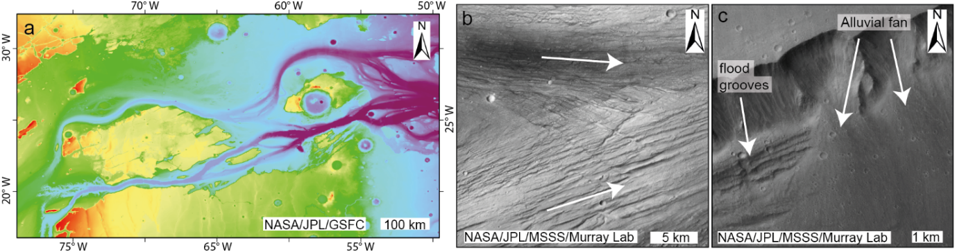

Figure 1: (a) MOLA topographic map showing Kasei Valles. (b) Juxtaposing grooved terrain, formed by different flood events. (c) Alluvial fan in Kasei Valles superposing flood grooves, suggesting lower magnitude flows of water were present, post-dating outflow floods.

Supervision
Dr Joel Davis is a specialist in planetary surface geology and geomorphology and a science team member for the HiRISE, CaSSIS, MSL Curiosity, and ExoMars PanCam missions. Professor Sanjeev Gupta is a specialist in earth science processes and has worked extensively on megaflooding on Mars and Earth. He is a Co-I on MSL, Mars 2020, ExoMars PanCam. Dr Peter Grindrod has worked extensively on solar system bodies and is an expert in planetary remote techniques.
Assistant Professor Gaia Stucky de Quay is an expert in earth and planetary surface processes, specialising in quantitative geomorphology.

Research Environment & Training
The Department of Earth Science and Engineering (ESE) is an STFC-accredited PhD training program. The Department is well-equipped with modern laboratories, offices and high-performance computing facilities. It also benefits from a formal collaboration (facilities and staff access; joint symposia) with colleagues at the Natural History Museum (NHM). Project-specific research training, including in industry standard GIS techniques, will be provided by the supervisors through weekly one-to-one meetings, group meetings and a mixture of supervised and online tutorials. In addition, students have access to high-quality transferable skills training provided by the Graduate School of Engineering and Physical Sciences (GSEPS). All students in ESE are automatically members of GSEPS. The Postgraduate programme involves regular report writing and presentation events in addition to research section and research group presentations. Students are strongly encouraged and enabled to attend international conferences and publish their work in respected journals.

References
- Davis, J. M., Balme, M., Grindrod, P. M., Williams, R. M. E. & Gupta, S. Extensive Noachian fluvial systems in Arabia Terra: Implications for early Martian climate. Geology 44, (2016). https://doi.org/10.1130/G38247.1.
- Davis, J. M., Grindrod, P. M., et al. A record of syn-tectonic sedimentation revealed by perched alluvial fan deposits in Valles Marineris, Mars. Geology 49, 1250–1254 (2021). https://doi.org/10.1130/G48971.1
- Carr, M. H. & Head, J. W. Geologic history of Mars. Earth Planet. Sci. Lett. 294, 185–203 (2010). https://doi.org/10.1016/j.epsl.2009.06.042.
- Warner, N., Gupta, S., Muller, J. P., Kim, J. R. & Lin, S. Y. A refined chronology of catastrophic outflow events in Ares Vallis, Mars. Earth Planet. Sci. Lett. 288, 58–69 (2009). https://doi.org/10.1016/j.epsl.2009.09.008
- Kite, E. S. Geologic Constraints on Early Mars Climate. Space Science Reviews vol. 215: 10 (2019). https://doi.org/10.1007/s11214-018-0575-5

