

Department of Mechanical Engineering
Health and Safety Committee

Wednesday 26th May 2021
at 12:30 pm in ‘Teams’

Minutes

Present:

Professor Mike Lowe (Chair),
Ms Julia Easton (Safety Manager),
Mr Guy Fairhurst (Building Manager)
Mr Phil Wilson (UNITE Rep)
Mr Paul Jobson (Technical Saff Rep)
Mr Eddie Hartrick (Safety Dept Rep)
Dr Catrin Davies (Representative of Post Doc Rep)
Ms Serena Dalrymple (Administrative Staff Rep)
Dhabya S A Alfalasi (Undergraduate Rep)
Jon Ryan (Fire Safety Rep)

1. | Apologies for absence
Ricardo Seccoli – is no longer the rep
Margarida Santos (Undergraduate rep)

2. | Minutes and Matters Arising from the meeting of 28th October 2020
1. | Apologies for absence
Margarida Santos (Undergraduate rep)
Ricardo Secoli (Post Doc rep)
John Field (Fire Safety Rep)

2. | Minutes and Matters Arising from the meeting of 10th February 2020
- AMT, indicated that he would adopt a policy to the effect that laser goggles are not regarded as an engineering control, in other words goggles are NOT acceptable as the “line of first defence”. He will add the requirement to a risk assessment for alignment as well as the steady state. Action AMT reallocated to JE
The laser safety pages on the Department Safety site are the ‘Faculty information’. The structure will need to be changed to add more information and be Mech Eng specific. JE will review for next time.

Though JE had input to the laser safety web page and the laser risk assessment form, they are a faculty page and document.
JE to take the discussion back to Alex for resolution

JE has edited the Faculty safety web page and uploaded notes on completing risk assessment for the use of lasers which includes the statement:
“The use of laser safety eye-wear should be considered a last resort, and ideally should not be required – even if it is present and routinely used.”

The link to the blank risk assessment form has also been repaired and the contact details for problems with the page changed to JE as Steve Greenwood has left. Action Complete

AMKPT outlined his concerns around the use of laser safety goggles. Particularly in relation to the visits that have taken place to HE institutions by the HSE, goggles come under special scrutiny associated with their condition, method of storage, and incorrect specification.

As we cannot change the Faculty position ourselves, for this Dept we
- recommend that goggles are not used as a first line of defence for alignment.
- Insist that there is a documented risk assessment for the alignment process, which is distinguishable from the risk assessment for ‘normal operation’.
- Inspection records are kept for laser safety eyewear, for which user checks are made before each use and at least every week.

The DLSO would like to introduce automated email reminders for weekly laser safety eyewear checks.

Alex has been asked how he will communicate /implement.

Alex has been asked again, and has been updated on the changes made to the laser safety pages, and has been asked about a document written by him on our local arrangements that is buried on the website and not apparently accessible

- Yellow Eurobins for disposal of bio waste: Signage is either not clear or not present. Action EH. Labelling is now in hand. The use of the facilities available in Bioengineering is not possible as they are already used to capacity by other departments. MED historically have used this facility, but we have no control of how other users make use of the facility and our human waste became contaminated with other bio waste. This being in breach of the Human Waste Act, MED were severely chastised.
JE proposed that Mech Eng have their own yellow bin. JE to liaise in the first instance with Nick Dent, Waste and Recycling Manager with the aim to keep a small locked bin within Stores. Action JE. Nic Dent has been e-mailed twice. He is meeting with JE to discuss this afternoon, (Wednesday 5th June). The Bessemer bins are already used to capacity, and there have been problems historically with using these.
JE met with Nic Dent. A HTA collection point within Mech Eng stores has been ruled out on cost grounds; though there are also other issues with siting one here. We produce little waste and the addition of a collection point incurs a minimum charge which is prohibitive for the volume involved. The proposal is for us to have our own lockable facility in Bessemer. There is resistance from Bioengineering who are in disagreement. Julia Cotton is meeting with JE, Ken Keating and Tim Venables from Bioengineering, Nic Dent, Steven Greenwood and Guy Fairhurst 31-10-19 to negotiate.
Mech Eng are now to get a small dedicated bin in the Bessemer loading bay. Action to remain until the bin is in place.
JE has prompted Nic Dent again, and again.
And again 3-2-21 as a small bin has appeared in the Bessemer loading bay – but it is not labelled. Nic has invited me to pursue him after today. From his reply I think it is ours, but needs labelling ( and a lock). Prompted again.

- Meeting to be convened to discuss how the CAGB First Aid notices will be arranged. Action JE. No progress

From our forum discussion SG has provided information on a system/template available into which you can put a First Aider list such as ours (managed by Serena) and it will generate bespoke notices for each area from the names. It was agreed to take a look at this as we need to follow up on this long-standing action. Concern with moving to specific notices for individual locations is the amount of work for Serena, or whoever wold take it on. However this is supposed to automate the process and not result in more work. JE to evaluate and discuss with relevant parties. No progress

New Equipment /New hazards

Action SG to provide an update to the policy on battery disposal.
Steve Greenwood has approached Nic Dent requesting that a policy for disposal of Lithium ion batteries is put in place. Steve to update next meeting. Action SG Steve has had no response from Nic Dent. Presently damaged batteries are dealt with as hazardous waste, but there needs to be formally documented advice for treatment of all types and condition of batteries.
JE has followed up with Nic Dent but has had no response yet.
The Battery Safety Forum will reconvene in the near future jointly chaired by Anisha Patel from the Batttery Group, and Beth Wallis the new Faculty Safety Adviser. I have suggested to Nic Dent that the forum may be able to assist is the development of the policy.

From the Mech Eng Safety Forum:

- The alarm in CAGB 124 Goods in/stores is still not working/audible. Action JE to follow up This will be rectified with the upcoming Fire Safety System upgrade in CAGB Complete

- The ongoing issue of the health and safety hazard, and difficulty in accessing the gas store for the RDW laser cutter was also raised.
It has agreed that the pavement will be dropped along Unwin Road, but this has been continually postponed. Progress is now halted while the level building project is underway as pavement is obstructed by the contractor compound.
Mark Pearce is preparing a PID (Project Initiation Document) which asks for allocation of funds. Quotes have been received; we are awaiting agreement on funding of the work. Action Mark Pearce
Guy to remind Mark and organise a meeting.

Safety training:
- The abrasive wheels training course (organised by Steve Greenwood), was scheduled to be hosted in Mech Eng and all Mech Eng technicians had taken the opportunity to sign up for it. This course has had to be postponed due to the Covid 19 shutdown. This needs to be resurrected now Steve has gone. JE to follow up.
JE has contacted the Workshop Managers across the faculty to start the ball rolling.

From Safety Training:
- Update on how many have taken the new laser safety course? Since the roll out of the new ‘Introduction to Laser Safety Course’ and the Department’s insistance that all those working in areas where lasers are used should complete this updated version – we should establish how many/ who has completed this. Action AKMPT / SD
Serena has kindly provided information on who has completed the updated course – and it is a disappointing response. What action we take has yet to be decided with the DLSO
From any other business:
- Steve Greenwood reported that the workflows for the Laser Safety, and General Risk Assessment sharepoint sites will be retired on 1st November 2020. We have been given only two months notice of this.
Historic records will still be available. Steve is working to transfer the workflows for the risk assessment form to 2013 workflows.
SG to produce a Risk assessment word document reflecting the content of the online form to be used as an alternative and if there are any problems with the availability of the online system. Action SG Action transfer to JE
For the laser safety systems we can move to the same system as used in FoNS – Charmian Alvares is the contact. Steve to pursue. Action SG Action transfer to JE
The Faculty employed a contractor to migrate the workflows for our Safety systems – so they are working at present. Complete
Efi is making astart on the word document.

3. | Accidents, Incidents, Non-compliances
Battery fire 123 4-11-2020

A destructive test of a proprietary Li-Ion battery pack was performed according to standard procedure. The purpose of the test was to determine whether the thermal runaway of a single cell within the pack would propagate to the other cells. Based on previous testing, the likelihood of propagation was thought to be small, but was planned for nonetheless.
Unfortunately, the pack underwent rapid propagation of thermal runaway, causing a number of cells to vent in a short period of time (<30s), and these vented gases then ignited. This fire was contained by the primary combustion chamber around it.
Before security attended the lab, they manually set of the fire alarm off via a break-glass point on level 2. The building was evacuated, apart from the attending personnel.
The activation of the fire alarm system had disabled the exhaust system.

4. | Inspections and Audits
- The Head of Department and Safety Manager conducted an inspection of the whole Department on 12-1-21. Very low numbers of people present, and adherence to covid measures was observed to be good.
- The head of Departmetn and Safety Manager conducted an inspection of the whole Depatment on 9-2-21.

5. | New Equipment/Research Programmes that may affect others / introduction of new hazards and related safety issues
6. | Building Issues
- The operation of the gas detection system in 123, 242, 258 is under review to ensure it is reflecting the work being carried out in the area. This is being done in conunction with central safety dept and the installer/maintenance company.
- Ppms continue to be accomodated at this time with permits being placed and liaison with lab users so that the elected room occupancy levels are adhered to.
- Social distancing and one way signage remains in place. Complaints about face coverings have reduced,
- The goods lift will not return to service this term.

7. | New Policies, Procedures and Codes of Practice
- The Department is expecting all staff and students attending site to take regular tests for Coivid 19.
- We are now implementing a stricter policy for people who need to do work within the 2m safe-distance separation, for example co-working on an experimental rig, or face-to-face training on the use of a facility or machine. In such cases it is a requirement that both people are tested in the preceding 48 hours and show a negative test result prior to starting the activity. Such activities for academic staff/RAs/RSs needs to be arranged as part of the regular planning for access to labs, which is overseen by group heads, and via line managers for technical staff.
- Stores /Goods in has moved to single person operation. Whilst this is difficult to manage the work and individuals are working longer hours on their days in College, it means that both staff are not exposed to the same threats at the same time.
8. | Fire Safety
- A comprehensive survey of the Fire detection and alarm system in CAGB has been carried out following concerns raised about the suitability of the existing system over a significant time by the Department; notably the intermittent and unreliable operation of the annunciator system.
A PO has been raised to Lloret who are going to carry out extensive remedial works to the fire alarm in accordance with the recommendations made in their report. Jon Ryan from the Fire Office will act as PM and Courtney and I will provide any/all support needed including liaison with building users.
The project will commence either week commencing 22nd February or 1st March.
The detection and alarm system will remain live throughout the work – and if any interruption to operation is required this will be supplemented alternative arrangements to ensure that no one is put at increased risk.

9. | College Safety Unit Summary
 | Copy circulated
10. | Radiation Safety Report (when applicable)
 | - Zhusheng Shi will be apointed RPS for 013 (training on Friday 12-2-21).
11. | OH Report
 | Copy circulated
12. | Safety Training
 | Nothing to report
13. | Any Other Business
14. | Dates of next meetings: 26th May 2021 @12:30 venue tbc

3. | Accidents, Incidents, Non-compliances
IN016457 Follow up on the battery fire that occurred in 123 on 4-11-2020. A change form has now ben submitted to change the operation of the LEV system in 123 and 242 such that it will operate until destruction in the event of a fire- without intervention to disable it. The approval process through the Fire office and Estates Facilites has been completed.
Guy to pursue this week.

IN016398 An original iPhone 7 plus charger (CE certified) was plugged in to socket DB-7R02-P-2L2 in room 712, floor 7 of City and Guilds Building. After a few minutes, there was a sudden bang sound which discharged part of the charger from the socket. Security were immediately contacted and a representative of the Estates team checked the socket. This might have resulted from the charger malfunctioning however there was no damage to the electric socket.
This was original manufacturer equipment with no visible damage or modification. The incident was not foreseen and is categorised as an extremely unlikely occurrence.

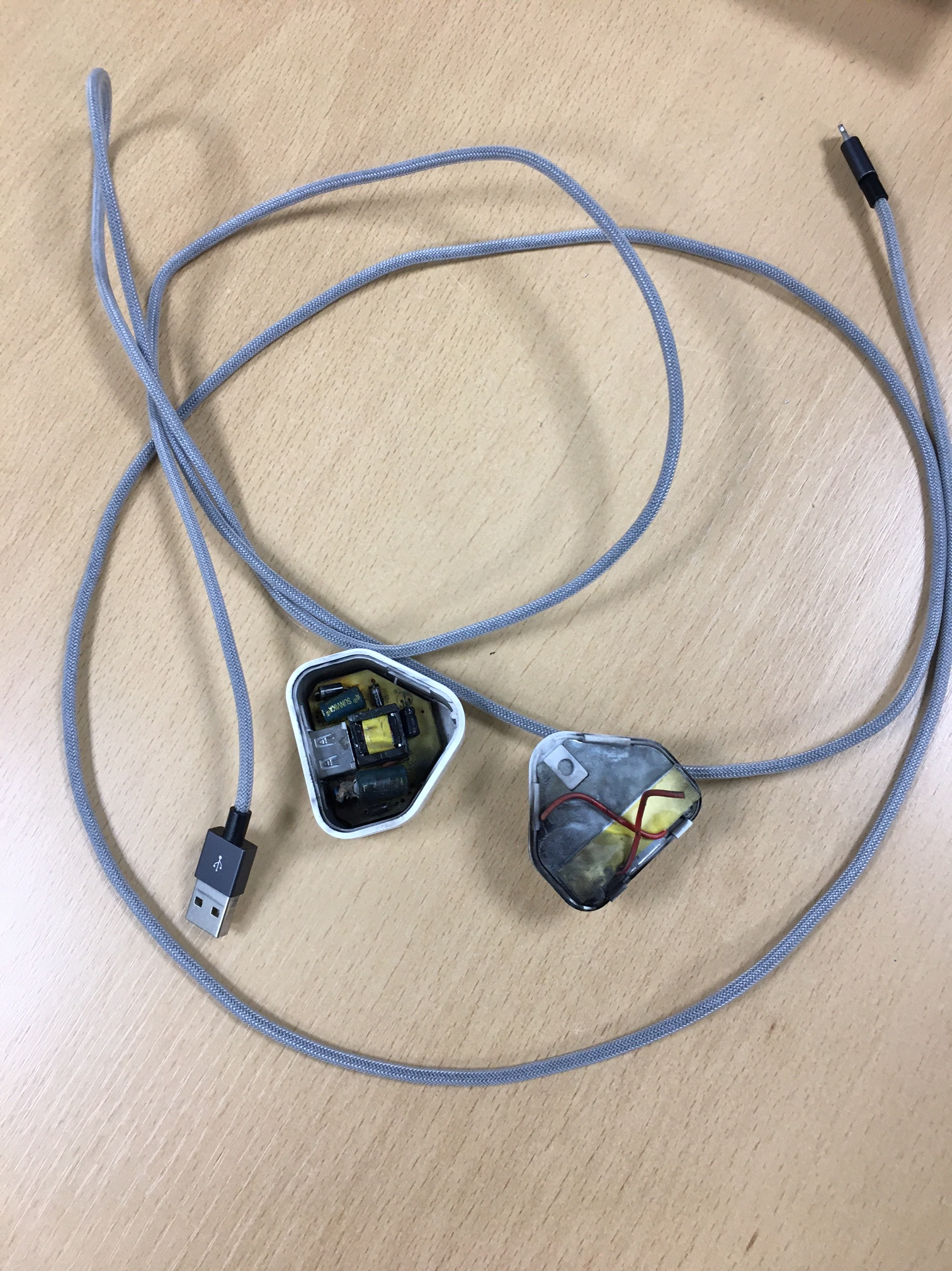

IN016575 On 20-4-21 during a routine low risk battery test, the Faraday Centre lab filled with smoke. This did not result in activation of the fire alarm. Controls for the experiment were effective – the ‘fire’ was contained within its enclosure filled with vermiculite. The container deforemed but remained in tact – all predictable. Thte concern was that the alarms were not activated in the presence of significant amounts of smoke.
Upon investigation it was discovered that the lab had been fitted with heat detection. It has been confirmed that the specification sheets completed by the group for the building project specified smoke detection.
The rational for this is as follows:
- We do about 20,000 hours of battery testing every week, and we’ve yet to have a failure for this low risk category of test that has required the building to be evacuated.
- In the very near future, the majority, if not all tests in this lab will be connected to the LEV system as precautionary measure for the event of a battery failing and catching fire. (note, we are not purposefully failing batteries in this lab).
- Therefore, I would expect the lev to capture any smoke generated by a battery fire and not trigger the lab smoke alarms.
- If the smoke breaches the containment, or if a piece of equipment catches fire (either as a result of a battery fire, or independent of it), then we would wish to detect this sooner rather than later.
- Our preference is not to lose the entire lab, to avoid the inconvenience of a building evacuation.
A heat detector may be considered in one location for a soldering station.

4. | Inspections and Audits
- On 24th February the Head of Department and Safety Manager conducted a whole Department Safety inspection and a Laser Safety Inspection accompanied by the Departmetn Laser Safety Officer of Cell 3 in 242. The Department remains quiet and no major safety concerns were observed at this time. Cell 3 in 242 was improved with the remnants of an old experiment requiring a laser now completely dissassembled and removed.
- On 5th May Eddie Hartrick (Safety Dept) visited the Stores /Goods In area to review the area and ‘interrogate’ staff on procedures for if they should receive a consignment of high consequence dangerous goods. The College anticipates a visit from the Department of Transport to assess compliance with receipt of goods that cannot be intercepted by a third party. Eddie appeared satisfied with the visit and operation.
Minor modifications to our existing risk assessment and documented operational procedures for the area were suggested.
- On 19th May Nigel Brandon (Faculty Dean) and Tin Venables (Faculty Operating Officer) visited the Department for a routine safety inspection. Both visitors were pleased with progress in Cell 7 of 123 which has undergone reconfiguration to better accommodate the combustion work in the facility. Other areas visited were Cell 2 123, RDW 3, Stores/Goods In, the Faraday Centree Faraday Centre laboratory, and the Adhesive Suite.
Concern was expressed at the lack of segregation of the workshop and stores areas, and the overflow of deliveries into RDW3. At the time of the visit a technician from Aero came to use the guillotine, and it was completely inaccessible (as many of the workshop faciliites were) with deliveries. The clutter within the workshop area was a safety concern.
- The next Head of Department and Safety Manager inspection will be the 9th June 2021.

5. | New Equipment/Research Programmes that may affect others / introduction of new hazards and related safety issues
 | - Purchase of Fluoroscope by the Biomechnaics Group – will be mentioned in radiation safety.
6. | Building Issues
- The work to upgrade the Fire Detection and Annunciation System in City and Guilds Building commenced at the beginning of March by Lloret. Work has been systematically completed on each floor from the top down to rectify any problems with the hidden system. Some remaining work is acknowledged throughout the building, for example to fit the sounder in 513, and comprehensive testing of the whole system will be done when all other work is completed. The project is presently on Level 2 and is scheduled to scomplete all work by 20th June; with testing of the system anticipated to commence 19th June.
The Department is delighted to be having the deficiencies in the existing system addressed, and appreciates the investment the College is making in our building, however it must be noted that concerns in operation of the system have been raised over a number of years. It has taken quite some time to get to this point.
There have been few complaints of disruption associated with this work, which has gone smoothly.
- Work is expected to commence in the near future to replace the roof on LT 200. This work will require asbestos removal from part of the roof structure. Occupants of the building should not be affected.
- Lab 101 is in the process of being emptied in advance of the project to improve the environment and install LEV. Expected start date is now mid June.
- From the Building Manager: Covid signage, one way systems and social distancing remain in place at this time.
- The Business School is about to commence a substantial project to waterproof the vaults. Access will be via the sunken garden SE corner door. The project manager is Kirsty Scallan.

7. | New Policies, Procedures and Codes of Practice
 | Nothing to raise.
8. | Fire Safety
The Head of Fire Safety is leaving on Friday. John Fielkd will be acting up until a new appointment is formally made.
College has received a visit from Zurich to look at passive fire protection.

9. | College Safety Unit Summary
 | Copy circulated
10. | Radiation Safety Report (when applicable)
 | - Richard van Arkel has been appointed Radiation Protection Supervisor following the purchase of a fluoroscope by the Biomechanics Group.
11. | OH Report
 | Copy circulated
12. | Safety Training
13. | Any Other Business
- Bethany Wallis has been appointed as Safety Adviser for the Faculty. This is a six month secondment commencing in June. The Faculty is trialling a system whereby a more junior safety adviser carries out the role under the supervision and guidance of myself and Ken Keating, the Safety Officer for Bioengineering. Beth will be spending a disproportionate amount of time in the Department to begin with as part of training and familiarisation with engineering and mechanical physical hazards.
- The committee still has a vacancy for a Post Doc rep.
- Sadly, this will be Philip Wilson’s last meeting as he will be retiring before our next meeting. I would like to thank Philip on behalf of the committee for more than ten years service as the Trade Union Rep.

14. | Dates of next meetings: either 27th Oct 2021 or 3rd Nov 2021 @12:30 venue tbc

