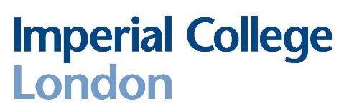
Department of Physics
Communicating Physics
Application form for 2024/25

Please note: Interviews will be taking place in person in Blackett 311.
NAME (in capitals):
COURSE CODE (e.g. F303):
CID NUMBER:
Please give below your reasons for wanting to take ‘Communicating Physics’:

Please indicate any prior teaching experience:

All students who are accepted on the course are required to undertake a DBS check. By returning this form it is understood that if you are selected for CP you are committed to the course and cannot withdraw at a later stage. Students who do withdraw will be asked to cover the cost of the DBS check.

Please return your completed form to r.bains@imperial.ac.uk by 14:00 pm on Friday 14th June 2024.

Interviews for the CP course will take place on Tuesday 25th June 2024.

