Getting started with Worktribe - Applicant

Introduction

Worktribe is a modern highly performant system which increases the efficiency and transparency of internal pre-award and research processes, particularly for internal and external multi-disciplinary collaborations. As the latest addition to the Worktribe research management suite, this online research ethics management software takes on the challenge of streamlining complex ethics review and approval processes for research projects.

Worktribe Ethics enables researchers and administrators to submit, review, amend, approve, and manage all research ethics applications online in one place. Features include clear workflows, dynamic forms, application routing, committee meeting tracking, document version control, filterable management reports and an open API for deeper data analysis. Managing ethical reviews and approvals in one place helps foster greater transparency, ethical compliance and research integrity, as well as saving academics and administrators time and stress

Although the platform has multiple uses the College and RGIT team will only use this platform for Imperial College Committees (ICREC and SETREC) ethics applications. Projects involving the NHS will still be processed via the IRAS system and will not require Worktribe review. This includes scoping questions that help identify what a project is about and depending on how these initial questions are answered additional pre-defined questions are generated to ensure that enough information is collected for committees to assess and approve an ethics application. Different sections include human participants, data generation, animals and methodology.

Table of Contents
1. Login to Worktribe 6
2. Overview of the Worktribe landing page 7
2.1. Home 7
2.2. Tabs in the home page 8
2.3. Profiles: My Profile 8
2.4. Projects 8
2.5. Ethics 9
2.6. Help 9
3. Overview of the Worktribe functions 10
3.1. Notifications 10
3.2. How to search for an Ethics Application 10
3.3. User menu 10
3.4. Announcements 11
3.5. Study Status 11
3.6. Monitoring of the ethics application 11
3.7. How to add a comment 12
3.7.1. How to format comments 12
3.7.2. Annotation Aside 13
3.8. How to @tag a person 13
4. What does the ethics review process involve? 14
5. How to create a new ethics application 15
5.1. Login in to Worktribe 15
5.2. Create a new application 15
5.3. Completing the application question tabs 17
5.3.1. Summary 17
5.3.2. Details 17
5.3.3. Scope 18
5.3.4. Methodology 18
5.3.5. Human Participants 18
5.3.6. Security 19
5.3.7. Environmental Impact 19
5.3.8. Data Management 19
5.3.9. Documents 19
6. Supervisor / HoD approval 21
6.1. Submitting ethics application to Supervisor/ HoD. 21
6.1.1. Review of ethics application by Supervisor 22
6.1.2. Resubmission of ethics application to Supervisor/ HoD 22
6.1.3. How will you know when it has been approved? 22
7. Review of ethics application 24
7.1. ERGC triages and reassigns the application 24
7.1.1. High risk studies 24
7.2. Confirmation of allocation by RGF to the researcher 24
7.3. RGF review of ethics application 24
8. Revision of the ethics application by researcher 24
8.1. Revision of supporting documents (Protocol, PIS ICF) 25
8.1.1. Version Comparison
9. RGF and Head of RGIT final review 25
10. Supervisor/ HoD approval of the application 25
11. Response and Approval 26
12. Post approval responsibilities (Amendments) 27
12.1. Creating an amendment 27
12.2. Updating the online application tabs 28
12.3. Updating the supporting documents. 28
12.4. Supervisor / HoD approval 28
13. Review of amendment 29
13.1. Amendment triage 29
14. Resubmit amendment for approval 29
15. Supervisor/ HoD approval of the amendment 29
16. Withdrawal of Application
17. Annual Progress Report (APR) 30
18. End of study (EoS) Notification 30

Login to Worktribe

Log in to Worktribe  Users should access the logon screen.  Enter your college username and password to access.  After logging in, Worktribe’ s homepage will appear. | 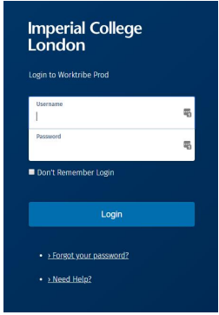

Overview of the Worktribe landing page

The Worktribe landing page has a variety of tabs and fields all assigned for specific functions. Understanding how the tabs and functions work will help you move through the ethics review process more easily.
After logging in the Worktribe homepage will appear with five tabs at the top of the page in the green bar.
- Home
- Profile
- Projects
- Ethics
- Help

Home
The home tab is positioned at the top left-hand side of the landing page. Clicking it will return you to the homepage.
A list of your ethics applications will be displayed as shown in the table below.
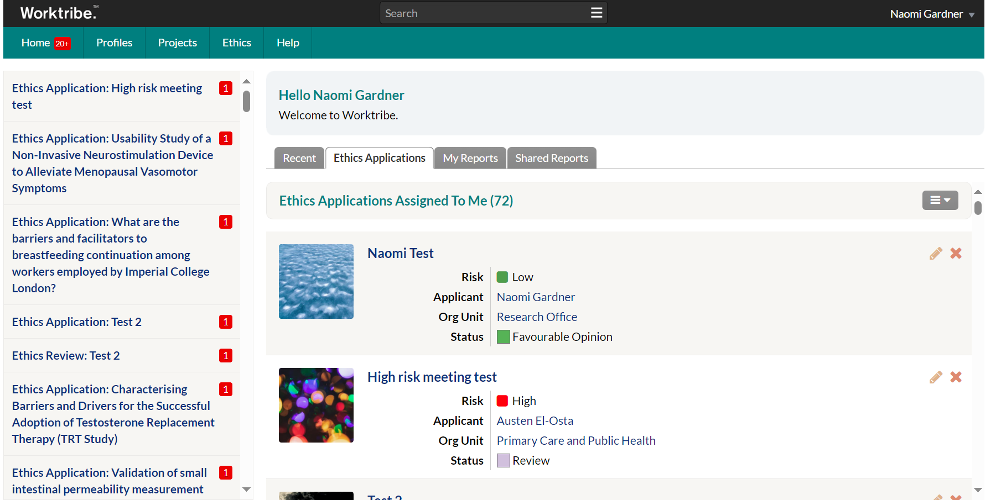

Tabs in the home page


- Recent: A list of recently accessed applications.
- Ethics Application: A summary of all your ethics applications.
- My Reports: A summary of your reports .
- Shared Reports: A summary of any reports shared with other users.
.

Profiles: My Profile

All Worktribe users have a corresponding ‘profile’ in which some basic information about users is stored. You will see your own profile by clicking on ‘My Profile’.
My profile page has four other tabs:
Summary: A summary of your personal information.
Details: Lists information about you. Note: Profiles are not editable by the user. If any part of your profile is incorrect, please contact Worktribe admin.
Projects: This tab is not applicable to ethics applications. If you are involved in costings and grant applications through the Worktribe system, you will see your grant projects listed here.
Ethics Application: A person can now access their Ethics applications from the My Profile option. The new tab includes all Ethics applications where the person is the applicant.

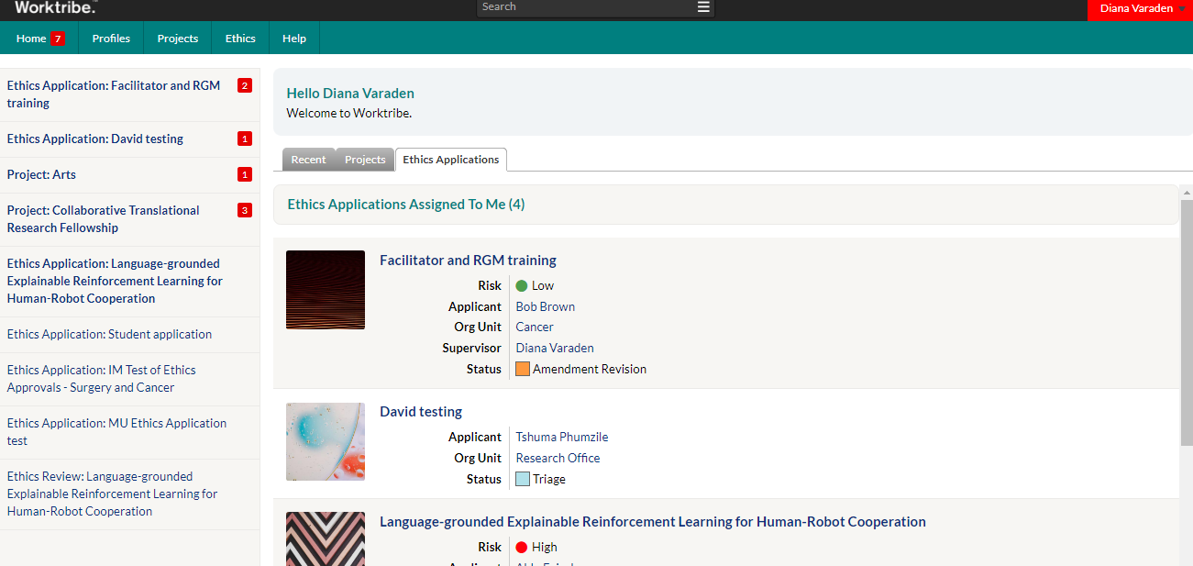

Projects
This tab is not applicable to ethics applications. If you are involved in costings and grant applications through the Worktribe system, you will see your grant projects listed here.

Ethics
For use when completing your ethics application through the system.
‘Create Application’: starts a new ethics application.
‘All Applications’. All your ethics applications can be found here.
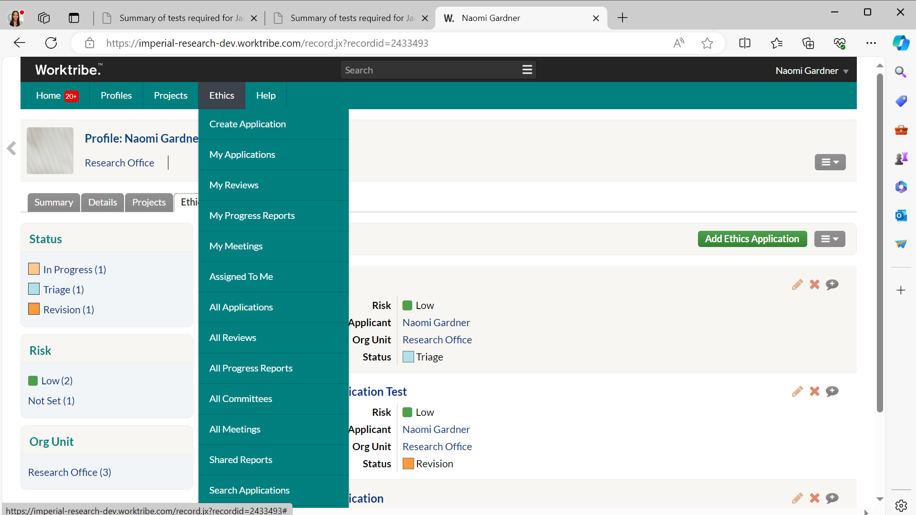

Help
Click on the Help button to reveal the Help menu.
Help topics: A link to Worktribe guidance and e-learning videos is provided by the Research Office.

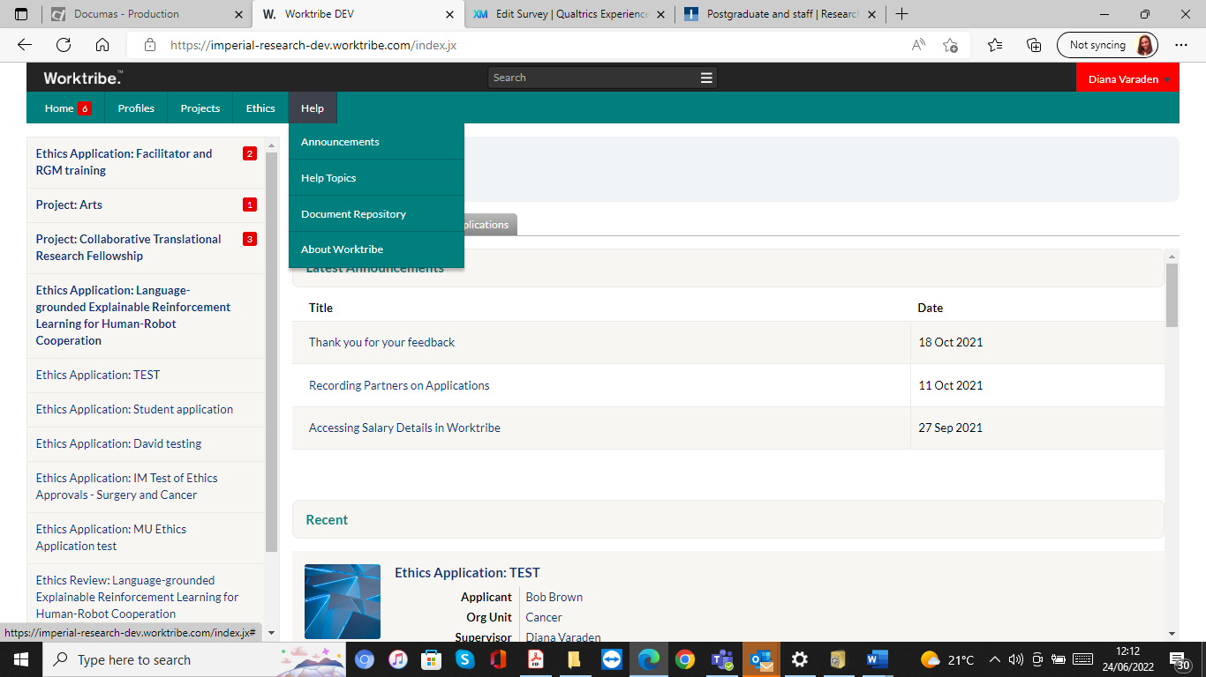

Overview of the Worktribe functions

Notifications
Notifications on the home screen exist in Worktribe to notify users of events that have occurred in the Worktribe system (e.g., notifying an approver to review the ethics application) or where another user has tagged them within a study.
@Tagging is the function used to message or notify another user. It’s important and is described in detail in the revision stage of the application where tagging a user is the method of communication used.
The notifications sidebar is positioned on the left-hand side of the homepage. This alerts users to notifications within ethics applications.

How to search for an Ethics Application
The search bar can be used to search across the whole system. If you start typing into the search box, there is a shortlist of items returned.
You can expand the search results by selecting ‘See all results for...’ at the bottom of the list. Search results depend on the user’s access rights, for example, searches will only return projects they have access to.

User menu
To reveal the User Menu, click on your name on the top right of the homepage.

Announcements
General notices affecting all Worktribe users will be collated in the Announcements page. The latest announcements are displayed at the top of the homepage.

Study Status
The ethics process is broken down into different stages. The Worktribe system has a status bar that allows you to follow the different stages of the application process.
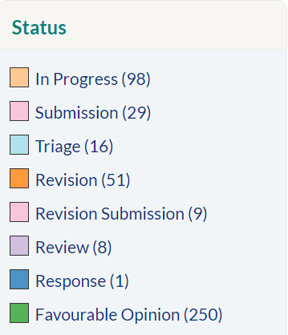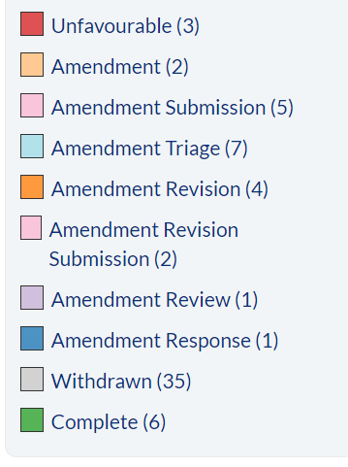

Below is a list of the activity taking place at each stage. Variations of these status’s can be used throughout the study.
- In Progress - The researcher has created their application and is continuing to make changes.
- Submission - The researcher has submitted their ethics application for review to RGIT and their supervisor/ HoD.
- Triage - The assigning and preliminary assessment of the application to the most appropriate person after the HoD has signed the application.
- Revision - Following receipt of the comments from the Research Governance Facilitator (RGF) and the Head of RGIT. The researcher will be required to revise the application.
- Review - High risk studies only – application is with the Committee for review.
- Response – RGIT prepares response regarding ethics application outcome.
- Favourable Opinion - This stage formally confirms that the ethics application is satisfactory, and approval has been issued for the study.

Monitoring of the ethics application
The comments tab allows a person to monitor and track the comments and status throughout the life of the study. Every comment that is added within the system will be recorded here.
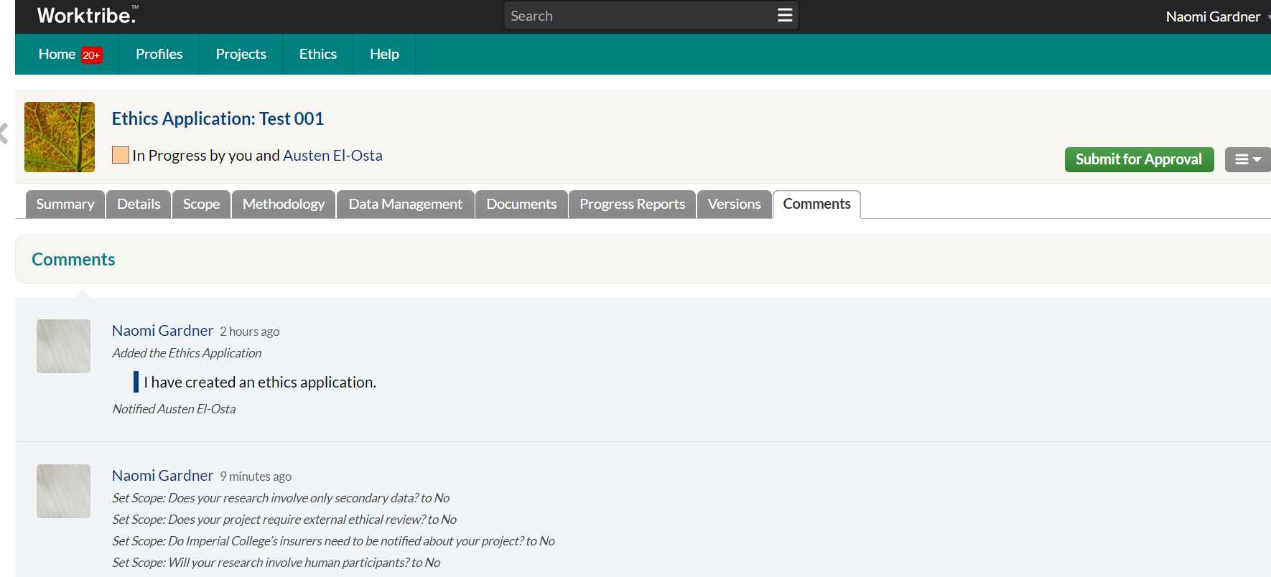

How to add a comment
You can add comments by pressing the grey bubble on the right-hand side of the chosen question and adding your comment.
Press Enter to add the comment to the thread. Once a comment has been adding it will change from to
Only the Supervisor and applicant can add and see comments. The HoD can only review and approve the application.
Please Note: Comments can be seen by the researchers and will be available in the comments tab audit trial so please make sure they are accurate, worded clearly and relevant.
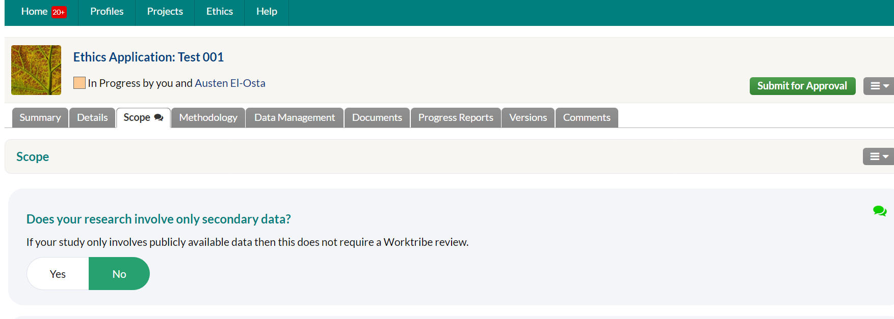

How to format comments
Comments can be formatted in two ways:
- Surround any word/phrase with * and it will appear bold.
- Surround any word/phrase with ` and it will appear preformatted.

Annotation Aside
From the comments tab, you can add additional comments for the study. Annotations can be added to items within the Details, Documents and Risk tab. This works in the same way as the comments tab; you can simply add text and/or tag, reference and/or format your comment. For example, a user may want to tag another user to alert them to an issue or simply ask the user to review and get their opinion.

How to @tag a person
You can tag other users or groups who have access to the application to alert them of any comments made.
Typing @ or clicking on the @ symbol on the end of the text box and start typing the name of the user/group for a list to emerge and select as needed. As comments cannot be removed, it is advised to take care when tagging other users/groups.
Tip: You can also tag other records within Worktribe for reference, using the # character. Like tagging, using the # symbol will produce a list from which to search from to select the appropriate record. Records can include other projects, documents, risk assessments etc. This might be useful if your application is linked to another study.

What does the ethics review process involve?

The steps highlighted in blue are relevant for supervisors and HoD.
If ethics approval is required, an online application form is completed by the relevant researcher, providing details of the project aims and methodology, and responses to key ethical considerations.
The application is submitted to the relevant supervisor/ HoD for review and approval.
Please note: The supervisor is not able to be one of the applicants.
The application is allocated to the Research Governance Facilitator (RGF) (reviewers) to consider the application and approve if appropriate.
The application is re- submitted to the relevant supervisor/ HoD for a final review and approval.
Approval of the application and a copy of the approval letter sent by RGIT.

The below diagram outlines the ethics application process and how each person’s responsibilities are laid out at each stage.

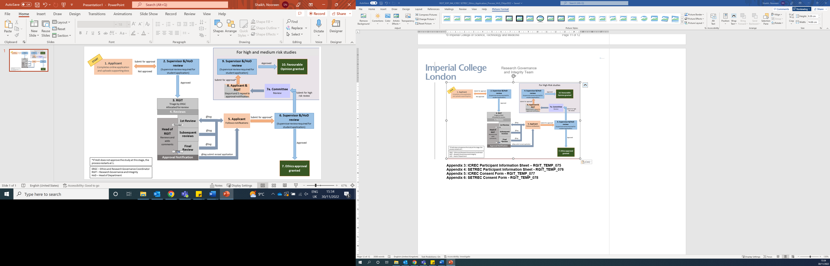

How to create a new ethics application

The following main steps will be followed during the life of the ethics application.
- Login
- Create a new application
- Complete the questions online
- Share your application with your Supervisor/HoD for approval
- Making changes requested or respond to modifications
- Post approval responsibilities

Login in to Worktribe
Instructions can be found at the start of the document.
If you are unable to gain access; please, you may need to be setup with login details please contact IT via the 1 service.
PLEASE NOTE: You need to be registered with Worktribe before attempting to login. Those who require ethics clearance before they are registered must do this in consultation with their relevant department as the department will have to add them to the system so that the user can be issued a username (active email address) and password by IT. Students will need to contact the Worktribe admin in to arrange login.

Create a new application
Click ‘Create Application’ within the Ethics tab.
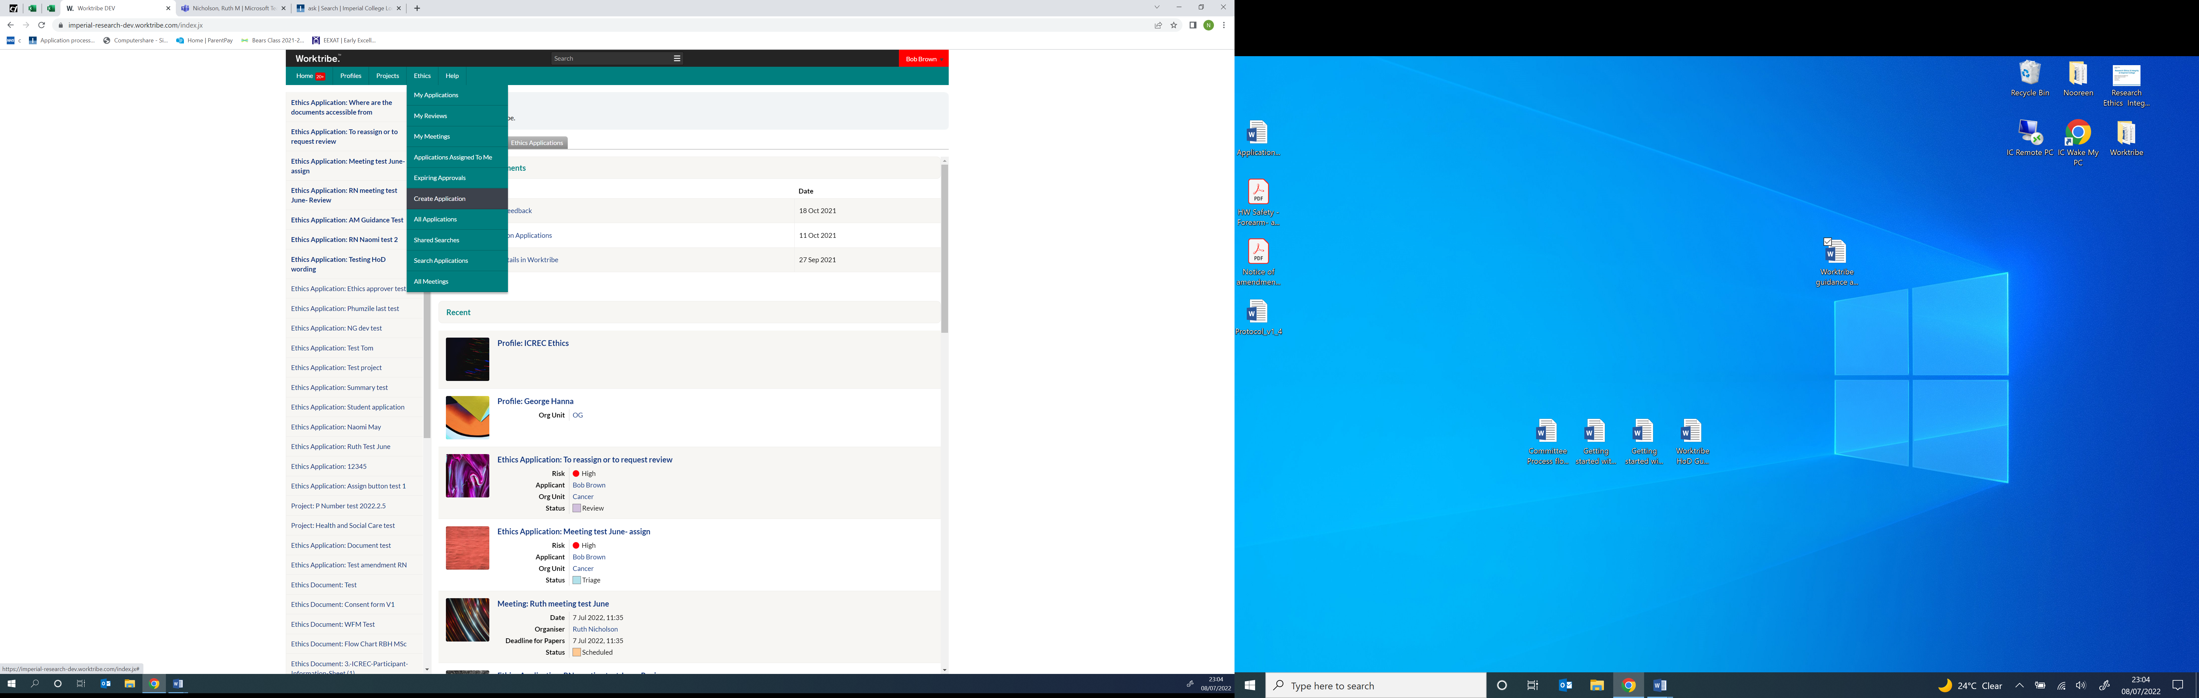
A pop-up window will appear. (Enable pop-ups in browser).
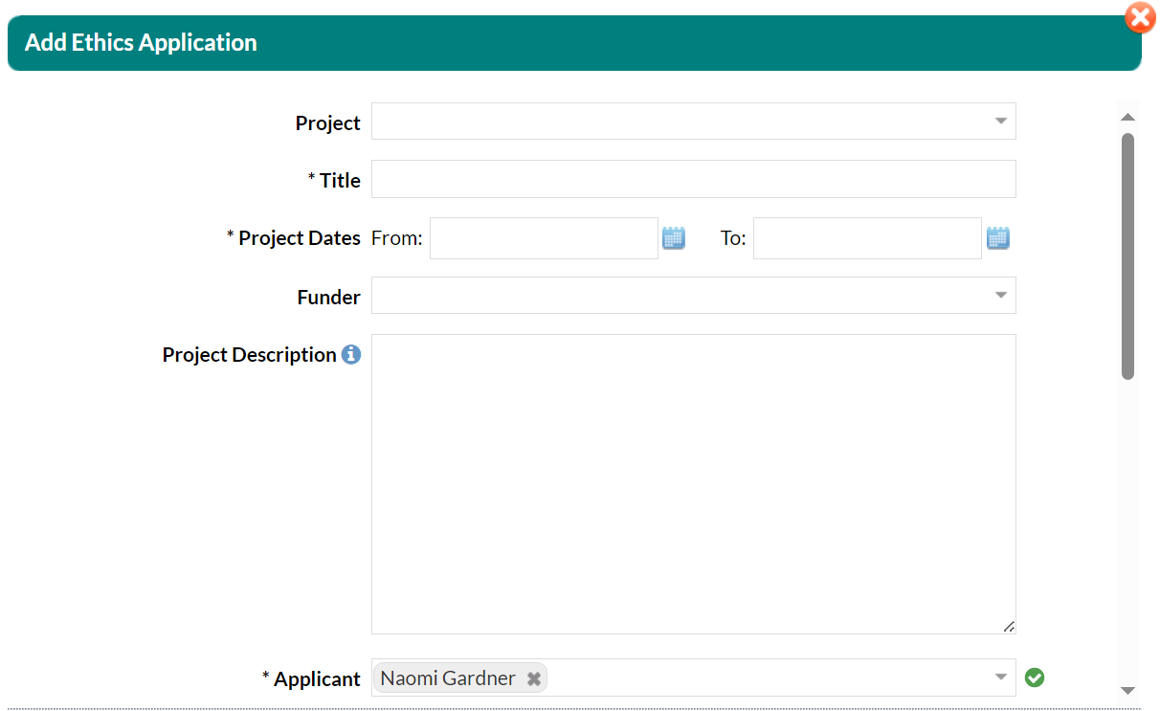
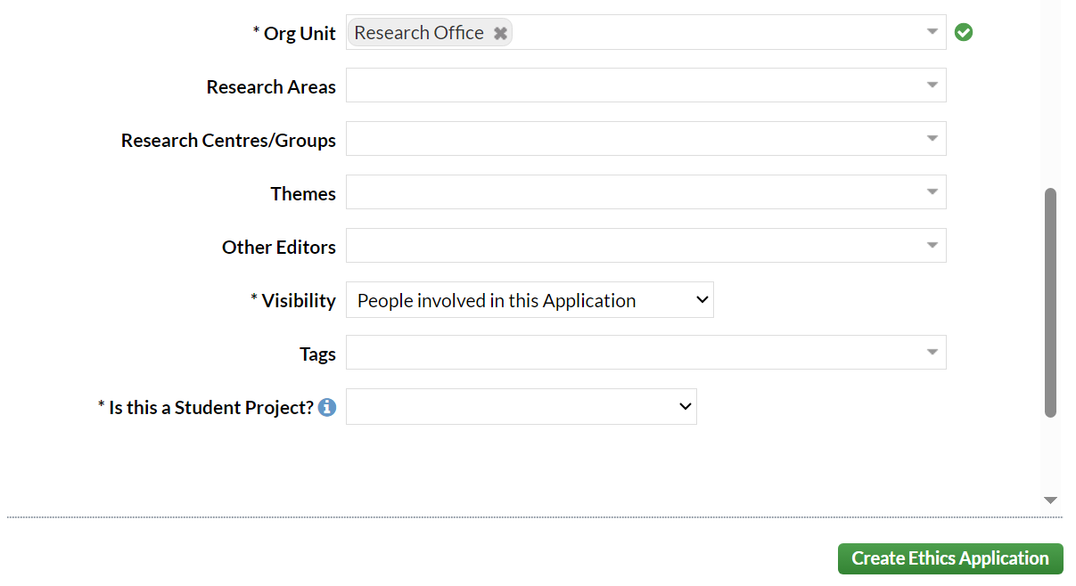
Ethics Application visibility
A new Ethics Visibility field has been added to org units. Selected groups will be able to see all applications from that level of the org unit and below. This field allows a Group to be given View Only access to all Ethics Applications associated with that Organisational Unit.

On submission additional tabs will appear such as a new optional Notes field to applications; available to populate by administrators or via the workflow at In Progress, Revision, Amendment, and Amendment Revision.

* Mandatory fields within Worktribe to create an application. Please note that undergraduate projects would not normally use this application process and should instead see the ICREC/SETREC website for the undergraduate application process.

If a keyword is not available, please contact Worktribe Admin to request for missing keywords to be added.
Other Editors- it’s important to remember that if you have multiple members of the study team involved in reviewing the application and you need to send it to another staff member for review before submitting it to RGIT, you can do this by adding them in ‘Other Editor’ in the details tab.

Once all fields have been completed, Click. and the ethics application will be created. The status of the study will change to .
The system has now created a record for you with a system generated number. The next step is to complete the electronic application form.

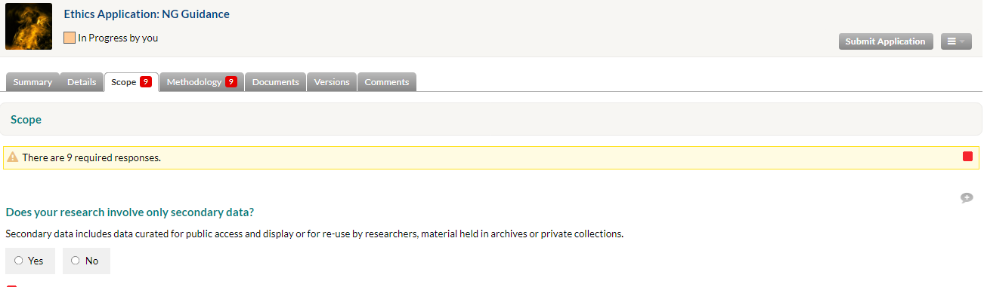

Tip: If you are working on the application form and you want to stop and continue at a later stage you do not need to save the document. It will always be available in the system until the study is completed.

Completing the application question tabs
The online application automatically generates tabs applicable to the ethics applications.
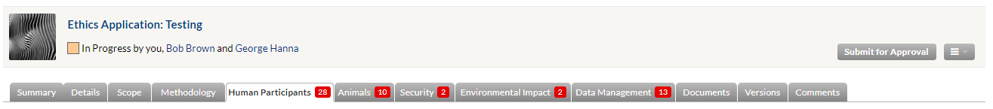
Each tab focuses on asking questions to help identify any potential ethical risks that may arise from the study.

Summary
Includes details of the applicant and the names of those assigned to the study. The risk level will be confirmed by the Ethics and Research Governance Coordinator (ERGC) when reviewed.
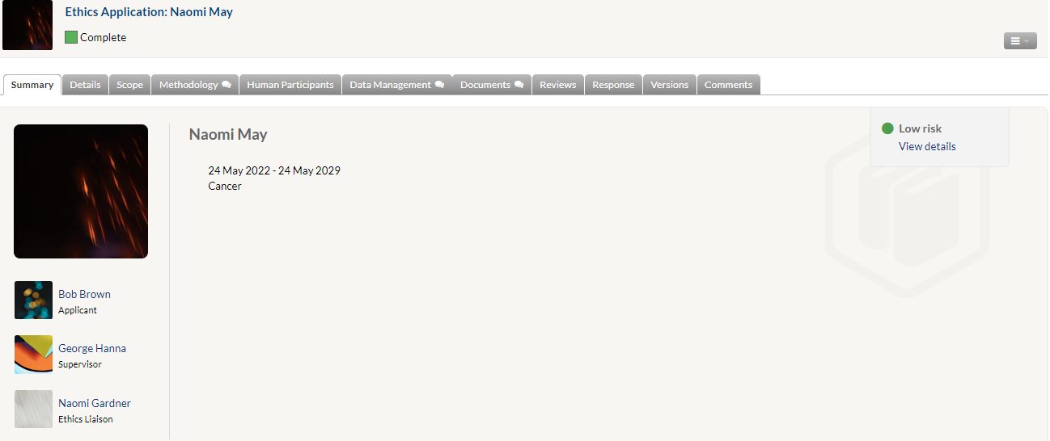

Details
The main details about the study are listed in this section, it will automatically populate relevant sections from creating the ethics application.
Not all questions need to be completed, the majority will have automatically populated. They can however be edited if required.
- Applicant ID: 7-digit ID number will be automatically generated on creation
- Supervisor: if you are a student, it should list the academic supervisor here.
- Applicant: the name of the applicant, additional applicants i.e., the PI if they are not completing the form).
- Submitter: includes the name of the person who submitted the application.
- Other’s editors: if more than one person is required to review the application.
- Risk: is the responsibility of the ERGC to assign the level of risk.
- Ethics Liaison: automatically populates the name of the ethics admin.
- Meeting: this field will only populate for studies requiring committee review where a meeting date has been confirmed and added in Worktribe.
- Submitted Date: automatically populates with the date the application was submitted.
- Decision Date: automatically be populated on approval of the study.
- Status: displays the status of the study. This tab is subject to change and will reflect the different stage in which the study is being reviewed.
- Assigned to: will include the name of the Research Governance Facilitator once one has been assigned to the study.
- Created: Include the dates the study was created.
- Created by: automatically populates the name of the person who created the application.
Please ensure that the Principal Investigator for the study is named as an applicant or as the supervisor (if applicable for a student project) in the Worktribe application.
The Principal Investigator is the overall lead researcher for research and are responsible for the overall conduct of a research project. They should also be named in the study protocol.

Scope
There are 9 mandatory questions in this section that aim to determine the level of ethical risk associated with the study. Additional questions may be generated according to how the questions have been answered. On completion of all mandatory fields the red notification flag will disappear from the tab.

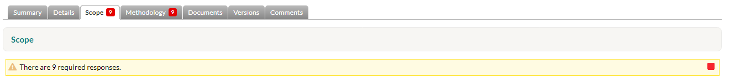
Additional comments can be found on some key questions outlining what information should be included within the section. (See below)

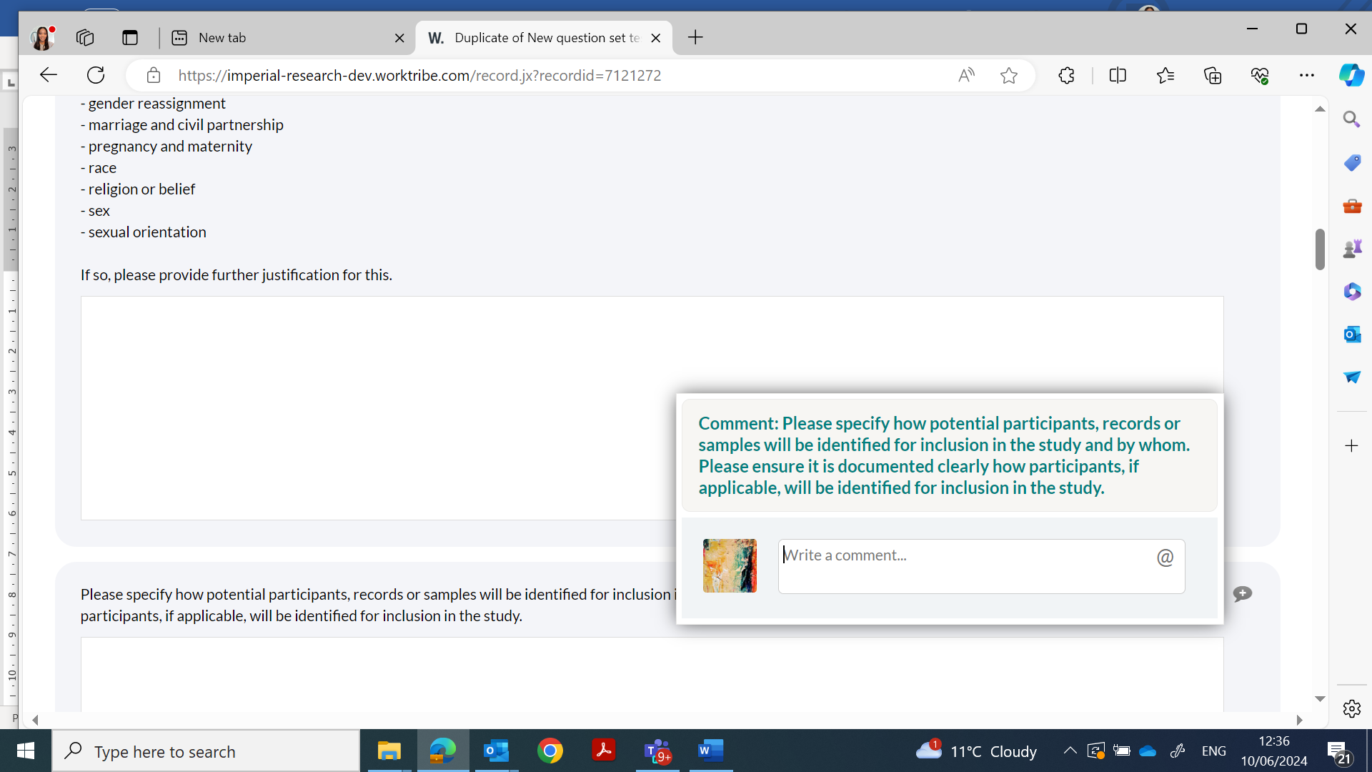

Methodology
There are 9 mandatory questions in this section. The questions cover the activity, analysis and principles or procedures.

Human Participants
There are 28 mandatory questions in this section. The questions aim is to get you to consider how you will ensure human participants are treated fairly and their welfare and rights are protected.

Key points
If your research involves collecting, storing or processing human tissue samples at Imperial College London then you will need to register the study with the Imperial College tissue bank to fall under the HTA licence.
If you using any medical device in the UK that is CE/UKCA marked but is being used outside its product limitation, or are you using any non-CE/non-UKCA marked product(s), please refer to the MHRA Guidance.

Security
There are 2 mandatory questions.

Environmental Impact
There are 2 mandatory questions in this section about potential environmental impact.

Data Management
There are 13 mandatory questions in this section covering the following: Practice of collecting, keeping, and using data securely, efficiently, and cost-effectively.

Key points
As per Imperial policy, data should be stored for 10 years post end of study.
Research involving photographs, videos or audio recordings of research participants should clearly identify who will have access to the recordings, information about the recordings, or the locations where the recording will occur. Also include details about where and how the recordings will be stored and if they will be deleted once transcribed. Research records are generally required to be maintained for 10 years following completion of the study. However, for recordings, researchers are encouraged to destroy the recordings once the information needed for your research has been obtained.
For data to be fully anonymous the code link must be removed. Most data will be pseudonymised so please ensure you are careful when answering this question.

Documents
Supporting document must be added to your application. ICREC and SETREC template documents can be found online. It is mandatory to use our templates. This ensures the documents include our standard ethical and legal clauses ensuring researchers adhere to IC policies and regulations.

Please ensure that all required documents (including questionnaires, advertisements and any other recruitment material) are uploaded when submitting your study.
Please ensure all documents have a version and date in the footer.

How to upload Documents?
The Documents tab is used to upload supporting documents (protocol, PIS and adverts etc).
Documents should be given a title which gives the document (e.g., Protocol v1.1 090722) a title, version, and date.
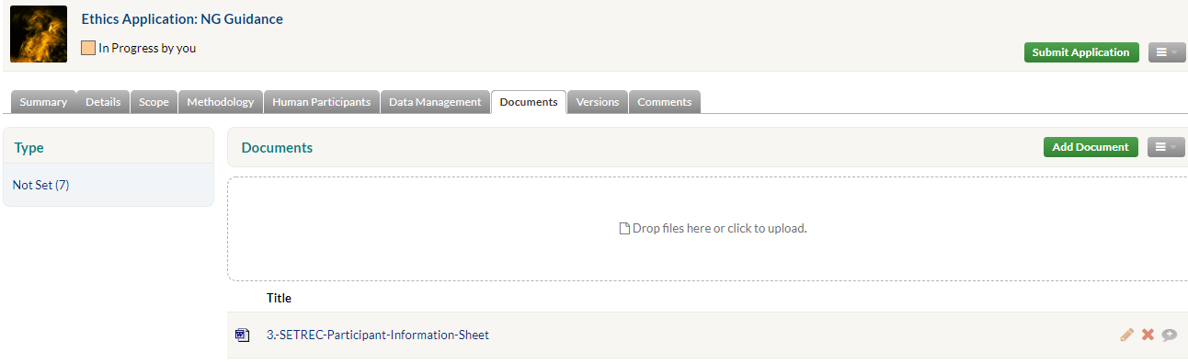
To upload any documents, Select in the top right corner. Or drag and drop into the box.

How to Delete Documents
Users can delete documents that have been uploaded. To delete a document:
Click on the icon.
Press OK to confirm that you wish to delete the document. The document will disappear. Users can delete multiple documents if required. Click on the menu and click on Select, allowing for multiple selections.

How to replace documents
Click on the 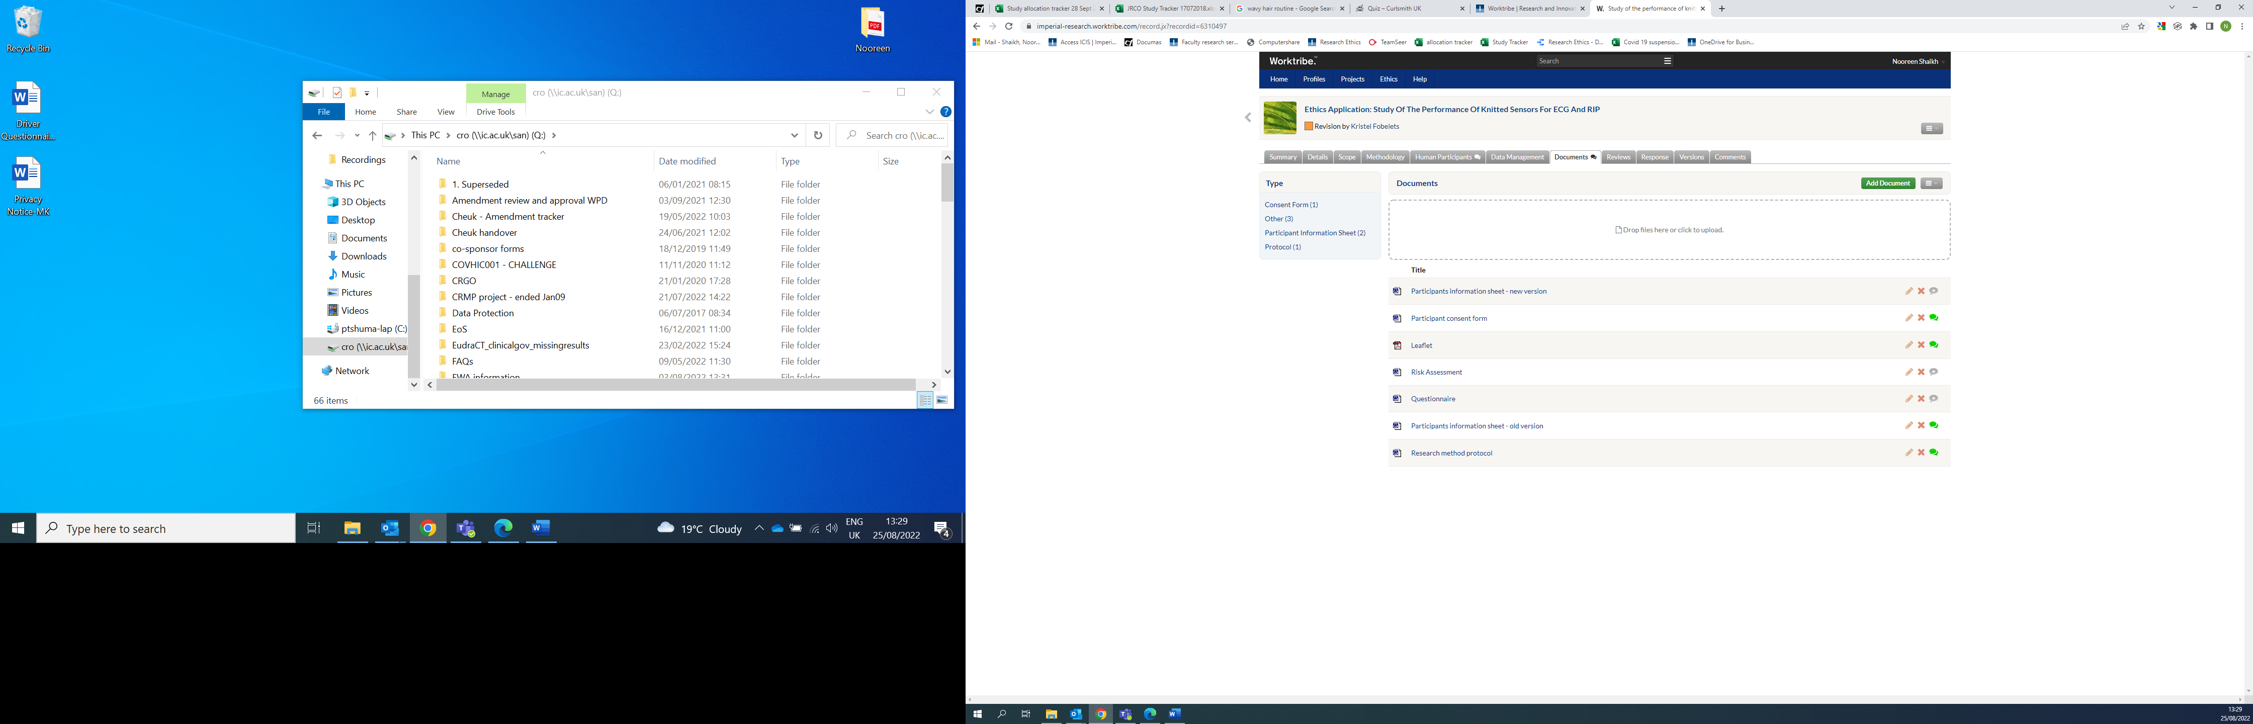next to the document you are replacing.
A pop-up window will appear. At the end of the file title click on replace. Upload the updated version and click update.
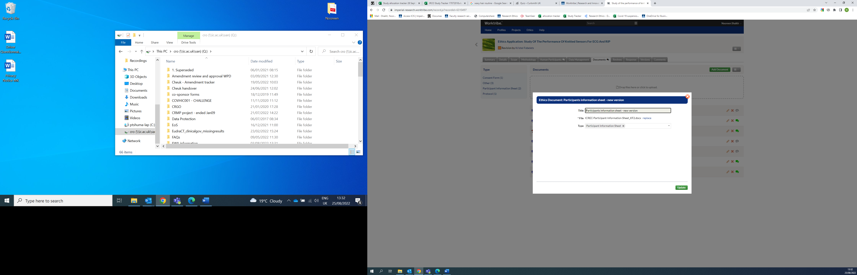
5.3.10 Progress Report (also includes End of Study Report)
This tab is only to be updated after you have submitted and received approval of your application. It is the responsibility of the Chief Investigator (CI), or someone delegated by the CI, to provide an annual progress report. The process for submitting an annual progress report (APR) will be explained in more detail in section 17.1.

You have now created your ethics application for review and approval.

Supervisor / HoD approval
Following completion of the application it will need to be submitted to your HoD and if required your supervisor for review. They will either review approve your application, or they may ask for further clarification or changes to be made.
If you are a student conducting the study for degree purposes, you must first request your supervisor’s approval. You can request the approval of ONE approver ONLY, so if you have more than one supervisor, please contact your supervisors to confirm who will take responsibility for signing your application.
Note: The Applicant cannot also be the named supervisor.

Submitting ethics application to Supervisor/ HoD.

Once you select your application will be sent to your supervisor (for students)/ HoD for approval before it’s submitted to the RGIT Office for ‘triage’.
On submission the study status will change from ‘In progress’ to ‘Submission’. A notification will be sent to your Supervisor/ HoD.
Only once the HoD has approved the application will it be accepted and made available to the ERGC and RGIT for triage.

Review of ethics application by Supervisor
If your application is not approved by your supervisor, you must address their comments, indicated by a speech bubble in the corresponding tab or in the comments tab.
Please Note: Comments can be seen by the researchers and will be available in the comments tab audit trail so please make sure they are accurate, worded clearly and relevant.

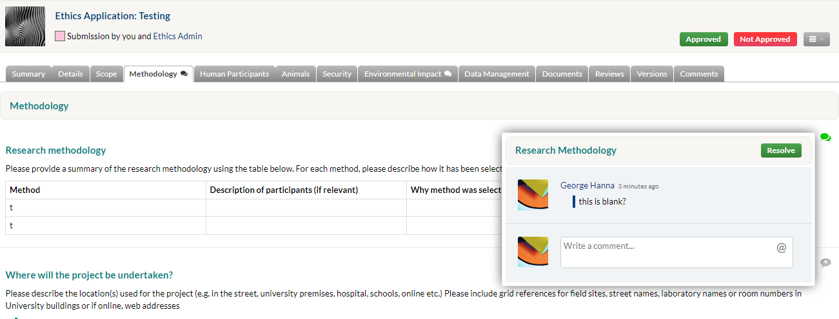

Resubmission of ethics application to Supervisor/ HoD
You will need to action/respond to the comments before clicking ..
Once Supervisor approves it will automatically be sent to the HoD for approval. The HoD can also ‘Not approve’, they should provide comments for their reasons. Step 6.1 above will need to be repeated.

How will you know when it has been approved?
The status of a study can be monitored via the Workflow diagram which appears to the right-hand pane of the summary tab to show key stages of the applications journey.
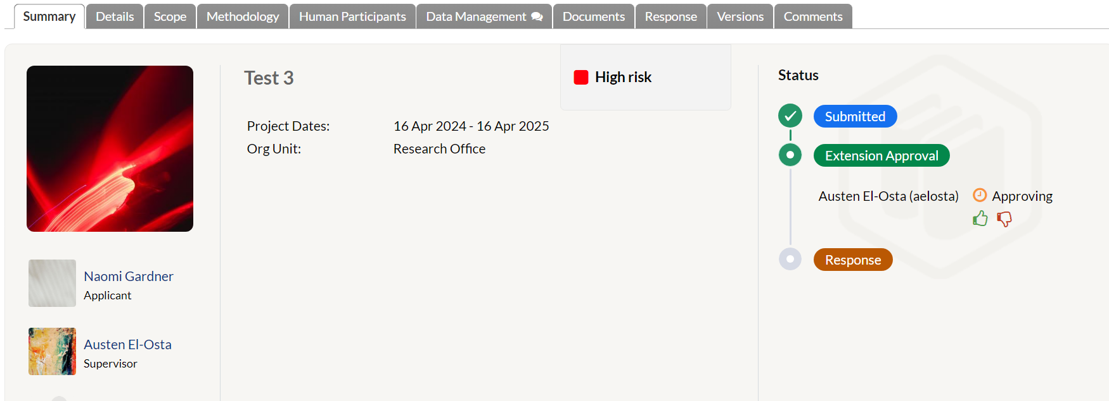
The screenshot shows that the application is with the supervisor for Approval. Once approval has been completed it will change colour from Green to Blue
Blue > Completed
Green > In progress
Brown > Not completed

On approval the study status will change from ‘submission to ‘triag

Review of ethics application

As soon as approval(s) is received the RGIT will be notified through the system.

ERGC triages and reassigns the application
The ERGC will review the application for risk and to an RGF. The RGF will receive a notification to inform them that they have been assigned your application for review.
Your notifications will update to show your application has been Triaged by the Ethics Coordinator.

High risk studies
If your study is deemed high-risk it therefore needs to go Committee, your study will still go through the normal review process. The only additional step involves Committee review and any revisions they request/suggest. You will receive a date for the meeting, (the PI will be required to attend), where any ethical issues will be discussed. Upon approval from the committee, you receive the final favourable opinion letter.
If your study is deemed low risk, however during the review process it is found to be high-risk, the study will from that point be deemed to require committee review and your study will follow the high-risk studies process.

Confirmation of allocation by RGF to the researcher
The RGF assigned your study will send you a message using the @tag function to let you know they are undertaking the ethics review. The audit trail can also be found in the Comments tab.

RGF review of ethics application
The populated tabs will be reviewed by the RGF. Comments will be added if further clarification or additional information is required. Comments will also be added into the comments box.
Supporting documents will be reviewed using the review function in Microsoft Word for Word documents. A comment will be added to the speech bubble beside the document.
After the RGFs initial review, it will be sent to the Head of RGIT for a second review.
Once complete, the application is returned to you to address the comments.

Revision of the ethics application by researcher

Click on the speech bubble icon to view all the comments. Each section needs to be reviewed; any questions/clarifications raised can be responded to by adding a comment directly next to each individual question. Please also update the application form questions where appropriate.

Revision of supporting documents (Protocol, PIS ICF)
All supporting documents requiring revisions will need to be reviewed to ensure the information is consistent, Information in the application form and with the comments raised by the RGF.
Please use track changes to edit and add comments directly in the word documents.
Upload all revised documents by ‘replacing’ ensuring they are titled, dated and versioned clearly.
8.1.1 Version comparison

Changes made to the application or documents by the applicant after responding to the RGF comments will be highlighted in orange by default. (whether major or minor). This will allow comparison between the previous versions of the application based on the status of the application.
A flag icon will appear within the tab where changes have been made to make it easier to find and review the changes.

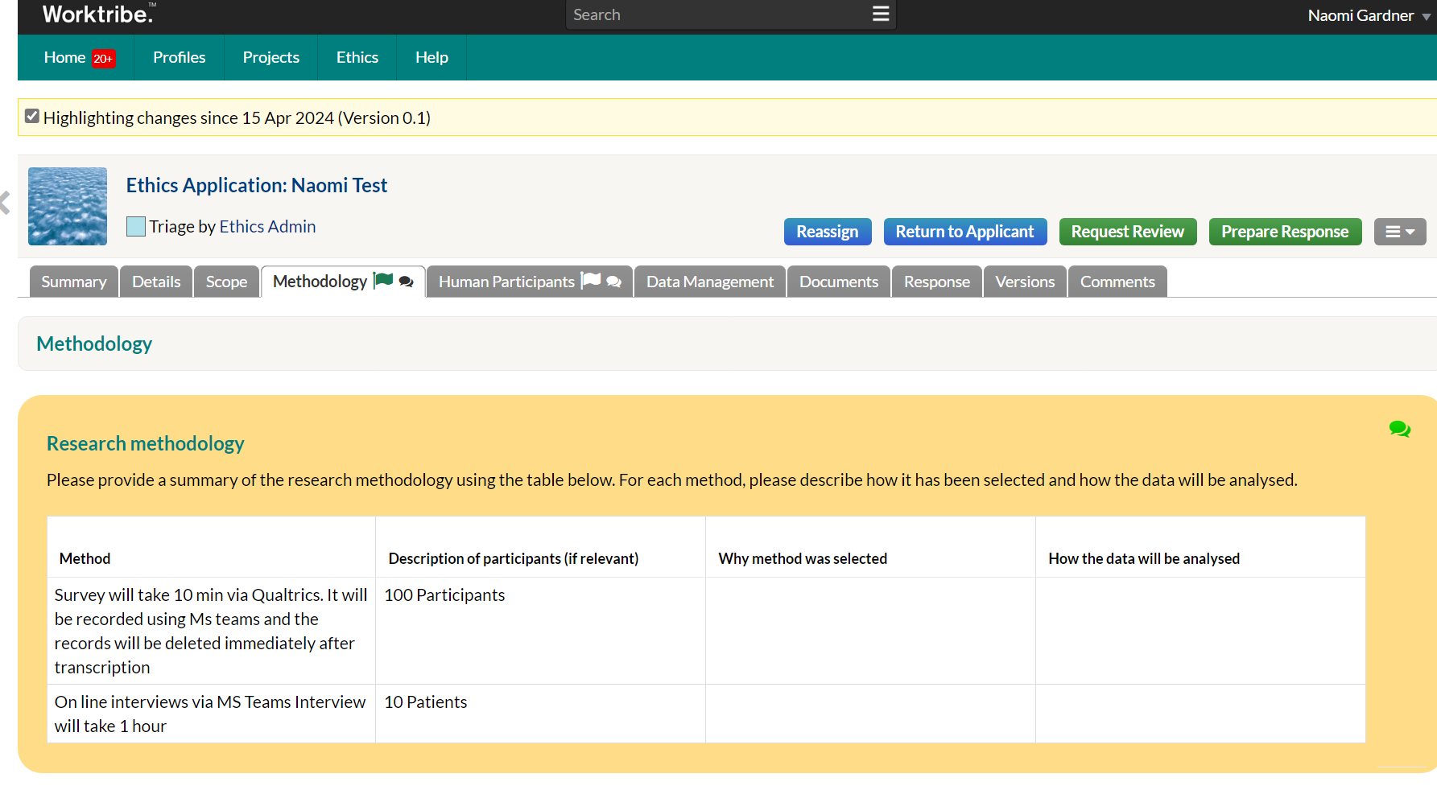
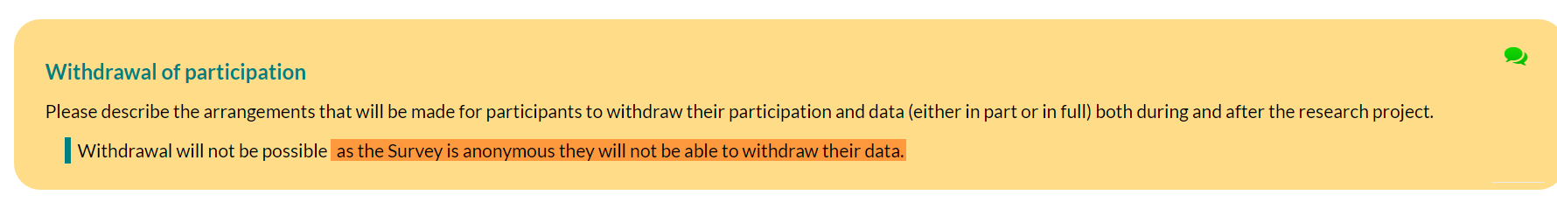
- The researcher should as per the guidance @tag you into a final comment this will send you an alert notifying you of any new updates.

@Tag the RGF into your final comment and state that your review and updates are complete. Do not submit the study back into Worktribe at this stage.
Note: Every time you are @tagged into a comment you will receive a separate notification alert in the system.
A workflow summary diagram appears to the right-hand pane of the summary tab to show key stages of the applications journey.

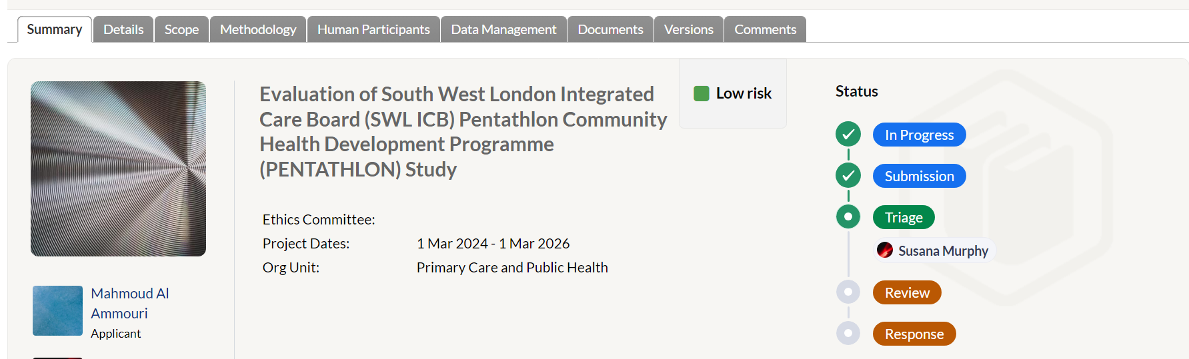

RGF and Head of RGIT final review
The RGF will review the revised application, documents, and your comments. If further amendments are required to the application, the RGF will @Tag with any further comments/changes required and you will need to repeat section 8 above.
Once all changes have been successfully made, the RGF will @tag with a comment notifying to ‘Resubmit for approval’.
@ (researchers name)
RGIT has reviewed the following application and all the changes have been made. Please go ahead and resubmit for final approval. Please note your HoD or supervisor will need to re-approve the application before we can send you the approval letter.

Click .

Supervisor/ HoD approval of the application

Once the application has been resubmitted for approval the final revised application will be reviewed and approved by your Supervisor/ HoD. You will be instructed to replace clean versions of your documents. The following notification will appear on re-submission
Study status will change to ‘Revision Submission’.

Note: RGIT favourable approval cannot be issued until final HoD approval is received.

On approval the status will change from revisions submission back to Triage.

Response and Approval
After HoD approval the status will change from ‘Revision submission’ to ‘Triage’. Once the study has gone through its final approval, the status will appear as
During the final approval a notification will be received to the applicant outlining the study approval and any conditions, along with confirmation that the approval letter and approved documents can be downloaded from the documents tab.

If a application is issued with an unfavourable opinion you will receive a message outlining the reasons for this. If you choose to re-submit the application again with the comments from the unfavourable opinion met you can create a duplicate application and make the changes, instead of having to start a new application.

Duplicate an Ethics Application
To create a duplicate of an existing Ethics Application. Select the
Action menu and the duplicate feature will create a copy of the Ethics Application.
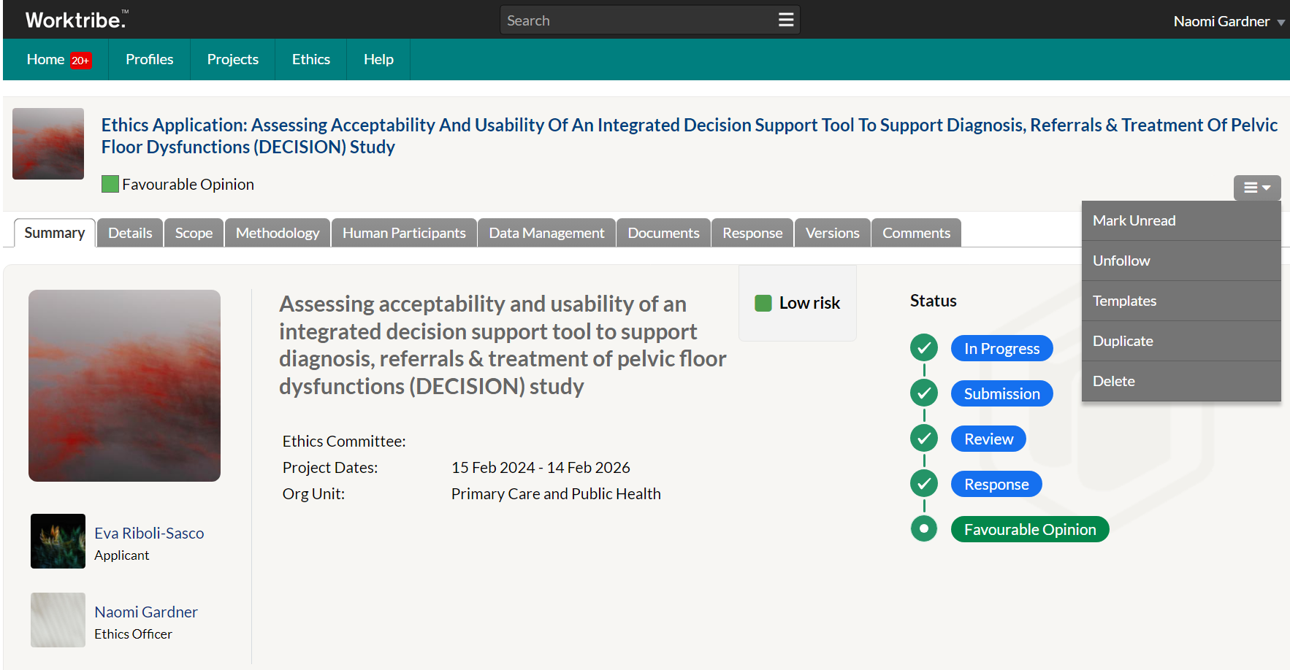
The duplicate Ethics Application is given the title “Duplicate of…”, fields and tabs not appropriate to be duplicated are not included and are blank, ready to start the application process again. The Versions, Reviews, Response tabs are not duplicated along with the following fields being set to null:

• Ethics Committee
• Ethics Officer
• Default Reviewers
• Lead Reviewer
• Route To
• Meeting
• Meeting Date

Post approval responsibilities (Amendments)

Creating an amendment
Your ethical approval is based on the online ethics form and supporting documents you originally submitted. If a change is made to your original ethics submission and you do not notify the RGI team, then your ethics approval may become invalid. Please submit an amendment if you want to change the study design, study team or request a time extension.
Please note: For requesting time extensions please do not use the ‘extend’ button in Worktribe, please following the process for completing an amendment.
Not to be used

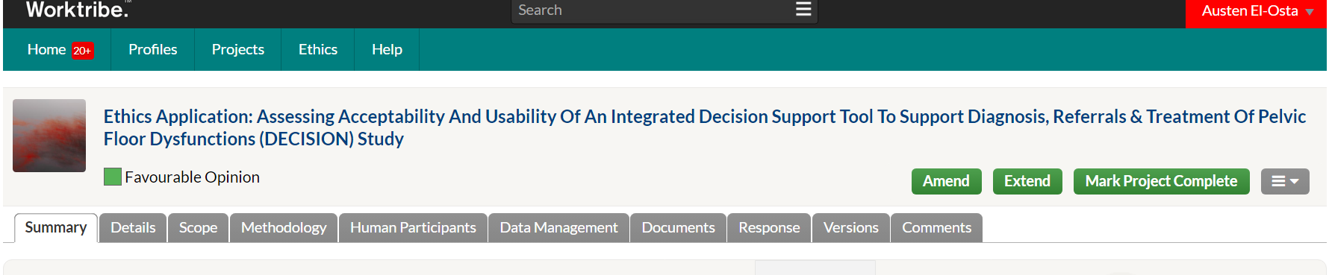
An amendment can be started by clicking .
This will generate the following pop-up message. “I am instigating this amendment for the following reason:”
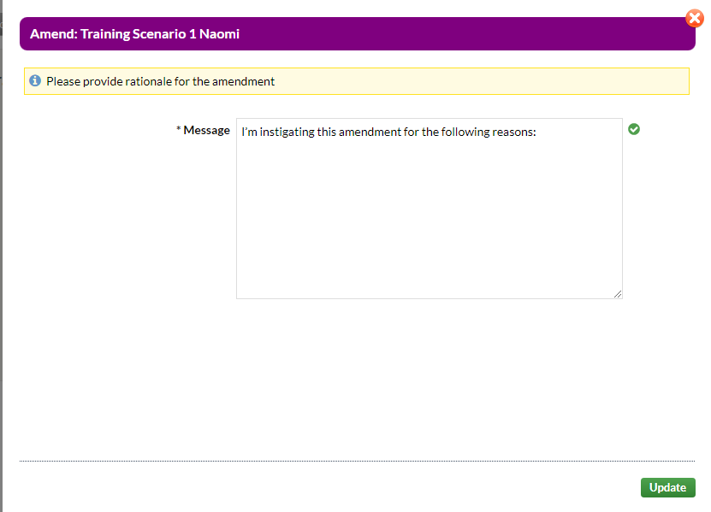

Include a summary of the changes being made to the study and why they are being made. You will also need to complete and upload the Notice of Amendment Form (Worktribe) which can be found at https://www.imperial.ac.uk/research-ethics-committee/application/post-approval/.

The status will change from the study being approved to .

Updating the online application tabs

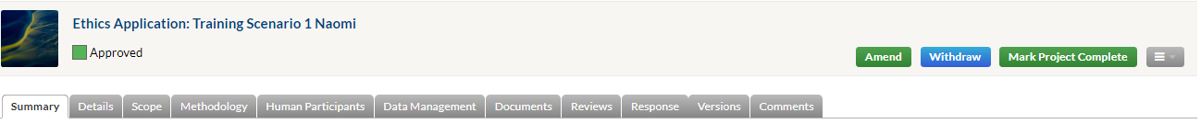

If the changes in the study require you to amend the online application form or you need to edit/make any changes to any of the documents, you will need to update all relevant sections. Ensure these changes are consistent throughout the documents and available to review through the Worktribe system. For example, if the sample size is to be increased you would edit and change the information In the human participants tab (see below).
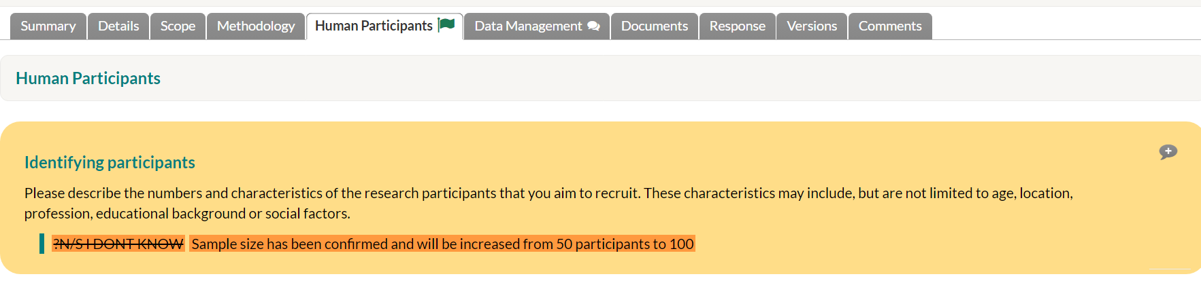

Updating the supporting documents.
If you need to upload the updated versions of a documents. You can make changes using tracked changes before uploading the new/revised documents to the documents tab.
*NB. Amended documents should be labelled as the next versions and dates from the current versions. The original approved versions should not be replaced.
After you press submit, the amendment will automatically be sent to the Supervisor/ HoD for approval. The status will change to ‘Amendment Submission’ before being sent to the RGIT.

Supervisor / HoD approval
The initial Supervisor/ HoD approval process is the same as previously described in section 6.
The study status will change from in ‘Amendment submission’ to ‘Amendment triage.

Review of amendment

Amendment triage
The amendment will be triaged in the same way as the original ethics application in section 7 above. Your homepage will update to show the amendment is triaged.

The amendment review will follow the same process as described above in sections 7, 8 and 9 making any revisions as requested by the RGF.

Resubmit amendment for approval
Once the RGF has confirmed that the amendment updates are successful, then you can submit the final revised application for approval. Select .

Supervisor/ HoD approval of the amendment
After your supervisor/HoD approves the amendment, the status will change from ‘Amendment Revision Submission’ to ‘Amendment Triage’.
Once the amendment has been approved by RGIT a notification alert will be sent advising that the amendment has been approved, with any conditions where appropriate, and that the approval letter is ready to be accessed from the documents tab. The status will change to ‘Favourable Opinion’.
Note: If the amendment requires Committee review then you will be notified of this, along with a date and the details for the Committee meeting during the review.

- Withdraw Ethics Application

You will also have the option to withdraw or mark the project as ‘complete’. Complete only applies after the study has ended and is not to be used during this process.
The workflow action to withdraw an Ethics Applications is available from the
action menu on an Ethics Application
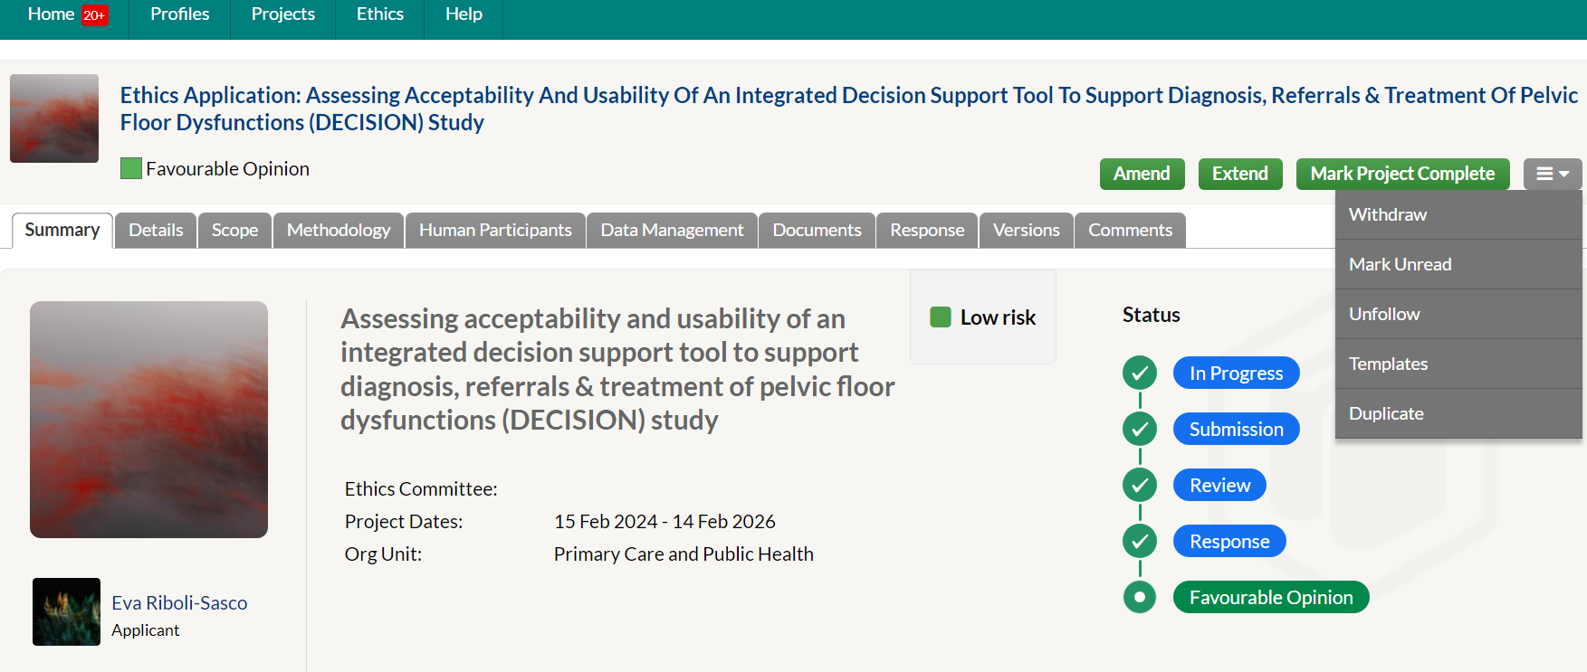
- Post-Approval Responsibilities

After your study has been given ethics approval, there are a number of responsibilities that you will need to maintain.
These include submitting an APR and End of Study Report..

Annual Progress Report (APR)

The Annual progress report [Word] must be completed within 30 days of the anniversary of a project being granted ethics approval.
If a study is completed within a year of first obtaining ethical approval, an End of Study Notification must be submitted instead as per the process below in section 18.
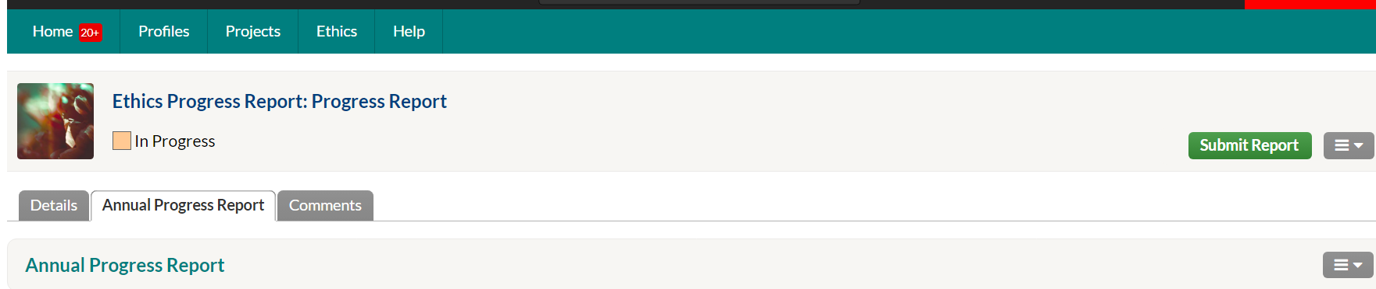

How to Submit an APR?
The Annual progress report [Word] document must be completed within 30 days of the anniversary of a project being granted ethics approval. If the Annual Progress Report request to the applicant is made via Worktribe, then the online worktribe form is completed for this.

Worktribe Studies
Studies approved via Worktribe (where the APR request is made via Worktribe), can complete the APR within the system. Go to your approved application in Worktribe and complete the Progress Report Tab and upload the APR document.

Pre Worktribe-Studies
The Annual progress report [Word] for studies approved pre Worktribe must be submitted to the Ethics and Research Governance Coordinator within 30 days of the anniversary of a project being granted ethics approval via e-mail.

How to submit APR requests via Worktribe
For requests made via Worktribe click on the Progress Report tab.
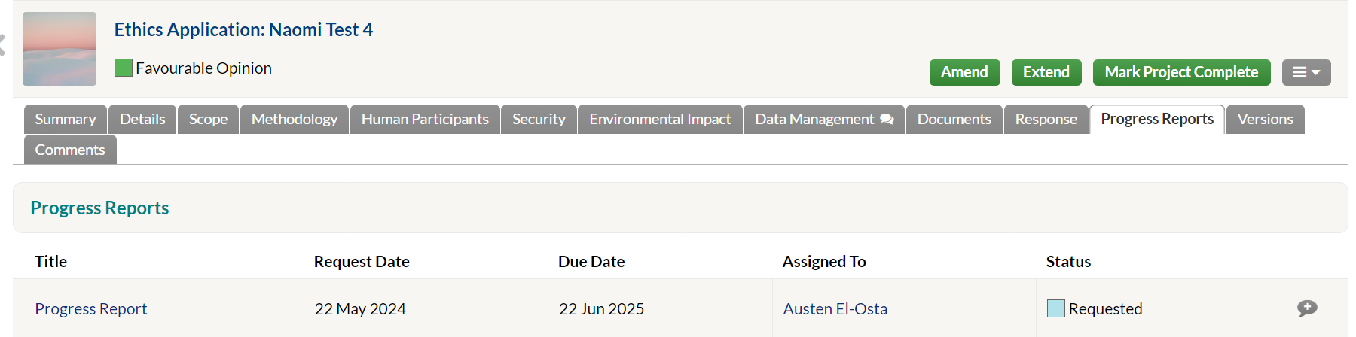
Open the progress report field.
The details tab will display information on when the report was requested and its due date.
The status will appear as “Requested”.

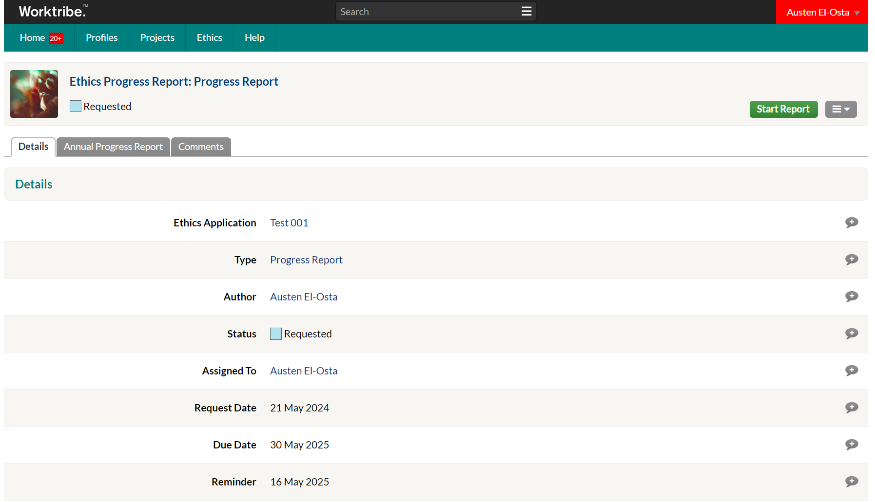
Study Type > This should already be completed by the RGF who issued sponsorship.
Progress Report should be displayed here.
Request Date: The date should automatically be populated by the RGF who issued sponsorship.
Due Date: The date should automatically be populated by the RGF who issued sponsorship.
Reminder: Not Applicable
Message: A message will appear asking you to complete the Annual Progress Report [Word]. A link to the document will also be included.
A notification will appear within the APR tab.

To start the report, select > Start Report
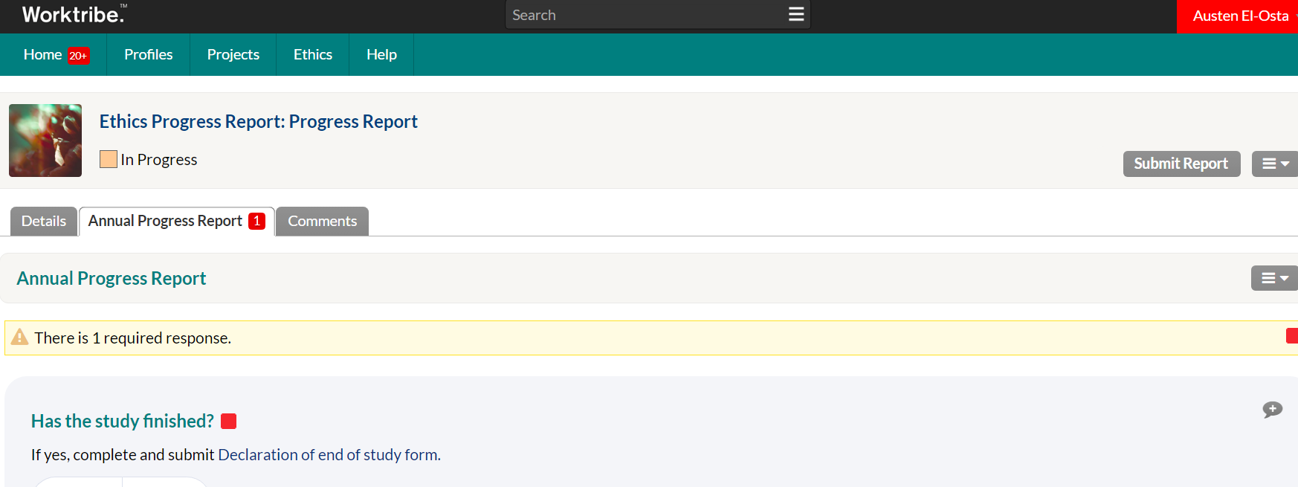

A notification will pop up alerting you to additional questions asking you to provide further information on the status of the study.
- Has the study finished? – Select No
- If no, what is the expected completion date?
- Has the study started?
- Number of participants recruited
- Provide reasons for the withdrawals
- Have there been any serious difficulties in recruiting participants?
- Do you plan to increase the planned recruitment of participants into the study?
- Have there been any Serious Adverse Events (SAEs) in this study?
- 'If yes, please give details.
- Have there been any Unexpected and Related SAEs in this study?
- If yes, please give details. The Principal Investigator should report any SAE that is both related to the research procedure and is unexpected, guidance can be found here.' (link: https://www.imperial.ac.uk/research-ethics-committee/safety-reporting/)
- Have any concerns arisen about the safety of participants in this study?
- Have any substantial amendments been made to the trial during the year?
- If yes, please give the date and amendment number for each substantial amendment made.
- Are there any other developments in the study that you wish to report to the Committee?
- Are there any ethical issues on which further advice is required?
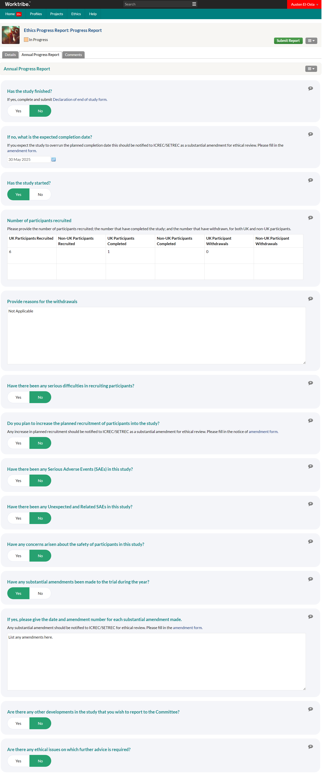
Once all the field have been completed
Select > Submit Report
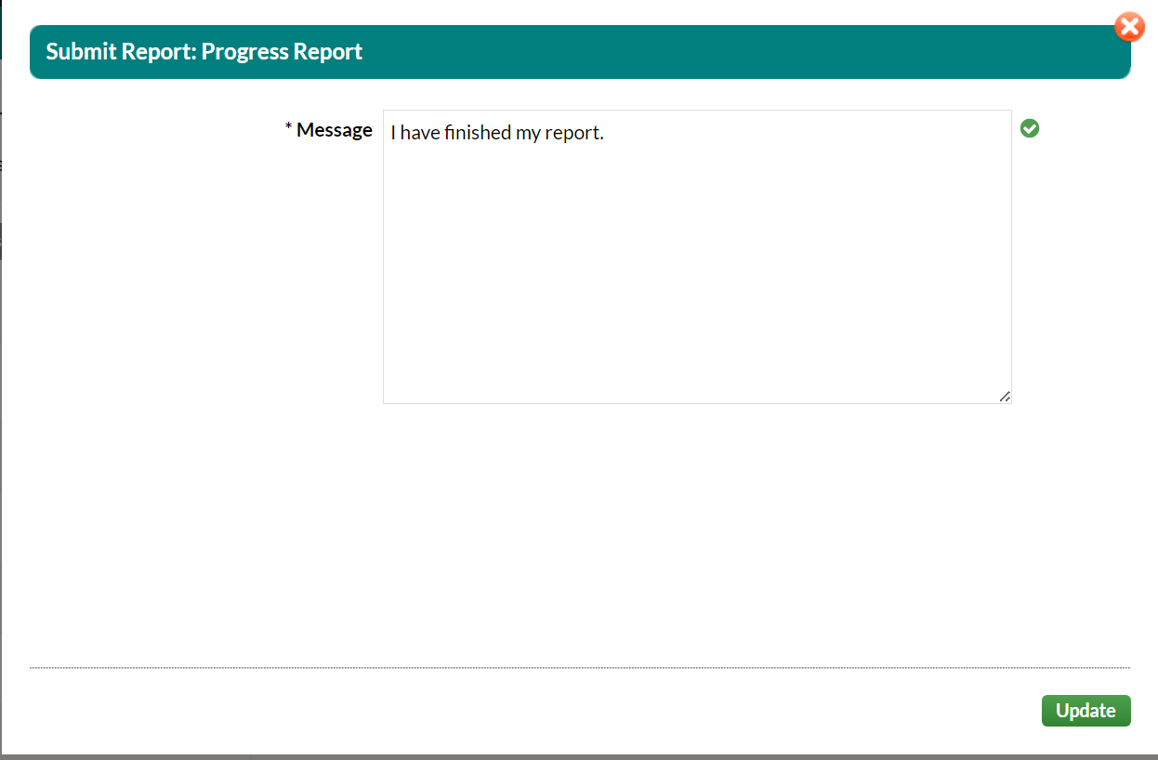
A message will pop-up saying, “I have finished my report.”
Press > Update.
The study status will change to “Submitted”.
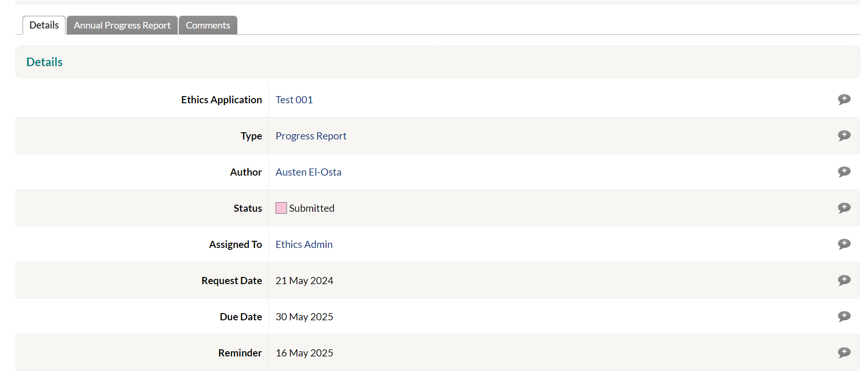

The ERGC will be responsible for reviewing the progress report. They will review the information in the details, APR tab and comments tab. If any further information or feedback is requiredthey will return the report back to the you asking to amend the report accordingly.
If the information is correct in all the tabs is completed correctly, they will select “Complete”.
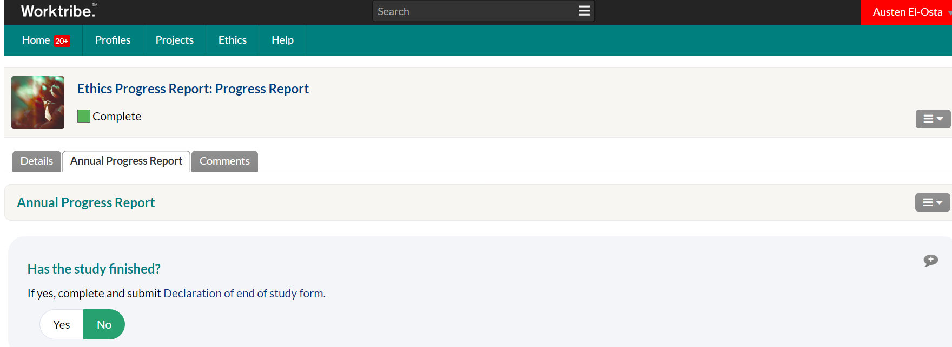
If during the review an amendment was required for example if you want to request a time extension. You will be advised to do this through the normal amendment process described in section 12.1.
Select the back button to go back to the main application page.
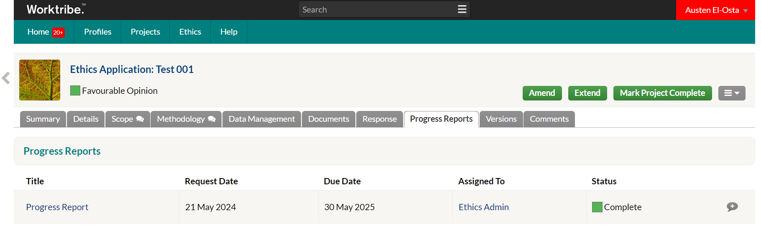
You can see in the progress report tab the status has changed to complete.

End of Study (EoS) Notification

The End of study notification [Word] and an End of study summary report [Word] must be forwarded to the ERGC within 90 days of termination of your study or when the practical research activity has ended. You must notify the committee within 15 days if you have terminated the study early. If you do not submit an End of Study report or extend the study end date with an amendment, your study will be assumed to be closed, and ethics approval will cease.
End of study reports for studies approved via Worktribe (and which the request came via Worktribe) can be completed within the system,as per the guidance below..

How to submit an End of Study Report via Worktribe

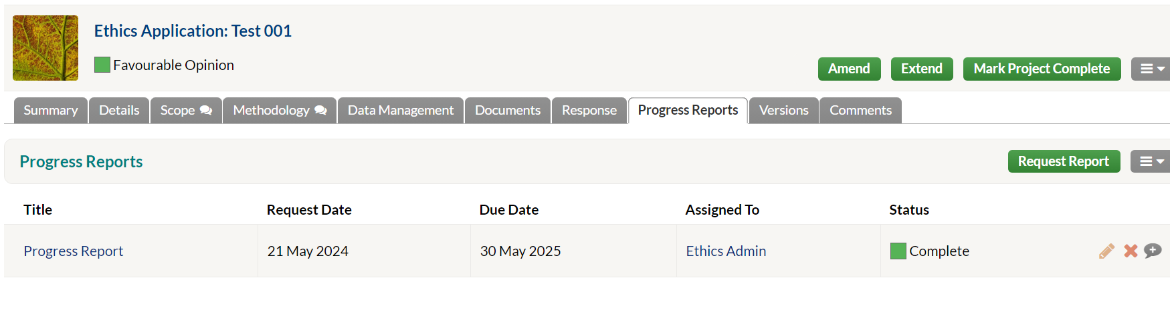
Click on the progress report tab and Select the Progress Report from the list.
Change “Has the study finished” to > Yes.
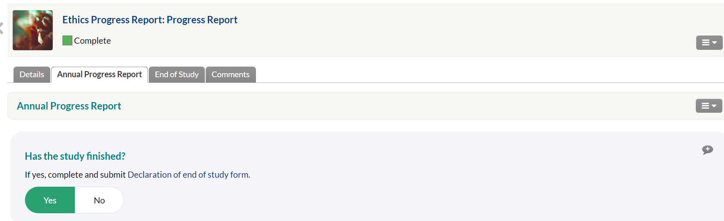

A new End of Study tab will populate at the top.
Select the End of Study tab and answer the questions below:
- Date study commenced
- Date study ended
- Number of participants recruited
- If different, please state the reason or this
- Did this study terminate prematurely?
- Have you provided a summary of the final report on the research?

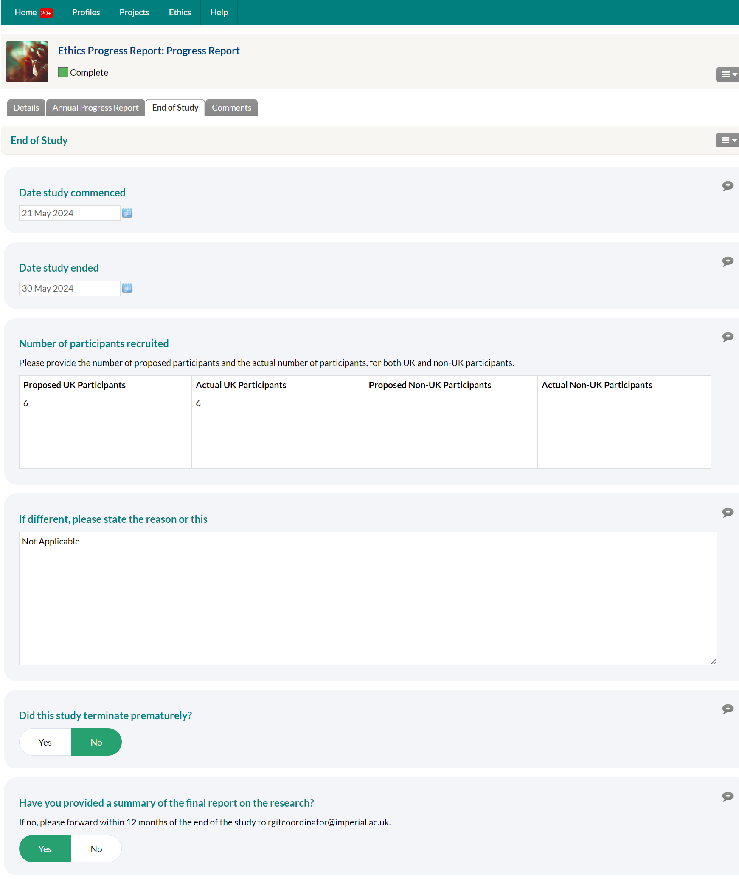
On completion of the EoS questions you will need to mark the study as complete within worktribe.
To do this Select > Mark Project Complete.
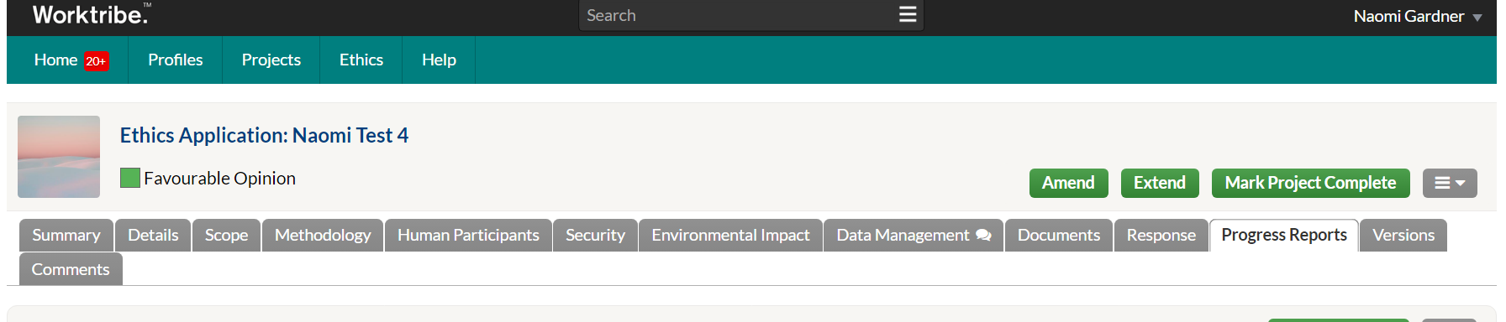
The ERGC will review the information and send a message acknowledging the final EoS report.

