Getting started with Worktribe – HoD and Supervisors

Worktribe is a modern highly performant system that increases the efficiency and transparency of internal pre-award and research processes, particularly for internal and external multi-disciplinary collaborations. As the latest addition to the [Worktribe research management suite](https://www.worktribe.com/what-we-do/research-management), this online research ethics management software takes on the challenge of streamlining complex ethical review and approval processes for research projects.

Worktribe Ethics enables researchers, administrators, Heads of Department and committee members to submit, review, amend, approve, and manage all research ethics applications online, in one place. Features include clear workflows, dynamic forms, application routing, committee meeting tracking, document version control, filterable management reports and an open Application Programming Interface for deeper data analysis. Managing ethical reviews and approvals in one place helps foster greater transparency, ethical compliance, and research integrity, as well as saving academics and administrators time and stress

Worktribe includes several areas of functionality that should provide a range of benefits, these include costings, grants and now research ethics applications.

Although the platform has multiple uses **the RGIT Team will only use this platform for Imperial College non-NHS ethics applications** This includesscoping questions that help identify what a project is about, and depending on how these initial questions are answered, additional pre-defined questions are generated to ensure that enough information is collected for committees to assess and approve an ethics application. Different sections include human participants, data generation and methodology.

Table of Contents

1. Login to Worktribe 4

2. Overview of the Worktribe landing page 5

2.1. Home 5

2.2. Profiles: My Profile 6

2.3. Projects 6

2.4. Ethics 6

2.5. Help 8

3. Overview of the Worktribe functions 9

3.1. Notifications 9

3.2. How to search for ethics applications 9

3.3. User menu 9

3.4. Announcements: 9

3.5. Study Status 9

3.6. Monitoring of the ethics application 11

4. What does the ethics review procedure involve? 12

5. How to review and approve an ethics application 13

5.1. Notification to review ethics application 13

5.2. Opening an ethics application for review 13

5.3. Reviewing the ethics application 14

5.3.1. Details tab 14

5.3.2. Reviewing all tabs 15

5.4. How to add a comment – Supervisors only 15

5.4.1. How to format comments – Supervisor only 16

5.4.2. Annotation Aside – Supervisor only 16

5.5. Review of Supporting Documents – Supervisor and HoD 16

5.5.1. Approving a study – Supervisor and HoD 16

5.5.2. Not approving a study – Supervisor and HoD 17

5.6. Review and approval of Revised Application by Supervisor/HoD - 2nd Review 17

6. Resubmission for approval (final stage) 18

6.1. Approving RGIT reviewed ethics application 18

7. Post-approval responsibilities 19

7.1. What happens to the study after you issue final HoD approval in Worktribe? 19

7.2. Approving an amendment 19

7.2.1. If an Amendment is required? 19

7.3. Researcher Submits amendment to Supervisor / HoD for approval. 19

7.3.1. Notification of amendment submission - Supervisor/HoD 19

7.4. Amendment review - Supervisors/ HoD 19

7.5. Not approving an amendment - Supervisor and HoD 19

7.6. Approving an amendment - Supervisor and HoD 20

8. Supervisor/ HoD Approval at the end of the amendment process. 21

8.1. Review of Revised Final Application by Supervisor/HoD - 2nd and Final Review 21

# Login to Worktribe

|  |  |
| --- | --- |
| Log in to Worktribe  Users should access the [logon screen](https://imperial-research.worktribe.com/).  Enter your college username and password to access.  After logging in, Worktribe’ s homepage will appear. | Image of logon screen |

# Overview of the Worktribe landing page

The Worktribe landing page has a variety of tabs and fields all assigned for specific functions. Understanding how the tabs and functions work will help you move through the ethics review process more easily.

After logging in the Worktribe homepage will appear. Five tabs will appear at the top of the page highlighted in Green.

1. Home
2. Profile
3. Projects
4. Ethics
5. Help

## Home

The home tab is positioned at the top left-hand side of the landing page. If you select this button, it returns you to the home page.

A list of your ethics applications will be displayed as shown in the table below.

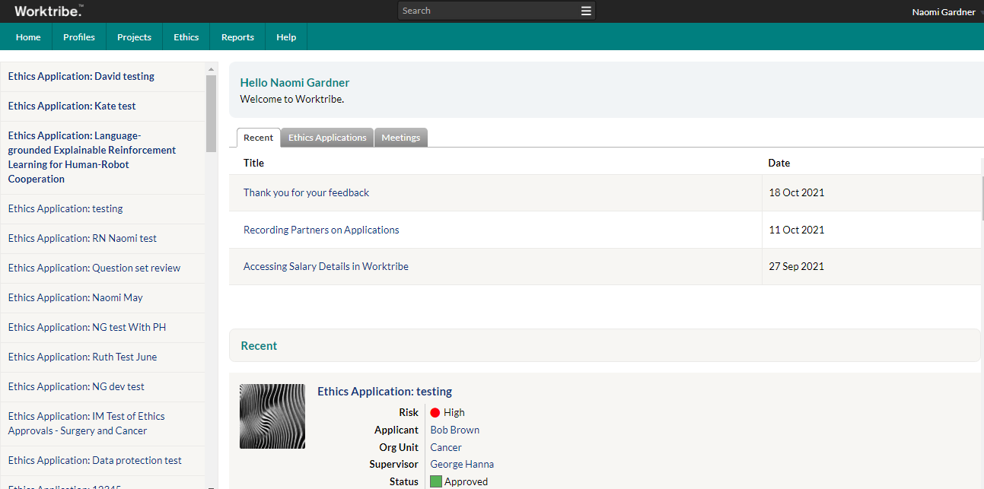

## Profiles: My Profile

All Worktribe users have a corresponding ‘profile’ including some basic information about users. You will see your own profile by **clicking** on **My Profile.**

My profile page has three tabs:

Image of home screen tabs

Summary:Asummary of your personal information.

Details: Lists information about you. **Note:** Profiles are not editable by the user. Ifany part of your profile is incorrect, please contact [Worktribe admin](mailto:Worktribe.admin@imperial.ac.uk).

Projects: This tab is not applicable to ethics applications.

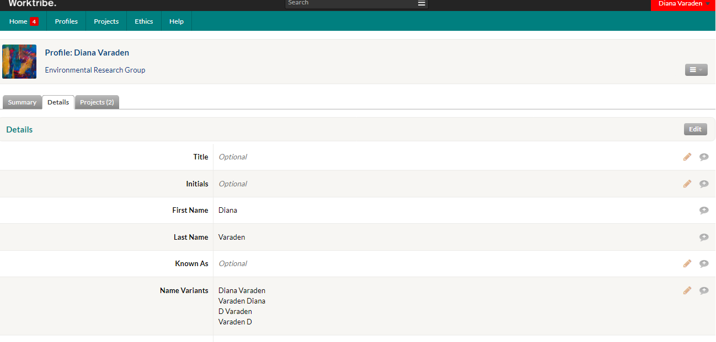

## Projects

This tab is not applicable to ethics applications. If you are involved in costing and grant applications through the Worktribe system, you will see your grant projects listed here.

## Ethics

For use when completing your review through the system.

1. **Click** on the **ethics tab.** All your ethics applications can be found here.
2. **Select ‘All applications’:** This allows you to follow the different stages of the application process, under ‘all applications’.

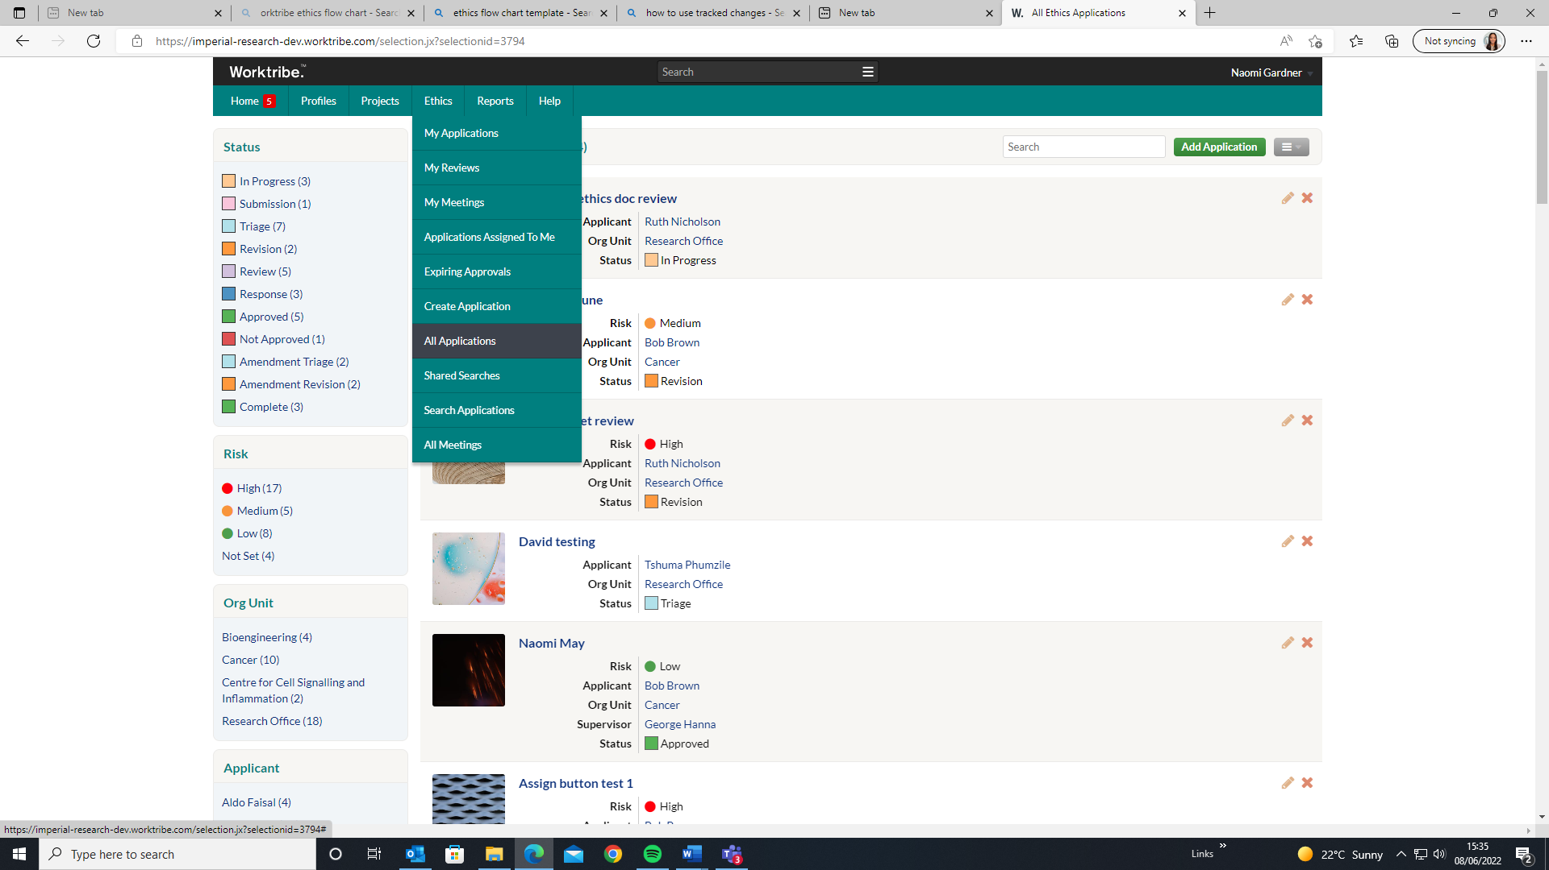

Recent: Contains a list of recently accessed applications for quick access. These can include ethics applications, profiles and anything else recently viewed.

Ethics Application:Displays of all your ethics applications and its status.

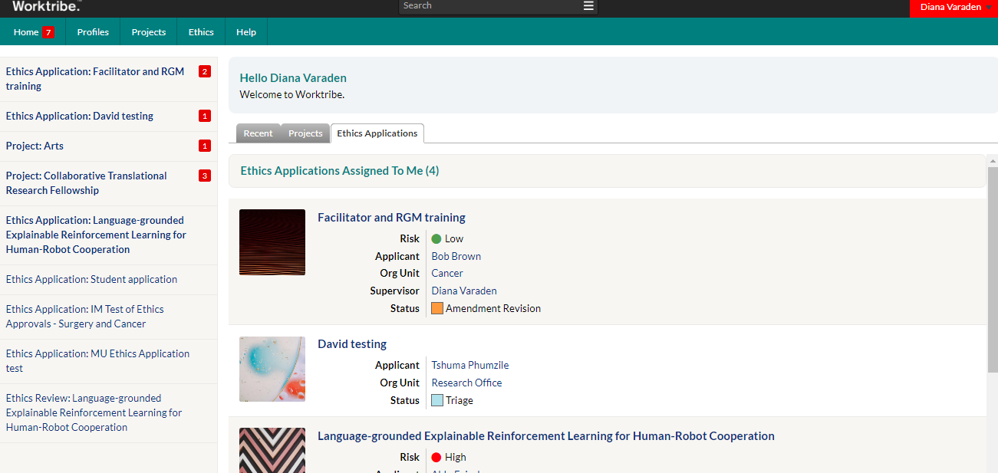

## Help

Click on the Help button to reveal the Help menu, which has the following options:

**Help topics:** A link to Worktribe guidance and e-learning videos provided by the Research Office is provided [here](https://www.imperial.ac.uk/research-and-innovation/research-office/preparing-and-costing-a-proposal/worktribe/).

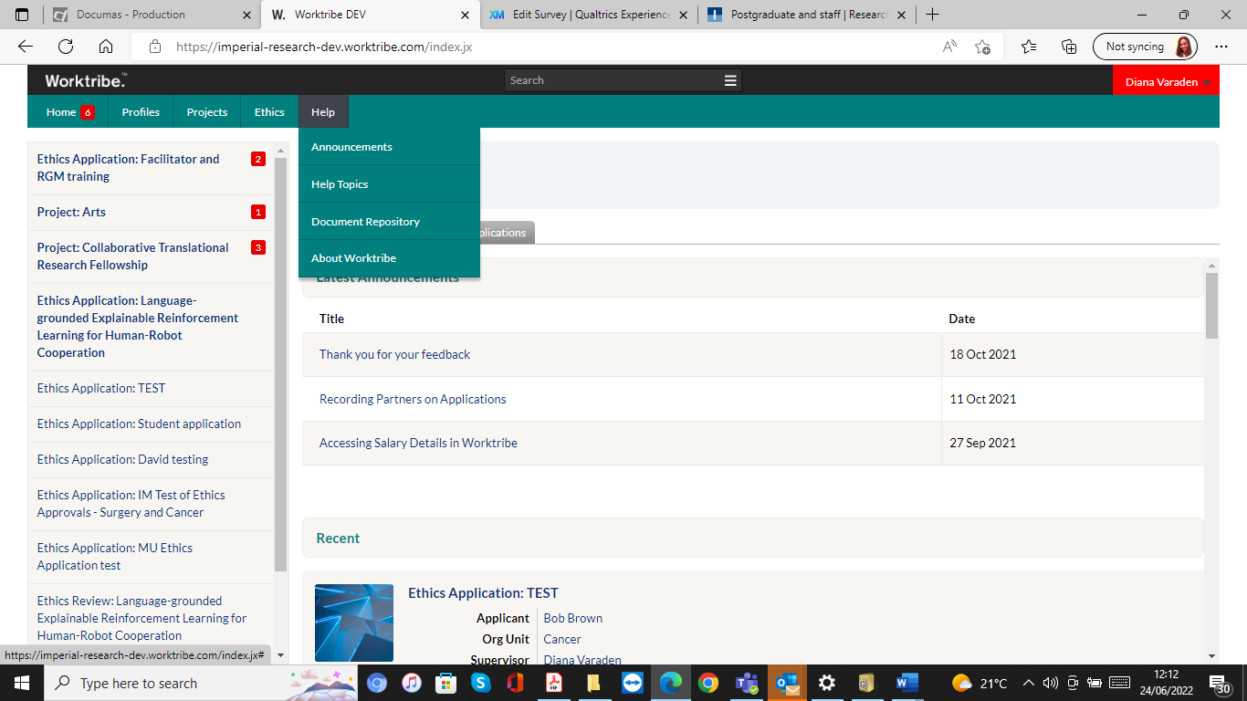

# Overview of the Worktribe functions

## Notifications

Notifications on the home screen exist in Worktribe to notify users of events that have occurred in the Worktribe system (e.g., notifying an approver to review the ethics application) or where another user has tagged them within a study.

**@Tagging** is the function used to message or notify another user. It’s important and is described in detail in the revision stage of the application where tagging a user is the method of communication used.

**The notifications sidebar** is positioned on the left-hand side of the homepage. This alerts users to notifications within ethics applications.

## How to search for ethics applications

The search bar can be used to search across the whole system. If you start typing into the search box, there is a shortlist of items returned.

You can expand the search results by selecting ‘See all results for...’ at the bottom of the list. Search results depend on the user’s access rights, for example, searches will only return projects they have access to.



## User menu

To reveal the User Menu, click on your name on the top right of the homepage.



## Announcements:

General notices affecting all Worktribe users will be collated in the Announcements page. The latest announcements are displayed at the top of the homepage.

## Study Status

The ethics process is broken down into different stages. The Worktribe system has a status bar that allows you to follow the different stages of the application process.

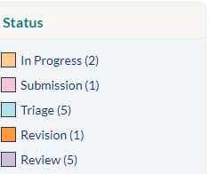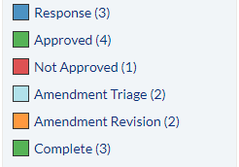

Below is a list of the activity taking place at each stage. Variations of these status’s can be used throughout the study.

In Progress: The researcher has createdtheir application and is continuing to make changes.

Submission*:* The researcher has submitted their ethics application for review to RGIT and their Supervisor/ HoD.

Triage: The assigning and preliminary assessment of the application to the most appropriate person after the HoD has signed the application.

Revision: Following receipt of the comments from the Research Governance Facilitator (RGF) and the Head of RGIT. The researcher will be required to revise the application.

Response: *This* stage involves the researchers answering and replying to the RGF ethics questions.

Review:This stage involves going over the researcher’s reply/comments and checking they have addressed and made all the necessary changes.

Approved:This stageformally confirms that the ethics application is satisfactory, and approval has been issued for the study.

## 3.6 Monitoring of the ethics application

The comments tab allows a person to monitor and track the comments and status throughout the life of the study. Every comment that is added within the system will be recorded here.

To see a summary of all the comments. **Click on the Comments tab**. This will display an audit trail of the comments.

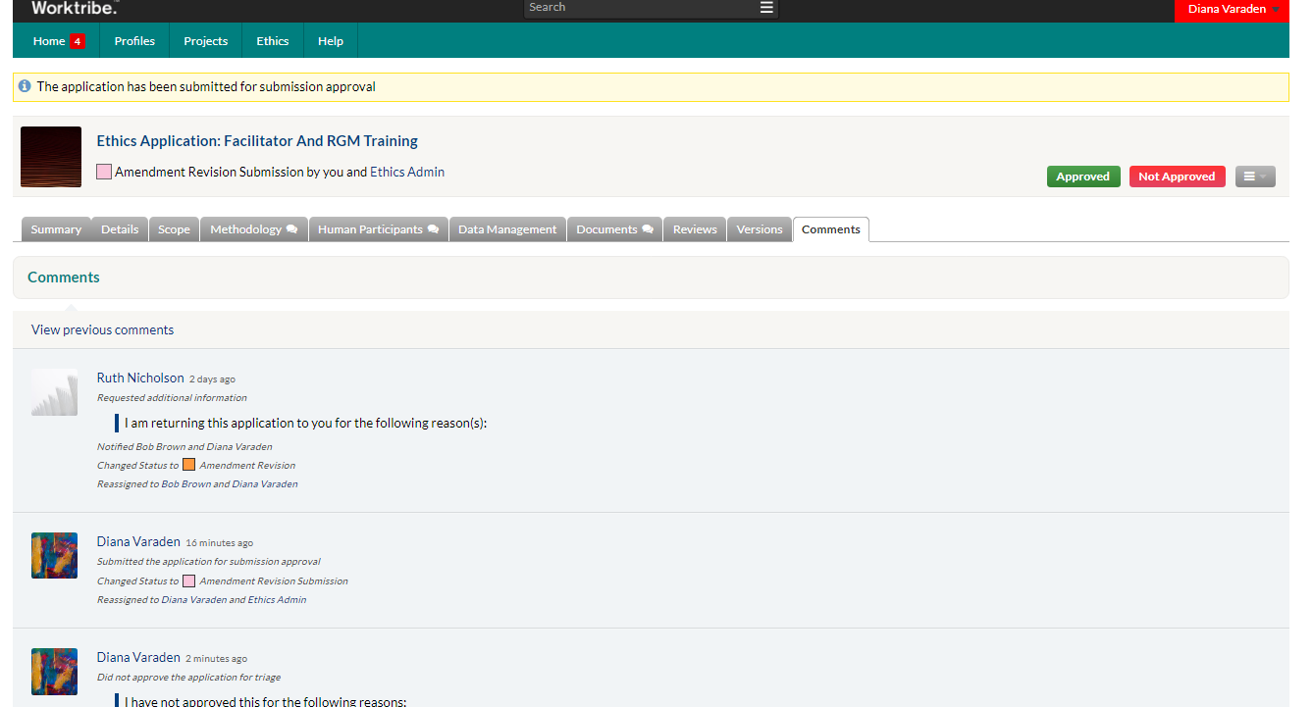

# What does the ethics review procedure involve?

The procedure takes place through the online ethics Worktribe system and involves the following basic steps:

The steps highlighted in blue are relevant for Supervisors and HoD.

1. If ethical approval is required an online application form is completed and supporting document submitted by the relevant researcher, providing details of the project’s aims and methodology, and responses to key ethical considerations.
2. The Supervisor/ HoD review the submitted documents and approve.
3. The application is allocated to the Research Governance Facilitator (RGF) to consider the application and approve if appropriate.
4. The Supervisor/ HoD review the final revised documents and approve.
5. Approval of the application and a copy of the approval letter is sent by RGIT.

**The below diagram outlines the ethics application approval process.**

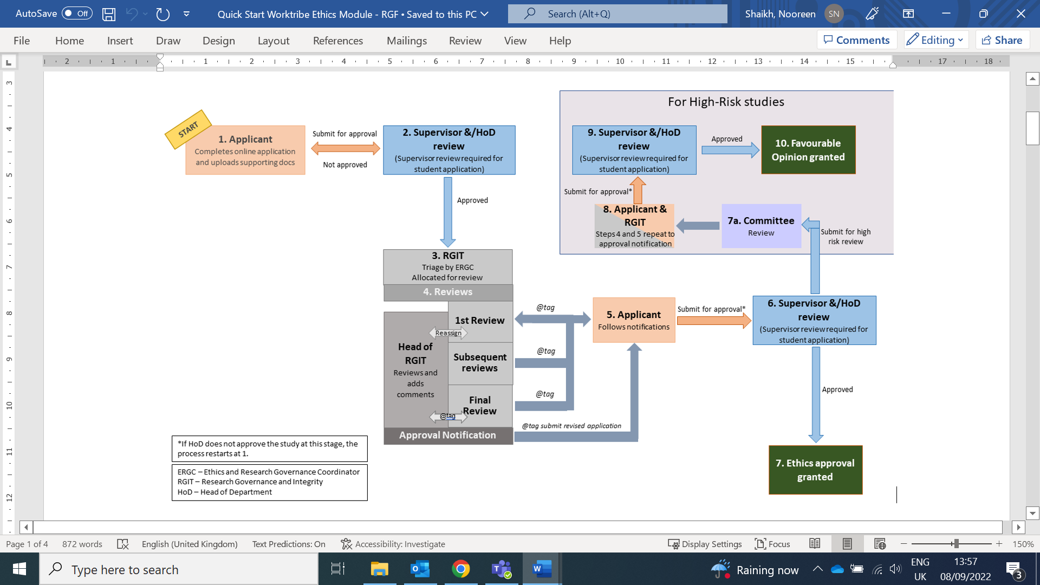

# How to review and approve an ethics application

## 5.1 Notification to review ethics application

You will receive an email notification when a researcher submits an ethics application alerting you to a new application for review and approval.

It is important to approve the studies in a timely manner, if the study hasn’t been approved the researcher may follow up with you.

For student applications, the Supervisor will also receive a notification, as HoD you will not be able to see the applications for student projects until it has been initially approved by the Supervisor. You will not be able to add comments, but you will be able to monitor the status of the study and the progress of the Supervisor’s review. You will receive a second notification after it has been approved by the Supervisor.

**Only once the Supervisor (for student applications only) and/or HoD approve the application will it be accepted and made available to the RGIT for review.**

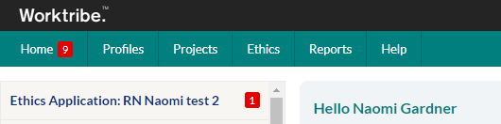

A notification overview shows the study status, who the study is assigned to and the comments thread.

## 5.2 Opening an ethics application for review

A status will appear that the online form has been submitted, is in progress and the named researcher.

**To open an application, you have two options.**

* **Click** the study title which is in large blue font. Open the application by **clicking** on the study name**.  
  Or** **click** the notification from the home screen. **Press** the Image of view details button button.

The application will open, and the status will appear as: Image of the submission by you and ethics admin status. Clicking on the ethics application reveals the window below.

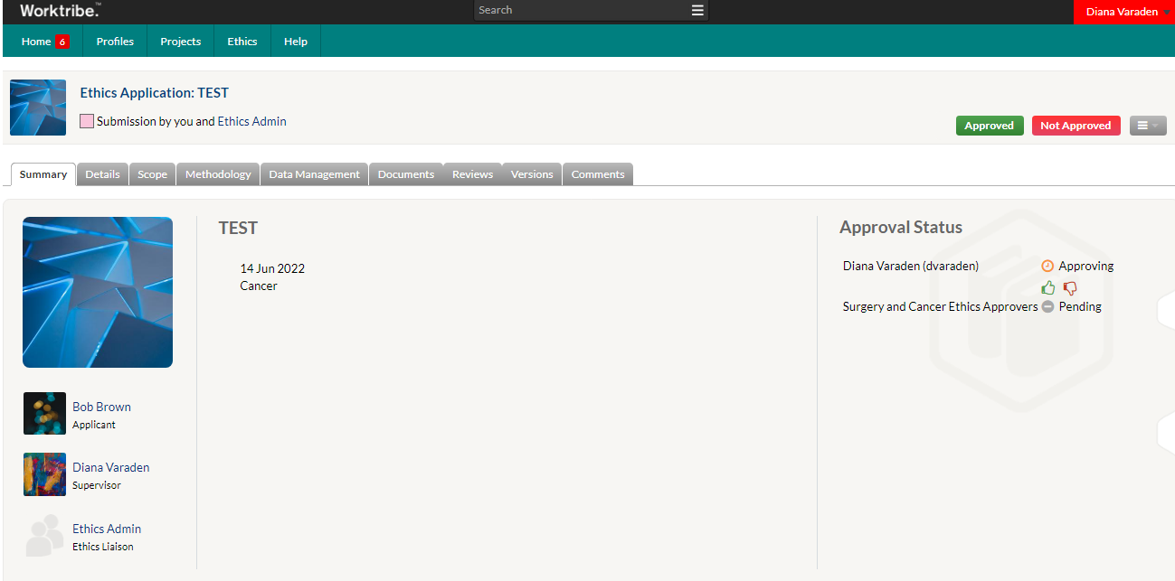

The right-hand side displays a list of the approval status.

In the example above Bob Brown is the researcher, Diana Varaden is the Supervisor and George Hanna (Surgery and Cancer Ethics Approvers) is the HoD.

You will now be able to read and view comments. If the Supervisor commented on the application form, you will be able to see their comments and any changes they may have requested.

## Reviewing the ethics application

A grey bar will appear with lots of different tabs. Each tab contains questions that will help answer and address any ethical issues that may arise.

Different tabs will populate at the top of the page depending on how the researcher answered the questions.

Image of ethics application tabs with red notification tabs

You will be able to read and review the researcher’s answers in the application and review any supporting documents.

## Details tab

Displays the key information from the study. You should check that you are correctly listed as the named Supervisor/HoD.

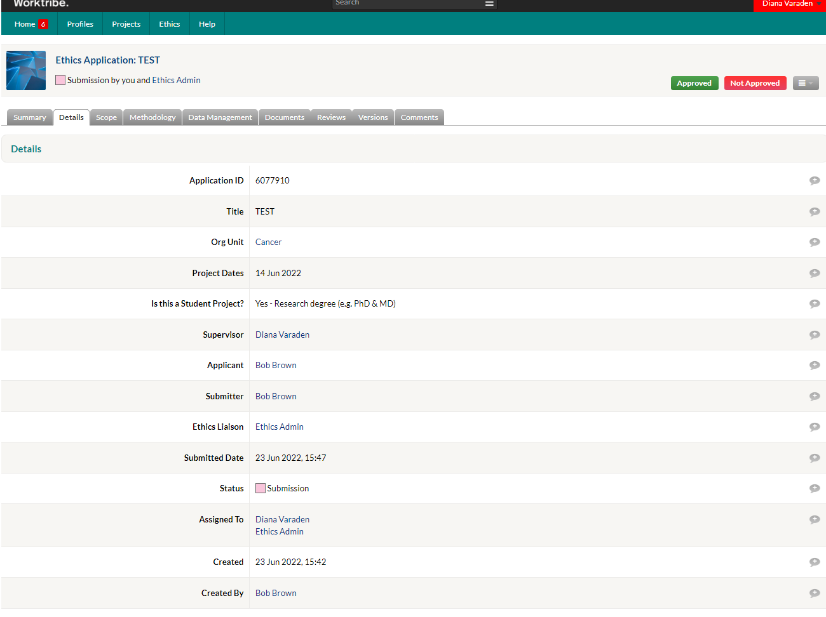

## Reviewing all tabs

Open each tab and read the answers to each question. If further clarification or additional information is required, you can add comments and then inform the researcher by ‘Not approving’ the application.

## How to add a comment – Supervisors only

As a supervisor you can add comments by pressing the grey bubble on the right-hand side of the chosen question and adding your comment.

**Please Note**: *Comments can be seen by the researchers and will be available in the comments tab audit trail so please make sure they are accurate, worded clearly and relevant.*

* Press **Enter** to send the comment and add to the thread.
* Once a comment has been adding it will change from Image of an empty speech bubbletoImage of an annotated speech bubble
* In the example below the comments show that some of the data section needs amending and the answer changed to ‘yes’.

Only the Supervisor can add and see comments from the researcher while working through the application form. **The HoD can only review and approve the application.**

The Supervisors can keep track of the comments made between them and the researcher by clicking on the speech bubble or comments button in the action panel.

Screenshot of an opened annotated speech bubble

### How to format comments – Supervisor only

Comments can be formatted in two ways:

1. Surround any word/phrase with **\*** and it will appear **bold**.
2. Surround any word/phrase with **`** and it will appear **preformatted.**

### Annotation Aside – Supervisor only

From the comments tab, as the supervisor you can add comments elsewhere within a study. Annotations can be added to items within the Details, Documents and Risk tab. This works in the same way as the comments tab; you can simply add text and/or tag, reference and/or format your comment. For example, a user may want to tag another user to alert them to an issue or simply ask the user to review and get their opinion.

If you deem the thread as completed or no longer required, you can click on the resolve bottomImage of resolve button. The annotation is now hidden however a record of the thread is still recorded in the comments thread for reference.

## Review of Supporting Documents – Supervisor and HoD

To review the supporting documents. Go to the **documents tab** and open the document you want to review.

If you need to raise a query regarding the documents. You can add a direct comment in the speech bubble next to the document**.**

### Approving a study – Supervisor and HoD

Once you have completed the review, you can approve it immediately **only** if no changes or clarifications are required by you. If you are happy with the application and supporting documents, you can approve the study immediately by **clicking**Image of approved button, which generates a pop-up window, add a message if required and **click Update**.

The study status will change to submitted and a notification will alert you to the study being moved to Triage. Image of the application has been approved for triage.

*Supervisor approval submits to HoD, and the HoD approval submits the application to RGIT.*

## Not approving a study – Supervisor and HoD

If you have any questions or need further clarification, you will need to send your comments back to the researcher. You can return your reasons by not approving the study. **Click** Image of not approved button.

**T**his will generate a pop-up window. With standard text. “*I have not approved this for the following reasons.”*

* **Add** a summary of the reason(s) for not approving the study.
* Click **Update.**

This will return the application back to the researcher. The researcher will receive a notification asking them to review your response and update the application form and documents accordingly.

Note: Every time you return the application back to the researcher the study status will revert to ‘in progress’.

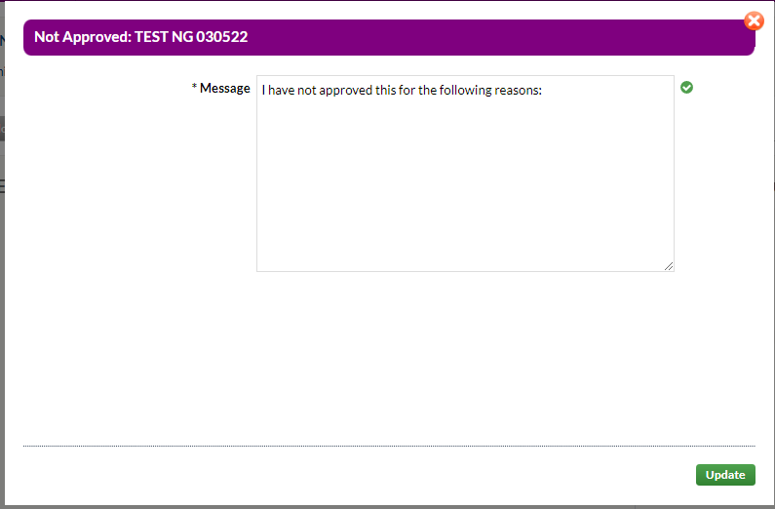

## Review and approval of Revised Application by Supervisor/HoD - 2nd Review

Once the Supervisor/HoD are satisfied and approve the application the ERGC will triage the study and assign it to a member of the RGF team.

**The application has successfully been reviewed and approved by you at this stage and sent to RGIT for triage.**

**NOTE**: If the project is deemed low risk, there is nothing further to do until after the assigned Research Governance Facilitator (RGF) has completed their final review and is ready to approve the study.

NOTE: If the project is deemed medium or high risk and requires Committee review, once the ERGC has completed their final review then the supervisor/HoD will review the revised application using the same process as described above. If you, the Supervisor/ HoD is happy for the documents to be reviewed by the Committee, then select Image of approved button. A pop-up window will appear for you to complete and **click Update**.

*If you have any issues, you can use the same process used in the initial review to read, respond or add comments to the application by clicking ‘Not Approved’.

# Resubmission for approval (final stage)

Supervisor/ HoD approval is required at the final stage of the approval process.

***Tip: To see an audit trail of all the comments between RGIT and the researcher go to the comments tab.***

## Approving RGIT reviewed ethics application

On final review of the revised application using the same process as described above. If you, the Supervisor/ HoD is happy you can issue approval by Selecting Image of approved button. A pop-up window will appear for you to complete and **click Update**.

*If you have any issues, you can use the same process used in the initial review to read, respond or add comments to the application by clicking ‘Not Approved’.

**You have now successfully reviewed and approved an ethics application.**

# Post-approval responsibilities

## What happens to the study after you issue final HoD approval in Worktribe?

**After the study has been given ethics approval there are responsibilities that you will need to maintain. Reviewing and approving any changes to the study, through any amendments, will be required until the study is completed.**

## Approving an amendment

The Worktribe online ethics application is used to amend the study design, study team or request a time extension. Once completed, the form will be submitted to the Supervisor/HoD for approval.

### If an Amendment is required?

The Supervisor/ HoD will need to review and add comments to the populated tabs that reflect the changes made to the study if required.

## Researcher Submits amendment to Supervisor / HoD for approval.

## Notification of amendment submission - Supervisor/HoD

A status will appear that the online form has been submitted and is in progress.

**Please note**: Once the researcher selects ‘Amend’ and updates the application for any changes then their application will be sent to the Supervisor /HoD for approval before it will be submitted to the RGIT Office for triage**. It is important to approve the amendment in a timely manner.**

## Amendment review - Supervisors/ HoD

A summary of the changes made to the application will appear on the landing page.

* You will need to review all the updates in the tabs and in the supporting documents.
* As a supervisor if you need to raise a query regarding the documents. You can add a direct comment next to the document**.**

The Supervisor can also add comments directly next to the document in the documents tab.

## Not approving an amendment - Supervisor and HoD

If you have any questions, and need clarification from the researcher, you will need to send your reasons back to the researcher.

After you have completed your review of the amendment you can return your response. **Click** Image of not approved button and a**dd** a summary of the reason(s) for not approving the study.

If you return the application the study status will change to:Image of amendment by you, message

The process can be repeated as needed until the researcher revises the amendment to your satisfaction.

## Approving an amendment - Supervisor and HoD

Once you have completed the review, you can approve it immediately **only** if no changes or clarifications are required by you by **clicking**Image of approved button.

The status changes to ‘*Amendment triage’.*

**The amendment has successfully been reviewed and approved by you at this stage and sent to RGIT. While the study is being reviewed by RGIT the status will remain in Triage.**

***NOTE****: There is nothing further to do until the after the assigned Research Governance Facilitator (RGF) has completed their final review and is ready to approve the study.*

Supervisor/ HoD Approval at the end of the amendment process.

## 8.1 Review of Revised Final Application by Supervisor/HoD - Final Review

* The final review of the revised application uses the same process as described above, if the Supervisor/ HoD is happy they can issue approval by Selecting Image of approved button.
* The study status will change from ‘amendment revision submission’ to ‘amendment triage’.
* If you have any questions or need any changes or clarification from the research on final review, you can raise a query and send a comment by not approving the amendment using the same process as above. **Click** Image of not approved button.
* Clicking not approved returns the application status back to **‘amendment revision’**
* The process continues as described above moving though the same steps as described until the study is approved and moved into Triage which allows the RGIT to issue the approval letter.
* Once RGIT issue approval of the amendment and upload the approval letter the status of the amendment will change to approved.

**You have successfully reviewed and approved an amendment.**